WEEK 3 ASSIGNMENT
Advanced Data Analysis
and Visualization in Logistics
Exploratory data analysis, statistical interpretation,
visualization and operational insights
━━━━━━━━━━━━━━━━━━━━━━━━━━━━━━━━
Prepared by | Rohan Sandip Nikam
Dataset | Synthetic logistics delivery dataset
Records analysed | 985 unique orders
Tools | Python, Pandas, NumPy, Matplotlib, Seaborn
DATASET DISCLOSURE
The source dataset is synthetic and was created for training and assignment practice. It is not a record of actual company deliveries. The supplementary shipment-volume field is also simulated for demonstration.

Executive Summary
A concise overview of the analysis and its principal findings.
This report analyses a simulated logistics delivery dataset. The raw file contained 1,000 rows and 14 source fields. After removing 15 exact duplicate records, 985 unique orders remained. The analysis examined delivery-time distributions, delivery status, traffic and weather conditions, vehicle performance, transportation cost, monthly trends and correlations.
985  Unique orders | 22.34%  On-time delivery rate | 77.66%  Delayed delivery rate
625.5 min  Average delivery time | 587.0 min  Median delivery time | INR 1,086.62  Average delivery cost

Key findings
- 765 orders (77.7%) were classified as delayed using actual delivery time compared with promised delivery time.
- High-traffic orders had the largest average delivery time (791.0 minutes), compared with 493.4 minutes in low traffic.
- Rainy-weather orders had the largest average delivery time (734.4 minutes) among the weather categories.
- Distance and delivery cost showed a strong positive Pearson correlation (r = 0.86) in this simulated dataset.
- August 2026 recorded the highest monthly order count (132 orders) in the generated date range.
Interpretation boundary
These are findings from a simulated dataset. They demonstrate how logistics data can be analysed; they should not be generalized as real-world industry performance benchmarks.

1. Assignment Objective and Scope
The Week 3 task focuses on exploring and visualizing logistics data, calculating central tendencies and distributions, examining correlations, and interpreting visualizations to identify operational efficiency patterns, possible cost drivers and bottlenecks.

Objectives
- Describe the structure and key variables of a hypothetical logistics dataset.
- Perform exploratory data analysis and descriptive statistical calculations.
- Create visualizations for distributions, comparisons, trends and relationships.
- Interpret the results in the context of delivery performance and transportation cost.
- Develop practical recommendations while acknowledging limitations of simulated data.

2. Dataset Description
The raw logistics dataset contains 1,000 synthetic records and 14 original columns. The records represent hypothetical deliveries between cities in Maharashtra and other sample city locations. The generated order dates range from 01 January 2026 to 27 October 2026.
The source fields describe order identifiers and dates, origin and destination cities, distance, traffic, weather, vehicle type, order value, promised and actual delivery time, delivery cost, delivery status and inventory quantity.
Supplementary simulated variable
The source data did not contain a direct shipment-volume field. To demonstrate shipment-volume visualization, shipment_volume_units was generated reproducibly from cleaned inventory_qty and a simulated demand draw. It is not observed shipment information and is treated as an illustrative variable only.

3. Data Preparation for EDA
The Week 2 preprocessing workflow was applied to the raw file before analysis. The goal was to obtain a consistent dataset and reduce the effect of known data-quality issues without hiding the fact that the data was simulated.
Preparation check | Result / method
Raw records / fields | 1,000 rows × 14 columns
Exact duplicates | 15 rows removed
Unique records after duplicate removal | 985 rows
Missing cells in raw file | 104 across six columns
Date handling | Mixed date strings parsed to datetime; no unparsed dates remained
Categorical cleanup | Whitespace removed and labels standardized with title case
Missing-value treatment | Median for numeric columns; mode for traffic_level and weather
Business validation | Non-positive distance/time/cost and negative inventory checked; invalid values re-imputed
Outlier treatment | IQR boundaries calculated and capping applied to selected numeric fields
Final validation | 985 unique rows retained; zero missing cells and zero duplicate rows

Raw missing-value profile
Column | Missing cells | Share of 1,000 rows
distance_km | 23 | 2.3%
traffic_level | 12 | 1.2%
weather | 18 | 1.8%
actual_delivery_minutes | 15 | 1.5%
delivery_cost_inr | 16 | 1.6%
inventory_qty | 20 | 2.0%

The six affected fields were distance_km (23), traffic_level (12), weather (18), actual_delivery_minutes (15), delivery_cost_inr (16) and inventory_qty (20). These values sum to 104 missing cells in the original file.
Variable | Q1 | Q3 | Lower IQR limit | Upper IQR limit | Potential outliers
Distance (km) | 141.4 | 385.9 | -225.3 | 752.6 | 2
Actual time (min) | 342.0 | 865.0 | -442.5 | 1,649.5 | 7
Delivery cost (INR) | 626.3 | 1,450.3 | -609.6 | 2,686.3 | 2
Inventory quantity | 39.0 | 112.0 | -70.5 | 221.5 | 1

IQR flags are statistical indicators, not automatic proof of erroneous records. In this exercise, selected extreme values were capped to the calculated boundaries to preserve rows for practice analysis.

4. Exploratory Data Analysis and Statistical Methods
Exploratory data analysis (EDA) was used to inspect the dataset before drawing conclusions. The analysis checked record counts, data types, missing values, duplicate rows, descriptive statistics and category frequencies.

Central tendency and dispersion
Mean describes the arithmetic average, median gives the 50th percentile, and mode identifies the most frequently occurring value. Standard deviation describes the spread around the mean. For skewed numeric distributions, the median can be more representative of a typical observation than the mean.
Variable | Mean | Median | Std. dev. | Minimum | Maximum
Distance (km) | 265.08 | 276.50 | 143.61 | 5.00 | 752.65
Order value (INR) | 12,036.41 | 11,505.71 | 7,202.64 | 276.89 | 24,988.84
Promised time (min) | 493.67 | 501.00 | 242.84 | 60.00 | 896.00
Actual time (min) | 625.50 | 587.00 | 358.25 | 5.00 | 1,649.50
Delivery cost (INR) | 1,086.62 | 1,081.47 | 552.61 | 5.00 | 2,686.26
Inventory quantity | 74.78 | 74.00 | 42.80 | 0.00 | 221.50
Simulated units | 14.51 | 14.00 | 8.78 | 0.00 | 30.00

Categorical frequency profile
Field | Category | Orders | Share
traffic_level | Medium | 436 | 44.3%
traffic_level | Low | 288 | 29.2%
traffic_level | High | 261 | 26.5%
weather | Clear | 456 | 46.3%
weather | Cloudy | 234 | 23.8%
weather | Rainy | 190 | 19.3%
weather | Foggy | 105 | 10.7%
vehicle_type | Bike | 347 | 35.2%
vehicle_type | Tempo | 230 | 23.4%
vehicle_type | Van | 222 | 22.5%
vehicle_type | Truck | 186 | 18.9%
performance_status | Delayed | 765 | 77.7%
performance_status | On-Time | 220 | 22.3%

Categorical modes
Field | Mode (most frequent value) | Frequency
traffic_level | Medium | 436
weather | Clear | 456
vehicle_type | Bike | 347
performance_status | Delayed | 765

The average actual delivery time was 625.5 minutes and the median was 587.0 minutes. The mean is above the median, indicating a longer upper tail in delivery durations. The capped maximum was 1649.5 minutes.

5. Distribution and Delivery Status Visualizations

5.1 Actual delivery-time distribution
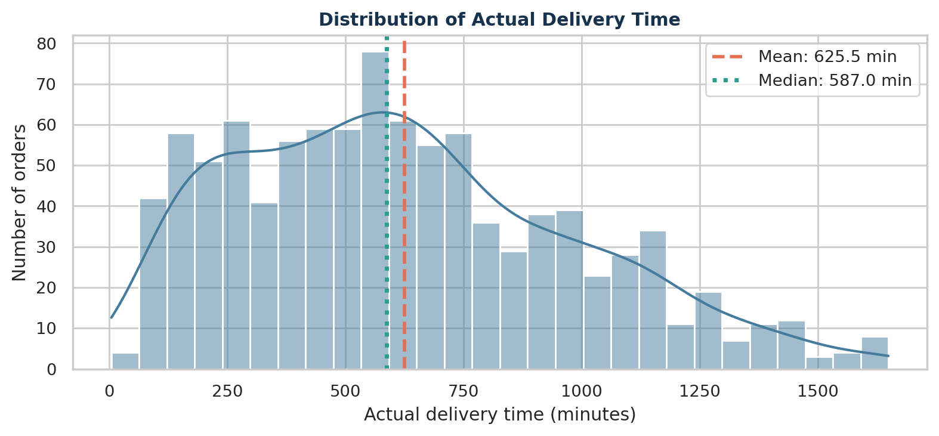
Figure 1. Histogram and density curve of actual delivery time.
The mean (625.5 minutes) is above the median (587.0 minutes). The distribution therefore has a longer high-duration tail. A histogram is appropriate because it shows where delivery durations are concentrated and whether observations are symmetric or skewed.

5.2 On-time versus delayed deliveries
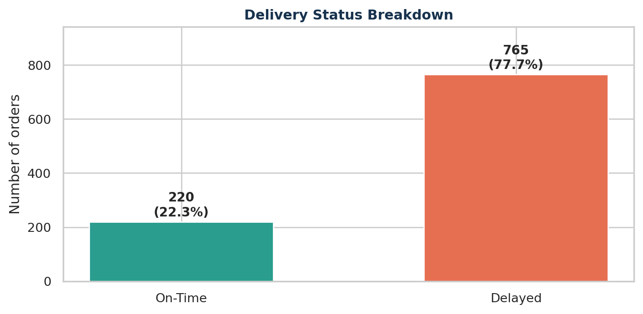
Figure 2. Count and percentage of on-time and delayed orders.
Using the rule actual_delivery_minutes ≤ promised_delivery_minutes, 220 orders were on time (22.34%) and 765 were delayed (77.66%). This bar chart gives a direct operational performance summary. The high delayed share is a feature of this generated dataset, not a real-world benchmark.

6. Traffic and Weather Analysis

6.1 Traffic level and delivery time
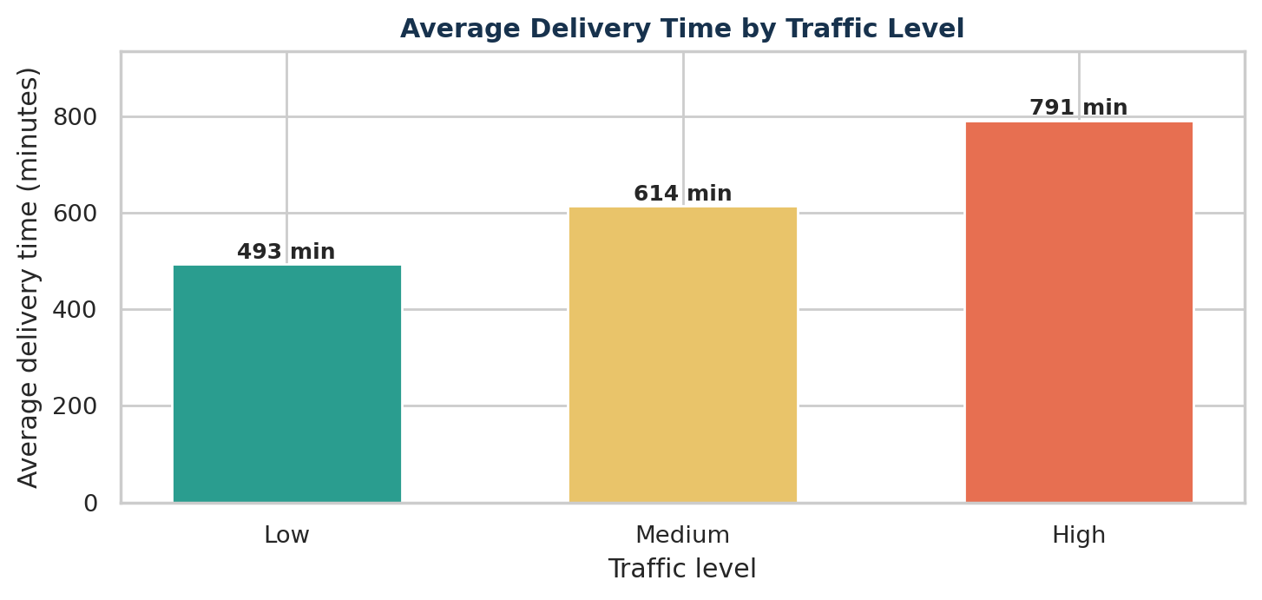
Figure 3. Average actual delivery time across traffic categories.
Group summary - Low: n=288, mean=493.4 min, on-time=55.2%; Medium: n=436, mean=613.7 min, on-time=13.8%; High: n=261, mean=791.0 min, on-time=0.4%.
High traffic averaged 791.0 minutes, versus 493.4 minutes in low traffic. The lower on-time rate in high traffic reflects the time multiplier built into this synthetic dataset.

6.2 Weather and delivery time
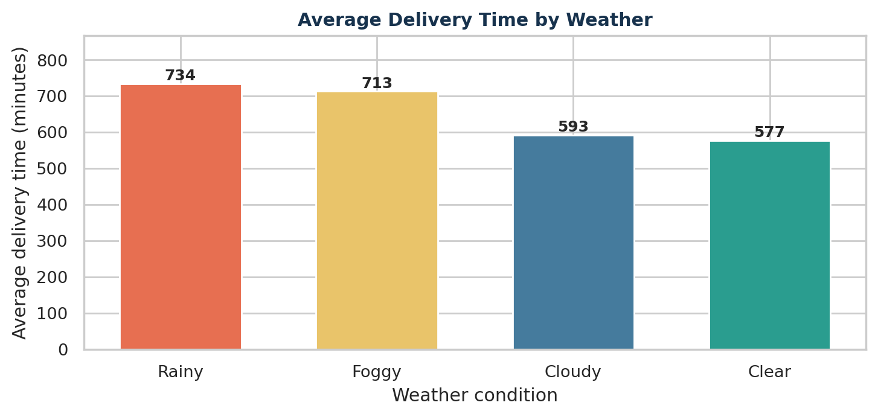
Figure 4. Average actual delivery time across weather categories.
Rainy and foggy orders had longer average delivery times (734.4 and 713.1 minutes) than clear-weather orders (576.9 minutes). This reflects the simulation design, not causal evidence.

7. Vehicle Performance and Cost Relationships

7.1 Vehicle-type delivery performance
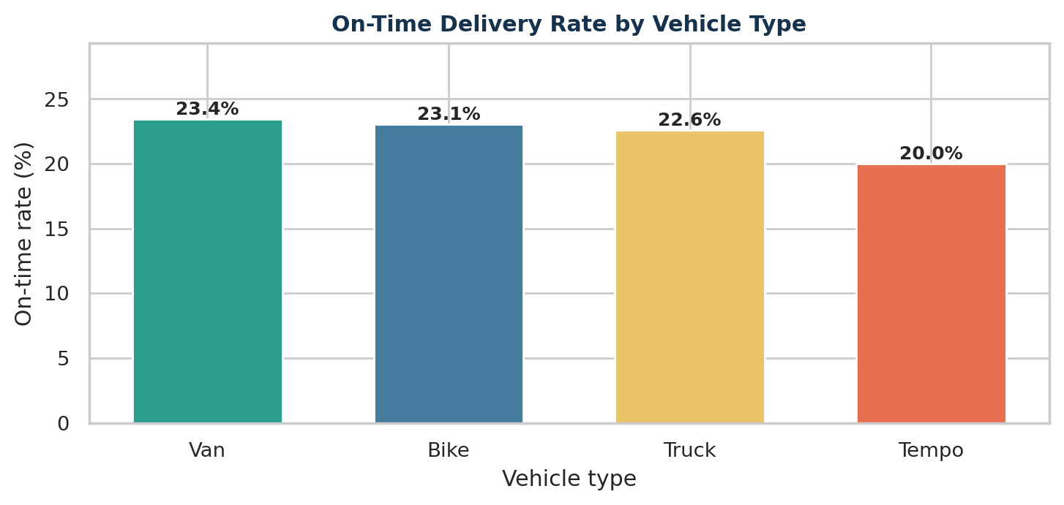
Figure 5. On-time delivery rate by vehicle type.
Vehicle | Orders | Avg. time (min) | Avg. cost (INR) | On-time rate
Van | 222 | 598.0 | 1,072.09 | 23.4%
Bike | 347 | 632.8 | 1,087.76 | 23.1%
Truck | 186 | 630.4 | 1,086.07 | 22.6%
Tempo | 230 | 637.0 | 1,099.38 | 20.0%

Vans had the shortest average delivery time (598.0 minutes) and the highest on-time rate (23.4%). Tempos had the longest average time (637.0 minutes) and the highest average cost (1099.38 INR). Differences are descriptive; vehicle choice was not randomly controlled, so this does not establish that a vehicle type causes better performance.

7.2 Distance and transportation cost
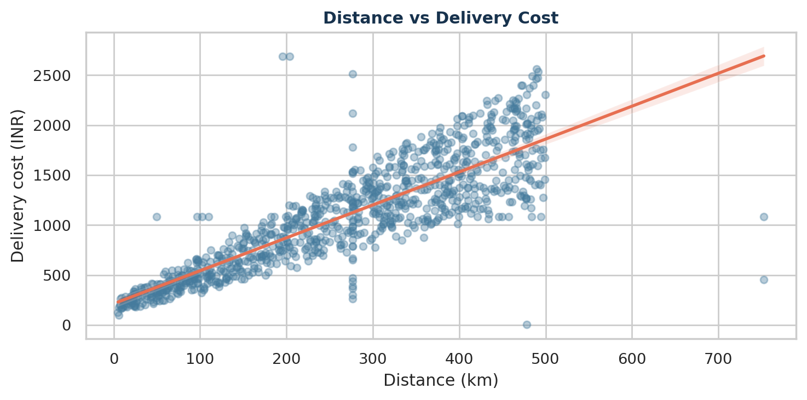
Figure 6. Scatter plot with linear trend line for distance and cost.
Distance and delivery cost had a Pearson correlation of r = 0.856, a strong positive relationship in this dataset. The scatter plot is appropriate because both variables are numerical; the trend line helps visualize the direction of the relationship. The relationship is expected because the synthetic cost-generation formula directly included distance.

8. Delivery Promise and Monthly Trend Analysis

8.1 Promised versus actual delivery time
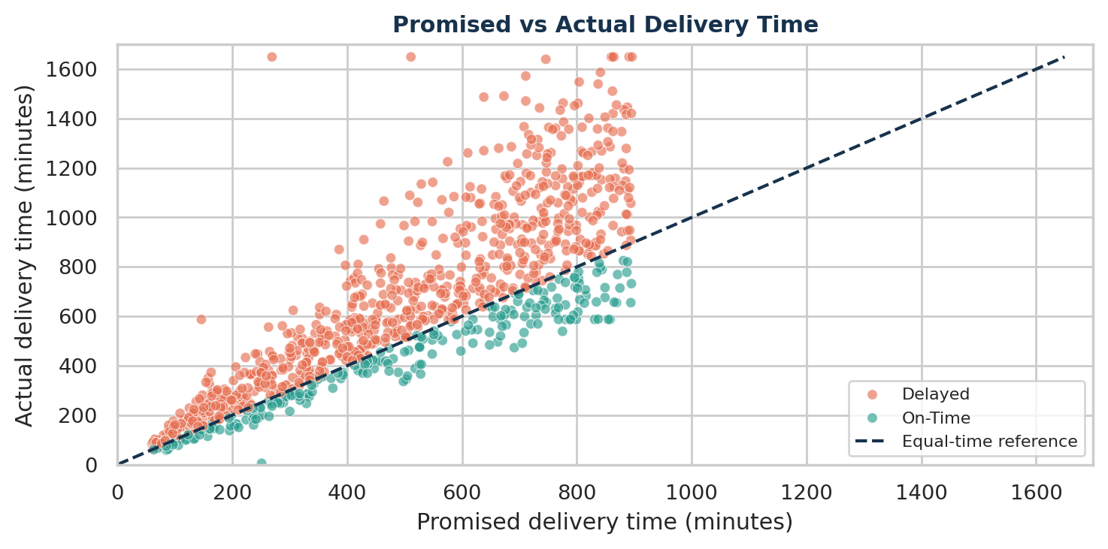
Figure 7. Actual time compared with promised time; dashed line indicates equality.
Promised and actual delivery time had a Pearson correlation of r = 0.849. Points above the dashed equality line represent delayed orders; points below it represent deliveries completed earlier than promised. This visual directly supports the definition of the on-time/delayed target.

8.2 Monthly order volume and on-time rate
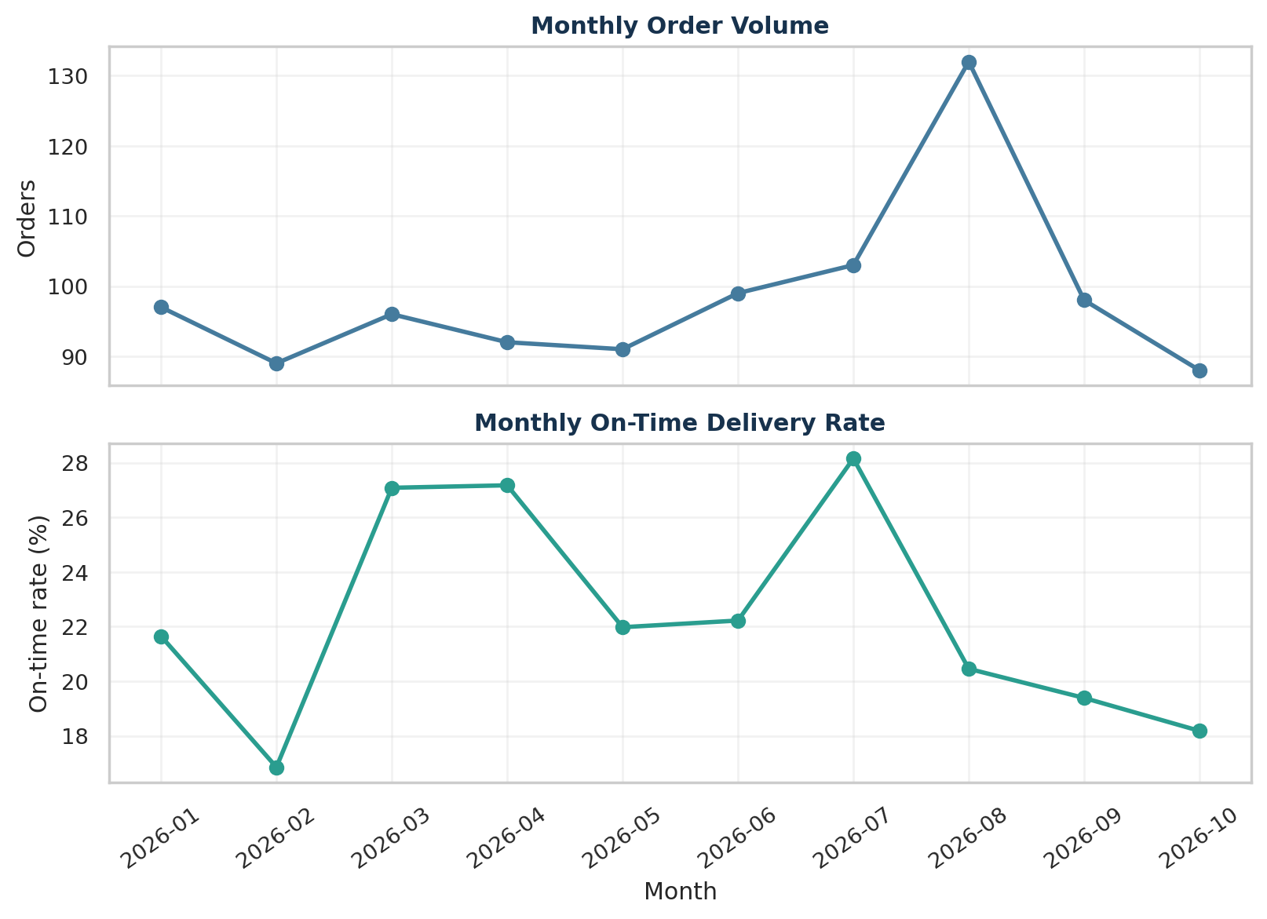
Figure 8. Monthly order counts and on-time delivery rate, January to October 2026.
Month | Orders | Avg. time (min) | On-time rate
2026-01 | 97 | 608.2 | 21.6%
2026-02 | 89 | 729.8 | 16.9%
2026-03 | 96 | 577.1 | 27.1%
2026-04 | 92 | 617.1 | 27.2%
2026-05 | 91 | 606.4 | 22.0%
2026-06 | 99 | 582.8 | 22.2%
2026-07 | 103 | 670.1 | 28.2%
2026-08 | 132 | 617.1 | 20.5%
2026-09 | 98 | 610.2 | 19.4%
2026-10 | 88 | 646.0 | 18.2%

August had the highest order count (132), while October had the lowest (88). July recorded the highest on-time rate (28.2%) and February the lowest (16.9%). October covers dates only through 27 October in the generated file, so the month is incomplete and its volume should not be compared directly with full months without adjustment.

9. Correlation and Shipment-Volume Demonstration

9.1 Pearson correlation
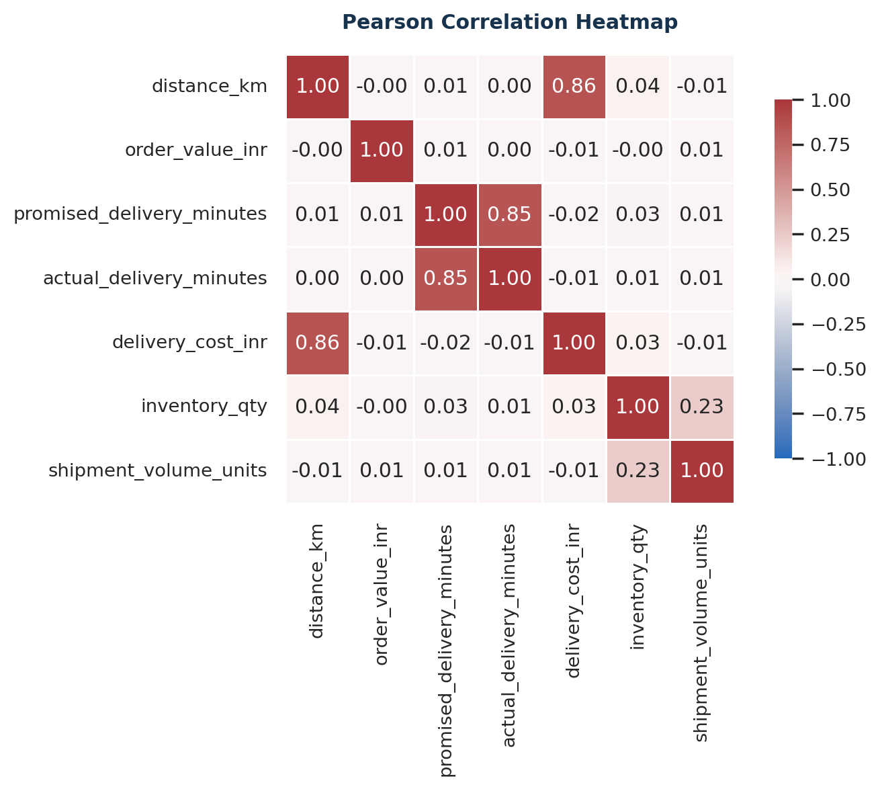
Figure 9. Pearson correlation matrix for numeric features.
Variable 1 | Variable 2 | Correlation (r) | Direction
distance_km | delivery_cost_inr | 0.856 | Positive
promised_delivery_minutes | actual_delivery_minutes | 0.849 | Positive
inventory_qty | shipment_volume_units | 0.229 | Positive
distance_km | inventory_qty | 0.040 | Positive
delivery_cost_inr | inventory_qty | 0.032 | Positive

The strongest original-feature relationships were distance with delivery cost (r = 0.856) and promised time with actual time (r = 0.849). The inventory-to-simulated-volume correlation was 0.229; this relationship is expected because the demonstration shipment units were constrained by inventory quantity.
Correlation caution
Correlation measures linear association, not causation. Derived variables such as delay_minutes and late_minutes were excluded from the primary heatmap because they are calculated from actual and promised times and would create mechanically related correlations.

9.2 Supplementary simulated shipment volume
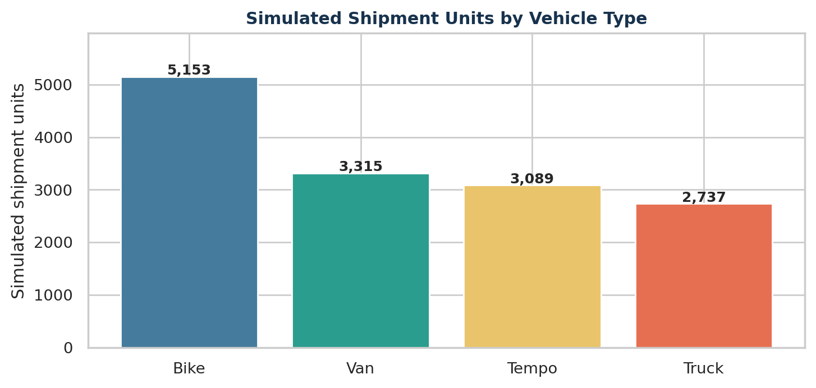
Figure 10. Simulated shipment units by vehicle type.
The supplementary simulation generated 14,294 shipment units across 985 orders. Bikes account for the largest simulated total in this generated sample (5,153 units). This field was introduced only to demonstrate a shipment-volume grouping and chart; it should not be used as evidence about actual vehicle capacity or historical throughput.

10. Analytical Insights and Recommendations
The analysis indicates several areas that a logistics operator could investigate. Because the dataset is hypothetical, the recommendations are framed as operational hypotheses to validate with real shipment data.
Area | Evidence from this sample | Potential action
Delivery reliability | 77.7% of simulated orders were delayed. | Review promise-time setting, dispatch timing and exception management.
Traffic conditions | High traffic averaged about 791 minutes versus 493 minutes in low traffic. | Test traffic-aware route planning and time-of-day dispatch windows.
Weather conditions | Rainy and foggy records had higher average delivery times than clear-weather records. | Consider weather buffers, driver safety procedures and proactive customer notifications.
Vehicle comparison | Van had the lowest average time and highest on-time percentage in this sample; Tempo had the highest mean cost. | Review vehicle assignment by route type, distance, shipment characteristics and cost per kilometre before changing allocation.
Transportation costs | Distance and delivery cost were strongly correlated (r = 0.856). | Monitor cost per kilometre, route distance and avoidable detours.
Monthly variation | Order volume and on-time rate changed from month to month. | Plan staffing and vehicle availability using demand forecasts and complete-month comparisons.

Suggested operational follow-up
- Collect real dispatch and GPS timestamps to distinguish loading time, travel time, waiting time and last-mile service time.
- Add route-level distance, road type, planned departure time and peak-hour indicators to test the traffic relationship more accurately.
- Compare cost per kilometre and cost per successful on-time delivery rather than using average cost alone.
- Use complete calendar months for trend comparisons; normalize partial months or exclude them from month-to-month rankings.

11. Limitations and Conclusion

Limitations
- The dataset is synthetic and was generated for educational practice; it does not represent a public logistics data source or a real company.
- The generated delivery-time formula intentionally uses traffic and weather multipliers, while distance is used directly in the delivery-cost formula. Consequently, some correlations reflect the simulation rules rather than general logistics laws.
- The shipment_volume_units field was created from inventory and a seeded random demand draw. It is not an observed shipment-volume measurement.
- Outlier capping and median/mode imputation change the distribution. Results should therefore be interpreted as outputs of the documented preprocessing pipeline.
- No causal inference or statistical significance test was performed. Group differences are descriptive comparisons only.

Conclusion
This project demonstrated how Python can be used to explore a logistics dataset, calculate descriptive statistics, visualize delivery performance and identify relationships among operational variables. In the cleaned sample of 985 unique orders, the on-time delivery rate was 22.34%, mean delivery time was 625.5 minutes, and mean delivery cost was INR 1,086.62. Traffic and weather groupings revealed notable differences in average delivery duration, while distance and delivery cost showed a strong positive correlation. The findings illustrate how EDA can guide questions about route planning, scheduling, vehicle assignment and cost control. Real operational decisions should be made only after validating these patterns with actual logistics records.

Appendix A. Reproducible Python Code
The following excerpts show the main analysis operations. They are intended to be run in a notebook after the Week 2 cleaned dataset has been created. The complete figures and tabular results in this report were generated with the same documented logic.

Load data and create analysis fields
import pandas as pd, numpy as np
import matplotlib.pyplot as plt
import seaborn as sns
df = pd.read_excel('Week2_Logistics_Preprocessed.xlsx',
sheet_name='Cleaned_Data')
df['delay_minutes'] = df['actual_delivery_minutes'] - df['promised_delivery_minutes']
df['performance_status'] = np.where(df['delay_minutes'] <= 0, 'On-Time', 'Delayed')

Optional simulated shipment-volume field
rng = np.random.default_rng(42)
demand = rng.integers(1, 31, size=len(df))
stock = df['inventory_qty'].clip(lower=0).fillna(0).astype(int)
df['shipment_volume_units'] = np.minimum(stock, demand)

Descriptive statistics and grouped analysis
metric_cols = ['distance_km', 'promised_delivery_minutes',
'actual_delivery_minutes', 'delivery_cost_inr']
stats = df[metric_cols].describe().T
traffic = df.groupby('traffic_level')['actual_delivery_minutes'].agg(['count', 'mean'])
correlation = df[metric_cols].corr(method='pearson')

Visualize and save a chart
sns.scatterplot(data=df, x='distance_km', y='delivery_cost_inr')
plt.title('Distance vs Delivery Cost')
plt.tight_layout()
plt.savefig('distance_vs_cost.png', dpi=300)
plt.show()

Delivery performance KPI
on_time_rate = df['performance_status'].eq('On-Time').mean() * 100
print(f'On-time delivery rate: {on_time_rate:.2f}%')

Source and reproducibility note: The input file was the synthetic Week 2 logistics dataset created for this assignment. All figures and summary values in this document are derived from the CSV file using the preprocessing and analysis steps documented above.

