WEEK 1 PROJECT REPORT

Strategic Planning and
Data Exploration in Logistics
Logistics Delivery Performance Analysis and Delay Investigation
Prepared as a Python Data Science Project
Week 1 Internship Report

Intern | Rohan Sandip Nikam
Internship Role | Logistics Data Analyst Intern
Organization | YuvaIntern
Internship Period | 22 October 2026 – 19 November 2026
Submitted as a strategic planning proposal.

Tools: Python | Pandas | NumPy | Matplotlib | Seaborn | Google Colab | GitHub
Dataset: 500 simulated delivery records, January-June 2026

Contents
- 1. Executive Summary
- 2. Background Research and Literature Review
- 3. Project Definition and Objectives
- 4. Dataset Description and Data Quality
- 5. KPIs and Initial Results
- 6. Exploratory Data Analysis and Findings
- 7. Proposed Data Science Methodologies
- 8. Strategic Roadmap
- 9. Python Code Illustrations
- 10. Recommendations, Limitations, and Conclusion
- 11. References

1. Executive Summary
This project explores a realistic logistics problem: a delivery company wants to understand late deliveries, improve delivery reliability, and make better decisions about dispatch planning and operating cost. The analysis uses a simulated dataset of 500 delivery records and Python tools to inspect data quality, calculate logistics KPIs, and compare delivery performance across traffic levels, weather conditions, vehicle types, months, and distance groups.
Metric | Result | Interpretation
Total deliveries | 500 | Records included in the analysis
On-time deliveries | 235 (47.00%) | Orders labelled On Time
Delayed deliveries | 265 (53.00%) | Orders labelled Delayed
Average actual delivery time | 422.44 minutes | Mean time recorded for a delivery
Average delivery cost | INR 475.11 | Mean cost after median imputation of missing costs

Initial patterns suggest higher delay rates under high traffic and longer average delays during storm conditions. Delayed orders also show higher average cost and actual delivery time than on-time orders in this simulated dataset. These are exploratory associations, not proof of causation. No predictive model has been trained in this Week 1 report.

2. Background Research and Literature Review
Delivery reliability is an important part of logistics performance. The World Bank’s Logistics Performance Index highlights the speed and reliability of supply chains and includes dimensions related to service quality, tracking, transport infrastructure, and whether shipments reach consignees within expected time [1]. This supports using on-time delivery rate, delivery time, and cost as practical measures for a logistics analysis.
Research by Rokoss and colleagues examines machine-learning approaches for predicting delivery times in small-batch manufacturing. The study discusses the value of selecting meaningful features and shows how delivery-date forecasts can support earlier planning and decision-making [2]. Although manufacturing delivery differs from last-mile parcel delivery, the principle is relevant: estimates are more useful when the model uses information available at the right stage of the order process.
A public Kaggle competition dataset titled “Package delivery time prediction” provides a further example of delivery analytics data. Its documentation describes delivery duration records alongside geography and weather information [3]. It is a useful reference for thinking about future data needs. It was not used to calculate the results in this report; the working CSV used here is a simulated educational dataset.

Research implications for this project
- Delivery reliability should be measured directly using an on-time rate and a delay rate [1].
- Delivery time prediction is a plausible future use of machine learning, but feature availability and validation matter [2].
- A more robust future dataset should contain timestamped orders, dispatch and arrival times, geography, route conditions, weather, and holiday information where available [3].
Data-source note: public resources were reviewed to support the project rationale. The 500-row CSV analyzed here was generated for practice, not downloaded from a logistics company or Kaggle.

3. Project Definition and Objectives

3.1 Scenario and problem statement
Assume a logistics company manages daily orders using bikes, vans, and trucks. The company records the distance, traffic level, weather condition, promised delivery time, actual delivery time, delivery cost, and final status. Operations managers have observed that some deliveries miss their promised time. They need an evidence-based way to investigate the patterns and decide where to focus operational improvements.

3.2 Problem statement
How can delivery and contextual data be explored to measure reliability, identify patterns associated with delays, and define a feasible roadmap for future delay prediction and delivery-planning improvement?

3.3 Objectives
- Inspect data structure, data types, duplicates, and missing values.
- Calculate core logistics KPIs, including on-time rate, delay rate, average delivery time, and average delivery cost.
- Compare delivery outcomes across traffic, weather, vehicle type, month, and distance categories.
- Use exploratory findings to propose appropriate predictive and optimization methods.
- Define a realistic end-to-end workflow from data collection through model evaluation and business recommendations.

3.4 Scope
Week 1 covers strategic planning, initial data exploration, descriptive analysis, and code illustrations. Training, tuning, validating, and deploying a predictive model are proposed future steps, not completed deliverables in this report.

4. Dataset Description and Data Quality
The working dataset has 500 rows and 11 columns before cleaning, with order dates from January through June 2026. One row represents one delivery order. The dataset is simulated and designed for learning basic data cleaning and exploratory analysis.
Column | Description
order_id | Unique order identifier
order_date | Date the order was recorded
distance_km | Delivery distance in kilometres
traffic_level | Traffic category: Low, Medium, or High
weather | Weather category: Clear, Rain, or Storm
vehicle_type | Bike, Van, or Truck
order_value_inr | Order value in Indian rupees
promised_delivery_minutes | Promised delivery duration in minutes
actual_delivery_minutes | Actual delivery duration in minutes
delivery_cost_inr | Delivery operating cost in Indian rupees
delivery_status | Outcome category: On Time or Delayed

4.1 Data-quality checks and cleaning decisions
Check | Observed result | Treatment
Dataset size | 500 rows, 11 columns | Retained for analysis
Duplicate rows | 0 | Checked with duplicated(); duplicate rows were removed if present
traffic_level missing | 8 | Filled with “Unknown” to preserve records
weather missing | 5 | Filled with “Unknown” to preserve records
delivery_cost_inr missing | 4 | Filled with the column median
order_date type | Initially text/object | Converted to datetime for month-level analysis

After these steps, all missing values in the handled columns were filled. The “Unknown” category preserves the fact that traffic or weather data were not recorded; it should not be interpreted as a real traffic or weather condition. Median imputation was used for missing cost values to reduce sensitivity to extreme values. Imputation assumptions should be documented in production work.

5. KPIs and Initial Results
The following KPIs are used to summarize the service level and operating efficiency of the delivery process.
KPI | Definition / formula | Result
Total deliveries | Count of delivery records | 500
On-time delivery rate | (On-time deliveries / total deliveries) × 100 | 47.00%
Delivery delay rate | (Delayed deliveries / total deliveries) × 100 | 53.00%
Average delivery time | Mean of actual_delivery_minutes | 422.44 minutes
Average delivery cost | Mean of delivery_cost_inr after median imputation | INR 475.11
Average delay minutes | Mean(actual time − promised time); negative means early | 2.45 minutes

The on-time rate and delay rate sum to 100% because each row in this dataset is labelled either “On Time” or “Delayed.” In a live system, cancelled, returned, missing, or exception orders might need additional outcome categories.

6. Exploratory Data Analysis and Findings

6.1 Overall delivery status
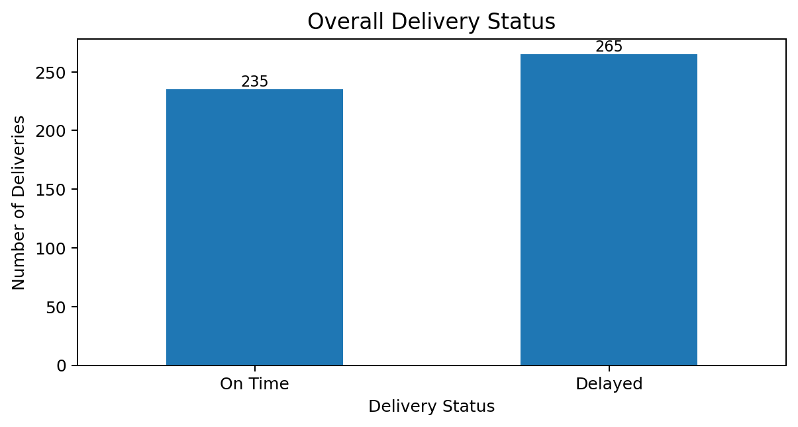
Figure 1. Count of on-time and delayed deliveries in the simulated dataset.
Of 500 orders, 265 were delayed (53.0%) and 235 were on time (47.0%). This establishes a baseline against which later operational changes or models could be evaluated.

6.2 Traffic level
Traffic level | Delayed (%) | On time (%) | Avg. delay (min)
High | 87.22% | 12.78% | 25.12
Medium | 59.31% | 40.69% | 3.22
Low | 14.19% | 85.81% | -18.52
Unknown | 75.00% | 25.00% | 12.62

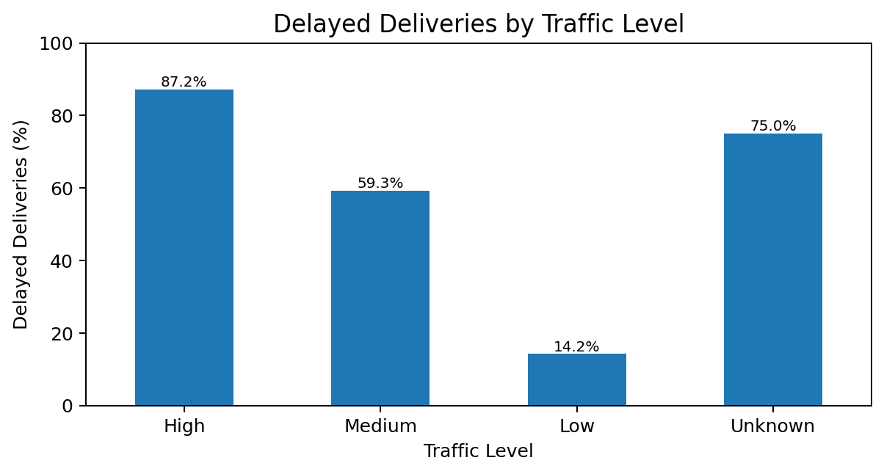
Figure 2. Share of deliveries classified as delayed within each traffic category.
High traffic shows the largest within-category delay rate (87.22%) and the highest average delay (25.12 minutes). Low traffic shows a 14.19% delay rate and an average delay of -18.52 minutes, meaning deliveries were early on average. The Unknown group is based on only records with missing traffic labels and should be interpreted cautiously.

6.3 Weather condition
Weather | Average delay (minutes)
Storm | 28.59
Unknown | 18.00
Rain | 10.38
Clear | -4.49

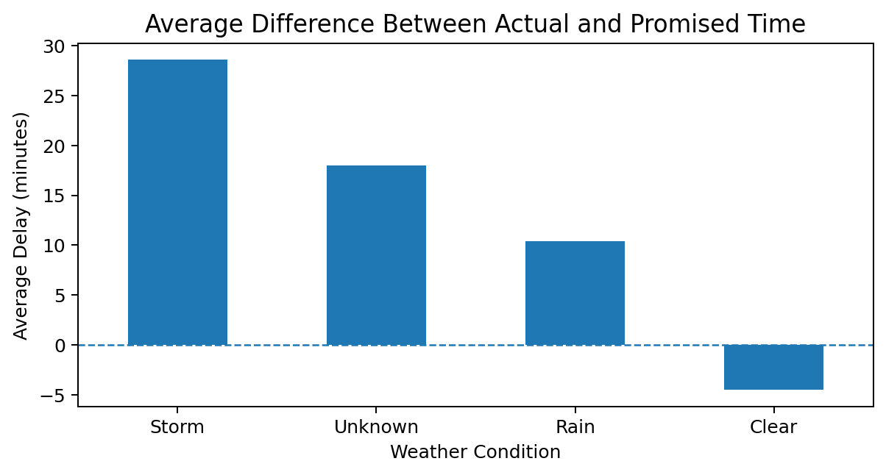
Figure 3. Mean actual-minus-promised delivery time by weather condition.
Storm conditions have the highest average delay (28.59 minutes), followed by Unknown (18.00) and Rain (10.38). Clear conditions have an average value of -4.49 minutes, meaning deliveries are early on average. These are descriptive associations in the simulated data and may be influenced by other features or by the way the dataset was generated.

6.4 Vehicle type
Vehicle type | Delayed (%) | On time (%)
Bike | 50.81% | 49.19%
Truck | 55.15% | 44.85%
Van | 52.92% | 47.08%

Truck has the highest delay rate among the three vehicle types (55.15%), while Bike has the lowest (50.81%). The differences are modest, so vehicle type alone should not be treated as a cause. Traffic, weather, distance, and other operating conditions should be considered together.

6.5 Monthly delivery trend
Month | Delayed (%) | On time (%)
2026-01 | 46.15% | 53.85%
2026-02 | 61.33% | 38.67%
2026-03 | 45.56% | 54.44%
2026-04 | 54.55% | 45.45%
2026-05 | 57.45% | 42.55%
2026-06 | 54.79% | 45.21%

February has the highest monthly delay rate (61.33%) and March the lowest (45.56%). With only six months represented and a simulated dataset, this pattern is exploratory and is not evidence of a recurring seasonal trend.

6.6 Distance category
Distance category | Delayed (%) | On time (%)
Short | 40.95% | 59.05%
Medium | 56.15% | 43.85%
Long | 56.23% | 43.77%

Short-distance deliveries (up to 100 km) have a 40.95% delay rate. Medium (over 100 to 250 km) and Long (over 250 to 500 km) categories show delay rates of 56.15% and 56.23%, respectively. The medium and long rates are nearly equal; there is not a steadily increasing delay rate across all distance groups.

6.7 Comparison by final delivery status
Status | Orders | Avg. distance | Avg. cost | Avg. actual time
Delayed | 265 | 266.26 km | INR 502.64 | 448.53 min
On Time | 235 | 244.21 km | INR 444.06 | 393.02 min

Compared with on-time orders, delayed orders have a higher average distance (266.26 vs. 244.21 km), cost (INR 502.64 vs. INR 444.06), and actual delivery time (448.53 vs. 393.02 minutes). These group comparisons are useful for investigation, but they do not establish that distance or cost causes delays.

7. Proposed Data Science Methodologies
Method | Application in this project | Output / evaluation
Exploratory Data Analysis | Summarize distributions and compare delivery outcomes across features. | Tables, charts, descriptive statistics
Classification | Predict On Time vs. Delayed using information available before delivery is completed. | Precision, recall, F1-score, confusion matrix; ROC-AUC if appropriate
Regression | Estimate actual delivery duration or delay minutes. | MAE, RMSE, and R-squared
Clustering | Group deliveries with similar operational characteristics after scaling numeric features. | Cluster profiles and operational interpretation
Optimization | Explore route, departure-time, and vehicle allocation options under operational constraints. | Travel time/cost objectives subject to capacity and service constraints

For a classification model, candidate features include distance, traffic level, weather, vehicle type, order date features, and the promised duration if it is known before dispatch. The final status can be the target. Actual delivery time must not be used as an input to a model that predicts delay before the delivery happens, because it would reveal information from the outcome.
For regression, the target could be actual delivery minutes or delay minutes. Clustering is exploratory and should only be used if grouping customers, routes, or orders serves a clear operational goal. Route optimization would require richer data such as origin/destination coordinates, road-network travel times, vehicle capacity, and delivery time windows; those fields are not present in the current dataset.

8. Strategic Roadmap
Phase | Activities | Deliverable
1. Business understanding | Define late-delivery problem, stakeholders, decision needs, and KPIs. | Problem statement and success criteria
2. Data collection | Obtain order, promised/actual timestamps, route distance, traffic, weather, vehicle, cost, and exception data. | Documented dataset and data dictionary
3. Data understanding | Inspect schema, distributions, missing values, duplicates, and possible data errors. | Data-quality summary
4. Data preparation | Clean values, parse timestamps, derive delay minutes, encode categories, and create valid features. | Analysis-ready dataset
5. Exploratory analysis | Compare delay rates by traffic, weather, vehicle, month, and distance. | EDA charts and findings
6. Predictive modeling | Build baseline classifier/regressor; split data into train/test sets; use cross-validation where suitable. | Candidate model and metrics
7. Evaluation | Compare against simple baselines; check class imbalance, errors, leakage, and stability. | Model evaluation report
8. Operational recommendations | Turn validated patterns into dispatch buffers, monitoring, or trial changes. | Action plan and monitoring KPIs

The roadmap resembles a staged data-science workflow: understand the business problem first, prepare reliable data, explore the patterns, model only when the target and features are appropriate, then evaluate before recommending operational changes.

9. Python Code Illustrations
The snippets below illustrate reproducible parts of the workflow. They are examples, not evidence that a predictive model has already been trained.

9.1 Load the CSV and inspect
import pandas as pd
import numpy as np
import matplotlib.pyplot as plt
import seaborn as sns
df = pd.read_csv("/content/logistics_delivery_data.csv")
print("Shape:", df.shape)
print(df.info())
print(df.isnull().sum())

9.2 Clean missing values and create delay feature
df = df.drop_duplicates().copy()
df["traffic_level"] = df["traffic_level"].fillna("Unknown")
df["weather"] = df["weather"].fillna("Unknown")
df["delivery_cost_inr"] = df["delivery_cost_inr"].fillna(
df["delivery_cost_inr"].median()
)
df["order_date"] = pd.to_datetime(df["order_date"])
df["delay_minutes"] = (
df["actual_delivery_minutes"] - df["promised_delivery_minutes"]
)

9.3 Calculate core KPIs
total = len(df)
on_time = (df["delivery_status"] == "On Time").sum()
delayed = (df["delivery_status"] == "Delayed").sum()
print("On-time rate (%):", round(on_time / total * 100, 2))
print("Delay rate (%):", round(delayed / total * 100, 2))
print("Average actual time (min):", round(df["actual_delivery_minutes"].mean(), 2))
print("Average cost (INR):", round(df["delivery_cost_inr"].mean(), 2))

9.4 Illustrative classification pipeline for a later phase
from sklearn.model_selection import train_test_split
from sklearn.linear_model import LogisticRegression
from sklearn.metrics import classification_report, confusion_matrix
features = [
"distance_km", "promised_delivery_minutes",
"traffic_level", "weather", "vehicle_type"
]
X = pd.get_dummies(
df[features], columns=["traffic_level", "weather", "vehicle_type"], dtype=int
)
y = (df["delivery_status"] == "Delayed").astype(int)
X_train, X_test, y_train, y_test = train_test_split(
X, y, test_size=0.2, random_state=42, stratify=y
)
model = LogisticRegression(max_iter=1000)
model.fit(X_train, y_train)
pred = model.predict(X_test)
print(classification_report(y_test, pred))
print(confusion_matrix(y_test, pred))
Modeling caution: this pipeline is illustrative for a future phase. Its features should be audited for availability at the time of prediction, and evaluation should be compared with a baseline. Because the working dataset is simulated and small, any model score would not demonstrate real-world performance.

10. Recommendations, Limitations, and Conclusion

10.1 Preliminary recommendations
- Review high-traffic dispatch windows and validate any time buffers against real operational data.
- Test whether storm conditions justify additional lead-time buffers or revised dispatch decisions.
- Investigate medium- and long-distance routes, which show higher delay rates than short routes in this dataset.
- Track on-time rate, delay rate, average delivery time, and delivery cost together.
- Collect route-level timestamps before changing staffing, fleet allocation, or customer promises.

10.2 Limitations
- The dataset is simulated, and descriptive associations do not prove causation.
- Unknown traffic/weather groups represent missing information and have small counts; only January-June 2026 is covered.
- GPS coordinates, route sequence, driver/warehouse details, and several real operational factors are not available.
- No predictive model or route-optimization algorithm is delivered in this Week 1 report.

10.3 Conclusion
This Week 1 project explores 500 simulated delivery records using Python. The on-time rate is 47.0%, while 53.0% are delayed. High traffic and storm conditions show the strongest delay patterns. Validate these findings with real operational data before acting; future work can evaluate prediction models and route optimization.

11. References
[1] World Bank. (2023, April 21). World Bank Releases Logistics Performance Index 2023: Resilience and reliability are crucial in the performance of logistics.
https://www.worldbank.org/en/news/press-release/2023/04/21/world-bank-releases-logistics-performance-index-2023
[2] Rokoss, A., Syberg, M., Tomidei, L., Hülsing, C., Deuse, J., et al. (2024). Case study on delivery time determination using a machine learning approach in small batch production companies. Journal of Intelligent Manufacturing, 35, 3937–3958.
https://doi.org/10.1007/s10845-023-02290-2
[3] Kaggle. (n.d.). Package delivery time prediction — dataset and competition description. Accessed 24 October 2026.
https://www.kaggle.com/c/package-delivery-time-prediction/data
Dataset used for calculations: logistics_delivery_data.csv, a simulated educational dataset created for this project. The external references support the background and methodology discussion; they are not the source of the numeric results.

