WEEK 2 | INTERNSHIP TASK
DATA COLLECTION,
CLEANING & PREPROCESSING
FOR LOGISTICS ANALYSIS
A practical Python data-preprocessing report
1,000  raw records | 14  source columns | 985  cleaned records
Prepared for: Week 2 Internship Submission
Prepared on: 4 November 2026
Python • Pandas • NumPy • Matplotlib • Seaborn • Scikit-learn

1. Executive Summary
This report documents a simulated logistics data-preprocessing workflow using Python. A 1,000-row dataset with 14 source columns was created to represent orders, routes, delivery conditions, delivery times, transportation costs and inventory. The raw file intentionally contains missing values, duplicate rows, inconsistent category formatting, mixed date formats, invalid values and extreme observations so that common data-quality treatments can be demonstrated.
The workflow identified 104 missing cells and 15 duplicate records. Missing numeric values were imputed using medians, selected categorical values using modes, duplicate rows were removed, dates were parsed into a datetime type, invalid values were corrected, and potential outliers were capped using IQR limits. Min-Max Scaling and Standardization were then demonstrated on six numeric features.
Main result: The cleaned analytical table contains 985 rows and 17 columns, with 0 missing cells and 0 duplicate rows after validation.

1.1 Objectives
- Simulate the collection of logistics data and describe its structure.
- Inspect data types, summary statistics and data completeness.
- Identify and treat missing values, duplicate records and inconsistent categories.
- Convert date fields, validate business rules and investigate potential outliers.
- Apply Min-Max Scaling and Standardization to selected numerical features.
- Validate and export the cleaned and scaled datasets for further analysis.

1.2 Dataset Profile
Attribute | Description
Dataset name | Week 2 Logistics Delivery Dataset
Data origin | Synthetic data generated for preprocessing practice
Raw size | 1,000 rows × 14 columns
Domain | Logistics / transportation / order delivery
Date field | order_date; stored as text in the raw CSV with mixed formats
File formats | CSV and Excel workbook
Python environment | Google Colab or Jupyter Notebook

Data provenance note: This is a newly generated synthetic dataset, not a download from a public data portal. It simulates typical logistics fields and known quality issues. If the evaluator strictly requires a publicly sourced dataset, the raw file should be replaced with an open dataset and its source URL and access date should be documented.

1.3 Source Columns
The 14 source fields cover order identifiers and dates, origin and destination cities, route distance, traffic and weather conditions, vehicle type, order value, promised and actual delivery times, delivery cost, delivery status and inventory quantity. The accompanying Excel workbook includes a Data_Dictionary sheet with the full column descriptions and expected data types.

2. Data Understanding and Initial Quality Assessment
The raw CSV was loaded with Pandas. Initial inspection used head(), tail(), shape, info(), dtypes, describe() and describe(include="object"). These checks provide a first view of the records, column types, numeric ranges and category values.
import pandas as pd
import numpy as np
import matplotlib.pyplot as plt
import seaborn as sns

df = pd.read_csv('Week2_Logistics_Raw_Dataset_1000_Rows.csv')
print(df.shape)
df.head()
df.info()
df.describe()
df.describe(include='object')

2.1 Missing Value Identification
Missing values were identified with isnull().sum(). The raw dataset contains 104 missing cells, equal to approximately 0.74% of the 14,000 data cells. The affected fields are shown below.
Column | Missing cells | Missing %
distance_km | 23 | 2.3%
traffic_level | 12 | 1.2%
weather | 18 | 1.8%
actual_delivery_minutes | 15 | 1.5%
delivery_cost_inr | 16 | 1.6%
inventory_qty | 20 | 2.0%

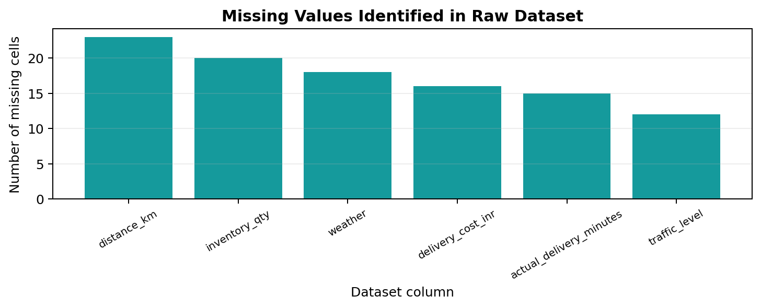
Figure 1. Missing-value counts in the raw logistics dataset.

2.2 Missing Value Treatment
Numeric variables were imputed with their column median. The median is less influenced by extreme values than the arithmetic mean. The two incomplete categorical fields, traffic_level and weather, were filled with their respective modes (most frequent categories). The original raw DataFrame was preserved and processing was performed on a copy.
df_clean = df.copy()

numerical_cols = [
'distance_km', 'actual_delivery_minutes',
'delivery_cost_inr', 'inventory_qty'
]

for col in numerical_cols:
df_clean[col] = df_clean[col].fillna(df_clean[col].median())

for col in ['traffic_level', 'weather']:
df_clean[col] = df_clean[col].fillna(df_clean[col].mode()[0])

print(df_clean.isnull().sum())

2.3 Duplicate Records
The duplicated() method identified 15 exact duplicate rows after missing-value imputation and category formatting. These repeated records were removed with drop_duplicates(), reducing the row count from 1,000 to 985. Duplicate removal prevents repeated orders from being counted more than once in summaries and analysis.
duplicate_count = df_clean.duplicated().sum()
print('Duplicate rows:', duplicate_count)

df_clean = df_clean.drop_duplicates()
print('Shape after duplicate removal:', df_clean.shape)

3. Data Type Correction and Consistency

3.1 Standardizing Categorical Text
Some category values were deliberately stored with leading/trailing spaces and inconsistent capitalization. str.strip() removes surrounding spaces and str.title() standardizes capitalization. Consistent labels are important for grouping, filtering and plotting.
categorical_cols = [
'traffic_level', 'weather',
'vehicle_type', 'delivery_status'
]

for col in categorical_cols:
df_clean[col] = df_clean[col].str.strip().str.title()

3.2 Converting the Order Date
The order_date column was initially an object (text) column and contained more than one date representation. It was converted using pandas.to_datetime() with format="mixed", dayfirst=True and errors="coerce". No parsing failures were produced in the reproduced workflow. Year, month and day helper columns were then extracted for time-based analysis.
df_clean['order_date'] = pd.to_datetime(
df_clean['order_date'],
format='mixed', dayfirst=True, errors='coerce'
)

df_clean['year'] = df_clean['order_date'].dt.year
df_clean['month'] = df_clean['order_date'].dt.month
df_clean['day'] = df_clean['order_date'].dt.day
Result: order_date is converted to datetime64[ns]. Date parsing failures: 0. The three derived fields increase the analytical table from 14 to 17 columns.

3.3 Business-Rule Validation
Values were checked against simple logistics business rules. A distance of zero or less is not a valid transport distance; a delivery time and delivery cost must be positive; inventory cannot be negative. Values violating these rules were replaced with NaN and subsequently imputed using the median of the corresponding column.
Column | Invalid condition | Records flagged
distance_km | ≤ 0 | 2
actual_delivery_minutes | ≤ 0 | 0
delivery_cost_inr | ≤ 0 | 0
inventory_qty | < 0 | 1

df_clean.loc[df_clean['distance_km'] <= 0, 'distance_km'] = np.nan
df_clean.loc[df_clean['actual_delivery_minutes'] <= 0, 'actual_delivery_minutes'] = np.nan
df_clean.loc[df_clean['delivery_cost_inr'] <= 0, 'delivery_cost_inr'] = np.nan
df_clean.loc[df_clean['inventory_qty'] < 0, 'inventory_qty'] = np.nan

for col in numerical_cols:
df_clean[col] = df_clean[col].fillna(df_clean[col].median())

4. Outlier Detection and Treatment
An outlier is an observation that lies unusually far from the central pattern of a variable. The IQR method was used to flag potential outliers in distance, actual delivery duration, delivery cost and inventory quantity. A statistical outlier is not automatically a data-entry error; it may represent a genuine long route, severe delay or unusual shipment.

4.1 Interquartile Range (IQR)
The IQR is the range of the middle 50% of observations:
IQR = Q3 − Q1
Lower fence = Q1 − 1.5 × IQR
Upper fence = Q3 + 1.5 × IQR
Q1 is the 25th percentile and Q3 is the 75th percentile. Values below the lower fence or above the upper fence are flagged as potential outliers.
Feature | Lower fence | Upper fence | Outliers flagged
distance_km | -225.35 | 752.65 | 2
actual_delivery_minutes | -442.50 | 1649.50 | 7
delivery_cost_inr | -609.62 | 2686.26 | 2
inventory_qty | -70.50 | 221.50 | 1

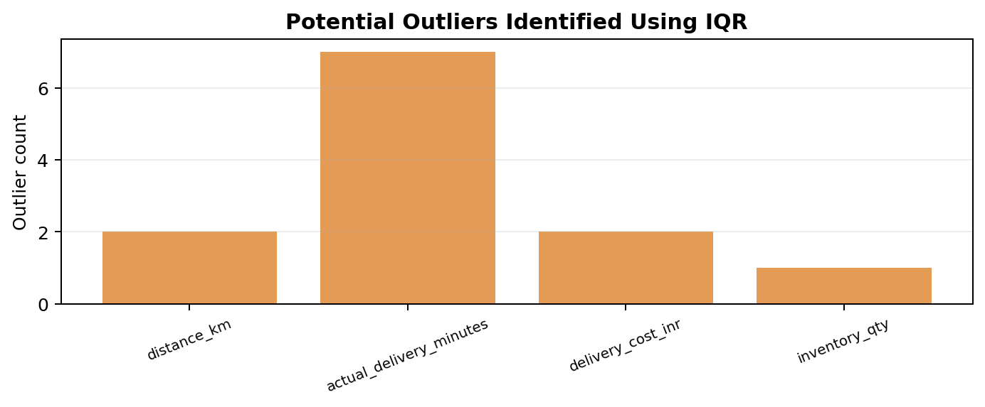
Figure 2. Potential outlier counts identified before capping.

4.2 IQR Capping
Capping (also called winsorization in this context) replaced values below the lower fence with the lower fence and values above the upper fence with the upper fence. This retained all 985 cleaned records while limiting the influence of extreme values. Capping was applied to the four features used in IQR detection.
outlier_cols = [
'distance_km', 'actual_delivery_minutes',
'delivery_cost_inr', 'inventory_qty'
]

for col in outlier_cols:
q1 = df_clean[col].quantile(0.25)
q3 = df_clean[col].quantile(0.75)
iqr = q3 - q1
lower = q1 - 1.5 * iqr
upper = q3 + 1.5 * iqr
df_clean[col] = df_clean[col].clip(
lower=lower, upper=upper
)

Methodological caution: In a production analysis, confirm whether an extreme observation is erroneous or operationally meaningful before capping it. The IQR fences are a screening rule, not a universal definition of bad data.

5. Feature Scaling
The numerical features have different units and ranges: kilometres, rupees, minutes and item counts. Scaling transforms these values to comparable scales. It is especially useful for distance- or gradient-based machine-learning methods. Scaling is not required for every model (for example, many tree-based models do not depend on feature magnitude in the same way).

5.1 Min-Max Scaling
Formula:X_scaled = (X − X_min) / (X_max − X_min)
Min-Max Scaling maps a feature to a selected range, commonly 0 to 1. It preserves the relative ordering of values, but it can be sensitive to extreme values; therefore, the project applied the selected IQR capping step before scaling.

5.2 Standardization (Z-score)
Formula:Z = (X − μ) / σ
Standardization subtracts the feature mean (μ) and divides by the feature standard deviation (σ). The transformed feature has a mean close to zero and standard deviation close to one when measured with the population convention used by StandardScaler.

5.3 Implementation
from sklearn.preprocessing import MinMaxScaler, StandardScaler

scale_cols = [
'distance_km', 'order_value_inr',
'promised_delivery_minutes', 'actual_delivery_minutes',
'delivery_cost_inr', 'inventory_qty'
]

df_minmax = df_clean.copy()
minmax_scaler = MinMaxScaler()
df_minmax[scale_cols] = minmax_scaler.fit_transform(
df_minmax[scale_cols]
)

df_standard = df_clean.copy()
standard_scaler = StandardScaler()
df_standard[scale_cols] = standard_scaler.fit_transform(
df_standard[scale_cols]
)

6. Results and Validation
Final validation checks confirmed that the cleaned DataFrame contains no missing cells and no exact duplicate rows. The original source columns were retained, and year, month and day were added as derived date features.
Validation metric | Before processing | After cleaning
Rows | 1,000 | 985
Columns | 14 | 17
Missing cells | 104 | 0
Duplicate rows | 15 | 0
Date type | object / text | datetime64[ns] + year/month/day

6.1 Scaling Output Example
The following sample row values were observed in the practical comparison for the distance_km feature:
Original distance (km) | Min-Max scaled | Standardized
105.5 | 0.134421 | -1.111825
440.2 | 0.582091 | 1.219968
19.1 | 0.018859 | -1.713758

For example, a standardized distance value of 1.219968 indicates a distance above the feature mean by approximately 1.22 standard deviations. A Min-Max value of 0.582091 indicates a position about 58.2% of the way from the observed minimum to the observed maximum for that scaled feature.

6.2 Exporting the Results
The final workflow exports the cleaned dataset and both scaled versions as separate sheets in one Excel workbook. This makes the outputs easy to inspect and reuse.
with pd.ExcelWriter('Week2_Logistics_Preprocessed.xlsx') as writer:
df_clean.to_excel(writer, sheet_name='Cleaned_Data', index=False)
df_minmax.to_excel(writer, sheet_name='MinMax_Scaled', index=False)
df_standard.to_excel(writer, sheet_name='Standardized', index=False)

7. Reflection: Why Data Quality Matters in Logistics
Logistics decisions depend on accurate and consistent operational data. Missing delivery times can distort service-level calculations; duplicate orders can inflate shipment volumes and costs; inconsistent traffic or vehicle labels can fragment category-level reporting; incorrect dates can produce misleading monthly trends; and extreme values can dominate averages or affect distance-based models.
The preprocessing workflow improves completeness, consistency and comparability. A reliable prepared dataset supports more trustworthy analysis of on-time performance, route distances, delivery costs, traffic conditions, weather patterns and inventory. The quality of conclusions still depends on validating business definitions and checking whether unusual observations are genuine.

8. Limitations and Good-Practice Notes
- The dataset is synthetic. Results demonstrate the preprocessing methods and should not be interpreted as actual company performance.
- Median and mode imputation are simple baseline methods. More advanced imputation may be appropriate when missingness is systematic or important relationships must be preserved.
- IQR capping can hide meaningful operational extremes. Review extreme shipments with subject-matter context before changing production records.
- For predictive modelling, split the data into training and test sets before fitting scalers. Fit each scaler only on training data, then use transform() on test data to prevent data leakage.
- The delivery_status field was retained as supplied. In a real project, validate it against actual_delivery_minutes and promised_delivery_minutes to ensure the label is logically consistent.

9. Conclusion
This task demonstrated a complete simulated preprocessing pipeline using Pandas, NumPy, visualization libraries and Scikit-learn. The raw data was inspected, cleaned, validated and transformed into cleaned and scaled outputs. The exercise shows that careful preparation is a necessary foundation for dependable logistics analytics and subsequent machine-learning work.

References / Further Reading
- Pandas and NumPy documentation: https://pandas.pydata.org/docs/ and https://numpy.org/doc/
- Scikit-learn preprocessing: https://scikit-learn.org/stable/modules/preprocessing.html
- Matplotlib and Seaborn documentation: https://matplotlib.org/stable/contents.html and https://seaborn.pydata.org/

Appendix A. Reproducible Python Pipeline
The following consolidated script reproduces the main preprocessing sequence. Run it in order after uploading the raw CSV to the notebook environment. It uses the same column names as the supplied synthetic dataset.
import pandas as pd
import numpy as np
from sklearn.preprocessing import MinMaxScaler, StandardScaler

# 1. Load raw data
df = pd.read_csv('Week2_Logistics_Raw_Dataset_1000_Rows.csv')
df_clean = df.copy()

# 2. Standardize categorical text
categorical_cols = ['traffic_level', 'weather', 'vehicle_type', 'delivery_status']
for col in categorical_cols:
df_clean[col] = df_clean[col].str.strip().str.title()

# 3. Impute missing numeric and categorical values
numerical_cols = ['distance_km', 'actual_delivery_minutes', 'delivery_cost_inr', 'inventory_qty']
for col in numerical_cols:
df_clean[col] = df_clean[col].fillna(df_clean[col].median())
for col in ['traffic_level', 'weather']:
df_clean[col] = df_clean[col].fillna(df_clean[col].mode()[0])

# 4. Remove exact duplicate rows
df_clean = df_clean.drop_duplicates().copy()

# 5. Parse mixed date formats and derive date features
df_clean['order_date'] = pd.to_datetime(
df_clean['order_date'], format='mixed', dayfirst=True, errors='coerce'
)
df_clean['year'] = df_clean['order_date'].dt.year
df_clean['month'] = df_clean['order_date'].dt.month
df_clean['day'] = df_clean['order_date'].dt.day

# 6. Replace values that break business rules with NaN
invalid_rules = {
'distance_km': df_clean['distance_km'] <= 0,
'actual_delivery_minutes': df_clean['actual_delivery_minutes'] <= 0,
'delivery_cost_inr': df_clean['delivery_cost_inr'] <= 0,
'inventory_qty': df_clean['inventory_qty'] < 0
}
for col, rule in invalid_rules.items():
df_clean.loc[rule, col] = np.nan
for col in numerical_cols:
df_clean[col] = df_clean[col].fillna(df_clean[col].median())

# 7. Detect potential outliers and cap using IQR fences
outlier_cols = numerical_cols
for col in outlier_cols:
q1 = df_clean[col].quantile(0.25)
q3 = df_clean[col].quantile(0.75)
iqr = q3 - q1
lower = q1 - 1.5 * iqr
upper = q3 + 1.5 * iqr
df_clean[col] = df_clean[col].clip(lower=lower, upper=upper)

# 8. Create separate scaled datasets
scale_cols = [
'distance_km', 'order_value_inr', 'promised_delivery_minutes',
'actual_delivery_minutes', 'delivery_cost_inr', 'inventory_qty'
]
df_minmax = df_clean.copy()
mm = MinMaxScaler()
df_minmax[scale_cols] = mm.fit_transform(df_minmax[scale_cols])

df_standard = df_clean.copy()
ss = StandardScaler()
df_standard[scale_cols] = ss.fit_transform(df_standard[scale_cols])

# 9. Validate and export
print('Cleaned shape:', df_clean.shape)
print('Missing cells:', df_clean.isna().sum().sum())
print('Duplicate rows:', df_clean.duplicated().sum())

with pd.ExcelWriter('Week2_Logistics_Preprocessed.xlsx') as writer:
df_clean.to_excel(writer, sheet_name='Cleaned_Data', index=False)
df_minmax.to_excel(writer, sheet_name='MinMax_Scaled', index=False)
df_standard.to_excel(writer, sheet_name='Standardized', index=False)

