81

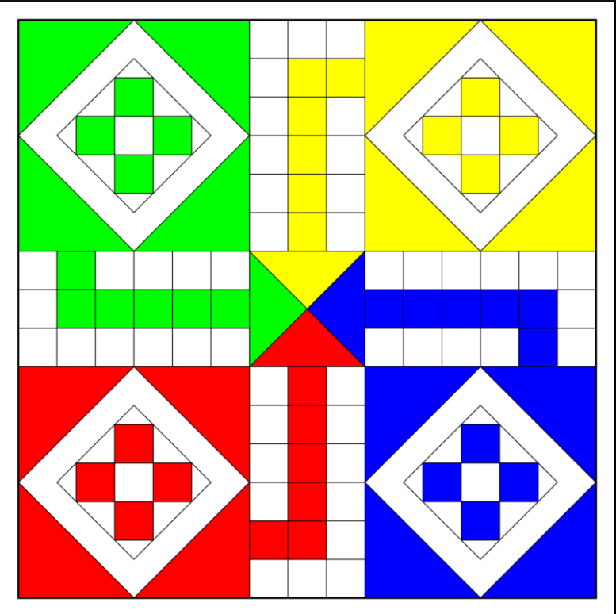

Finish Track

0

39

26

13

51

100

80

90

70

64

60

Home

Home

Home

Home

**POSITION TO COORD:**

**0 -> {21, 31}; 6 -> {17,18}; 19 -> {21,11}; 32 -> {32,14}; 45 -> {28,21}**

**X translation -> 3**

**Y translation -> 2**

<https://www.mailsend-online.com/blog/setting-windows-console-text-colors-in-c.html>