 | Dr D Y Patil Pratishthan’s  Dr. D.Y. Patil Institute of Engineering, Management and Research, Akurdi, Pune
Academic Year: 2026-27 | BE Project Synopsis | Revision : 00 Dated : 20/11/2019
Term – I | Department: Artificial Intelligence and Data Science | Date of Preparation:  16/08/2026

Project Title | Nutrio: Packaged Food Label Describer
Domain Name | Food Safety - Retails
Group Leader | Rohan Jagdish Sali
Group Member | Aditya Manish Patil  Rahul Kumar Singh  Prajwal Madhav Waghmare
Guide Name | Mrs. Sneha Kanawade

ABSTRACT:

Nutrio is a React Native application that scans packaged-food labels and converts complex ingredient and nutritional information into simple, visual and understandable insights. Using OCR, RAG and a vector database, it identifies ingredients, nutrients, additives, sugars, colors, flavors and allergens, and presents their relevant information in a structured format. The system focuses on general food awareness rather than fitness-based personalization.

Keywords: Food Label Analysis, Explainable AI, Packaged Food, OCR, RAG, Vector Database,

Nutrition, Food Additives, Allergen Detection, React Native.

MOTIVATION:

Food labels are often complex and difficult to understand.

Users may not recognize technical ingredient names or additives.

Important information about allergens and nutrients can be overlooked.

Existing apps often focus on personalized fitness or diet tracking.

Nutrio aims to make food-label information simple, transparent and accessible to everyone.

OBJECTIVES:

Scan packaged food labels using a smartphone camera.

Extract label information using OCR and Identify ingredients, nutrients and food additives.

Highlight potential allergens and concerning constituents.

Explain unfamiliar ingredients in simple language.

Interpret available expiry/best-before information.

Present results using visual and structured formats and provide general alternative food suggestions.

ARCHITECTURE DIAGRAM:

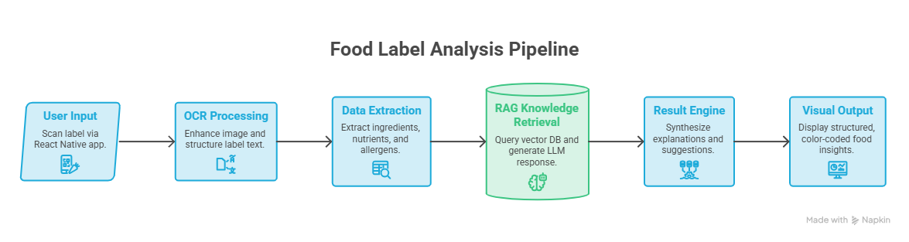

Figure 1. Architecture of Nutrio System

APPLICATION AREAS:

Retails Industry

Public Domain

Food Safety Departments (FDA)

CONCLUSION:

Nutrio provides an intelligent and accessible way to understand packaged food labels. By combining OCR, RAG, vector databases and visual presentation, it transforms complex food information into simple and meaningful insights. The system focuses on consumer awareness rather than extensive personalization, helping users make more informed food choices.

Name and Sign. of Students - | Sign. of Guide
Rohan Sali  Aditya Patil  Rahul Singh  Prajwal Waghmare | Mrs. Sneha Kanawade

