**JAVASCRIPT ASSIGNMENT**

**TASKS:** Perform all array functions

**ARRAYS:**

var a = [1,2,3]

var b = ['a', 'b', 'c']

1. **Concat**: a.concat(b);

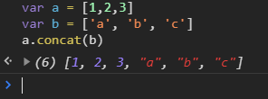

1. **Every**: a.every((item) => item > 3)

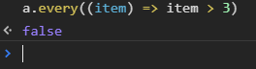

1. **Filter**: a.filter((item)=> /[0-3]/.test(item));



1. **ForEach**: var product = 1;

a.forEach((item) => {

product = product*item;

console.log(product);

});

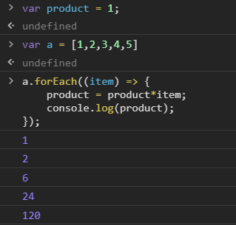

1. **IndexOf**: a.indexOf(3)

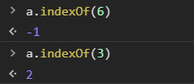

1. **Join**: b.join(“”) (Join without any spaces)



1. **lastIndexOF**: a.lastIndexOf(5)

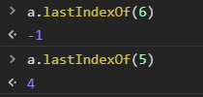

1. **Map**: a.map(Math.pow)



1. **Pop**: a.pop()



1. **Push:** a.push(69)

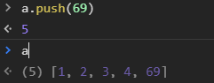

1. **Reduce**: a.reduce((square, item) => square = square+item*item)



1. **ReduceRight**: a.reduceRight((square, item) => square = square-item)



1. **Reverse**: b.reverse()



1. **Shift**: a.shift()

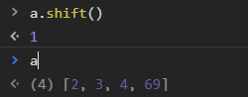

1. **Slice**: b.slice(1,3)



1. **Some**: a.some((item) => item%3 == 0)



1. **Sort**: c = [3, 2, 1, 4, 6, 11, 5]

c.sort((a,b) => a - b);

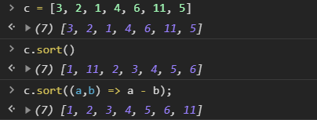

1. **Splice**: c.splice(4,2,23,54)

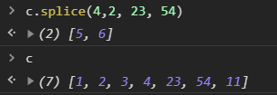

1. **toString**: c.toString()



1. **Unshift**: a.unshift(1)

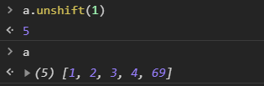

**TASK:** Difference between \n and \r

**\r** (ASCII code 13) is a **carriage return** (first column of current line) and **\n** (ASCII code 10) is a **line feed** (newline). In typewriters, to go to the start of the new line, one would **return** the carriage to the leftmost position and then **feed** the paper up a line.



**Unix**: \n for a new line

**Mac prior to OS9**: \r for a new line

**Windows**: \r\n for a new line