* In the Copy (The intro part and all)
* We will take an example of an app.js which prints “Hello World”

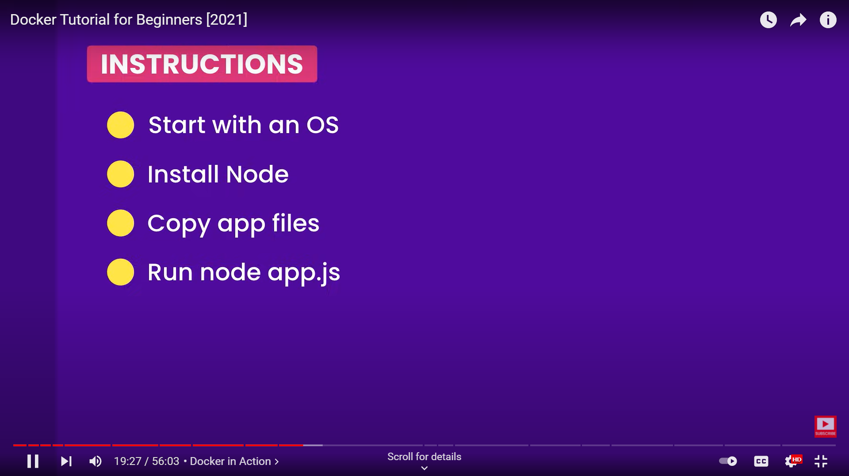

We will write these instruction to docker file and run it directly.

We will create a Dockerfile inside the folder where our app.js is located

Then we will write instruction into it.

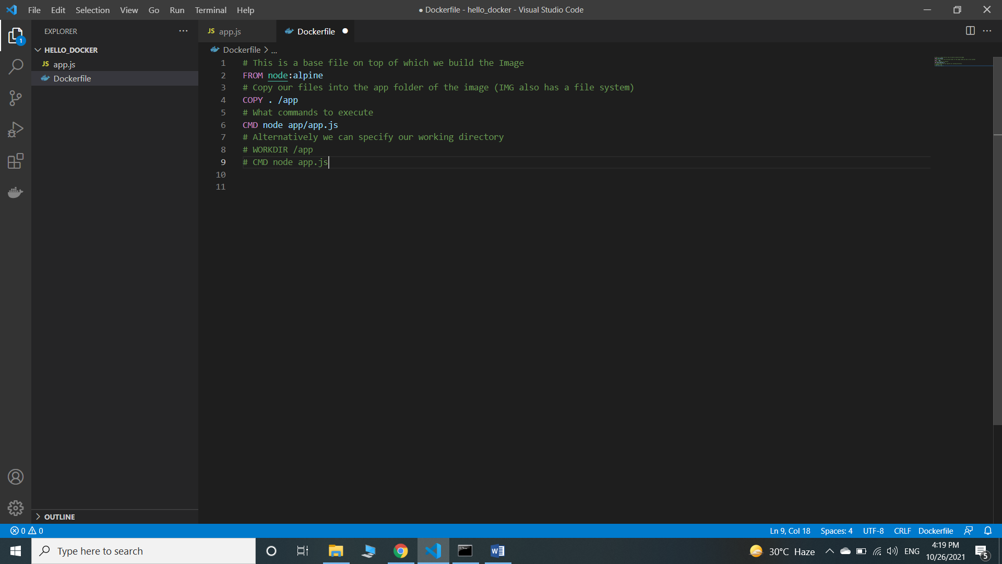

Now we will tell Docker to package our application

docker build –t tag_name “Path for docker file”

Eg -> docker build -t hello-docker .

docker image ls (To check the info of image created)

docker run docker-tag-name

Eg -> docker run hello-docker

docker images (To see all the docker images in the system)

**How to Push on dockerhub**

docker login

docker tag hello-docker:latest singhrohanss007/hello-docker

docker push singhrohanss007/hello-docker

**Docker Commands**

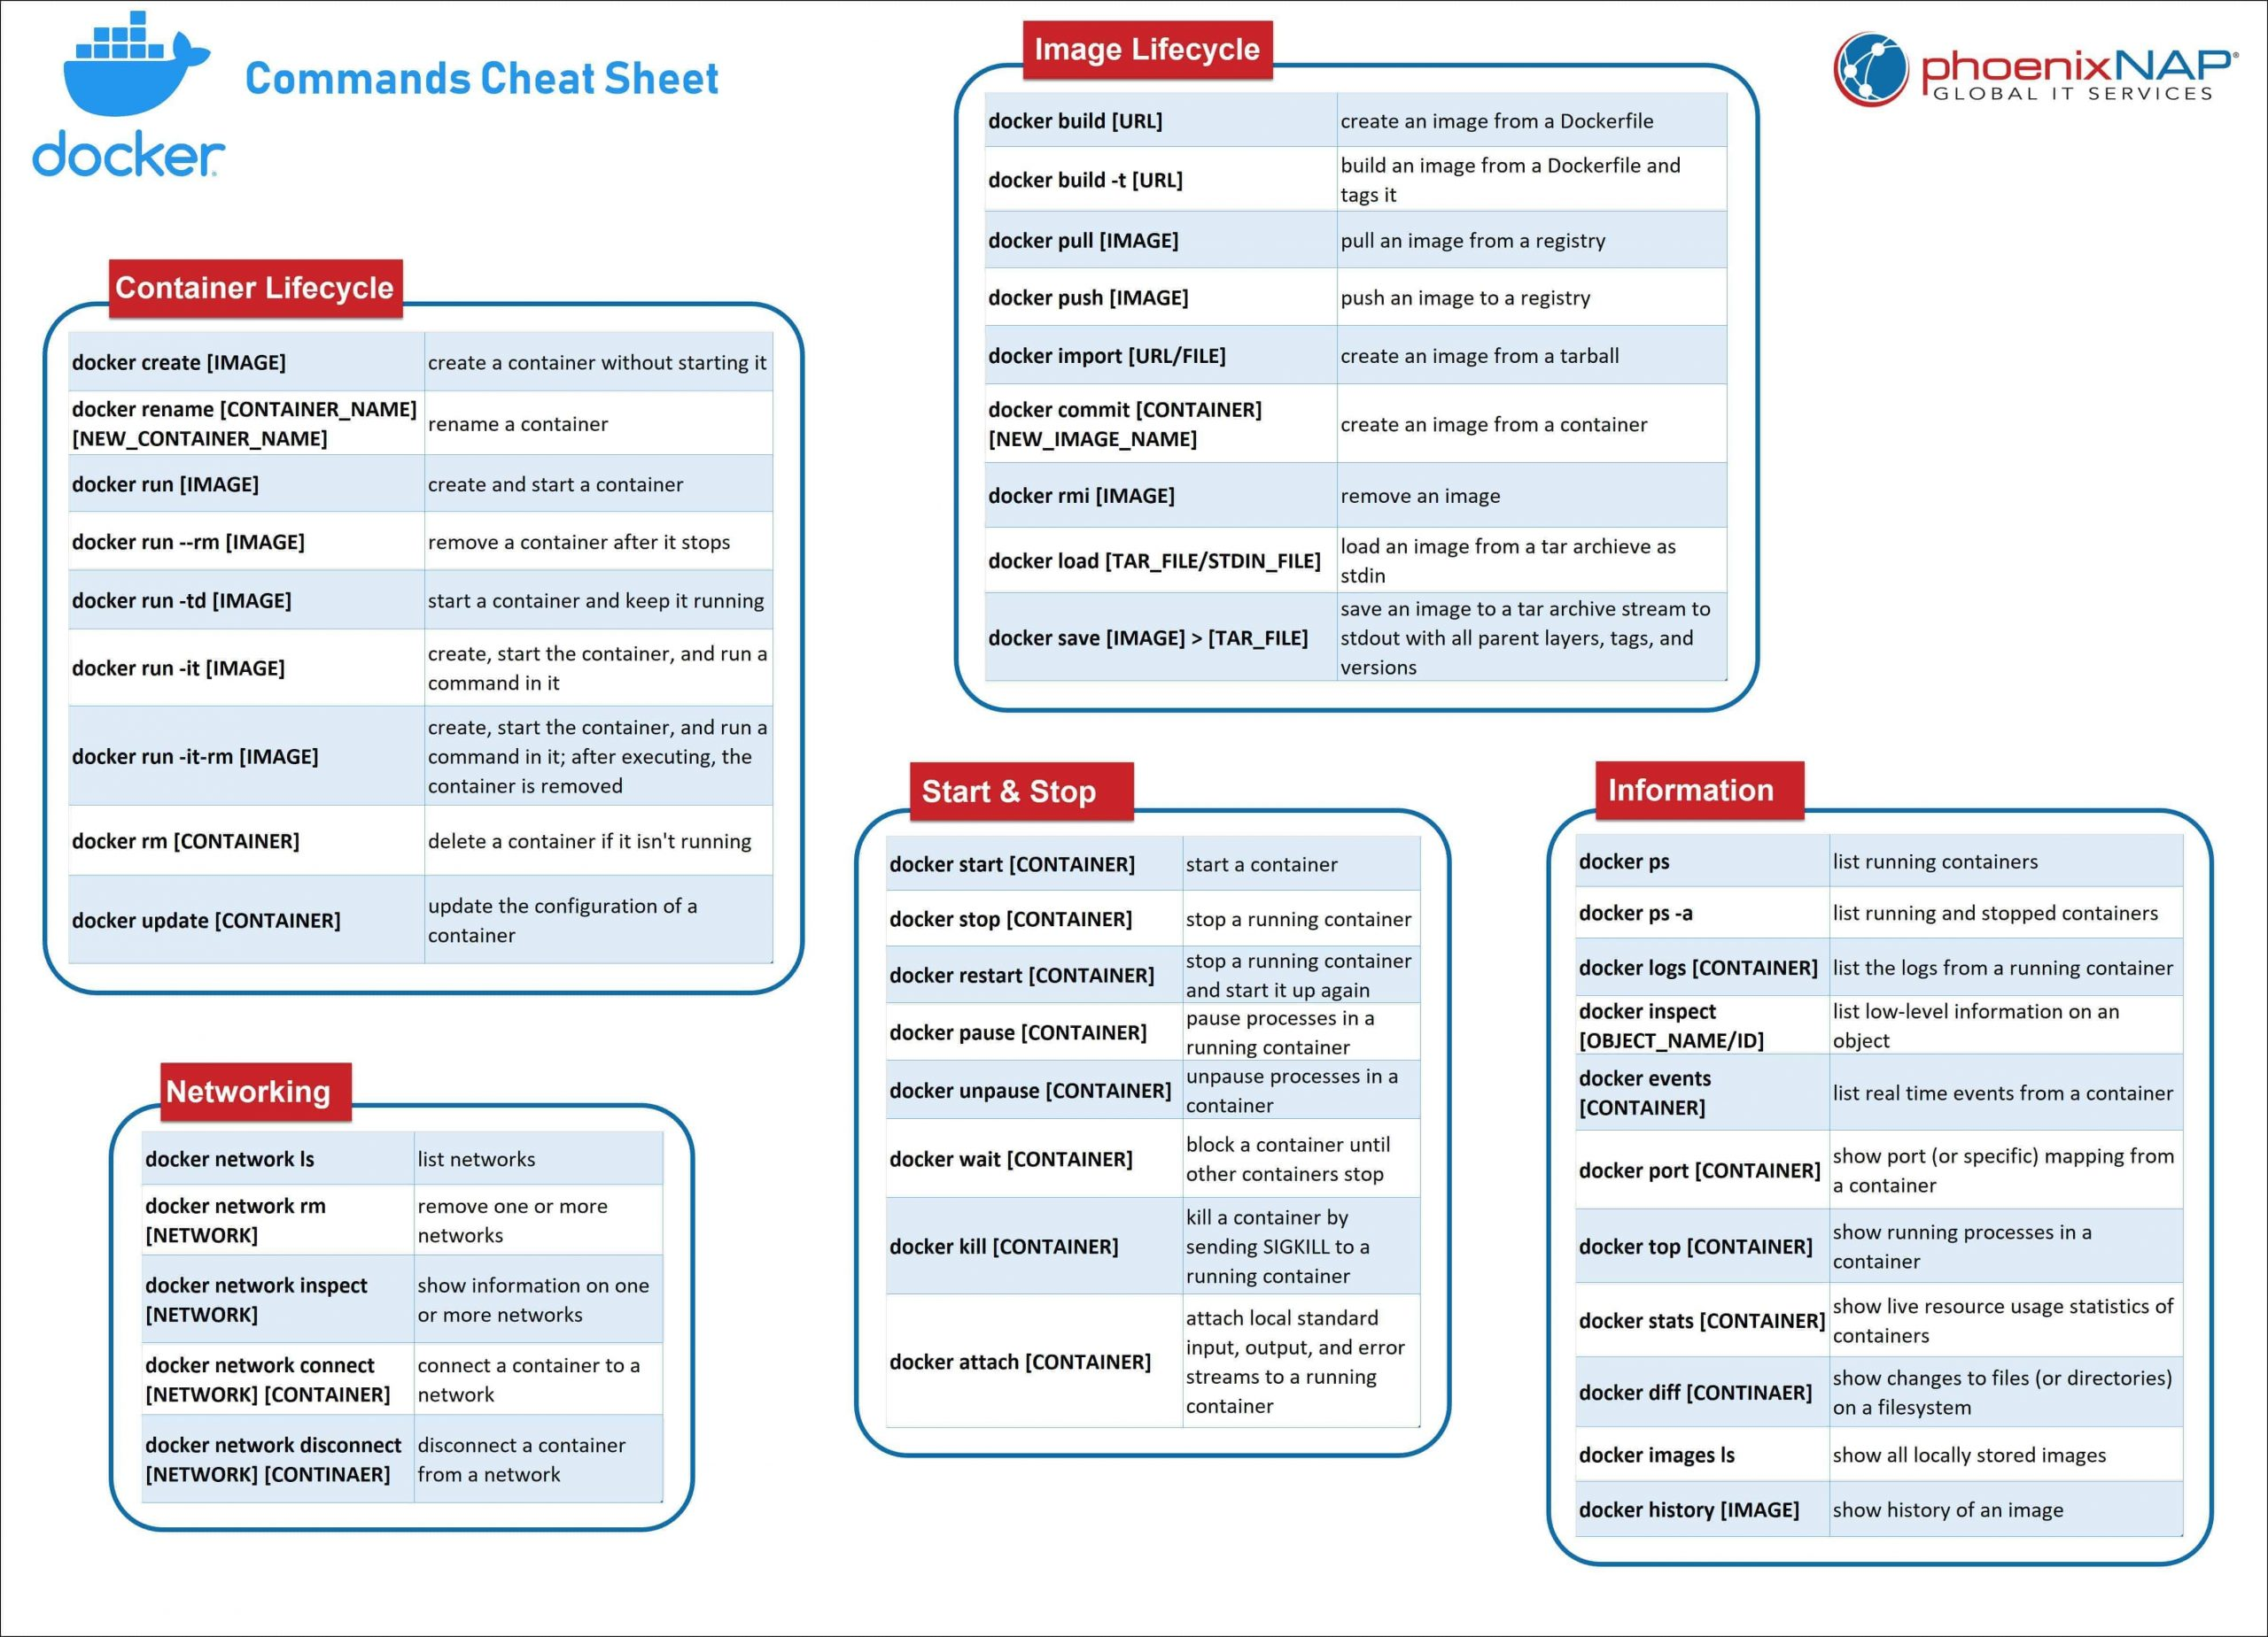

**Best Practices**

*https://docs.docker.com/develop/develop-images/dockerfile_best-practices/*

**Docker for Django**

mkdir django_docker #make a directory where you want to store project

cd django_docker #head inside folder

docker-compose # For multicontainer docker applications

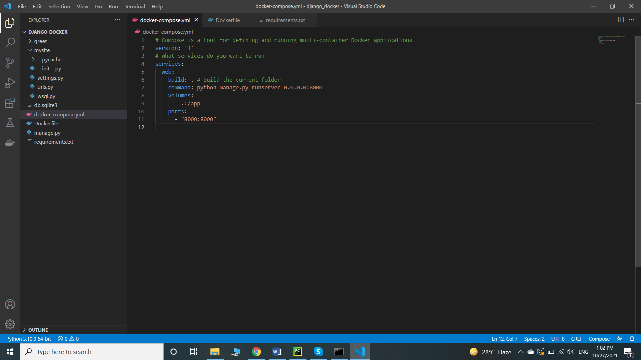

Dockerfile #make dockerfile for setting up the project initials

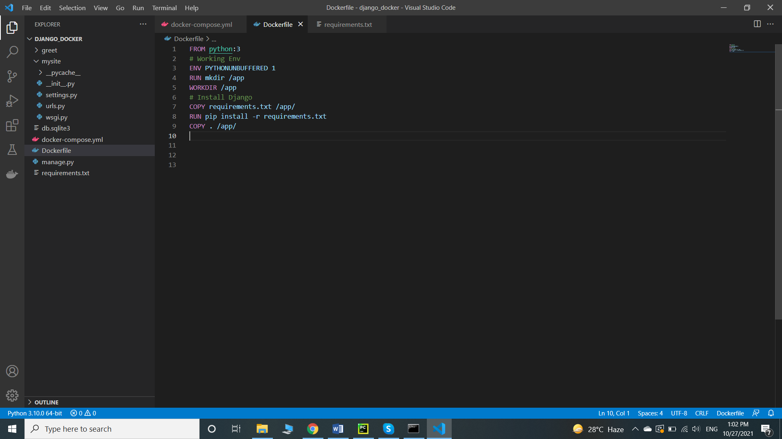

docker-compose run web django-admin startproject mysite . # start the project

docker-compose up # Start the docker image

docker ps # Check if the image is running or not

docker exec django_docker-web-1 python manage.py startapp greet # To execute any command using docker