Review 3 Agent 13 Secure Shredding Agent
Chapter 5: Testing, Evaluation, and Results
- 5.1 Test Cases & Scenarios
  - Agent 13 is a working independent secure-shredding service for Phase A of the Agentic Shell project. This review evaluates its behavior, local response times and remaining limitations. On 22 October 2026, all 28 Python tests and the prebuilt native fault-injection harness passed. Testing used disposable files and temporary directories, with no master shell or LLM.
  - Simple scenarios covered service health, agent information, regular-file inspection and dry-run preview. Inspection returned file metadata. Preview preserved the sample contents and issued a confirmation token. Running shred without a token also preserved the file, demonstrating the default dry-run behavior.
  - The chained scenario was inspect, preview, confirm, overwrite and verify removal. A real CLI capture used a 4,000-byte disposable sample. The service removed it only after receiving the preview token. Reusing that token returned INVALID_TOKEN. Separate tests verified expiry, path mismatch, changed files, and invalidation after service restart.
  - Lifecycle checks covered Unix socket communication, a second service instance, SIGTERM/SIGINT shutdown, socket cleanup and restart. The independent demo also inspected and removed a 4,000-byte sample, showed operation logs and restarted successfully. The current socket API accepts fixed actions and parameters; natural-language command chains are outside this implementation.
  - Unsafe scenarios included traversal, paths outside the allowed root, symlinks, hardlinks, directories, FIFOs, missing files and permission failures. JSON tests rejected malformed messages, duplicate keys, invalid types and unsupported actions. An outside canary file remained unchanged. Peer-UID policy was unit-tested with controlled credentials; no extra user account was created.
  - The native harness forced short writes, interrupted I/O, random-generation failures, fsync errors, source-name replacement and restore conflicts. It verified recovery state and preservation of a new source name. Holding a descriptor after unlink confirmed logical overwriting across a 180,000-byte file. These tests do not certify erasure of SSD cells, snapshots or backups.
- 5.2 Performance Metrics
  - Functional result: 28 of 28 Python tests passed in 0.925 seconds on the current run, with no failures or errors. The native harness also passed. Intent translation accuracy is not applicable because Phase A does not translate natural language or invoke a language model; the test pass fraction is not an LLM accuracy score.
  - Latency was measured on Ubuntu 22.04.5, x86-64, Python 3.10.12, on 22 October 2026. One serial service received five health warm-up calls, followed by 20 samples per action. Each measurement timed a new Unix socket client call through receipt and validation of its JSON response. File operations used 4,096-byte temporary files.
  - The table reports milliseconds. The 95th percentile uses the nearest-rank method. Execution includes the native overwrite, fsync and unlink sequence, but excludes file creation, preview and CLI interpreter startup. These are local observations from one run, not a throughput guarantee or a comparison across storage technologies.
Action | n | Median ms | p95 ms
health | 20 | 0.148 | 0.474
inspect_target | 20 | 0.181 | 0.434
preview_shred | 20 | 0.202 | 0.483
execute_shred | 20 | 2.856 | 3.532
Table 5.1 Local response latency for 20 calls per action.
  - Recovery evaluation: the injected failure cases passed their expected checks for restoration, recovery path, bytes written and unlink state. An LLM invalid-command recovery rate is not applicable, and no general recovery percentage is claimed. A failed execution can leave partly overwritten data; restoration restores a name rather than undoing changed bytes.
  - The systemd user unit passed configuration verification. Live systemd installation and enablement were not performed. The 22 October checks reused the existing C binaries; compilation evidence is recorded in docs/TESTING.md from 15 October. The current run verifies runtime behavior, not a fresh build.
Chapter 6: Conclusion & Future Scope
- 6.1 Summary of Contributions
  - The project delivers the complete standalone path from CLI to Unix socket service, Python ctypes, C library and Linux file operations. It provides inspection, default dry-run, single-use confirmation, descriptor-based validation, structured errors and graceful process lifecycle handling. It needs neither root privileges nor a cloud service.
  - The public C header, Python wrapper, versioned JSON API and proposed four-tool manifest prepare Agent 13 for future integration. The roadmap, architecture diagrams, test suite, user-service unit and demonstration guide make the implementation explainable and reproducible. The class master shell and other 34 agents remain future work.
- 6.2 Challenges Encountered
  - The main safety challenge was file identity changing between preview and execution. Fingerprint checks, advisory locking, private staging and descriptor-based mutation address common replacement races. Token state must also handle expiry, reuse, mismatch and restart without allowing an old approval to delete a different file.
  - I/O failure can occur after data has changed, so errors report partial progress and recovery location. Advisory locks cannot stop uncooperative writers. SSD wear leveling, copy-on-write storage, retained copies and snapshots prevent a complete physical-erasure guarantee. These limits remain even when every application test passes.
- 6.3 Future Work
  - The next class integration step is to agree on the shared agent contract and let a future master call the existing service API. If the class selects MCP or an LLM router, a separate adapter should preserve Agent 13 validation and require explicit user approval before execute_shred. Neither component is implemented in Phase A.
  - Further evaluation can cover more supported local filesystems, file sizes, controlled power-loss scenarios and live multi-user isolation. Crash-recovery guidance and systemd deployment should also be exercised on the final demonstration machine. Voice input and semantic search belong to the wider shell or other agents; Agent 13 should retain its narrow shredding responsibility.
Chapter 7: Screenshots

Recorded CLI and test output from 22 October 2026 is reproduced below. Extracts omit the temporary socket argument, show selected JSON fields and redact confirmation tokens. All targets were disposable files.
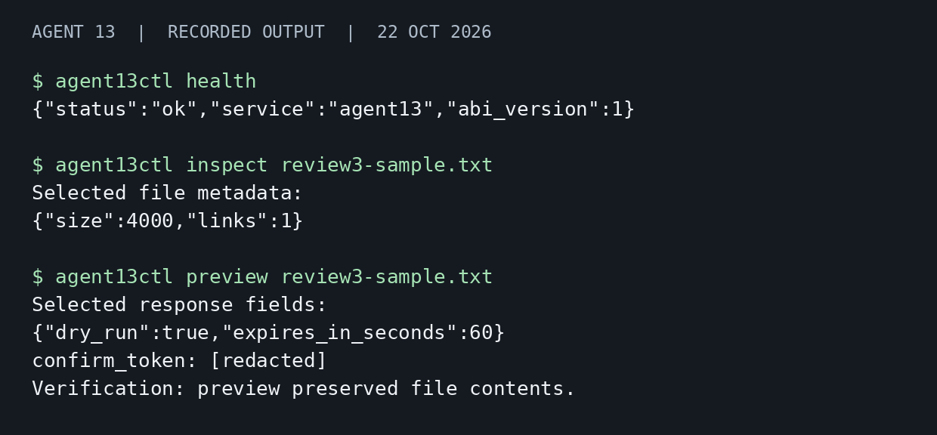
Figure 7.1 Health inspection and dry-run preview with the token redacted.
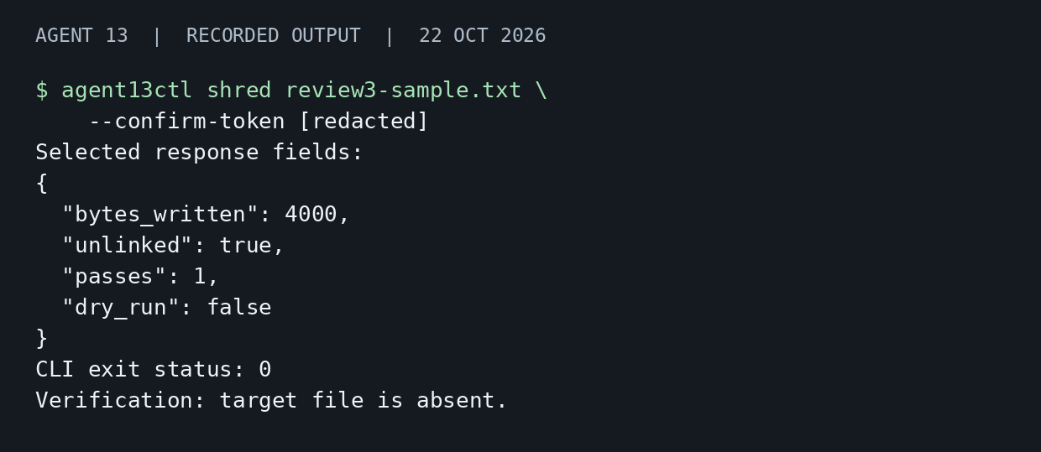
Figure 7.2 Confirmed overwrite of 4,000 bytes and verification of removal.
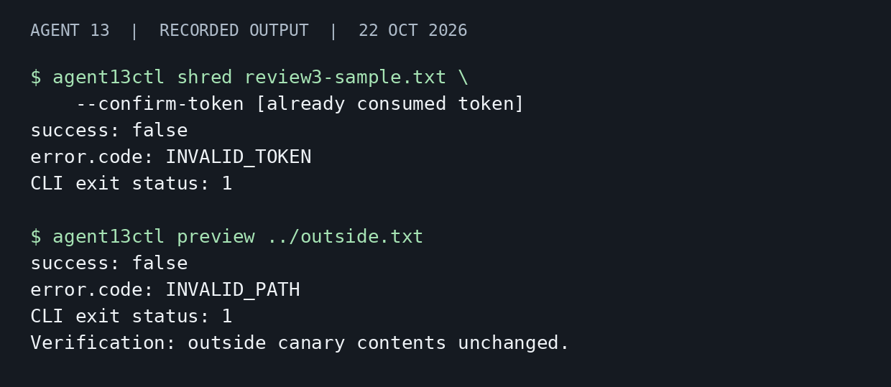
Figure 7.3 Reused token and traversal rejected while the canary survives.
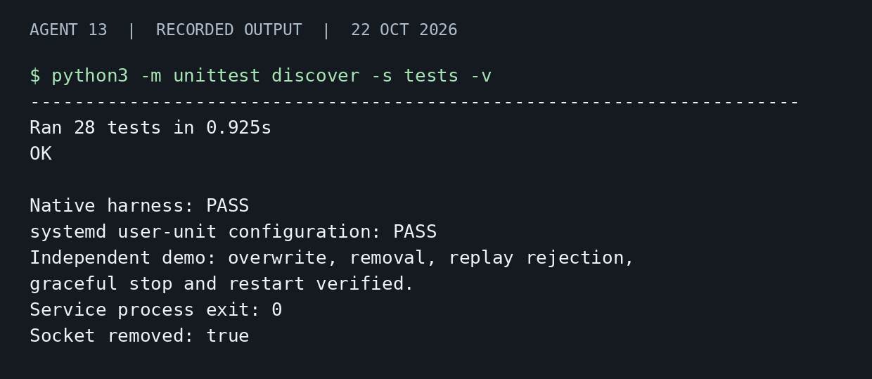
Figure 7.4 Automated test summary and graceful service shutdown.

