**VISVESVARAYA TECHNOLOGICAL UNIVERSITY**

**“JnanaSangama”, Belgaum -590014, Karnataka.**



**DATA STRUCTURE LAB RECORD**

***Submitted by***

**Rohan Siwach (1BM19CS132)**

***Under the Guidance of***

|  |  |
| --- | --- |
| **Prof. SHEETAL VA**  **Assistant Professor, BMSCE** |  |

***in partial fulfillment for the award of the degree of***

**BACHELOR OF ENGINEERING**

***in***

**COMPUTER SCIENCE AND ENGINEERING**



**B.M.S. COLLEGE OF ENGINEERING**

**(Autonomous Institution under VTU)**

**BENGALURU-560019**

**Sep-2020 to Jan-2021**

**B. M. S. College of Engineering,**

**Bull Temple Road, Bangalore 560019**

(Affiliated To Visvesvaraya Technological University, Belgaum)

**Department of Computer Science and Engineering**



**CERTIFICATE**

This is to certify that the LAB RECORD carried out by  **Rohan Siwach (1BM19CS132)** who is the bonafide students of **B. M. S. College of Engineering.** It is in partial fulfillment for the award of **Bachelor of Engineering in Computer Science and Engineering** of the Visveswaraiah Technological University, Belgaum during the year 2020-2021. The lab report has been approved as it satisfies the academic requirements in respect of **DATA STRUCTURE LAB RECORD (19CS3PCDST)** work prescribed for the said degree.

Signature of the Guide                 Signature of the HOD

Prof. Prof. Sheelal VA Dr. Umadevi V

Assistant Professor Associate Prof.& Head, Dept. of CSE

BMSCE, Bengaluru BMSCE, Bengaluru

External Viva

Name of the Examiner                                                                                       Signature with date

1._____________________________ ________________________

2. _____________________________ _________________________

Lab1}

Write a program to simulate the working of stack using an array with the following : a) Push b) Pop c) Display The program should print appropriate messages for stack overflow, stack underflow

|  |
| --- |
| #include <stdio.h> |
|  | #define stack_size 5 |
|  | int top =-1; |
|  | int s[10]; |
|  | int item; |
|  | void push() |
|  | { |
|  | if(top==stack_size-1) |
|  | { |
|  | printf ("stack overflow\n"); |
|  | return; |
|  | } |
|  | top=top+1; |
|  | s[top]=item; |
|  | } |
|  | int pop() |
|  | { |
|  | if (top==-1) |
|  | return -1; |
|  | else |
|  | return s[top--]; |
|  | } |
|  | void display() |
|  | { |
|  | int i; |
|  | if (top==-1) |
|  | { |
|  | printf("stack is empty\n"); |
|  | return; |
|  | } |
|  | printf ("contents of the stack\n"); |
|  | for(i=top;i>=0;i--) |
|  | { |
|  | printf("%d\n", s[1]); |
|  | } |
|  | } |
|  | int main () |
|  | { |
|  | int item_deleted ; |
|  | int choice; |
|  | for(;;) |
|  | { |
|  | printf("\n 1:push\n 2:pop\n 3:display\n"); |
|  | printf ("enter the choice \n"); |
|  | scanf ("%d", &choice); |
|  | switch (choice) |
|  | { |
|  | case 1: printf("enter the item to be inserted\n"); |
|  | scanf("%d" ,&item); |
|  | push(); |
|  | break; |
|  | case 2: item_deleted=pop(); |
|  | if(item_deleted==-1) |
|  | printf("stack is empty\n"); |
|  | else |
|  | printf("item deleted is %d\n",item_deleted); |
|  | break; |
|  | case 3: display(); |
|  | break; |
|  | default: exit(0); |
|  | } |
|  | } |
|  | return 0; |
|  | } |

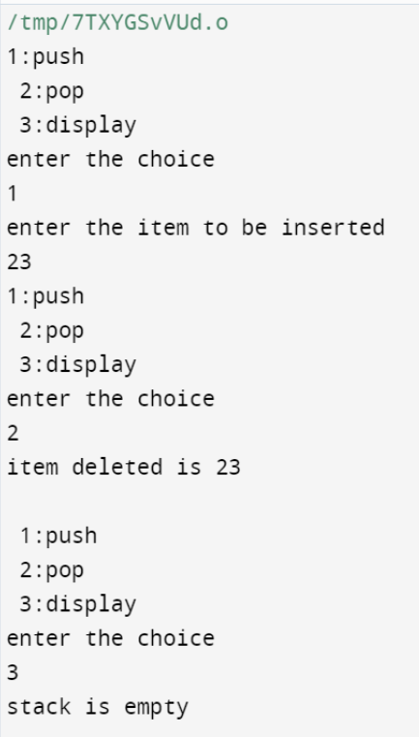

Lab2}

WAP to convert a given valid parenthesized infix arithmetic expression to postfix expression. The expression consists of single character operands and the binary operators + (plus), - (minus), * (multiply) and / (divide)

|  |
| --- |
| #include<stdio.h> |
|  | #include<stdlib.h> |
|  | #include<ctype.h> |
|  | #include<string.h> |
|  | #define SIZE 100 |
|  | char stack[SIZE]; |
|  | int top = -1; |
|  | void push(char item) |
|  | { |
|  | if(top >= SIZE-1) |
|  | { |
|  | printf("\nStack Overflow."); |
|  | } |
|  | else |
|  | { |
|  | top = top+1; |
|  | stack[top] = item; |
|  | } |
|  | } |
|  | char pop() |
|  | { |
|  | char item ; |
|  |  |
|  | if(top <0) |
|  | { |
|  | printf(" invalid infix expression"); |
|  | getchar(); |
|  | exit(1); |
|  | } |
|  | else |
|  | { |
|  | item = stack[top]; |
|  | top = top-1; |
|  | return(item); |
|  | } |
|  | } |
|  | int is_operator(char symbol) |
|  | { |
|  | if(symbol == '^' || symbol == '*' || symbol == '/' || symbol == '+' || symbol =='-') |
|  | { |
|  | return 1; |
|  | } |
|  | else |
|  | { |
|  | return 0; |
|  | } |
|  | } |
|  | int precedence(char symbol) |
|  | { |
|  | if(symbol == '^') |
|  | { |
|  | return(3); |
|  | } |
|  | else if(symbol == '*' || symbol == '/') |
|  | { |
|  | return(2); |
|  | } |
|  | else if(symbol == '+' || symbol == '-') |
|  | { |
|  | return(1); |
|  | } |
|  | else |
|  | { |
|  | return(0); |
|  | } |
|  | } |
|  |  |
|  | void InfixToPostfix(char infix_exp[], char postfix_exp[]) |
|  | { |
|  | int i, j; |
|  | char item; |
|  | char x; |
|  | push('('); |
|  | strcat(infix_exp,")"); |
|  |  |
|  | i=0; |
|  | j=0; |
|  | item=infix_exp[i]; |
|  |  |
|  | while(item != '\0') |
|  | { |
|  | if(item == '(') |
|  | { |
|  | push(item); |
|  | } |
|  | else if( isdigit(item) || isalpha(item)) |
|  | { |
|  | postfix_exp[j] = item; |
|  | j++; |
|  | } |
|  | else if(is_operator(item) == 1) |
|  | { |
|  | x=pop(); |
|  | while(is_operator(x) == 1 && precedence(x)>= precedence(item)) |
|  | { |
|  | postfix_exp[j] = x; |
|  | j++; |
|  | x = pop(); |
|  | } |
|  | push(x); |
|  | push(item); |
|  | } |
|  | else if(item == ')') |
|  | { |
|  | x = pop(); |
|  | while(x != '(') |
|  | { |
|  | postfix_exp[j] = x; |
|  | j++; |
|  | x = pop(); |
|  | } |
|  | } |
|  | else |
|  | { |
|  | printf("\nInvalid infix Expression.\n"); |
|  | getchar(); |
|  | exit(1); |
|  | } |
|  | i++; |
|  | item = infix_exp[i]; |
|  | } |
|  | if(top>0) |
|  | { |
|  | printf("\nInvalid infix Expression.\n"); |
|  | getchar(); |
|  | exit(1); |
|  | } |
|  | if(top>0) |
|  | { |
|  | printf("\nInvalid infix Expression.\n"); |
|  | getchar(); |
|  | exit(1); |
|  | } |
|  | postfix_exp[j] = '\0'; |
|  | } |
|  | int main() |
|  | { |
|  | char infix[SIZE], postfix[SIZE]; |
|  | printf("\nEnter Infix expression : "); |
|  | gets(infix); |
|  | InfixToPostfix(infix,postfix); |
|  | printf("Postfix Expression: "); |
|  | puts(postfix); |
|  | return 0; |
|  | } |

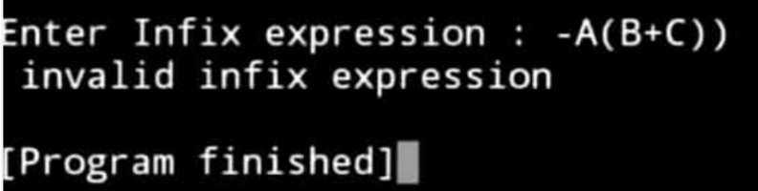

Lab3}

WAP to simulate the working of a queue of integers using an array. Provide the following operations a) Insert b) Delete c) Display The program should print appropriate messages for queue empty and queue overflow conditions

|  |
| --- |
| #include<stdio.h> |
|  | #include<stdlib.h> |
|  | #define QUE_SIZE 3 |
|  | int item,front=0,rear=-1,q[10]; |
|  | void insertrear() |
|  | {if(rear==QUE_SIZE-1) |
|  | { |
|  | printf("queue overflow\n"); |
|  | return; |
|  | } |
|  | rear=rear+1; |
|  | q[rear]=item; |
|  | }int deletefront() |
|  | {if (front>rear) |
|  | {front=0; |
|  | rear=-1; |
|  | return -1; |
|  | }return q[front++]; |
|  | }void displayQ() |
|  | {int i; |
|  | if (front>rear) |
|  | { |
|  | printf("queue is empty\n"); |
|  | return; |
|  | } |
|  | printf("contents of queue\n"); |
|  | for(i=front;i<=rear;i++) |
|  | { |
|  | printf("%d\n",q[i]); |
|  | }} |
|  | int main() |
|  | { |
|  | int choice; |
|  | for(;;) |
|  | { |
|  | printf("1:insertrear 2:deletefront 3:display 4:exit\n"); |
|  | printf("enter the choice\n"); |
|  | scanf("%d",&choice); |
|  | switch(choice) |
|  | { |
|  | case 1:printf("enter the item to be inserted\n"); |
|  | scanf("%d",&item); |
|  | insertrear (); |
|  | break; |
|  | case 2:item=deletefront(); |
|  | if(item==-1) |
|  | printf("queue is empty\n"); |
|  | else |
|  | printf("item deleted=%d\n",item); |
|  | break; |
|  | case 3:displayQ(); |
|  | break; |
|  | default:exit (0); |
|  |  |
|  | } |
|  |  |
|  | } |
|  | } |

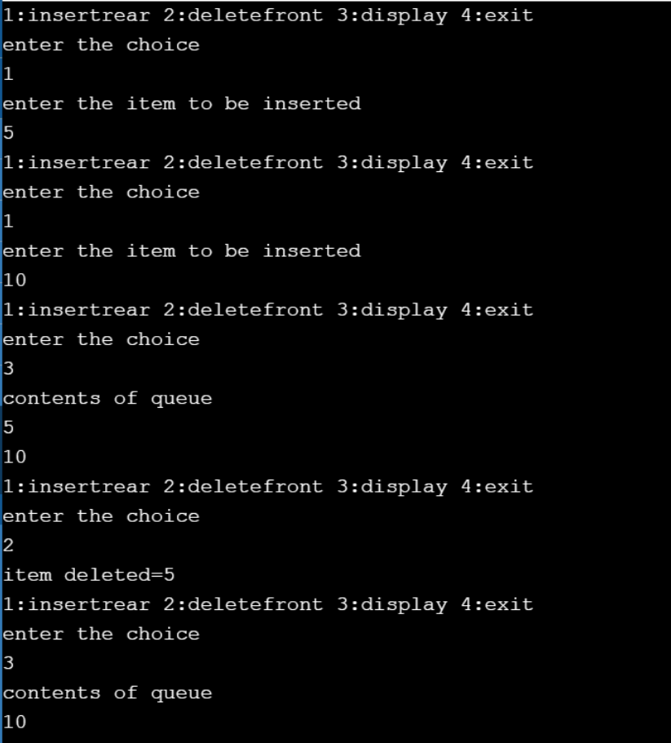

Lab4}

WAP to simulate the working of a circular queue of integers using an array. Provide the following operations. a) Insert b) Delete c) Display The program should print appropriate messages for queue empty and queue overflow conditions

|  |
| --- |
| #include<stdio.h> |
|  | #include<stdlib.h> |
|  | #define que_size 3 |
|  | int item,front=0,rear=-1,q[que_size],count=0; |
|  | void insertrear() |
|  | { |
|  | if(count==que_size) |
|  | { |
|  | printf("queue overflow"); |
|  | return; |
|  | } |
|  | rear=(rear+1)%que_size; |
|  | q[rear]=item; |
|  | count++; |
|  | } |
|  | int deletefront() |
|  | { |
|  | if(count==0) return -1; |
|  | item = q[front]; |
|  | front=(front+1)%que_size; |
|  | count=count-1; |
|  | return item; |
|  | } |
|  | void displayq() |
|  | { |
|  | int i,f; |
|  | if(count==0) |
|  | { |
|  | printf("queue is empty"); |
|  | return; |
|  | } |
|  | f=front; |
|  | printf("contents of queue \n"); |
|  | for(i=0;i<=count;i++) |
|  | { |
|  | printf("%d\n",q[f]); |
|  | f=(f+1)%que_size; |
|  | } |
|  | } |
|  | void main() |
|  | { |
|  | int choice; |
|  | for(;;) |
|  | { |
|  | printf("\n1.Insert rear \n2.Delete front \n3.Display \n4.exit \n "); |
|  | printf("Enter the choice : "); |
|  | scanf("%d",&choice); |
|  | switch(choice) |
|  | { |
|  | case 1:printf("Enter the item to be inserted :"); |
|  | scanf("%d",&item); |
|  | insertrear(); |
|  | break; |
|  | case 2:item=deletefront(); |
|  | if(item==-1) |
|  | printf("queue is empty\n"); |
|  | else |
|  | printf("item deleted is %d \n",item); |
|  | break; |
|  | case 3:displayq(); |
|  | break; |
|  | default:exit(0); |
|  | } |
|  | } |
|  | getch(); |
|  | } |

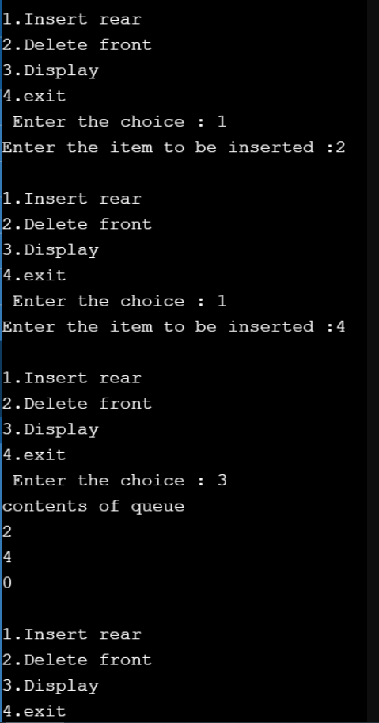

Lab5}

WAP to Implement Singly Linked List with following operations a) a) Create a linked list. b) Insertion of a node at first position, at any position and at end of list. c) Display the contents of the linked list.

Lab6}

WAP to Implement Singly Linked List with following operations a) a) Create a linked list. b) Deletion of first element, specified element and last element in the list. c) Display the contents of the linked list.

Merged program:

|  |
| --- |
| #include<stdio.h> |
|  | #include<stdlib.h> |
|  | struct node{ |
|  | int info; |
|  | struct node *link; |
|  | }; |
|  | typedef struct node *NODE; |
|  | NODE getnode(){ |
|  | NODE x; |
|  | x=(NODE)malloc(sizeof(struct node)); |
|  | if(x==NULL){ |
|  | printf("Memory full\n"); |
|  | exit(0); |
|  | } |
|  | return x; |
|  | } |
|  | void freenode(NODE x){ |
|  | free(x); |
|  | } |
|  | NODE insert_front(NODE first,int item){ |
|  | NODE temp; |
|  | temp=getnode(); |
|  | temp->info=item; |
|  | temp->link=NULL; |
|  | if(first==NULL) |
|  | return temp; |
|  | temp->link=first; |
|  | first=temp; |
|  | return first; |
|  | } |
|  | NODE delete_front(NODE first){ |
|  | NODE temp; |
|  | if(first==NULL){ |
|  | printf("List is empty cannot delete\n"); |
|  | return first; |
|  | } |
|  | temp=first; |
|  | temp=temp->link; |
|  | printf("Item deleted at front end is %d\n",first->info); |
|  | free(first); |
|  | return temp; |
|  | } |
|  | NODE insert_rear(NODE first,int item){ |
|  | NODE temp,cur; |
|  | temp=getnode(); |
|  | temp->info=item; |
|  | temp->link=NULL; |
|  | if(first==NULL) |
|  | return temp; |
|  | cur=first; |
|  | while(cur->link!=NULL) |
|  | cur=cur->link; |
|  | cur->link=temp; |
|  | return first; |
|  | } |
|  | NODE delete_rear(NODE first){ |
|  | NODE cur,prev; |
|  | if(first==NULL){ |
|  | printf("List is empty cannot delete\n"); |
|  | return first; |
|  | } |
|  | if(first->link==NULL){ |
|  | printf("Item deleted is %d\n",first->info); |
|  | free(first); |
|  | return NULL; |
|  | } |
|  | prev=NULL; |
|  | cur=first; |
|  | while(cur->link!=NULL){ |
|  | prev=cur; |
|  | cur=cur->link; |
|  | } |
|  | printf("Item deleted at rear end is %d",cur->info); |
|  | free(cur); |
|  | prev->link=NULL; |
|  | return first; |
|  | } |
|  | NODE insert_pos(int item,int pos,NODE first){ |
|  | NODE temp,cur,prev; |
|  | int count; |
|  | temp=getnode(); |
|  | temp->info=item; |
|  | temp->link=NULL; |
|  | if(first==NULL&&pos==1){ |
|  | return temp; |
|  | } |
|  | if(first==NULL){ |
|  | printf("Invalid position\n"); |
|  | return first; |
|  | } |
|  | if(pos==1){ |
|  | temp->link=first; |
|  | first=temp; |
|  | return temp; |
|  | } |
|  | count=1; |
|  | prev=NULL; |
|  | cur=first; |
|  | while(cur!=NULL&&count!=pos){ |
|  | prev=cur; |
|  | cur=cur->link; |
|  | count++; |
|  | } |
|  | if( |
|  | count==pos){ |
|  | prev->link=temp; |
|  | temp->link=cur; |
|  | return first; |
|  | } |
|  | printf("Invalid position\n"); |
|  | return first; |
|  | } |
|  | NODE delete_pos(int pos,NODE first){ |
|  | NODE cur; |
|  | NODE prev; |
|  | int count,flag=0; |
|  | if(first==NULL || pos<0){ |
|  | printf("Invalid position\n"); |
|  | return NULL; |
|  | } |
|  | if(pos==1){ |
|  | cur=first; |
|  | first=first->link; |
|  | freenode(cur); |
|  | return first; |
|  | } |
|  | prev=NULL; |
|  | cur=first; |
|  | count=1; |
|  | while(cur!=NULL){ |
|  | if(count==pos){ |
|  | flag=1; |
|  | break; |
|  | } |
|  | count++; |
|  | prev=cur; |
|  | cur=cur->link; |
|  | } |
|  | if(flag==0){ |
|  | printf("Invalid position\n"); |
|  | return first; |
|  | } |
|  | printf("Item deleted at given position is %d\n",cur->info); |
|  | prev->link=cur->link; |
|  | freenode(cur); |
|  | return first; |
|  | } |
|  | void display(NODE first){ |
|  | NODE temp; |
|  | if(first==NULL) |
|  | printf("List empty cannot display items\n"); |
|  | for(temp=first;temp!=NULL;temp=temp->link){ |
|  | printf("%d\n",temp->info); |
|  | } |
|  | } |
|  | void main() |
|  | { |
|  | int item,choice,key,pos; |
|  | int count=0; |
|  | NODE first=NULL; |
|  | for(;;){ |
|  | printf("\n1:Insert rear\n2:Delete rear\n3:Insert front\n4:Delete front\n5:Insert info position\n6:Delete info position\n7:Display list\n8:Exit\n"); |
|  | printf("Enter the choice: "); |
|  | scanf("%d",&choice); |
|  | switch(choice){ |
|  | case 1:printf("Enter the item at rear end\n"); |
|  | scanf("%d",&item); |
|  | first=insert_rear(first,item); |
|  | break; |
|  | case 2:first=delete_rear(first); |
|  | break; |
|  | case 3:printf("\nEnter the item at front end\n"); |
|  | scanf("%d",&item); |
|  | first=insert_front(first,item); |
|  | break; |
|  | case 4:first=delete_front(first); |
|  | break; |
|  | case 5:printf("Enter the item to be inserted at given position\n"); |
|  | scanf("%d",&item); |
|  | printf("Enter the position\n"); |
|  | scanf("%d",&pos); |
|  | first=insert_pos(item,pos,first); |
|  | break; |
|  | case 6:printf("Enter the position\n"); |
|  | scanf("%d",&pos); |
|  | first=delete_pos(pos,first); |
|  | break; |
|  | case 7:display(first); |
|  | break; |
|  | default:exit(0); |
|  | break; |
|  | } |
|  | } |
|  | } |

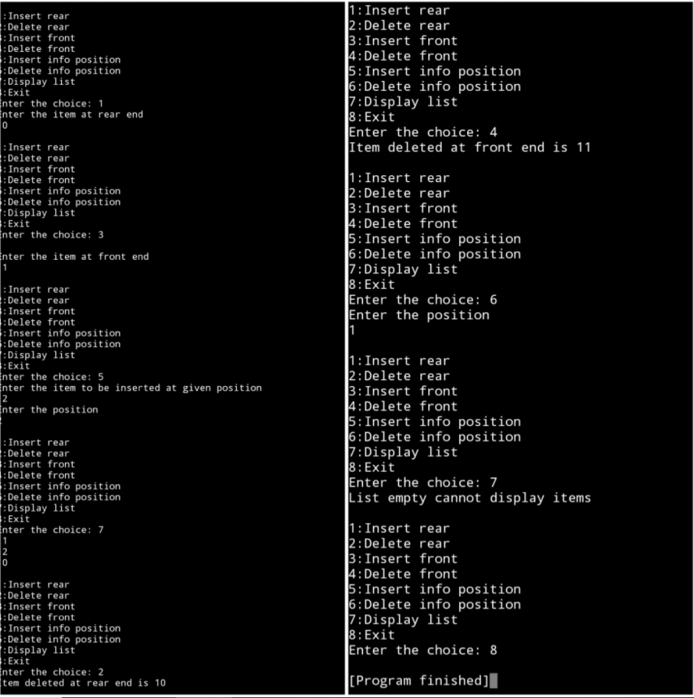

Lab7}

WAP Implement Single Link List with following operations a) a) Sort the linked list. b) Reverse the linked list. c) Concatenation of two linked lists

|  |
| --- |
| #include<stdio.h> |
|  | #include<malloc.h> |
|  |  |
|  | struct node{ |
|  | int num; |
|  | struct node *next; |
|  | }; |
|  |  |
|  | typedef struct node *NODE; |
|  |  |
|  | NODE getNode(){ |
|  | NODE temp = (NODE)malloc(sizeof(struct node)); |
|  | if(temp == NULL){ |
|  | return NULL; |
|  | } |
|  | return temp; |
|  | } |
|  |  |
|  | void freeNode(NODE temp){ |
|  | free(temp); |
|  | } |
|  |  |
|  | NODE insertFront(NODE first){ |
|  | NODE temp; |
|  | temp = getNode(); |
|  | int num; |
|  | scanf("%d",&num); |
|  | temp->num = num; |
|  | temp->next = NULL; |
|  | if(first==NULL){ |
|  | return temp; |
|  | } |
|  | temp->next = first; |
|  | first = temp; |
|  | return first; |
|  | } |
|  |  |
|  | NODE deleteFront(NODE first){ |
|  | NODE temp; |
|  | if(first==NULL){ |
|  | printf("List is empty\n"); |
|  | return NULL; |
|  | } |
|  | if(first->next == NULL){ |
|  | printf("Deleted element = %d\n",first->num); |
|  | freeNode(first); |
|  | return NULL; |
|  | } |
|  | temp = first; |
|  | temp = temp->next; |
|  | printf("Deleted elements = %d\n",first->num); |
|  | freeNode(first); |
|  | return temp; |
|  | } |
|  |  |
|  | NODE sort(NODE first){ |
|  | NODE curr,temp; |
|  | if(first==NULL){ |
|  | return NULL; |
|  | } |
|  | curr = first; |
|  | while(curr!=NULL){ |
|  | temp = curr->next; |
|  | while(temp!=NULL){ |
|  | if(temp->num<curr->num){ |
|  | int num = curr->num; |
|  | curr->num=temp->num; |
|  | temp->num = num; |
|  | } |
|  | temp = temp->next; |
|  | } |
|  | curr = curr->next; |
|  | } |
|  | return first; |
|  | } |
|  |  |
|  | void display(NODE first){ |
|  | NODE curr; |
|  | if(first==NULL){ |
|  | printf("List is empty\n"); |
|  | return; |
|  | } |
|  | curr = first; |
|  | while(curr!=NULL){ |
|  | printf("%d ",curr->num); |
|  | curr=curr->next; |
|  | } |
|  | printf("\n"); |
|  | } |
|  |  |
|  | NODE reverse(NODE first){ |
|  | NODE curr=NULL; |
|  | NODE temp = getNode(); |
|  | while(first!=NULL){ |
|  | temp = first; |
|  | first = first->next; |
|  | temp->next = curr; |
|  | curr = temp; |
|  | //printf("%d ",first->num); |
|  | } |
|  | return temp; |
|  | } |
|  |  |
|  | NODE concat(NODE first){ |
|  | NODE sec = NULL; |
|  | int chq; |
|  | while(1){ |
|  | printf("Enter the choice:\n1-insertFront\t2-deleteFront\t3-display\t4-concat\n"); |
|  | scanf("%d",&chq); |
|  | if(chq==4){ |
|  | break; |
|  | } |
|  | switch(chq){ |
|  | case 1: |
|  | sec = insertFront(sec); |
|  | break; |
|  | case 2: |
|  | sec = deleteFront(sec); |
|  | break; |
|  | case 3: |
|  | display(sec); |
|  | break; |
|  | } |
|  | } |
|  | NODE curr; |
|  | if(first==NULL){ |
|  | return sec; |
|  | } |
|  | if(sec==NULL){ |
|  | return first; |
|  | } |
|  | curr = first; |
|  | while(curr->next!=NULL){ |
|  | curr = curr->next; |
|  | } |
|  | curr->next = sec; |
|  | return first; |
|  | } |
|  |  |
|  | int main(){ |
|  | int chq; |
|  | NODE first = NULL; |
|  | while(1){ |
|  | printf("Enter the choice:\n1-insertFront\t2-deleteFront\t3-display\t4-sort\t5-reverse\t6-concat\t7-exit\n"); |
|  | scanf("%d",&chq); |
|  | switch(chq){ |
|  | case 1: |
|  | first = insertFront(first); |
|  | break; |
|  | case 2: |
|  | first = deleteFront(first); |
|  | break; |
|  | case 3: |
|  | display(first); |
|  | break; |
|  | case 4: |
|  | first = sort(first); |
|  | break; |
|  | case 5: |
|  | first = reverse(first); |
|  | break; |
|  | case 6: |
|  | printf("Creating the second list for concat\n"); |
|  | concat(first); |
|  | break; |
|  | case 7: |
|  | return 0; |
|  |  |
|  | } |
|  | } |
|  | } |

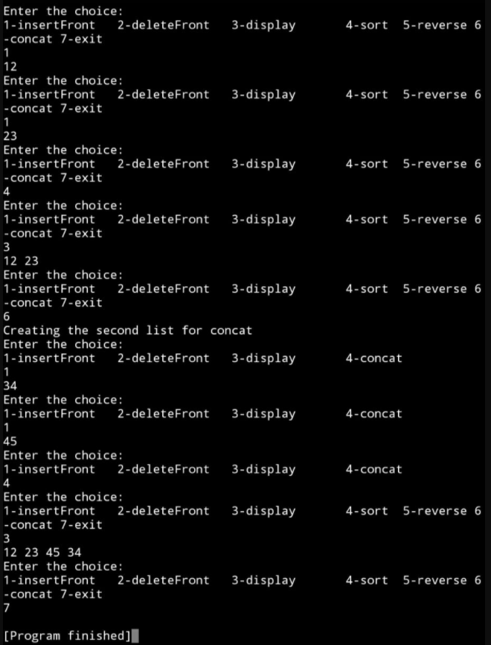

Lab8}

WAP to implement Stack & Queues using Linked Representation

Implement queue

#include<stdio.h>

#include<conio.h>

#include<alloc.h>

#include<process.h>

struct node

{

  int info;

  struct node *link;

};

typedef struct node *NODE;

NODE getnode()

{

NODE x;

x=(NODE)malloc(sizeof(struct node));

if(x==NULL)

 {

  printf("mem full\n");

  exit(0);

 }

 return x;

}

void freenode(NODE x)

{

free(x);

}

NODE insert_rear(NODE first,int item)

{

NODE temp,cur;

temp=getnode();

temp->info=item;

temp->link=NULL;

if(first==NULL)

 return temp;

cur=first;

while(cur->link!=NULL)

 cur=cur->link;

cur->link=temp;

return first;

}

NODE delete_front(NODE first)

{

NODE temp;

if(first==NULL)

{

printf("list is empty cannot delete\n");

return first;

}

temp=first;

temp=temp->link;

printf("item deleted at front-end is=%d\n",first->info);

free(first);

return temp;

}

void display(NODE first)

{

 NODE temp;

 if(first==NULL)

 printf("list empty cannot display items\n");

 for(temp=first;temp!=NULL;temp=temp->link)

  {

  printf("%d\n",temp->info);

  }

}

void main()

{

int item,choice,pos;

NODE first=NULL;

clrscr();

for(;;)

{

printf("\n 1:Insert_rear\n 2:Delete_front\n 3:Display_list\n 4:Exit\n");

printf("enter the choice\n");

scanf("%d",&choice);

switch(choice)

 {

  case 1:printf("enter the item at rear-end\n");

scanf("%d",&item);

first=insert_rear(first,item);

break;

  case 2:first=delete_front(first);

break;

  case 3:display(first);

break;

 default:exit(0);

break;

 }

}

getch();

}

Implement stack

#include<stdio.h>

#include<conio.h>

#include<alloc.h>

#include<process.h>

struct node

{

  int info;

  struct node *link;

};

typedef struct node *NODE;

NODE getnode()

{

NODE x;

x=(NODE)malloc(sizeof(struct node));

if(x==NULL)

 {

  printf("mem full\n");

  exit(0);

 }

 return x;

}

void freenode(NODE x)

{

free(x);

}

NODE insert_front(NODE first,int item)

{

NODE temp;

temp=getnode();

temp->info=item;

temp->link=NULL;

if(first==NULL)

return temp;

temp->link=first;

first=temp;

return first;

}

NODE delete_front(NODE first)

{

NODE temp;

if(first==NULL)

{

printf("stack is empty cannot delete\n");

return first;

}

temp=first;

temp=temp->link;

printf("item deleted at front-end is=%d\n",first->info);

free(first);

return temp;

}

void display(NODE first)

{

 NODE temp;

 if(first==NULL)

 printf("stack empty cannot display items\n");

 for(temp=first;temp!=NULL;temp=temp->link)

  {

  printf("%d\n",temp->info);

  }

}

void main()

{

int item,choice,pos;

NODE first=NULL;

clrscr();

for(;;)

{

printf("\n 1:Insert_front\n 2:Delete_front\n 3:Display_list\n 4:Exit\n");

printf("enter the choice\n");

scanf("%d",&choice);

switch(choice)

 {

  case 1:printf("enter the item at front-end\n");

scanf("%d",&item);

first=insert_front(first,item);

break;

  case 2:first=delete_front(first);

break;

  case 3:display(first);

break;

 default:exit(0);

break;

 }

}

Lab9}

WAP Implement doubly link list with primitive operations a) a) Create a doubly linked list. b) Insert a new node to the left of the node. b) c) Delete the node based on a specific value. c) Display the contents of the list

|  |
| --- |
| #include<stdio.h> |
|  | #include<stdlib.h> |
|  | struct node |
|  | { |
|  | int info; |
|  | struct node *rlink; |
|  | struct node *llink; |
|  | }; |
|  | typedef struct node *NODE; |
|  | NODE getnode() |
|  | { |
|  | NODE x; |
|  | x=(NODE)malloc(sizeof(struct node)); |
|  | if(x==NULL) |
|  | { |
|  | printf("mem full\n"); |
|  | exit(0); |
|  | } |
|  | return x; |
|  | } |
|  | void freenode(NODE x) |
|  | { |
|  | free(x); |
|  | } |
|  | NODE insert_rear(NODE head,int item) |
|  | { |
|  | NODE temp,cur; |
|  | temp=getnode(); |
|  | temp->rlink=NULL; |
|  | temp->llink=NULL; |
|  | temp->info=item; |
|  | cur=head->llink; |
|  | temp->llink=cur; |
|  | cur->rlink=temp; |
|  | head->llink=temp; |
|  | temp->rlink=head; |
|  | head->info=head->info+1; |
|  | return head; |
|  | } |
|  | NODE insert_leftpos(int item,NODE head) |
|  | { |
|  | NODE temp,cur,prev; |
|  | if(head->rlink==head) |
|  | { |
|  | printf("list empty\n"); |
|  | return head; |
|  | } |
|  | cur=head->rlink; |
|  | while(cur!=head) |
|  | { |
|  | if(item==cur->info)break; |
|  | cur=cur->rlink; |
|  | } |
|  | if(cur==head) |
|  | { |
|  | printf("key not found\n"); |
|  | return head; |
|  | } |
|  | prev=cur->llink; |
|  | printf("enter towards left of %d=",item); |
|  | temp=getnode(); |
|  | scanf("%d",&temp->info); |
|  | prev->rlink=temp; |
|  | temp->llink=prev; |
|  | cur->llink=temp; |
|  | temp->rlink=cur; |
|  | return head; |
|  | } |
|  | NODE delete_all_key(int item,NODE head) |
|  | { |
|  | NODE prev,cur,next; |
|  | int count; |
|  | if(head->rlink==head) |
|  | { |
|  | printf("LE"); |
|  | return head; |
|  | } |
|  | count=0; |
|  | cur=head->rlink; |
|  | while(cur!=head) |
|  | { |
|  | if(item!=cur->info) |
|  | cur=cur->rlink; |
|  | else |
|  | { |
|  | count++; |
|  | prev=cur->llink; |
|  | next=cur->rlink; |
|  | prev->rlink=next; |
|  | next->llink=prev; |
|  | freenode(cur); |
|  | cur=next; |
|  | } |
|  | } |
|  | if(count==0) |
|  | printf("key not found"); |
|  | else |
|  | printf("key found at %d positions and are deleted\n", count); |
|  |  |
|  | return head; |
|  | } |
|  | NODE ddelete_rear(NODE head) |
|  | { |
|  | NODE cur,prev; |
|  | if(head->rlink==head) |
|  | { |
|  | printf("list is empty\n"); |
|  | return head; |
|  | } |
|  | cur=head->llink; |
|  | prev=cur->llink; |
|  | head->llink=prev; |
|  | prev->rlink=head; |
|  | printf("the node deleted is %d \n",cur->info); |
|  | freenode(cur); |
|  | return head; |
|  | } |
|  | void display(NODE head) |
|  | { |
|  | NODE temp; |
|  | if(head->rlink==head) |
|  | { |
|  | printf("list empty\n"); |
|  | return; |
|  | } |
|  | for(temp=head->rlink;temp!=head;temp=temp->rlink) |
|  | printf("%d\n",temp->info); |
|  | } |
|  | void main() |
|  | { |
|  | int item,choice,key; |
|  | NODE head,tem; |
|  | head=getnode(); |
|  | head->rlink=head; |
|  | head->llink=head; |
|  | for(;;) |
|  | { |
|  | printf("\n1.insert_rear 2.insert_key 3.display 4.delete key 5.delete_rear 6.exit\n"); |
|  | printf("enter the choice : "); |
|  | scanf("%d",&choice); |
|  | switch(choice) |
|  | { |
|  | case 1:printf("enter the item : "); |
|  | scanf("%d",&item); |
|  | head=insert_rear(head,item); |
|  | break; |
|  | case 2:printf("enter the key item : "); |
|  | scanf("%d",&item); |
|  | head=insert_leftpos(item,head); |
|  | break; |
|  | case 3:display(head); |
|  | break; |
|  | case 4:printf("enter the key item : "); |
|  | scanf("%d",&item); |
|  | head=delete_all_key(item,head); |
|  | break; |
|  | case 5:head=ddelete_rear(head); |
|  | break; |
|  | default:exit(0); |
|  | break; |
|  | } |
|  | } |
|  | } |

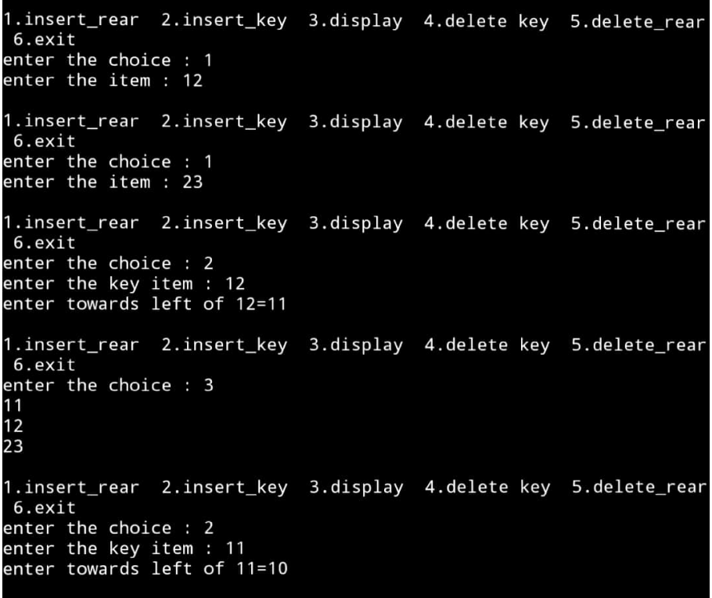

Lab10}

Write a program a) To construct a binary Search tree. b) To traverse the tree using all the methods i.e., in-order, preorder and post order c) To display the elements in the tree.

|  |
| --- |
| #include<stdio.h> |
|  | #include<malloc.h> |
|  |  |
|  | struct node{ |
|  | struct node *left; |
|  | int value; |
|  | struct node *right; |
|  | }; |
|  |  |
|  | typedef struct node *NODE; |
|  |  |
|  | NODE getNode(){ |
|  | NODE temp; |
|  | temp = (NODE)malloc(sizeof(struct node)); |
|  | return temp; |
|  | } |
|  |  |
|  | NODE insert(NODE root){ |
|  | int value; |
|  | NODE temp,curr,prev; |
|  | temp = getNode(); |
|  | printf("Enter the value:\n"); |
|  | scanf("%d",&value); |
|  | temp->value = value; |
|  | temp->left = NULL; |
|  | temp->right = NULL; |
|  | if(root==NULL){ |
|  | return temp; |
|  | } |
|  | curr = root; |
|  | prev = NULL; |
|  | while(curr!=NULL){ |
|  | prev = curr; |
|  | if(value<curr->value){ |
|  | curr = curr->left; |
|  | }else{ |
|  | curr = curr->right; |
|  | } |
|  | } |
|  | if(value<prev->value){ |
|  | prev->left = temp; |
|  | }else{ |
|  | prev->right = temp; |
|  | } |
|  | return root; |
|  | } |
|  |  |
|  | void display(NODE root,int i){ |
|  | int j; |
|  | if(root!=NULL){ |
|  | display(root->right,i+1); |
|  | for(j=0;j<i;j++){ |
|  | printf(" "); |
|  | } |
|  | printf("%d\n",root->value); |
|  | display(root->left,i+1); |
|  | } |
|  | } |
|  |  |
|  | void preOrder(NODE root){ |
|  | if(root==NULL){ |
|  | return; |
|  | } |
|  | printf("%d ",root->value); |
|  | preOrder(root->left); |
|  | preOrder(root->right); |
|  | } |
|  |  |
|  | void inOrder(NODE root){ |
|  | if(root == NULL){ |
|  | return; |
|  | } |
|  | inOrder(root->left); |
|  | printf("%d ",root->value); |
|  | inOrder(root->right); |
|  | } |
|  |  |
|  | void postOrder(NODE root){ |
|  | if(root == NULL){ |
|  | return; |
|  | } |
|  | postOrder(root->left); |
|  | postOrder(root->right); |
|  | printf("%d ",root->value); |
|  | } |
|  |  |
|  | int main(){ |
|  | int chq;NODE root = NULL; |
|  | while(1){ |
|  | printf("Enter the choice:\t1-Insert\t2-Display\t3-Preorder\t 4-Inorder\t5-Postorder\t6-Exit\n"); |
|  | scanf("%d",&chq); |
|  | switch(chq){ |
|  | case 1: |
|  | root = insert(root); |
|  | break; |
|  | case 2: |
|  | if(root==NULL){ |
|  | printf("Tree is empty\n"); |
|  | }else{ |
|  | display(root,0); |
|  | } |
|  | break; |
|  | case 3: |
|  | if(root==NULL){ |
|  | printf("Tree is empty\n"); |
|  | }else{ |
|  | preOrder(root); |
|  | printf("\n"); |
|  | } |
|  | break; |
|  | case 4: |
|  | if(root==NULL){ |
|  | printf("Tree is empty\n"); |
|  | }else{ |
|  | inOrder(root); |
|  | printf("\n"); |
|  | } |
|  | break; |
|  | case 5: |
|  | if(root==NULL){ |
|  | printf("Tree is empty\n"); |
|  | }else{ |
|  | postOrder(root); |
|  | printf("\n"); |
|  | } |
|  | break; |
|  | case 6: |
|  | return 0; |
|  | } |
|  | } |
|  | } |

