SHRI GOVINDRAM SEKSARIA INSTITUTE OF TECHNOLOGY AND SCIENCE, INDORE 
Department of Applied Mathematics and Computational Science
MCA I Year Semester I Session: July-December 2025
LAB ASSIGNMENT
MA10401: STATISTICAL COMPUTING TECHNIQUES
SUBMITTED TO SUBMITTED BY Dr. Deepti Mokati Rohan Yadav Dr. Kajal Mittal 0801CA251120

S. No. | List of Programs Using C | Page No.
1. | Write a program to calculate mean , median , mode in an individual series. | 2
2. | Write a program to calculate mean , median , mode in a discrete series. | 4
3. | Write a program to calculate mean , median , mode in a continuous series. | 7
4. | Write a program to calculate geometric mean and harmonic mean for discrete series. | 10
5. | Write a program to calculate mean deviation from mean , median , mode in continuous series. | 12
6. | Write a program to calculate standard deviation for continuous series using array. | 15
7. | Write a program to calculate one period ahead forecast using Naïve method. | 17
8. | Write a program to calculate one period ahead forecast with 3-period moving average and 5-period moving average using Moving Average Method . | 19
9. | Write a program to calculate standard statistical measures[Mean Error(ME),Mean Square Error(MSE)] using exponential forecasting method. | 22
10. | Write a program to calculate relative measures of forecasting[ Percentage Error, Mean Percentage Error(MPE),Mean Absolute Percentage Error(MAPE)] using exponential forecasting method. | 25
11. | Write a program to generate random numbers using mid square method. | 28

Program 1. Write a program to calculate mean , median , mode in an individual series #include <stdio.h>
#include <conio.h>
void sort(int a[], int n) {
int i, j, t;
for(i=0;i<n-1;i++)
for(j=i+1;j<n;j++)
if(a[i]>a[j]) { t=a[i]; a[i]=a[j]; a[j]=t; } //swap the elements
}
float findMean(int arr[], int n) {
int i, sum = 0;
for(i = 0; i < n; i++) sum += arr[i];
return (float)sum / n;
}
float findMedian(int arr[], int n) { // Function to calculate Median
sort(arr, n); // sort first
if(n % 2 == 0) return (arr[n/2 - 1] + arr[n/2]) / 2.0;
else return arr[n/2];
}
int findMode(int arr[], int n) { // Function to calculate Mode
sort(arr, n); // sort first
int mode = arr[0];
int maxCount = 1, count = 1, i;
for(i = 1; i < n; i++) {
if(arr[i] == arr[i-1]) count++;
else count = 1;
if(count > maxCount) {
maxCount = count;
mode = arr[i]; } }
return mode; }
int main() { // Main function
int arr[100], n, i, mode;
float mean, median;
clrscr();
printf("Enter the number of elements: ");
scanf("%d", &n);
printf("Enter %d elements:\n", n);
for(i = 0; i < n; i++) scanf("%d", &arr[i]);
mean = findMean(arr, n); median = findMedian(arr, n); mode = findMode(arr, n); printf("\nMean=%.2f\nMedian=%.2f\nMode=%d", mean, median, mode); getch();
return 0;
}

Output
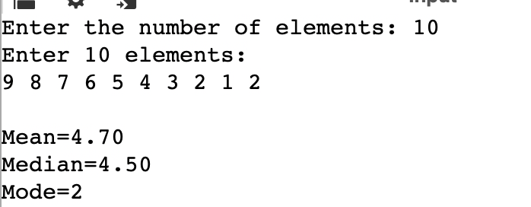

Program 2.Write a program to calculate mean , median , mode in a discrete series. #include <stdio.h>
#include <conio.h>
int main() {
int n, i, totalFreq = 0, totalFX = 0;
float mean, median;
int mode;
clrscr();
printf("Enter number of distinct values: ");
scanf("%d", &n);
int x[100], f[100], cf[100], fx[100];
for(i = 0; i < n; i++) {
printf("Value at index %d: ", i);
scanf("%d", &x[i]);
}
for(i = 0; i < n; i++) { // Input frequencies
printf("Frequency of value %d: ", x[i]);
scanf("%d", &f[i]);
fx[i] = x[i] * f[i];
totalFreq += f[i];
totalFX += fx[i];
}
cf[0] = f[0]; // Cumulative frequency
for(i = 1; i < n; i++) cf[i] = cf[i-1] + f[i];
mean = (float)totalFX / totalFreq; // Mean
int mid = (totalFreq + 1) / 2;// Median
for(i = 0; i < n; i++) {
if(mid <= cf[i]) {
median = x[i];
break;
}
}
int maxFreq = f[0]; // Mode
mode = x[0];
for(i = 1; i < n; i++) {
if(f[i] > maxFreq) {
maxFreq = f[i];
mode = x[i];
}
}
printf("\n+-------+-------+-------+-------+-------+\n"); // Print Table Header printf("| Index | Value | Freq | CF | F*X |\n");
printf("+-------+-------+-------+-------+-------+\n");
for(i = 0; i < n; i++) { // Print Table Rows
printf("| %2d | %2d | %2d | %2d | %2d |\n",
i, x[i], f[i], cf[i], fx[i]);
printf("+-------+-------+-------+-------+-------+\n");
}
printf("| Total | - | %2d | - | %2d |\n", totalFreq, totalFX); // Print Totals
printf("+-------+-------+-------+-------+-------+\n");
printf("\nMean = %.2f\n", mean); // Print Mean, Median, Mode
printf("Median = %.2f\n", median);
printf("Mode = %d\n", mode);
getch();
return 0;
}
Output:
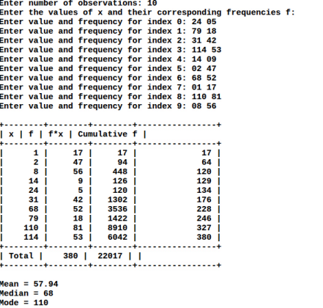
Program 3.Write a program to calculate mean , median , mode in a continuous series. #include <stdio.h>
#include <conio.h>
int main() {
int n, i;
float mean, median, mode;
int f[100];
float lower[100], upper[100], mid[100], cumf[100];
clrscr();
printf("Enter number of classes: ");
scanf("%d", &n);
for(i = 0; i < n; i++) { // Input classes and frequencies printf("Enter lower and upper limit of class %d: ", i+1);
scanf("%f %f", &lower[i], &upper[i]);
mid[i] = (lower[i] + upper[i]) / 2; // midpoint
printf("Enter frequency of class %d: ", i+1);
scanf("%d", &f[i]);
}
cumf[0] = f[0]; // Cumulative frequency
for(i = 1; i < n; i++) cumf[i] = cumf[i-1] + f[i];
int totalF = 0; //Mean
float totalFX = 0;
for(i = 0; i < n; i++) {
totalFX += f[i] * mid[i];
totalF += f[i];
}
mean = totalFX / totalF;
int N = totalF; //median
int median_class;
for(i = 0; i < n; i++) {
if(cumf[i] >= N/2) {
median_class = i;
break;
}
}
float L = lower[median_class];
float h = upper[median_class] - lower[median_class];
int CF = (median_class == 0) ? 0 : cumf[median_class-1]; int f1 = f[median_class];
median = L + ((N/2.0 - CF) / f1) * h;
int modal_class = 0; // Mode
int maxf = f[0];
for(i = 1; i < n; i++) {
if(f[i] > maxf) {
maxf = f[i];
modal_class = i;
}
}
L = lower[modal_class];
f1 = f[modal_class];
int f0 = (modal_class == 0) ? 0 : f[modal_class-1];
int f2 = (modal_class == n-1) ? 0 : f[modal_class+1];
mode = L + ((float)(f1 - f0) / (2*f1 - f0 - f2)) * h;
printf("\n+------------+--------+----------+-------+\n"); // Display closed table printf("| Class | Freq | Midpoint | C.F. |\n");
printf("+------------+--------+----------+-------+\n");
for(i = 0; i < n; i++) {
printf("| %.2f-%.2f | %3d | %6.2f | %3.0f |\n",
lower[i], upper[i], f[i], mid[i], cumf[i]);
printf("+------------+--------+----------+-------+\n");
}
printf("| Total | %3d | - | - |\n", totalF);
printf("+------------+--------+----------+-------+\n");
printf("\nMean = %.2f\n", mean); // Display results
printf("Median = %.2f\n", median);
printf("Mode = %.2f\n", mode);
getch();
return 0;
}
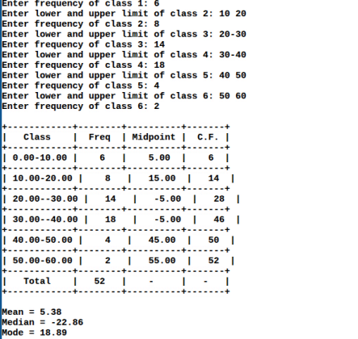
Program 4. Write a program to calculate geometric mean and harmonic mean for discrete series.
#include <stdio.h>
#include <math.h>
int main() {
int n, i,totalF = 0;
int x[100], f[100];
float Hsum = 0; // sum of f/x for harmonic mean
double logGsum = 0; // sum of f*log(x) for geometric mean
printf("Enter number of distinct values: ");
scanf("%d", &n);
for(i = 0; i < n; i++) {
printf("Enter value and frequency for index %d: ", i);
scanf("%d %d", &x[i], &f[i]); }
for(i = 0; i < n; i++) {
Hsum += (float)f[i] / x[i];
logGsum += f[i] * log10(x[i]); // using log base 10 for table clarity
totalF += f[i]; }
float HM = totalF / Hsum; // Harmonic Mean
double GM = pow(10, logGsum / totalF); // Geometric Mean using log10 printf("\n+-------+-------+--------+---------+------------+\n");
printf("| Index | x[i] | f[i] | log10(x) | f[i]*log10(x) |\n");
printf("+-------+-------+--------+---------+------------+\n");
double fLogx;
for(i = 0; i < n; i++) {
fLogx = f[i] * log10(x[i]);
printf("| %2d | %3d | %3d | %6.4f | %8.4f |\n",
i, x[i], f[i], log10(x[i]), fLogx);
printf("+-------+-------+--------+---------+------------+\n"); } printf("| Total | - | %3d | - | %8.4f |\n", totalF, logGsum); printf("+-------+-------+--------+---------+------------+\n"); printf("\nHarmonic Mean = %.4f\n Geometric Mean = %.4f\n", HM, GM); return 0;
}
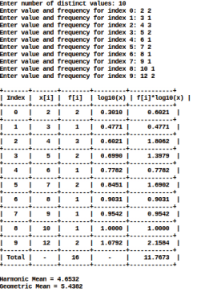

Program 5.Write a program to calculate mean deviation from mean , median , mode in continuous series.
#include <stdio.h>
#include <math.h>
int main() {
int n, i;
float lower[100], upper[100], mid[100], f[100], cumf[100];
float sumFX = 0, totalF = 0, mean, median, mode;
float h, L;
printf("Enter number of classes: ");
scanf("%d", &n);
for(i = 0; i < n; i++) {
printf("Enter lower and upper limit of class %d: ", i+1);
scanf("%f %f", &lower[i], &upper[i]);
mid[i] = (lower[i] + upper[i]) / 2;
printf("Enter frequency of class %d: ", i+1);
scanf("%f", &f[i]);
}
cumf[0] = f[0];
for(i = 1; i < n; i++) cumf[i] = cumf[i-1] + f[i];
for(i = 0; i < n; i++) {
sumFX += f[i] * mid[i];
totalF += f[i];
}
mean = sumFX / totalF;
int median_class;
int N = totalF;
for(i = 0; i < n; i++) {
if(cumf[i] >= N/2) { median_class = i; break; } }
L = lower[median_class];
h = upper[median_class] - lower[median_class];
float CF = (median_class == 0) ? 0 : cumf[median_class-1];
float f1 = f[median_class];
median = L + ((N/2.0 - CF)/f1)*h;
int modal_class = 0;
float maxf = f[0];
for(i = 1; i < n; i++) {
if(f[i] > maxf) { maxf = f[i]; modal_class = i; } }
L = lower[modal_class];
f1 = f[modal_class];
float f0 = (modal_class == 0) ? 0 : f[modal_class-1];
float f2 = (modal_class == n-1) ? 0 : f[modal_class+1];
mode = L + ((f1 - f0)/(2*f1 - f0 - f2))*h;
printf("\n+------------+--------+----------+------------+--------+\n");
printf("| Class | Freq | Midpoint | F*Midpoint| C.F. |\n");
printf("+------------+--------+----------+------------+--------+\n");
for(i = 0; i < n; i++) { printf("| %.2f-%.2f | %3.0f | %6.2f | %7.2f | %3.0f |\n", lower[i], upper[i], f[i], mid[i], f[i]*mid[i], cumf[i]);
}
printf("+------------+--------+----------+------------+--------+\n");
printf("| Total | %3.0f | - | %7.2f | - |\n", totalF, sumFX);
printf("+------------+--------+----------+------------+--------+\n"); printf("\nMean = %.2f\n Median = %.2f\n Mode = %.2f\n", mean,median,mode); return 0;
}
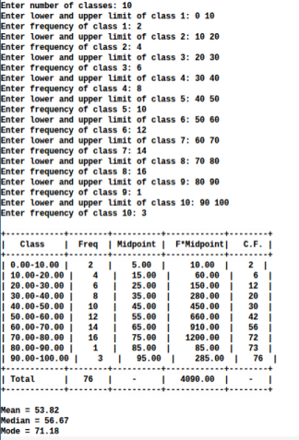

Program 6.Write a program to calculate standard deviation for continuous series using array.
#include <stdio.h>
#include <math.h>
int main() {
int n, i;
float L[50], U[50], F[50], x[50];
float fx[50], fx2[50];
float mean, sd, total_f = 0, total_fx = 0, total_fx2 = 0;
printf("Enter the number of class intervals: ");
scanf("%d", &n);
printf("\nEnter Lower Limit, Upper Limit, and Frequency for each class:\n");
for(i = 0; i < n; i++) {
printf("Class %d: ", i + 1);
scanf("%f%f%f", &L[i], &U[i], &F[i]);
x[i] = (L[i] + U[i]) / 2; // Midpoint
fx[i] = F[i] * x[i];
fx2[i] = F[i] * x[i] * x[i];
total_f += F[i];
total_fx += fx[i];
total_fx2 += fx2[i];
}
mean = total_fx / total_f;
sd = sqrt((total_fx2 / total_f) - (mean * mean));
printf("\n+-------------+-------------+-------+-----------+-------------+\n");
printf("| Class Int. | Midpoint(x) | F | Fx | Fx^2 |\n");
printf("+-------------+-------------+-------+-----------+-------------+\n");
for(i = 0; i < n; i++) {
printf("| %5.0f - %-5.0f | %11.2f | %5.0f | %9.2f | %11.2f |\n",
L[i], U[i], x[i], F[i], fx[i], fx2[i]);
}
printf("+-------------+-------------+-------+-----------+-------------+\n"); printf("| Total | | %5.0f | %9.2f | %11.2f |\n", total_f, total_fx, total_fx2); printf("+-------------+-------------+-------+-----------+-------------+\n"); printf("\nMean = %.2f", mean);
printf("\nStandard Deviation = %.2f\n", sd);
return 0;
}
Output:
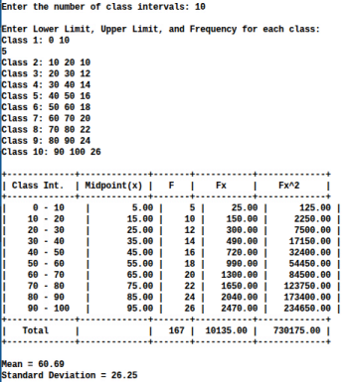

Program 7.Write a program to calculate one period ahead forecast using Naïve method. #include <stdio.h>
int main() {
int n, i;
float actual[50], forecast[50];
printf("Enter the number of periods: ");
scanf("%d", &n);
printf("\nEnter actual values for each period:\n");
for(i = 0; i < n; i++) {
printf("Actual value for period %d: ", i + 1);
scanf("%f", &actual[i]);
}
// Naïve Forecast: F(t+1) = A(t)
forecast[0] = 0; // First period has no forecast
for(i = 1; i < n; i++) {
forecast[i] = actual[i - 1];
}
printf("\n+---------+-------------+-------------+\n");
printf("| Period | Actual(A) | Forecast(F) |\n");
printf("+---------+-------------+-------------+\n");
for(i = 0; i < n; i++) {
if(i == 0)
printf("| %3d | %9.2f | --- |\n", i + 1, actual[i]);
else
printf("| %3d | %9.2f | %9.2f |\n", i + 1, actual[i], forecast[i]);
}
printf("+---------+-------------+-------------+\n");
// Forecast for next (n+1)th period
printf("\nForecast for next period (Period %d) = %.2f\n", n + 1, actual[n - 1]); return 0;
}
Output:
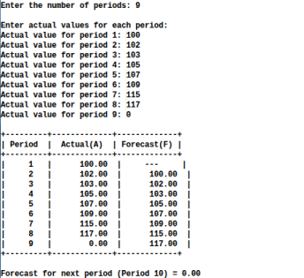

Program 8 Write a program to calculate one period ahead forecast with 3-period moving average and 5-period moving average using Moving Average Method .
#include <stdio.h>
int main() {
int n, i;
printf("Enter number of periods: ");
scanf("%d", &n);
double data[n];
printf("Enter the data values:\n");
for (i = 0; i < n; i++) {
printf("Period %d: ", i + 1);
scanf("%lf", &data[i]);
}
double ma3[n], ma5[n];
for (i = 2; i < n; i++) {
ma3[i] = (data[i] + data[i - 1] + data[i - 2]) / 3.0;
}
for (i = 4; i < n; i++) { // Calculate 5-period moving average ma5[i] = (data[i] + data[i - 1] + data[i - 2] + data[i - 3] + data[i - 4]) / 5.0;
}
printf("\n-------------------------------------------------------------\n");
printf("| Period | Actual Value | 3-Period MA | 5-Period MA |\n");
printf("-------------------------------------------------------------\n");
for (i = 0; i < n; i++) {
printf("| %6d | %12.2lf |", i + 1, data[i]);
if (i >= 2)
printf(" %11.2lf |", ma3[i]);
else
printf(" --- |");
if (i >= 4)
printf(" %11.2lf |\n", ma5[i]);
else
printf(" --- |\n");
}
printf("-------------------------------------------------------------\n");
double nextMA3 = (data[n - 1] + data[n - 2] + data[n - 3]) / 3.0;
double nextMA5 = (data[n - 1] + data[n - 2] + data[n - 3] + data[n - 4] + data[n - 5]) / 5.0; printf("\nOne-Period Ahead Forecasts:\n");
printf("Using 3-Period MA: %.2lf\n", nextMA3);
printf("Using 5-Period MA: %.2lf\n", nextMA5);
return 0;
}Output:
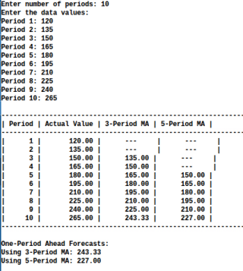

Program 9.Write a program to calculate standard statistical measures[Mean Error(ME),Mean Square Error(MSE)] using exponential forecasting method.
#include <stdio.h>
#include <math.h>
int main() {
int n, i;
double alpha;
printf("Enter number of periods: ");
scanf("%d", &n);
double actual[n], forecast[n];
printf("Enter the actual data values:\n");
for (i = 0; i < n; i++) {
printf("Period %d: ", i + 1);
scanf("%lf", &actual[i]);
}
printf("Enter smoothing constant (alpha between 0 and 1): ");
scanf("%lf", &alpha);
printf("Enter initial forecast (F1): ");
scanf("%lf", &forecast[0]);
double error[n], squaredError[n];
double ME = 0.0, MSE = 0.0;
for (i = 1; i < n; i++) {
forecast[i] = forecast[i - 1] + alpha * (actual[i - 1] - forecast[i - 1]);
}
for (i = 0; i < n; i++) {
error[i] = actual[i] - forecast[i];
squaredError[i] = error[i] * error[i];
ME += error[i];
MSE += squaredError[i];
}
ME /= n;
MSE /= n;
printf("\n-------------------------------------------------------------\n"); printf("| Period | Actual Value | Forecast | Error | Squared Error |\n"); printf("-------------------------------------------------------------\n"); for (i = 0; i < n; i++) {
printf("| %6d | %12.2lf | %8.2lf | %6.2lf | %13.2lf |\n",
i + 1, actual[i], forecast[i], error[i], squaredError[i]); }
printf("-------------------------------------------------------------\n"); printf("\nMean Error (ME) = %.4lf", ME);
printf("\nMean Square Error (MSE) = %.4lf\n", MSE);
double nextForecast = forecast[n - 1] + alpha * (actual[n - 1] - forecast[n - 1]); printf("\nOne-Period Ahead Forecast = %.4lf\n", nextForecast); return 0;
}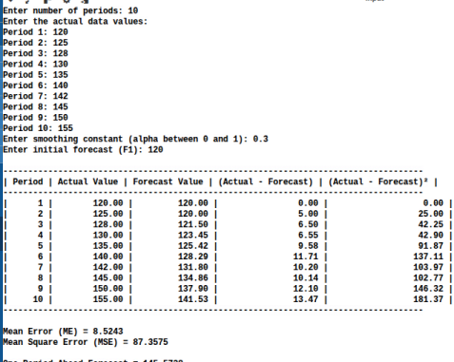

Program 10.Write a program to calculate relative measures of forecasting[ Percentage Error, Mean Percentage Error(MPE),Mean Absolute Percentage Error(MAPE)] using exponential forecasting method.
#include <stdio.h>
#include <math.h>
int main() {
int n, i;
double alpha;
printf("Enter number of periods: ");
scanf("%d", &n);
double actual[n], forecast[n];
printf("Enter the actual data values:\n");
for (i = 0; i < n; i++) {
printf("Period %d: ", i + 1);
scanf("%lf", &actual[i]);
}
printf("Enter smoothing constant (alpha between 0 and 1): ");
scanf("%lf", &alpha);
printf("Enter initial forecast (F1): ");
scanf("%lf", &forecast[0]);
double ME = 0.0, MPE = 0.0, MAPE = 0.0;
double error, percError, absPercError;
for (i = 1; i < n; i++) {
forecast[i] = forecast[i - 1] + alpha * (actual[i - 1] - forecast[i - 1]);
}
printf("\n----------------------------------------------------------------------------------------------\n");
printf("| Period | Actual Value | Forecast Value | Percentage Error (%%) | Absolute Percentage Error (%%) |\n");
printf("----------------------------------------------------------------------------------------------\n"); for (i = 0; i < n; i++) {
if (actual[i] != 0) {
error = actual[i] - forecast[i];
percError = (error / actual[i]) * 100.0;
absPercError = fabs(percError);
} else {
percError = absPercError = 0.0; // Avoid division by zero
}
MPE += percError;
MAPE += absPercError;
printf("| %6d | %13.2lf | %14.2lf | %21.2lf | %29.2lf |\n",
i + 1, actual[i], forecast[i], percError, absPercError);
}
printf("----------------------------------------------------------------------------------------------\n"); MPE /= n;
MAPE /= n;
printf("\nMean Percentage Error (MPE) = %.4lf%%", MPE);
printf("\nMean Absolute Percentage Error (MAPE) = %.4lf%%", MAPE);
double nextForecast = forecast[n - 1] + alpha * (actual[n - 1] - forecast[n - 1]); printf("\n\nOne-Period Ahead Forecast = %.4lf\n", nextForecast);
return 0;
}
Output:
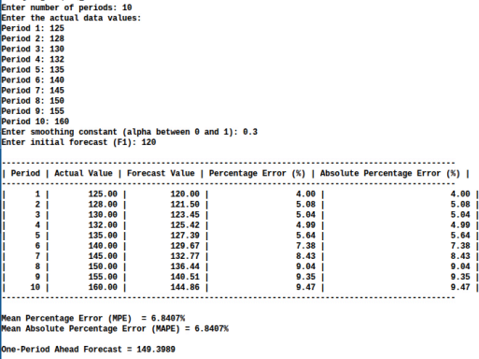

Program 11.Write a program to generate random numbers using mid square method. #include <stdio.h>
#include <math.h>
int main() {
long seed;
int n, i, digits;
printf("Enter initial seed (4-digit number recommended): ");
scanf("%ld", &seed);
printf("Enter number of random numbers to generate: ");
scanf("%d", &n);
printf("Enter number of digits in the seed: ");
scanf("%d", &digits);
printf("\n------------------------------------------------\n");
printf("| Iteration | Random Number (Normalized 0-1) |\n");
printf("------------------------------------------------\n");
for (i = 1; i <= n; i++) {
long squared = seed * seed;
int shift = (int)pow(10, digits/2); // Extract middle digits
seed = (squared / shift) % (int)pow(10, digits);
double randNum = (double)seed / pow(10, digits); // Normalize to [0,1] printf("| %9d | %28.6lf |\n", i, randNum);
}
printf("------------------------------------------------\n");
return 0;
}
Output:
