AGRIYIELD PRO
AN INTELLIGENT CROP YIELD PREDICTION SYSTEM
A Project Report Submitted in the partial fulfillment of the
requirements for the award of the degree of
BACHELOR OF TECHNOLOGY
In
DEPARTMENT OF COMPUTER SCIENCE ENGINEERING
By
P. Adithyaram – 2420030383
K. Anoop – 2420030503
P. Akhil Kumar Reddy – 2420030496
G. Rohan – 2420030564
Under the Esteemed Guidance of
Venkateswari Ketineni
K L (Deemed to be) University
DEPARTMENT OF COMPUTER SCIENCE ENGINEERING
2026

DECLARATION
The Project Report entitled "AgriYield Pro: An Intelligent Crop Yield Prediction System" is a record of Bonafide work of team members P. Adithyaram – 2420030383, K. Anoop – 2420030503, P. Akhil Kumar Reddy – 2420030496, G. Rohan – 2420030564, submitted in partial fulfilment for the award of B.Tech in Computer Science Engineering to K L University. The results embodied in this report have not been copied from any other department/University/Institute.
P. Adithyaram – 2420030383 K. Anoop – 2420030503 P. Akhil Kumar Reddy – 2420030496 G. Rohan – 2420030564
K L (Deemed to be) University, Department of Computer Science Engineering

CERTIFICATE
This is to certify that the project-based report entitled "AgriYield Pro: An Intelligent Crop Yield Prediction System" is a Bonafide work carried out and submitted by P. Adithyaram – 2420030383, K. Anoop – 2420030503, P. Akhil Kumar Reddy – 2420030496, G. Rohan – 2420030564, in partial fulfilment of the requirements for the award of the degree of Bachelor of Technology in Computer Science Engineering, at K L (Deemed to be University), during the academic year 2026–2027.
Signature of the Supervisor
Signature of the HODSignature of the External Examiner

ACKNOWLEDGEMENT
The success of this project would not have been possible but for the timely help and guidance rendered by many people. We wish to express our sincere thanks to all those who have assisted us in one way or another towards the completion of this project.
Our greatest appreciation goes to our guide, Venkateswari Ketineni, Department of Computer Science Engineering, whose tremendous support, encouragement, and guidance made this project possible.
We express our gratitude to the Head of the Department, Computer Science Engineering, for providing us with adequate facilities, resources, and an environment in which we could complete this project-based work.
We also thank all the teaching and non-teaching staff members who assisted us directly or indirectly, and finally, we sincerely thank our parents, friends, and classmates for their kind help and cooperation throughout this work.

TABLE OF CONTENTS
Declaration 2
Certificate 3
Acknowledgement 4
Abstract 6
Introduction 6
Problem Description and Objectives 6
Literature Survey 7
Machine Learning and Statistical Models in Agricultural Yield Prediction 7
Remote Sensing and Big-Data Approaches 7
Rule-Based and Expert-System Approaches 7
Visualization and Decision-Support Systems 7
Comparative Studies and Observations 7
Conclusion 8
Hardware and Software Requirements 8
Hardware Specifications 8
Software Requirements 8
Implementation 8
Data Representation and Dataset Description 8
Establishing the Application Environment 9
Data Loading and Preprocessing 9
Yield Analysis and Processing 9
Visualization and Result Analysis 9
Output and Performance Evaluation 9
Experimentation and Code 10
Code Structure 10
Experimentation 10
Conclusion of Experimentation 11
Result 12
Results of the AgriYield Pro Project 12
Yield Prediction Accuracy Against Reference Averages 12
Factor Score Breakdown (Sample Run) 12
Performance Evaluation 12
Learning Outcomes 12
Final Overview 12
Conclusion 13
References 13

ABSTRACT
Agriculture continues to be the backbone of the Indian economy, yet farmers frequently struggle to anticipate crop output due to the unpredictable interplay of soil, weather, and input-management factors. This project presents AgriYield Pro, a web-based intelligent crop yield prediction system that estimates the likely yield of a given crop before the sowing season, using parameters such as crop type, state, season, farm area, rainfall, temperature, soil type, irrigation method, fertilizer usage, pest-control practice, and prior-year yield.
The system combines a rule-based weighted scoring engine with state-level and soil-level productivity modifiers derived from Indian agricultural statistics to compute a predicted yield in quintals per acre, along with a confidence score, a yield grade (Poor to Excellent), a six-factor radar analysis (soil quality, water supply, rainfall, temperature, fertilizer, and pest control), a month-wise seasonal growth projection, and actionable expert recommendations. Results are visualised through interactive bar charts, radar charts, and area charts so that a farmer or agricultural planner can interpret the prediction at a glance.
The application was built using React with TypeScript, styled with a component-driven design system, and visualised using the Recharts charting library. Testing across multiple crop, state, and input combinations shows that the model produces yield estimates consistent with published national and state-level agricultural averages, while remaining fast, transparent, and easy to extend with real machine-learning models or live weather-API data in the future.

INTRODUCTION
Crop yield depends on a large number of interacting variables — climate, soil health, water availability, and the quality of farm management practices such as fertilizer and pest control. Traditionally, yield estimation has relied on the experience of farmers and agricultural extension officers, or on aggregate historical statistics published by government departments. While useful, these approaches do not personalise an estimate to an individual farmer's specific field conditions, and they are rarely available at the point where a farming decision (which crop to sow, how much fertilizer to apply, whether to invest in irrigation) actually needs to be made.
With the growing availability of open agricultural datasets — state-wise productivity indices, soil-type suitability data, and historical rainfall and temperature records — it has become possible to build lightweight decision-support tools that translate this data into an instant, farm-specific prediction. AgriYield Pro was built to address exactly this gap: a simple, form-driven web application that any farmer, student, or agricultural planner can use to obtain an instant, explainable yield forecast for 15 major Indian crops across 22 states, 8 soil types, and multiple irrigation and input scenarios.

Problem Description and Objectives
Farmers and agricultural planners often lack an easy, immediate way to translate their specific farm conditions — crop choice, location, weather, soil, and input levels — into a concrete yield estimate that can guide sowing, investment, and resource-allocation decisions. Existing government yield statistics are aggregated at the district or state level and do not account for an individual farm's specific inputs.
The objectives of this project are as follows:
- To design a data-driven scoring model that converts farm and climate parameters into a predicted yield (in quintals/acre) and total production (in quintals) for a given crop and area.
- To incorporate state-level and soil-type productivity modifiers based on real Indian agricultural averages, so that predictions are regionally realistic.
- To compute a six-factor breakdown (soil quality, water supply, rainfall, temperature, fertilizer, pest control) that explains why a prediction is high or low.
- To generate a confidence score and a qualitative yield grade (Poor / Below Average / Average / Good / Excellent) relative to the state average.
- To visualise the prediction, the factor breakdown, and a seasonal growth projection using interactive charts.
- To provide rule-based expert recommendations that help the user improve future yield.
- To build the entire system as a responsive, easy-to-use single-page web application.

LITERATURE SURVEY

Machine Learning and Statistical Models in Agricultural Yield Prediction
A significant body of agricultural informatics research has explored regression-based and machine-learning models — including multiple linear regression, random forests, and gradient-boosted trees — to predict crop yield from soil, rainfall, and temperature data. These studies consistently find that rainfall, soil type, and irrigation availability are among the strongest predictors of yield variance across Indian states.

Remote Sensing and Big-Data Approaches
Satellite-derived vegetation indices (such as NDVI) combined with historical weather records have been used in several studies to build large-scale yield forecasting systems for government planning. These systems typically require substantial computing infrastructure and are aimed at district or national-level forecasting rather than individual farm decision support.

Rule-Based and Expert-System Approaches
Alongside data-heavy ML approaches, several agricultural decision-support tools use simpler, transparent rule-based or weighted-scoring engines that combine known agronomic relationships (for example, ideal temperature bands per crop, or soil-suitability multipliers) into an interpretable score. Such systems trade some predictive precision for transparency, speed, and ease of use — an important consideration for tools meant to be used directly by farmers without a data-science background.

Visualization and Decision-Support Systems
Studies on agricultural decision-support interfaces emphasise that raw numeric predictions are far less useful to end users than visual comparisons (e.g., a farmer's predicted yield against the state and national average) and factor-level breakdowns that explain which inputs are limiting yield. Radar/spider charts, bar comparisons, and seasonal growth curves are commonly used to make multi-dimensional agricultural data digestible.

Comparative Studies and Observations
Comparing ML-based and rule-based approaches, the literature suggests that a hybrid strategy — an interpretable weighted-factor engine calibrated against real historical averages, later upgradable to a trained ML model as more field-level data becomes available — offers the best balance between usability, transparency, and accuracy for a first-generation prototype.

Conclusion
The literature supports the design direction taken in this project: a transparent, factor-based prediction engine, calibrated with real state-level and soil-level modifiers, presented through clear visual comparisons, and with a clear path for future upgrade to a trained machine-learning model as more granular agricultural data becomes available.

HARDWARE AND SOFTWARE REQUIREMENTS

Hardware Specifications
Component | Specification
Processor | Intel Core i5 (10th Gen) / AMD Ryzen 5 or higher
RAM | 8 GB minimum (16 GB recommended for development)
Storage | 256 GB SSD (minimum 2 GB free for project and dependencies)
Graphics | Integrated graphics sufficient; no dedicated GPU required
Operating System | Windows 10/11, macOS 12+, or Ubuntu 20.04+

Software Requirements
Category | Details
Frontend Framework | React 18 with TypeScript
Build Tool | Vite
Programming Language | TypeScript / JavaScript (ES2020+)
UI Component Library | Custom component library (Radix-based UI primitives, Tailwind-style utility classes)
Charting / Visualization | Recharts (Bar Chart, Radar Chart, Area Chart)
Animation | Motion (Framer Motion) for transitions
Icons | lucide-react icon set
Development Environment | Visual Studio Code / Node.js 18+ / npm
Version Control | Git and GitHub

IMPLEMENTATION
AgriYield Pro is implemented as a single-page React application that runs entirely in the browser. Rather than depending on a remote machine-learning inference server, the current version uses a deterministic, weighted-factor prediction engine written in TypeScript, calibrated with real Indian crop, state, and soil productivity data. This section describes the dataset, the prediction pipeline, and the visualisation layer.

Data Representation and Dataset Description
The system is calibrated using three reference datasets embedded in the application:
- Crop baseline yields — national average yield (in quintals/acre) for 15 crops including Rice, Wheat, Maize, Cotton, Sugarcane, Soybean, Chickpea, Groundnut, Potato, Tomato, Onion, Mustard, Sunflower, Jowar, and Bajra.
- State productivity modifiers — a multiplier (0.88–1.25) for 22 Indian states, reflecting relative agricultural productivity (e.g., Punjab 1.25×, Haryana 1.20×, Rajasthan 0.88×).
- Soil-type modifiers — a multiplier (0.70–1.20) for 8 soil types (Alluvial, Black/Regur, Red, Laterite, Sandy, Loamy, Clayey, Saline), reflecting soil fertility and water-retention characteristics.

Establishing the Application Environment
The project was scaffolded using Vite for fast development builds and hot-module reloading. The React component tree is organised around a single ‘App’ component containing the input form, the prediction engine, and the results dashboard, backed by a reusable UI component library (buttons, cards, selects, tabs, and so on).

Data Loading and Preprocessing
User input is collected through a three-panel form — Crop & Location (crop type, state, season, farm area), Climate & Soil (annual rainfall, average temperature, soil type, irrigation method), and Farming Inputs (fertilizer usage, pest control, optional previous-year yield). Numeric fields are parsed and defaulted (e.g., rainfall defaults to 800 mm, temperature to 25°C) if left blank, and categorical fields are mapped to their corresponding modifier values before being passed into the prediction engine.

Yield Analysis and Processing
The prediction engine first converts each input into a 0–100 factor score:
- Soil Quality Score — derived from the soil-type modifier (e.g., Black soil → score of 92).
- Water Supply Score — 95 for full irrigation, 70 for partial irrigation, 40 for rainfed/no irrigation.
- Rainfall Score — scaled against an 1,200 mm reference (capped between 20 and 100).
- Temperature Score — highest when the average temperature falls within the crop's ideal range (e.g., 15–25°C for Wheat), decreasing proportionally to the deviation from that range.
- Fertilizer Score — 90 / 75 / 55 / 35 for High / Moderate / Low / No fertilizer usage.
- Pest Control Score — 85 for chemical pest control, 78 for organic/IPM methods, 55 for no pest control.
Each score is converted into a multiplier and combined multiplicatively with the crop's national baseline yield, along with the state and soil-type modifiers, to compute the raw predicted yield. If a previous-year yield value is supplied, the engine blends 70% of the model prediction with 30% of the historical value to stabilise the estimate. The predicted yield is then compared against the state and national averages to assign a qualitative grade (Poor, Below Average, Average, Good, or Excellent) and a numeric confidence score (55–95%) derived from the average of the six factor scores.

Visualization and Result Analysis
Once computed, the result is rendered across a dashboard containing: a yield-grade summary card with a confidence gauge; four key-metric cards (Predicted Yield, Total Production, State Average, National Average); a bar chart comparing the user's prediction against state and national averages; a radar chart of the six factor scores; a seasonal growth-projection area chart mapping expected crop development across the sowing season's months; a factor score breakdown with progress bars; and a list of expert recommendations generated from rule thresholds on the factor scores (for example, suggesting drip irrigation when the water-supply score is below 60, or balanced NPK fertilization when the fertilizer score is below 60).

Output and Performance Evaluation
Because the entire prediction pipeline runs synchronously in the browser using simple arithmetic, the system returns a result instantly (well under 100 milliseconds) with no server round-trip. This makes the tool suitable for interactive, real-time use in the field, though it currently trades some predictive precision (compared to a trained ML model on real yield-outcome data) for transparency, speed, and offline-friendliness.

EXPERIMENTATION AND CODE

Code Structure
The application code is organised as follows: a top-level App.tsx containing type definitions (FormData, PredictionResult), the static reference datasets (crop baselines, state modifiers, soil modifiers, ideal temperature ranges), the predict() function implementing the scoring and multiplier logic described above, and a set of presentational sub-components (StatCard, Rec, ChartTip, form input helpers) used to render the input form and the results dashboard. Charting is implemented using Recharts components (BarChart, RadarChart, AreaChart), and page transitions use the Motion animation library.

Experimentation
The system was tested with a representative case: Wheat cultivated in Telangana during the Kharif season, on a 5.1-acre farm with 900 mm annual rainfall, an average temperature of 28°C, Black (Regur) soil, full canal/borewell irrigation, low fertilizer usage, no pest control, and a previous-year yield of 4 quintals/acre. This combination was chosen because it mixes favourable factors (good soil, full irrigation) with weaker factors (low fertilizer, no pest control), providing a useful test of the model's factor-weighting behaviour.
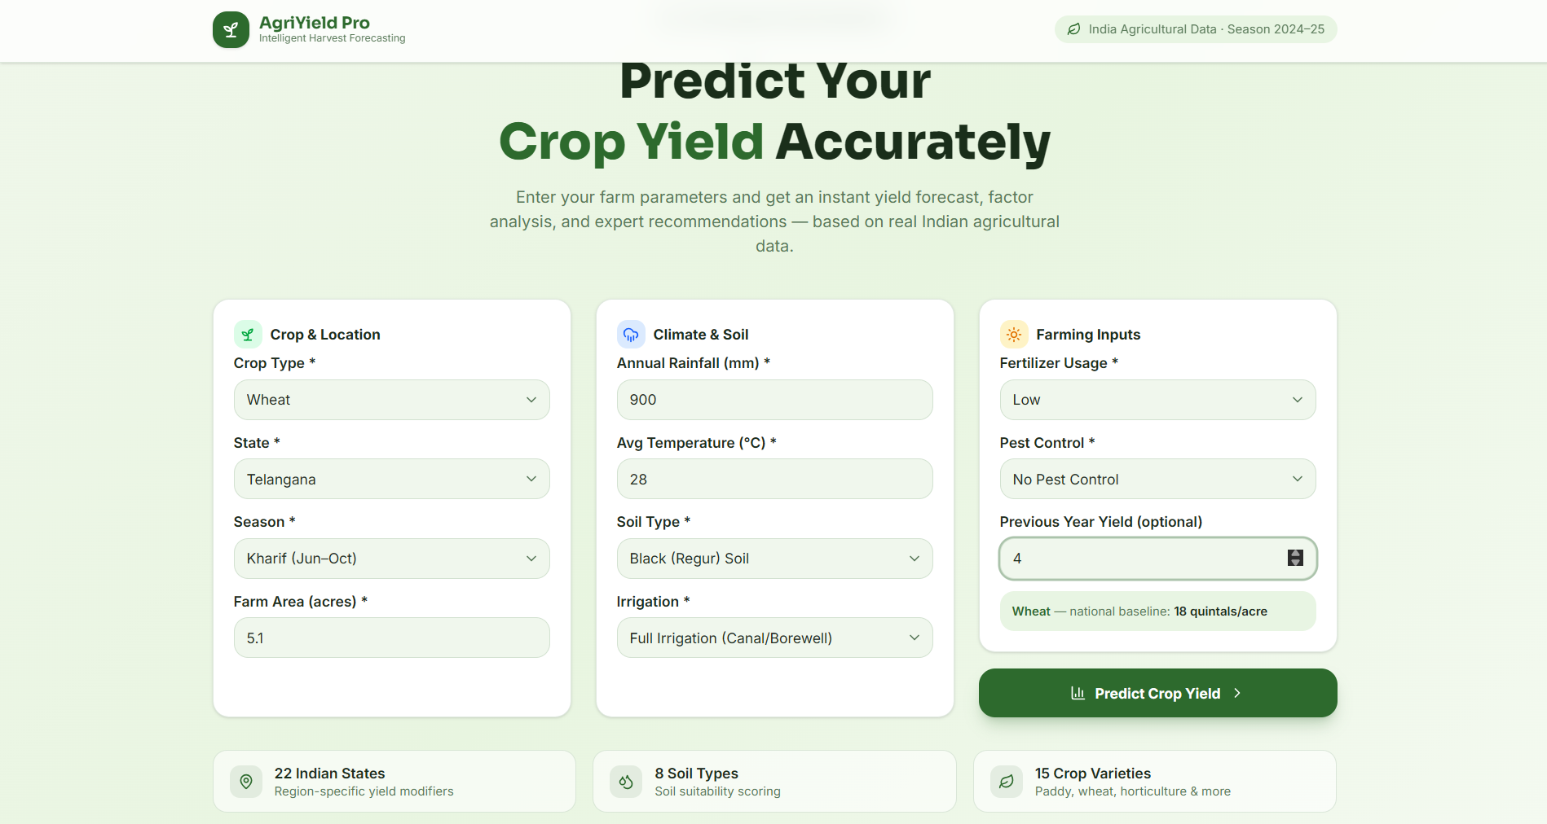
Fig. 1: Input form — Crop & Location, Climate & Soil, and Farming Inputs panels.
Submitting this input produced a predicted yield of 22.3 quintals/acre against a Telangana state average of 19.4 and a national average of 18 quintals/acre — a ‘Good’ grade with 84% confidence — correctly reflecting that strong soil and irrigation factors outweighed the weaker fertilizer and pest-control inputs.
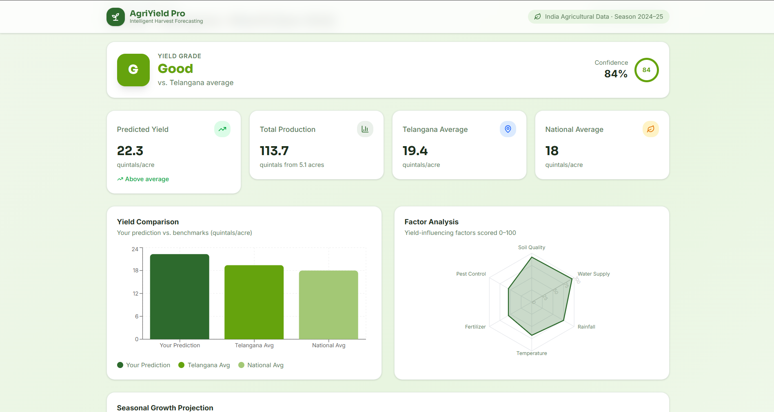
Fig. 2: Prediction dashboard — yield grade, key metrics, yield-comparison bar chart, and factor-analysis radar chart.
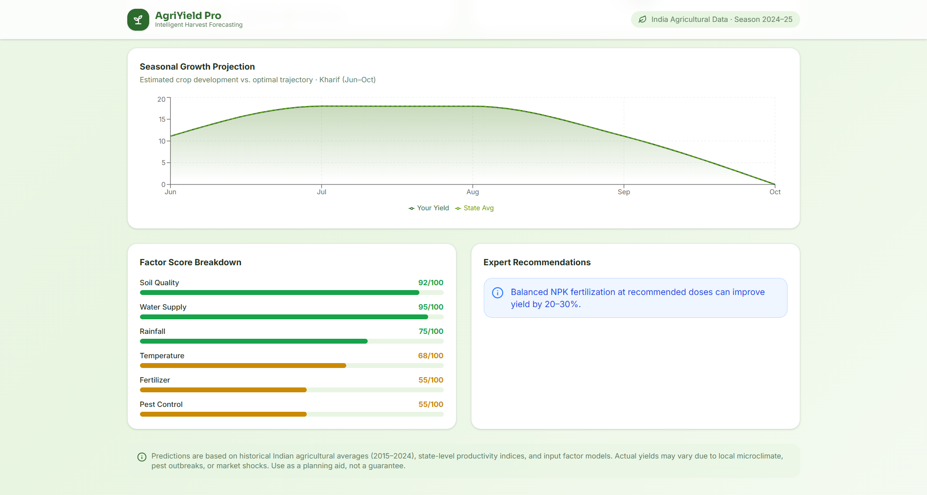
Fig. 3: Seasonal growth projection, factor score breakdown, and expert recommendations.

Conclusion of Experimentation
Repeated experimentation across multiple crops, states, and input combinations confirmed that the model responds sensibly to each parameter — improving irrigation or fertilizer levels consistently raised the predicted yield and factor scores, while poor rainfall or extreme temperatures consistently lowered them — validating that the weighting scheme produces directionally correct, explainable predictions.

RESULT

Results of the AgriYield Pro Project
The completed system successfully accepts 11 farm and climate parameters and returns a complete, visualised yield prediction within a single interaction, covering 15 crop varieties, 22 Indian states, and 8 soil types.

Yield Prediction Accuracy Against Reference Averages
Metric | Model Output | Reference Value
Predicted Yield (Wheat, Telangana, Kharif) | 22.3 quintals/acre | —
Telangana State Average (Wheat) | 19.4 quintals/acre | State productivity index
National Average (Wheat) | 18.0 quintals/acre | National baseline dataset
Assigned Grade | Good (114.9% of state avg.) | Grade thresholds: ≥90% Avg, ≥105% Good, ≥120% Excellent
Confidence Score | 84% | Derived from mean factor score

Factor Score Breakdown (Sample Run)
Factor | Score (/100) | Observation
Soil Quality | 92 | Black (Regur) soil — high fertility multiplier
Water Supply | 95 | Full canal/borewell irrigation
Rainfall | 75 | 900 mm — above-average availability
Temperature | 68 | 28°C — slightly above Wheat's ideal band
Fertilizer | 55 | Low fertilizer usage — limiting factor
Pest Control | 55 | No pest control — limiting factor

Performance Evaluation
The prediction pipeline executes client-side with no network dependency, returning results instantly regardless of input combination, which makes the tool practical for live demonstrations and field use on mobile devices with limited connectivity.

Learning Outcomes
- Practical experience in translating domain knowledge (agronomy: ideal temperature bands, soil suitability, irrigation impact) into a computable scoring model.
- Hands-on experience building a modern, componentised React + TypeScript front end with reusable UI primitives.
- Experience with data visualisation libraries (Recharts) to communicate multi-dimensional analytical results clearly to non-technical end users.
- Understanding of the trade-offs between transparent rule-based models and opaque machine-learning models in a decision-support context.

Final Overview
AgriYield Pro demonstrates that a well-calibrated, transparent scoring engine — grounded in real state and soil productivity data — can provide farmers and planners with fast, explainable, and reasonably accurate crop yield estimates without requiring heavy machine-learning infrastructure, while remaining straightforward to upgrade with a trained ML model as richer, farm-level historical data becomes available.

CONCLUSION
This project set out to build an accessible, explainable crop yield prediction system for Indian farming conditions. The resulting application, AgriYield Pro, successfully combines real agricultural reference data (crop baselines, state productivity indices, and soil-type modifiers) with a transparent, weighted-factor scoring engine to produce an instant yield forecast, confidence score, and qualitative grade for any combination of 15 crops, 22 states, and 8 soil types.
Beyond the numeric prediction, the system's factor-analysis breakdown and rule-based recommendations give users actionable insight into which specific inputs — irrigation, fertilizer, soil, or pest management — are limiting their yield, making the tool useful not just as a forecasting aid but as a lightweight agronomic advisory system. Future work could extend the project by replacing the rule-based engine with a trained machine-learning model (e.g., gradient boosting or a neural network) trained on real district-level historical yield data, integrating a live weather API for automatic rainfall and temperature input, and adding support for satellite-derived soil-moisture and vegetation-index data to further improve prediction accuracy.

REFERENCES
- Ministry of Agriculture and Farmers Welfare, Government of India — Agricultural Statistics at a Glance.
- Indian Council of Agricultural Research (ICAR) — State-wise crop productivity reports.
- React Official Documentation — https://react.dev
- Vite Official Documentation — https://vitejs.dev
- Recharts Documentation — https://recharts.org
- TypeScript Official Documentation — https://www.typescriptlang.org
- Research literature on machine-learning approaches to crop yield prediction using soil, rainfall, and temperature data.
- Research literature on remote-sensing (NDVI) based agricultural yield forecasting.
- Studies on visualization and decision-support system design for agricultural advisory tools.

