Q1. Deploy a website on localhost using either apache2 or Nginx. Create a DNS name for this website as ‘awesomeweb’. You can use any web template you want or can write your own simple HTML code.

1. Having the Windows as my base OS, I have installed the nginx server in my local machine.
2. Unzipped the nginx setup file.
3. Installed the nginx server and run command start nginx sand accessed the localhost on port 80.
4. After accessing it, I got the nginx webpage as shown below.

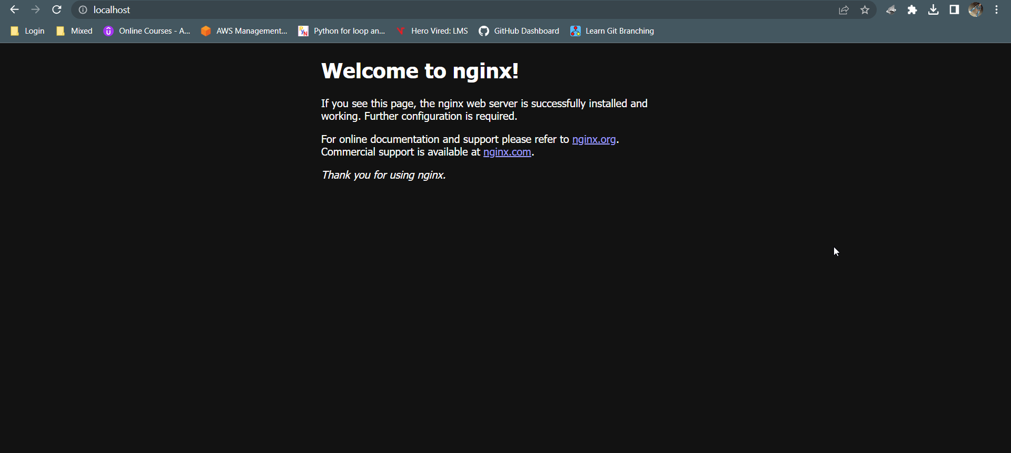

1. There is a html folder created when installed the nginx. So I changed some code in that html file and added the background image after downloading it from internet and kept it in the same html folder.
2. Added the line for applying the background image background-image: url('ocean-3605547_1920.jpg'); under body tag.
3. Also, I changed the text in heading and the body as well as colour of the fonts.   
     
   <h1><p style="color:orange">Welcome to Rohan's website!</p></h1>

<p style="color:orange">If you see this page, the website is working and fully functional.</p>

1. I have also given the name to localhost as awesomeweb.com and made the entry for 127.0.0.1 [www.awesomeweb.com](http://www.awesomeweb.com) in /etc/hosts file. So that when I access the awesomeweb.com I was getting the page created by me ussing nginx.
2. Please checkout the below image for the website. We can access the website by http://www.awesomeweb.com.



Q2: A website can have many subdomains and different services are running on them. Write a Python script to check the status of the subdomains which are up or down. The script should automatically check the status every minute and should update it in tabular format on the screen.

* I have created a script for checking the subdomains for a particular domain like google.com.
* I have imported requests library which checks the HTTP requests. So the logic is if we get the status code as 200 then it will show the URL otherwise it will pass.
* So I have created one file named subdomains.txt in which I entered multiple subdomains and it will check them one by one whether google.com has that subdomain or not.
* If it gets 200 error code then it will print the URL as an output.