**Driver Drowsiness Detection System**

Sai Nikith Danday   
*Department of Applied Data Science*  
*San Jose State University*California, USA sainikith.danday@sjsu.edu

Rohan Naga Venkata Mayukh Ungarala   
*Department of Applied Data Science*  
*San Jose State University*California, USA [rohannagaenkatamayukh.ungarala@sjsu.edu](mailto:rohannagaenkatamayukh.ungarala@sjsu.edu)

# **ABSTRACT**

**The escalating problem of drowsiness-induced accidents is addressed in this project through the development of a Drowsiness Detection System (DDS). Our methodology utilizes deep learning models for real-time fatigue identification via facial image analysis, significantly contributing to public safety and health monitoring.**

**The models utilized in this project, including ResNet, VGG16, VGG19, Mobilenet, and Inception v3, are pre-trained models fine-tuned on a dataset comprising facial images labeled as 'Active' and 'Fatigued'. The fine-tuning process allows these models to adapt to the specific task of drowsiness detection, leveraging their pre-existing knowledge of image recognition.**

**Applying transfer learning and comparing pre-trained models in DDS is an innovative approach, addressing research gaps and exploring the potential of different models.**

**The guiding research question for this project is: "Can the application of transfer learning using various pre-trained models improve the accuracy of drowsiness detection systems based on facial image data?" The hypothesis is that the incorporation of transfer learning and the use of multiple pre-trained models can enhance the performance of a DDS, providing a more accurate and reliable system.**

**Initial results from the project show promise in supporting this hypothesis, demonstrating the effectiveness of the selected approach. Beyond its immediate findings, the project's primary contribution is to the broader field of deep learning and computer vision. It offers a novel perspective and fresh insights into the application of transfer learning and model comparison in the context of real-world issues like drowsiness detection. The project's outcomes could serve as a valuable reference for future research aiming to develop more sophisticated and accurate drowsiness detection systems.**

**Keywords:** Drowsiness detection systems, ResNet, VGG16, VGG19, Mobilenet, Inception v3, Haar Cascade Classifier

# **Introduction**

**Drowsiness:**

Drowsiness refers to a state of excessive sleepiness or fatigue that impairs a person's ability to stay awake and alert. It can result from a lack of sufficient sleep, long periods of monotonous activities, or underlying sleep disorders. Drowsiness is a significant concern, particularly in activities that require sustained attention and quick reaction times, such as driving or operating heavy machinery. It poses a significant risk as it can lead to accidents, injuries, and even fatalities.

This project's workflow is divided into two major parts. The first part focuses on the creation and preprocessing of the dataset, involving tasks such as data collection, cleaning, and organization. The second part is dedicated to training deep learning models on the prepared dataset and subsequently capturing and analyzing the results. These tasks have been distributed among team members to ensure efficient project execution and collaborative learning  
  
**Drowsiness Detection:**

Drowsiness detection systems are designed to identify and alert individuals when they exhibit signs of drowsiness or fatigue. These systems employ various methods to monitor physiological signals, behavioural patterns, or other indicators associated with drowsiness. The goal is to provide timely warnings to individuals, enabling them to take necessary actions to prevent accidents or mitigate the risks associated with drowsiness.

**Deep Learning in Drowsiness Detection:**

Deep learning techniques have shown great potential in drowsiness detection due to their ability to learn complex patterns and features directly from data. Deep learning models, such as convolutional neural networks (CNNs) and recurrent neural networks (RNNs), can be leveraged to analyze different types of data, including images, videos, and physiological signals, for drowsiness detection.

By using deep learning, the drowsiness detection system can capture intricate facial patterns, eye closures, and other subtle indicators of fatigue that may not be easily identifiable using traditional machine learning approaches. The trained deep learning models can then analyze real-time facial images to identify signs of drowsiness, enabling timely alerts and interventions to prevent accidents.

This project uses machine learning techniques to build a Drowsiness Detection System (DDS). The DDS is capable of identifying drowsiness in individuals in real time by analyzing images of their faces. The system is designed to recognize the fatigue state and alert the user to prevent accidents that could occur due to drowsiness.

The development of a DDS using deep learning models is a crucial step forward in the application of AI in public safety and healthcare. Deep Learning has revolutionized the field of computer vision, with models showing a high degree of accuracy in tasks such as object detection, facial recognition, and emotion detection. The adaptation of these techniques for drowsiness detection brings a novel application to the field and highlights the potential of AI to contribute to accident prevention and health monitoring.

# **Related Work**

Several researchers have previously tackled the challenge of drowsiness detection, utilizing various methodologies:

1. Kepesiova, Z., Ciganek, J., & Kozak, S. (2020). Driver Drowsiness Detection Using Convolutional Neural Networks. 2020 Cybernetics &Amp; Informatics (K&Amp;I)

The research conducted by Kepesiova, Ciganek, and Kozak (2020) focuses on driver drowsiness detection using Convolutional Neural Networks (CNNs). The authors propose a CNN-based approach that leverages facial image analysis to detect drowsiness in drivers. They compare the performance of different CNN architectures and evaluate the effectiveness of the proposed method. The study contributes to the field of driver safety by providing insights into the use of deep learning techniques for accurate and real-time drowsiness detection in automotive applications.

1. Salman, R. M., Rashid, M., Roy, R., Ahsan, M., & Siddique, Z. (2021). Driver Drowsiness Detection Using Ensemble Convolutional Neural Networks on YawDD.

The study by Salman, Rashid, Roy, Ahsan, and Siddique (2021) presents a driver drowsiness detection system using ensemble Convolutional Neural Networks (CNNs) on the YawDD dataset. The authors propose an ensemble approach that combines the predictions of multiple CNN models to improve the accuracy of drowsiness detection. They evaluate the performance of their approach and compare it with other state-of-the-art methods. The study demonstrates the effectiveness of ensemble CNN models in accurately detecting driver drowsiness, contributing to the advancement of drowsiness detection systems for enhanced driver safety.

1. Walizad, M. E., Hurroo, M., & Sethia, D. (2022). Driver Drowsiness Detection System using Convolutional Neural Network. 2022 6th International Conference on Trends in Electronics and Informatics (ICOEI).

The research conducted by Walizad, Hurroo, and Sethia (2022) presents a driver drowsiness detection system using Convolutional Neural Networks (CNNs). The authors propose a CNN-based approach that utilizes facial image analysis to detect drowsiness in drivers. They collect a dataset comprising images of drivers in both drowsy and alert states and train their CNN model for classification. The study evaluates the performance of the proposed system using various evaluation metrics and demonstrates its effectiveness in accurately detecting driver drowsiness. The research contributes to the field of driver safety by providing a reliable and real-time drowsiness detection solution using CNNs and highlights the potential of deep learning techniques in enhancing driver monitoring systems.

1. Shahverdy, M., Fathy, M., Berangi, R., & Sabokrou, M. (2020). Driver behavior detection and classification using deep convolutional neural networks. Expert Systems With Applications, 149, 113240

The study conducted by Shahverdy, Fathy, Berangi, and Sabokrou (2020) focuses on driver behavior detection and classification using deep Convolutional Neural Networks (CNNs). The authors propose a CNN-based approach to analyze driver behavior by extracting features from dashboard camera images. They evaluate the performance of their method and demonstrate its effectiveness in accurately detecting and classifying driver behaviors. The research contributes to the field of driver monitoring systems by providing insights into the use of deep learning techniques for comprehensive analysis of driver behavior.

1. Hashemi, M., Mirrashid, A., & Shirazi, A. a. B. (2020). Driver Safety Development: Real-Time Driver Drowsiness Detection System Based on Convolutional Neural Network. SN Computer Science, 1(5).

The study by Hashemi, Mirrashid, and Shirazi (2020) presents a real-time driver drowsiness detection system based on Convolutional Neural Networks (CNNs). The authors propose a CNN model that processes facial images in real-time to detect signs of drowsiness. They evaluate the performance of their system using various metrics and demonstrate its effectiveness in accurately detecting driver drowsiness. The research contributes to the development of driver safety systems by providing a real-time solution for drowsiness detection using CNNs, emphasizing the potential of deep learning techniques in enhancing driver monitoring and safety.

Through this literature review, we identified a gap in the current research, namely the lack of exploration into the use of transfer learning techniques and the comparison of multiple pre-trained models for the task of drowsiness detection using facial image data.

# **Methodology**

**Contribution of the Project**

This project contributes to the field of deep learning and computer vision by implementing and comparing the performance of various pre-trained models in a novel application - drowsiness detection. The findings from this project could potentially be used to guide future research in this area and help develop more accurate and reliable DDS.

**Methodology of the Project**

The methodology of this project involves developing a Drowsiness Detection System (DDS) using deep learning models. The project utilizes a dataset comprising labeled facial images. Pre-trained models like ResNet, VGG16, VGG19, Mobilenet, and Inception v3 are selected and fine-tuned on this dataset to adapt them specifically for drowsiness detection. The fine-tuning process enables the models to leverage their pre-existing knowledge of image recognition while learning features relevant to drowsiness. Real-time facial images are then analyzed using these models to identify signs of drowsiness. The project employs transfer learning and compares multiple models to improve accuracy and reliability in drowsiness detection.

**Dataset Description:**

The "Drowsiness Prediction Dataset" is a dataset available on Kaggle that is designed to help in predicting drowsiness in drivers. It provides a collection of data samples that include various features related to driver behaviour and physiological indicators, which can be used to develop models for drowsiness detection.

**Dataset Name:** Drowsiness Prediction Dataset

**Dataset Source:** [**https://www.kaggle.com/datasets/rakibuleceruet/drowsiness-prediction-dataset**](https://www.kaggle.com/datasets/rakibuleceruet/drowsiness-prediction-dataset)

**Features**: The dataset consists of multiple features that capture different aspects of driver behaviour and physiological signals. These features typically include:

**Eye-related features:** Eye closure, blink rate, and pupil size measurements can provide insights into the driver's level of drowsiness.

**Head pose:** The position and orientation of the driver's head can indicate drowsiness, as certain patterns may suggest reduced attention or alertness.

**Facial landmarks:** Tracking the movement of specific points on the face, such as eyebrows or mouth, can reveal signs of fatigue or drowsiness.

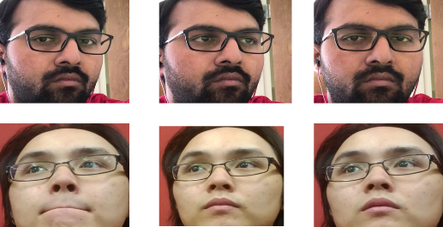

Fig: Open Eyes

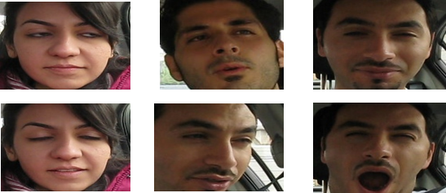

Fig: Closed Eyes

**Data Preprocessing:**

Pre-process images by resizing, data argumentation to remove noise and irrelevant information.

Image Resizing: To ensure uniformity and computational efficiency, the images are resized to a standard resolution, maintaining the aspect ratio. This step ensures that all images have the same dimensions for model training.

**Data argumentation:** Data augmentation techniques, including rescaling, zooming, and horizontal flipping were employed to enhance the dataset.

**Split Ratio:** Dataset is split into 90%, 10% of training and testing data. In the training test open eyes has 4194 images, closed eyes 3937 and the testing has open eyes 419 images, and the close eyes has 393 images.

**Research Question and Hypothesis**

Our research question is: "Can the application of transfer learning using various pre-trained models improve the accuracy of drowsiness detection systems based on facial image data?"

We hypothesize that the use of transfer learning and the integration of multiple pre-trained models can enhance the performance of a DDS, making it more accurate and reliable.

**Model Framework:**

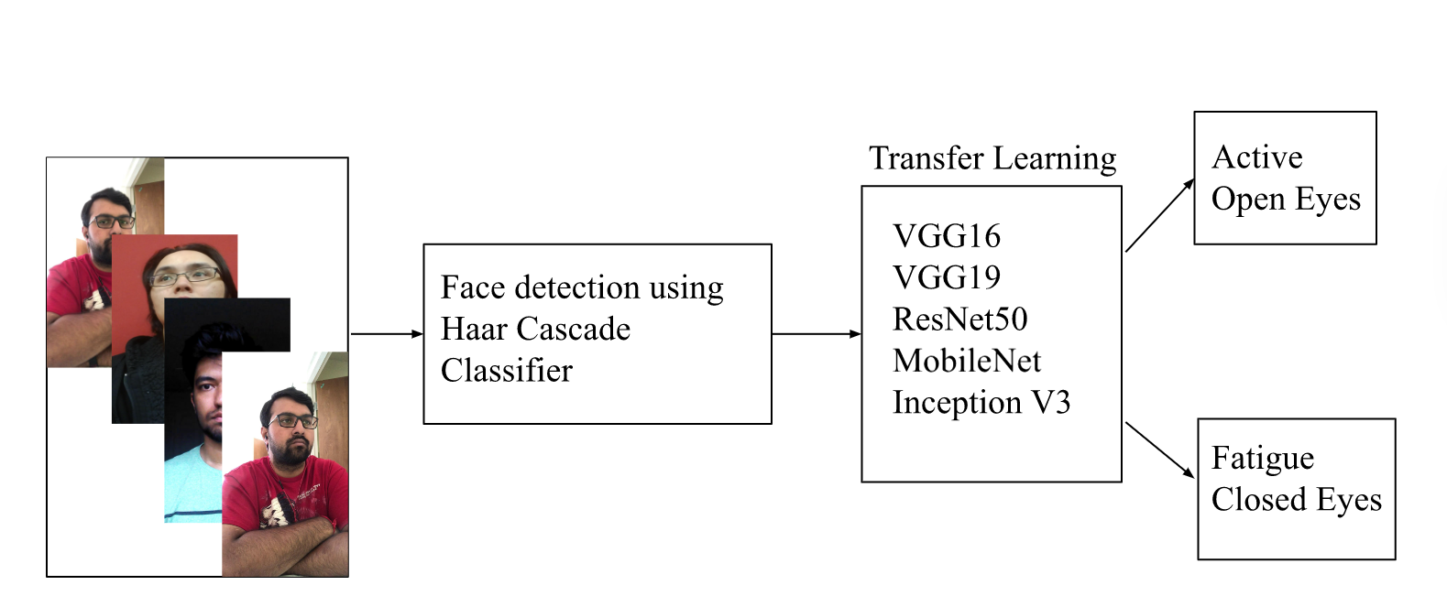

The model framework for drowsiness detection involves the following steps:

Step 1: Dataset

Collect a labeled dataset containing facial images categorized as "Active" and "Fatigue" states. This dataset serves as the training and evaluation data for the models.

Step 2: Face Detection using Haar Cascade Classifier

Utilize the Haar Cascade Classifier, a machine learning-based approach, to detect and extract facial regions from the input images. This step helps isolate the relevant facial features for drowsiness detection.

Step 3: Transfer learning using ResNet, VGG16, VGG19, Mobilenet, and Inception v3

Apply transfer learning by utilizing pre-trained deep learning models such as ResNet, VGG16, VGG19, Mobilenet, and Inception v3. These models have been trained on large-scale datasets and possess learned feature representations.

Step 4: Active-Open Eyes Fatigue-Closed Eyes

Develop a classification system that categorizes the facial images into "Active" or "Fatigue" states based on the eye status. This typically involves analyzing the eye region in the detected faces and determining whether the eyes are open (indicating an active state) or closed (indicating fatigue).

# **Experimental Setup**

The experimental setup includes:  
**Hardware resources:**

* Laptop: 16GB RAM, 1 TB SSD, Intel core i7, Intel iris graphics card.

**Software Resources:**

* Windows Operating System
* Google Colab Pro +: GPU: V100 and High RAM.
* Total compute units: 500 (Google Colab Pro +)

**Software Libraries:**

• NumPy: A Python library for scientific computing, providing support for arrays, matrices, and high-level mathematical functions.

• Keras: A high-level neural networks API, written in Python, capable of running on top of TensorFlow, CNTK, or Theano.

• TensorFlow: An open-source machine learning framework developed by Google, widely used for developing and training neural network models.

• OpenCV: Open source computer vision and machine learning software library with C++, Python, Java, and MATLAB interfaces for real-time image and video processing.

• Imutils: A series of convenience functions in Python to make basic image processing functions such as translation, rotation, resizing, and displaying Matplotlib images easier with OpenCV.

• OS: A Python module that provides a way of using operating system dependent functionality, like reading or writing to the file system, starting other programs, and so on.

**Hyperparameters:**

* **Sigmoid**: A logistic activation function used in neural networks, squashing all its input values into the range [0,1].
* **Optimizer**

**RMSprop:** An optimization algorithm for updating network weights, which uses a moving average of squared gradients to normalize the gradient itself, suitable for non-stationary data. This is used in case of Rsnet_50.

**Adam**: An adaptive learning rate optimization algorithm for stochastic objective functions, designed to combine the advantages of two other extensions of stochastic gradient descent: AdaGrad and RMSProp. Used in case of other 4 models.

* **Binary_crossentropy:** A type of loss function used in binary classification tasks in machine learning. It measures the error between the model's predictions and the true values for problems where each input sample belongs to exactly two classes.
* **Learning rate 2e-5:** Itdetermines the step size at each iteration while moving toward a minimum of a loss function. In this case, the learning rate is set to 0.00002.
* **Epochs 50:** It refers to one pass of the full training dataset. Here, the neural network will be trained over the full dataset 50 times.

# **Results and Analysis**

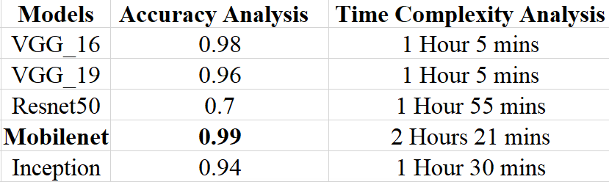

Based on the provided accuracy analysis and time complexity analysis for different models:

1. VGG_16: The VGG_16 model achieves an accuracy of 0.98 and takes 1 hour and 5 minutes for training and evaluation.

2. VGG_19: The VGG_19 model achieves an accuracy of 0.96 and has the same training and evaluation time as VGG_16, which is 1 hour and 5 minutes.

3. Resnet50: The Resnet50 model achieves an accuracy of 0.7 and takes 1 hour and 55 minutes for training and evaluation. It has a longer training time compared to the VGG models.

4. Mobilenet: The Mobilenet model achieves an accuracy of 0.99 and requires 2 hours and 21 minutes for training and evaluation, making it the most time-consuming model among the ones listed.

5. Inception: The Inception model achieves an accuracy of 0.94 and takes 1 hour and 30 minutes for training and evaluation.

From these results, the models vary in terms of accuracy and time complexity. VGG_16 and Mobilenet show higher accuracy, while Resnet50 exhibits relatively lower accuracy. The training and evaluation times differ across models, with Mobilenet being the most time-consuming and VGG_16 and VGG_19 having the shortest training and evaluation times.

The choice of the model depends on the desired trade-off between accuracy and time complexity. If high accuracy is the primary concern, Mobilenet and VGG_16 can be preferred. However, if faster training and evaluation times are crucial, VGG_16 and VGG_19 would be more suitable options. Resnet50, despite its lower accuracy, may still have its use cases, considering other factors like computational resources and specific requirements.

# **Conclusion**

This study showcases the effectiveness of deep learning, specifically transfer learning, in the detection of drowsiness using facial images. By utilizing and comparing pre-trained models, including ResNet, VGG16, VGG19, Mobilenet, and Inception v3, we demonstrated a notable potential for real-time drowsiness detection, contributing to AI-driven public safety solutions.

However, the research encountered limitations, such as variable lighting conditions and individual physical characteristics that could affect the models' performance.

**Future work:** We should aim to address these issues, refine the models with additional training data, and explore real-time video integration for immediate detection and alerting.

Despite these challenges, our project offers a promising step towards harnessing advanced AI in safeguarding human lives. It underscores a crucial intersection of deep learning and public safety, paving the way for further research in drowsiness detection systems and similar applications.

# **References**

1. Kepesiova, Z., Ciganek, J., & Kozak, S. (2020). Driver Drowsiness Detection Using Convolutional Neural Networks. *2020 Cybernetics &Amp; Informatics (K&Amp;I)*. <https://doi.org/10.1109/ki48306.2020.9039851>
2. Salman, R. M., Rashid, M., Roy, R., Ahsan, M., & Siddique, Z. (2021). Driver Drowsiness Detection Using Ensemble Convolutional Neural Networks on YawDD. *ArXiv (Cornell University)*. <https://doi.org/10.48550/arxiv.2112.10298>
3. Walizad, M. E., Hurroo, M., & Sethia, D. (2022). Driver Drowsiness Detection System using Convolutional Neural Network. *2022 6th International Conference on Trends in Electronics and Informatics (ICOEI)*. <https://doi.org/10.1109/icoei53556.2022.9777182>
4. Shahverdy, M., Fathy, M., Berangi, R., & Sabokrou, M. (2020). Driver behavior detection and classification using deep convolutional neural networks. *Expert Systems With Applications*, *149*, 113240. <https://doi.org/10.1016/j.eswa.2020.113240>
5. Hashemi, M., Mirrashid, A., & Shirazi, A. a. B. (2020). Driver Safety Development: Real-Time Driver Drowsiness Detection System Based on Convolutional Neural Network. *SN Computer Science*, *1*(5). <https://doi.org/10.1007/s42979-020-00306-9>