# ABSTRACT

India is mainly an agricultural country. Agriculture is the most important occupation for most Indian families. It plays a vital role in the development of the agricultural country. In India, agriculture contributes about 16% of total GDP and 10% of total exports. Water is the main resource for Agriculture. Irrigation is one method to supply water but in some cases, there will be a lot of water wastage. So, in this regard to save water and time we have proposed a project titled automatic irrigation system using IoT. In this proposed system we are using various sensors like temperature, humidity, soil moisture sensors which sense the various parameters of the soil, and based on soil moisture value land gets automatically irrigated by ON/OFF of the motor. These sensed parameters and motor status will be displayed on the user android application.

**KEYWORDS:** Internet of things (IoT), Arduino, Temperature sensor, Soil moisture sensor, And Humidity sensor.

# INTRODUCTION

Agriculture is the major source of income for the largest population in India and is a major contributor to the Indian economy. However, technological involvement and its usability have to be grown still and cultivated for the agro sector in India. Although few initiatives have also been taken by the Indian Government for providing online and mobile messaging services to farmers related to agricultural queries and agro vendor’s information to farmers. Based on the survey it is observed that agriculture contributes 27% to GDP, and Employs 70% of the Indian population.

IoT is changing the agriculture domain and empowering farmers to fight the huge difficulties they face. Agriculture must overcome expanding water deficiencies, restricted availability of lands while meeting the expanding consumption needs of a world population. New innovative IoT applications are addressing these issues and increasing the quality, quantity, sustainability, and cost-effectiveness of agricultural production.

Agriculture is the backbone of the Indian Economy. In today’s world, as we see rapid growth in the global population, agriculture becomes more important to meet the needs of the human race. However, agriculture requires irrigation and with every year we have more water consumption than rainfall, it becomes critical for growers to find ways to conserve water while still achieving the highest yield. But in the present era, the farmers have been using irrigation techniques through manual control in which they irrigate the land at the regular interval.

The Internet of Things (IoT) is a technology wherein a mobile device can be used to monitor the function of a device. The Internet of Things (IoT) is concerned with interconnecting communicating objects that are installed at different locations that are possibly distant from each other. Internet of Things (IoT) is a type of network technology, which senses the information from different sensors and makes anything to join the Internet to exchange information.

The proposed system has been designed to overcome the unnecessary water flow into the agricultural lands. Temperature, moisture, and humidity readings are continuously monitored by using temperature, moisture, and humidity sensor and sending these values to the assigned IP address. The android application continuously collects the data from that assigned IP address. Once the soil moisture values are exceeded the particular limit then the relay, which is connected to the Arduino microcontroller controls the

motor. The android application is a simple menu-driven application, with 4 options. This includes motor status, moisture, temperature, and humidity values. The motor status indicates the current status of the pump.

# LITERATURE SURVEY

The primary investigation is carried out under the following stages, such as Understanding the existing approaches, Understanding the requirements, developing an abstract for the system.

In this paper, soil moisture sensor, temperature, and humidity sensors are placed in the root zone of the plant and transmit data to the android application. The threshold value of the soil moisture sensor was programmed into a microcontroller to control water quantity. Temperature, humidity, and soil moisture values are displayed on the android application.

This paper on "Automatic Irrigation System on Sensing Soil Moisture Content" is intended to create an automated irrigation mechanism that turns the pumping motor ON and OFF on detecting the dampness content of the earth. In this paper, only soil moisture value is considered but the proposed project provided an extension to this existing project by adding temperature and humidity values.

This proposed paper is Arduino based remote irrigation system developed for the agricultural plantation, which is placed at the remote location and required water provides for plantation when the humidity of the soil goes below the set-point value. But in this, we did not aware of the soil moisture level so to overcome this drawback proposed system included with extra feature soil moisture value and temperature value which displayed on the farmer mobile application temperature, humidity, and soil moistures.

# OBJECTIVE OF THE PROJECT

The main objective of this project is to provide an automatic irrigation system thereby saving time, money & power for the farmer. The traditional farm-land irrigation techniques require manual intervention. With the automated technology of irrigation, human intervention can be minimized.

# PROPOSED SYSTEM

The below Figure 3.1 is an overall block diagram of an Arduino-based automatic irrigation system which consists of three sensors that are connected to the controller and sensed values from these sensors are sent to the mobile application.

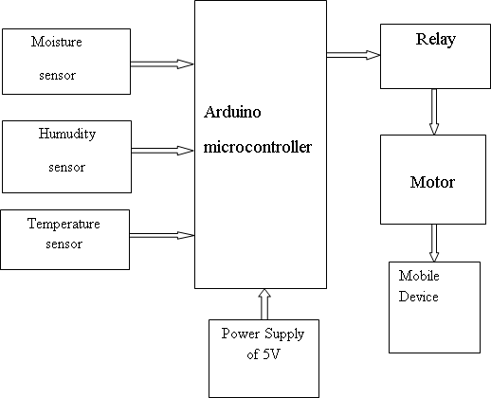

# Figure 3.1: Block Diagram of Automatic Irrigation System

Figure 3.1 shows the block diagram of a smart irrigation system with IoT. Farmers start to utilize various monitoring and controlled system to increase the yield with help of automation of agricultural parameters like temperature, humidity, and soil moisture are monitored and control the system which can help the farmers to improve the yield.

This proposed work includes an embedded system for automatic control of irrigation. This project has a wireless sensor network for real-time sensing of an irrigation system. This system provides a uniform and required level of water for the agricultural farm and it avoids water wastage. When the moisture level in the soil reaches below the threshold value the system automatically switches ON the motor. When the water level reaches a normal level the motor automatically switches OFF. The sensed parameters and current status of the motor will be displayed on the user’s android application.

# DESIGN

The design of a system explains temperature, humidity, and soil moisture values using a flow chart.

# A. FLOW CHART

A flowchart is a graphic representation of a logic sequence, work or manufacturing process, organization chart, or similar formalized structure. The flowchart is a means to visually present the flow of data through an information processing system.

# TEMPERATURE AND HUMIDITY SENSOR

Below Figure 4.1 shows the sensed values of temperature and humidity.

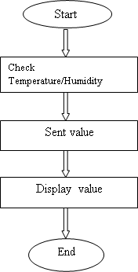

# Figure 4.1: Flowchart of Temperature/Humidity Sensor

The DHT11 is a basic, digital temperature and humidity sensor. It uses a capacitive humidity sensor and a thermistor to measure the surrounding air and spits out a digital signal on the data pin(no analog pins needed). It is simple to use but requires careful timing to grab data. Humidity sensors are used for measuring moisture content in the atmosphere. Then current temperature, humidity values are sent to the microcontroller, those values will display in the user's android app.

# SOIL MOISTURE SENSOR

Below Figure 4.2 shows the procedure of displaying soil moisture value.

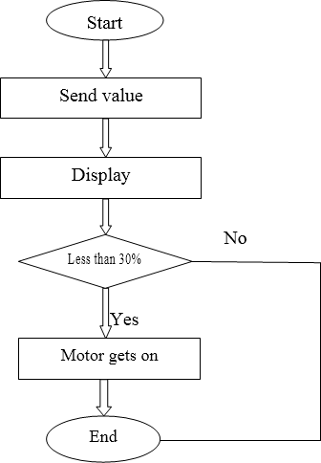

# Figure 4.2: Flow chart of Soil moisture sensor

Soil moisture sensors measure the water content in the soil. Moisture in the soil is an important component of the atmospheric water cycle. The sensor module outputs a high level of resistance when the soil moisture is low. It has both digital and analog outputs. The digital output is simple to use, but it is not as accurate as analog output based on moisture level motor gets turn on/off automatically.

# IMPLEMENTATION

The proposed agricultural system is designed to solve to find an optimal solution to the water crisis. The design implements IoT technology using an android device, a main controlling unit (MCU), sensors to measure various parameters.

# PROGRAMMING TECHNIQUES

This programming technique includes an explanation about Firebase and it uses the android application for human-readable form.

# Firebase

Firebase provides a quick way to keep sensory data collected at the device level, and it works great with the Android APIs, which are supported by Android Things. A lot of mobile and device programmers that I have come across struggle with server-side programming. Firebase can help bridge that gap and make it easier. It will be interesting to see developers use its offline features. If you are new to IoT or generally any device that collects data and needs to transmit it over networks, the golden rule to be assumed is that network connectivity cannot be assumed. As a result, you will need to collect the data offline and when the network is available, transmit this over to your server. Firebase with its offline features can make this simple for a lot of developers.

Firebase has a ton of features including Realtime Database, Authentication, Cloud Messaging, Storage, Hosting, Test Lab, and Analytics, but I’m only going to use Authentication and Real-time Database.

OK, let's move on to project construction.

I will divide this project into three parts:

* Creating a Firebase account
* Making the app
* Programming Arduino

# PROTOTYPE

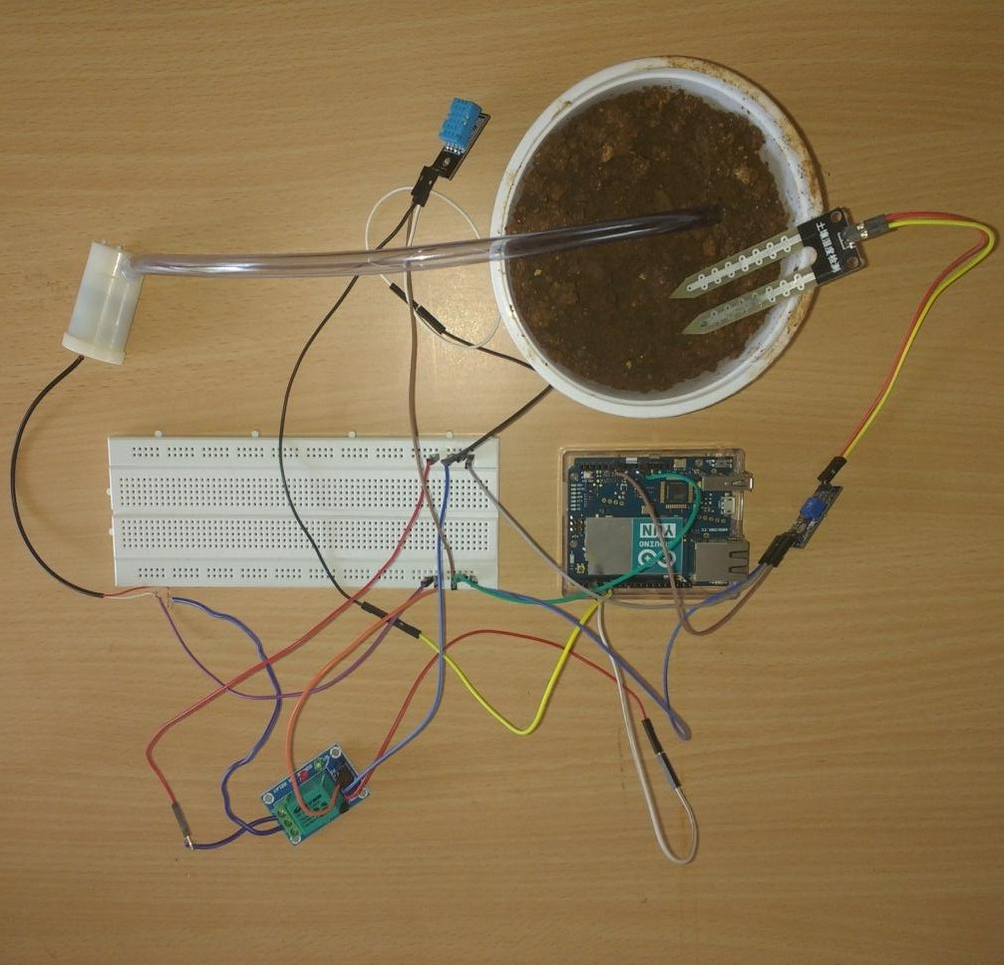

**Figure 5.1: Prototype of Automatic Irrigation System**

Figure 5.1 shows the prototype of an automatic irrigation system. The microcontroller Arduino is connected to the temperature sensor, soil moisture sensor, humidity sensor, relay, and motor. These sensors sense the various parameter of the soil, the motor is used to provide water to the land. And relay is used to control the motor

**CONCLUSION**

With more advancement in the field of IoT expected in the coming years, these systems can be more efficient, much faster, and less costly. In the Future, this system can be made as an intelligent system, wherein the system predicts user actions, rainfall patterns, time to harvest, an animal intruder in the field, and communicating the information through advanced technology like IoMT can be implemented so that agricultural system can be made independent of human operation and in turn quality and huge quantity yield can be obtained.