

#
Task1
###
Technical Specification Document

Author | Rohancherian783
Date | 2026-01-05
Version | 1.0.0

Table of Contents
- Introduction 1.1 Purpose 1.2 Scope
- Integration Overview 2.1 Integration Architecture 2.2 Integration Components
- Integration Scenarios 3.1 Scenario Description 3.2 Data Flows 3.3 Security Requirements
- Error Handling and Logging
- Testing Validation
- Reference Documents

- Introduction
1.1 Purpose
The purpose of this document is to provide a comprehensive technical specification for the integration scenario defined in the provided XML and Groovy files. The integration scenario involves the retrieval of emails from a Gmail account and sending them to a specified recipient. The business problem addressed here is the need for automated email processing, which allows organizations to streamline communication and ensure timely responses to inquiries. The integration leverages SAP Cloud Platform Integration (CPI) to facilitate the flow of data between the email server and the target system, ensuring that relevant information is captured and acted upon efficiently.
1.2 Scope
The scope of this integration includes the following components:
- Endpoints:
  - Sender Endpoint: IMAP server (imap.gmail.com:993) for retrieving emails.
  - Receiver Endpoint: SMTP server (smtp.gmail.com:587) for sending emails.
- Transformations:
  - The integration utilizes Groovy scripts for data transformation and content modification.
  - Content modifiers are used to set email headers and body content dynamically.
- Constraints:
  - The integration must handle various email formats and ensure proper encoding.
  - Security measures must be in place to protect sensitive information during transmission.
- Integration Overview
2.1 Integration Architecture
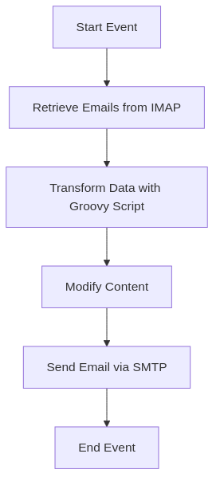
Integration Architecture
2.2 Integration Components
The integration components include:
- Adapters:
  - IMAP Adapter for receiving emails.
  - SMTP Adapter for sending emails.
- Script Steps:
  - Groovy Script for data transformation.
- Content Modifiers:
  - Content Modifier for setting email headers and body content.
- Integration Scenarios
3.1 Scenario Description
- Start Event: The integration process begins with a start event that triggers the email retrieval process.
- Retrieve Emails from IMAP: The integration connects to the Gmail IMAP server to fetch unread emails from the inbox.
- Transform Data with Groovy Script: The retrieved email data is processed using a Groovy script to extract relevant information such as subject, sender, and body.
- Modify Content: A content modifier is used to set the email subject and body dynamically based on the transformed data.
- Send Email via SMTP: The integration sends the processed email to the specified recipient using the SMTP server.
- End Event: The process concludes with an end event, indicating the completion of the email processing.
3.2 Data Flows
The data flows through the integration as follows:
- Incoming emails are fetched from the IMAP server.
- The email content is transformed and modified.
- The modified content is sent to the recipient via the SMTP server.
3.3 Security Requirements
- Use of secure connections (SSL/TLS) for both IMAP and SMTP communication.
- Authentication mechanisms must be implemented to ensure that only authorized users can access the email accounts.
- Sensitive information in emails must be handled according to data protection regulations.
- Error Handling and Logging
Error handling mechanisms must be implemented to capture and log any errors that occur during the integration process. This includes:
- Logging of failed email retrieval attempts.
- Logging of errors during email sending.
- Notifications to administrators in case of critical failures.
- Testing Validation
Testing must be conducted to validate the integration scenario, including:
- Unit testing of Groovy scripts.
- End-to-end testing of the email retrieval and sending process.
- Performance testing to ensure that the integration can handle the expected load.
- Reference Documents
- SAP Cloud Platform Integration Documentation
- Email Protocol Specifications (IMAP, SMTP)
- Groovy Language Documentation

