Training Report: Exercise 3.4
Trace Interaction & Object Selection System
1. Objective
The objective of this exercise is to implement a reusable object hover and selection system using line trace interactions. Because the mouse cursor is used by default for the camera look action (controlling view rotation and direction), the player can navigate freely without holding mouse buttons. To select an object, the player must physically move towards the selectable object, center it in their viewpoint to look at it, and press the selection action to confirm. This creates a highly immersive first-person or third-person walkthrough experience where the camera center doubles as a cursor for interaction, while dynamically switching to a free mouse cursor once a UI panel is opened.
2. Technical Architecture & Component Interaction
The trace-based selection system is built with a decoupled architecture involving the Player Controller, the Object Manager, the Selectable Object actors, and the Object Info Panel widget. The interactions and technical details are described below:
Class / Component | Technical Logic & Methods | Role in Selection Workflow
AAVP_RohanChoudharyPlayerController | • Tick(): Executes a LineTraceSingleByChannel on ECC_Visibility from the viewpoint center (when cursor is hidden) or under the cursor (when cursor is visible).  • SetNavigationMode(bool bCursorActive): Toggles bShowMouseCursor and sets input mode between GameOnly (free-look) and GameAndUI (cursor control).  • HandleSelectPressed(): Runs selection traces and instantiates WBP_ObjectInfoPanel if a selectable item is clicked.  • HandleBackPressed(): Passes nullptr selection to clear panel. | Manages the player input states, traces viewpoint center or screen cursor position, and orchestrates navigation/focus changes.
AArchSelectableObject | • UPROPERTY bHovered, bSelected.  • SetHoveredState(bool), SetSelectedState(bool).  • UpdateVisualState(): Sets text render colors (Green for hovered, Yellow for selected, White for normal) and custom depth stencil values (1 for hover, 2 for select) to trigger outline rendering. | Represents the interactable showroom assets, updating their visual outlines and labels based on hover/select states.
AArchObjectManager | • SelectObject(AArchSelectableObject* NewSelection):  - If NewSelection is valid, enables its selected state.  - If NewSelection is nullptr, clears current selection.  - Broadcasts OnObjectSelected delegate (which updates PlayerController input focus and WBP_ObjectInfoPanel). | Acts as the database manager, tracking selected object IDs and broadcasting changes to decouple gameplay logic from UI updates.
UObjectInfoPanelWidget  (WBP_ObjectInfoPanel) | • NativeConstruct(): Registers with manager selection delegates.  • HandleObjectSelected(const FArchObjectInfo&):  - If ObjectID.IsNone(), collapses MainPanelBorder.  - If valid, populates category, area, room name, description, and sets visibility to SelfHitTestInvisible. | User interface widget that displays CSV-loaded metadata and updates or collapses itself dynamically on selection changes.

3. Interaction Instructions
To inspect items inside the architectural showroom, follow these instructions:
1. **Navigate and Center View**: Use the movement controls to go towards the selectable object and look at it directly. Because the mouse is used for the look action (camera rotation) by default, the cursor is hidden, and looking at an object centers it in the trace line.
2. **Hover Outline**: When the trace overlaps a selectable object, its text label changes to Green and its custom depth outline activates, indicating it is interactable.
3. **Select and Inspect**: Press the selection input (Left Click / E Key). The selection is confirmed: the text turns Yellow, the WBP_ObjectInfoPanel slides open, the cursor is shown, and the input mode switches to Game and UI so you can interact with the panel.
4. **Deselect**: To go back to free mouse navigation, either press the Back input (Escape / Backspace) or click on empty space. The panel collapses, the cursor hides, and mouse look is restored.
4. Play-in-Editor Verification
Testing the interaction inside the showroom confirms that looking at and clicking the Luxury Armchair selects it successfully. The on-screen details panel (WBP_ObjectInfoPanel) populates its metadata fields (Name, Category, Room, Area, Description, Material Group) and displays the mouse cursor for UI interactions:
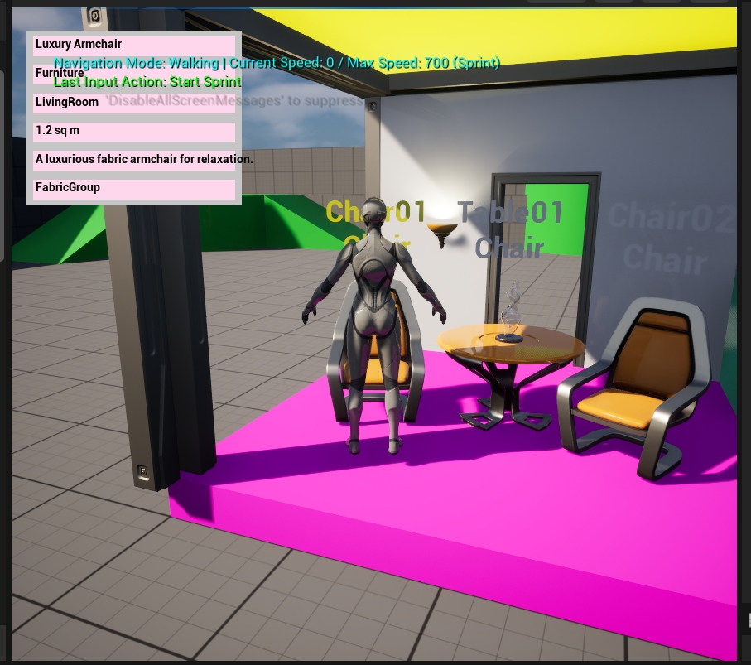
Figure 1: In-game view showing selected Luxury Armchair, yellow selection visual, and active metadata panel.

