Training Report: Exercise 4.6
Basic Performance Review & Profiling
1. Objective
The objective of this exercise is to conduct a performance profile of the mini architecture scene prototype using Unreal Engine's built-in diagnostics tools (in-game stats HUD, stat GPU, and Unreal Insights). This review quantifies performance under typical play conditions, identifies potential processing bottlenecks, evaluates the overhead of custom C++ logic and widgets, and outlines optimization guidelines to support project scaling.
2. Technical Performance Observations
Profiling was conducted in editor play mode from a consistent viewport position. The prototype exhibits a stable, high frame rate of approximately 55-60 FPS (averaging 60 FPS), indicating excellent out-of-the-box performance. The detailed metrics recorded are summarized in the tables below:
Metric / Thread Name | Average Value | Technical Purpose & Status
Total Frame Time | 17.82 ms | Average time spent to render a single frame. Comfortably near the 60 FPS target (16.6 ms budget).
Game Thread | 16.13 ms | Handles character movement, player controller input, object selection logic. Runs smoothly with no script-side bottlenecks.
Draw Thread | 12.34 ms | Prepares graphics command lists. Low cost due to a moderate draw call count (393 draws).
RHIT (RHI Thread) | 8.40 ms | Submits draw commands to the graphics API. Low overhead, indicating stable driver submission.
GPU Time | 18.44 ms | Time spent by the GPU rendering geometry, post-processing, and lighting. The main driver of frame time (GPU bound).

Footprint Metric | Value | Design Impact
System Memory (RAM) | 1.23 GB (Avg) / 3.01 GB (Max) | Memory footprint remains light, allowing high scaling overhead for expanded maps.
Video Memory (VRAM) | 3.73 GB (Avg) / 4.30 GB (Max) | VRAM consumption is moderate, driven by high-resolution mesh textures and post-process buffers.
Draw Calls (Draws) | 393 | Total batch count is low. Well within modern hardware capabilities (standard limit is 2,000-3,000).
Primitives (Prims) | 571.6K | Total geometry complexity is highly optimized, ensuring minimal vertex processing overhead.

3. Unreal Insights Profile Analysis
A detailed Timing Insights capture (Figure 2) was taken to analyze where rendering and logic time is spent. The GPU trace reveals that the performance is predominantly driven by engine-level rendering systems rather than gameplay logic or custom scripting. Key findings include:
- Temporal Super Resolution (TSR): TSR accounts for 12.5 ms of the 13.0 ms post-processing budget. This is the single most expensive rendering pass in the project. TSR is an engine-level upscaling system, not caused by gameplay code.
- Deferred Lighting: RenderDeferredLighting costs 1.3 ms, with lights taking 615 us and direct lighting taking 613.9 us. This confirms that the 6 custom showroom lights (directional sun, wall sconces, point fills) are highly optimized.
- Specular Reflections: Specular reflections on the glossy magenta floor and glass panels are handled by Lumen. ReflectionEnvironment costs only 593.1 us, indicating that the Lumen reflection settings are well-balanced.
- Slate UI: SlateUI cost is only 819.4 us. Custom widgets (Object Info Panel, Design Option Switcher) use event-driven bindings and do not tick, resulting in minimal CPU overhead.
4. Efficiency of Custom Logic & Blueprints
An audit of custom Blueprints and C++ classes confirms that gameplay scripting is optimized for CPU efficiency:
- Tick Elimination: Custom classes (AArchObjectManager, AArchSelectableObject, AArchAnimatedDoor) have Tick disabled or set to false by default (except for AArchSelectableObject which only ticks when hovered/selected to run highlight updates). This prevents frame-by-frame polling overhead on the CPU.
- Event-Driven HUD: UI updates are handled exclusively via event dispatchers (e.g. OnObjectSelected). Metadata fields in the Object Info Panel and Design Option Switcher are updated only when selection changes, saving CPU cycles.
5. Scaling Suggestions for Larger Projects
To maintain 60 FPS as the showroom environment scales (e.g., adding multiple rooms, high-density assets, or more materials), the following optimizations are recommended:
- Instanced Static Meshes (ISMs): Repetitive structural components (walls, frames, panels, lights) should be converted into ISMs or Hierarchical ISMs (HISMs) to combine draw calls and reduce the Draw thread timing.
- TSR Resolution Scaling: Expose TSR settings in a graphical settings menu, allowing users to decrease the screen percentage on lower-end hardware to reduce the 12.5 ms GPU TSR overhead.
- Baked Shadowing for Static Lights: The sconce lights currently cast dynamic shadows. Baking static shadows for immobile lights (using Lightmass or GPU Lightmass) will reduce ShadowDepths overhead (currently 587.9 us) to zero.
6. Runtime Verification
The following figures display the performance overlays and diagnostic tools used to verify scene execution:
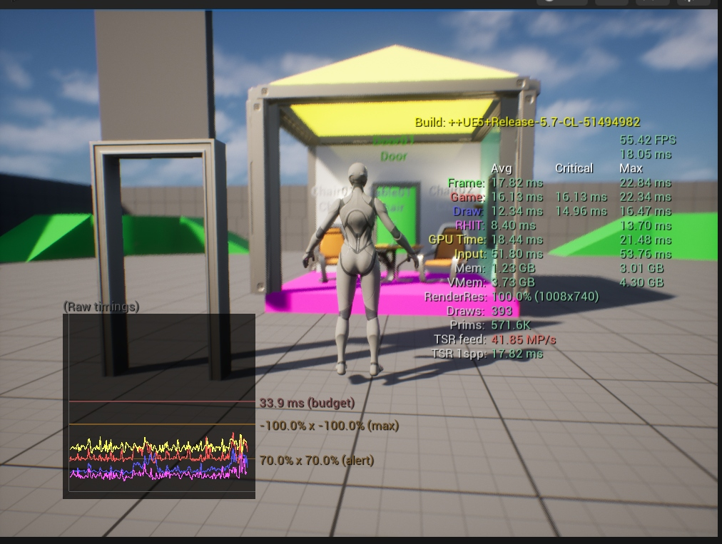
Figure 1: Viewport performance statistics showing FPS, frame timings, and memory consumption during runtime.
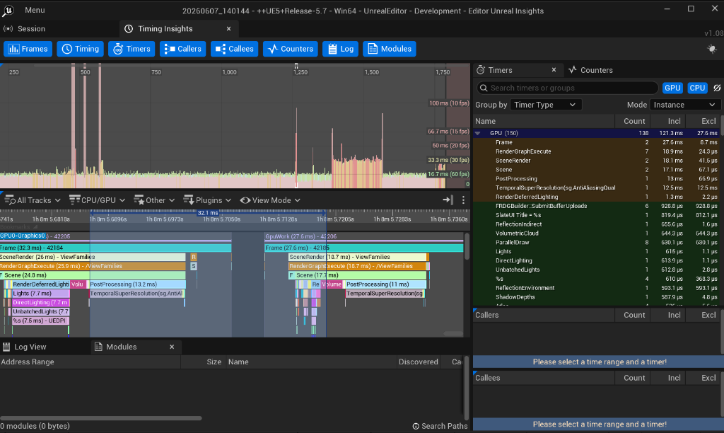
Figure 2: Unreal Insights Timing graph detailing post-processing, TSR, and deferred lighting GPU costs.

