Training Report: Exercise 3.6
Organizing Scene Variants with Data Layers
1. Objective
The objective of this exercise is to implement an efficient scene organization method suitable for large-scale World Partition levels. Instead of standard level streaming, this visualization project utilizes Unreal Engine's Data Layers subsystem to group scene design variations (specifically, furniture configurations). A C++ toggle mechanism has been implemented and bound to the 'L' key using the Enhanced Input system, allowing design variants to be dynamically loaded, activated, and unloaded at runtime.
2. Technical Implementation Details
The toggle architecture is integrated into the player controller using the Data Layer Subsystem. Below are the primary technical components implemented in C++:
Header changes in AAVP_RohanChoudharyPlayerController.h:
• Forward declaration of class UDataLayerAsset;
• Property: UPROPERTY(EditAnywhere, BlueprintReadWrite, Category = "DataLayers")
TObjectPtr<UDataLayerAsset> FurnitureDataLayerAsset;
• Function: UFUNCTION(BlueprintCallable, Category = "DataLayers")
void HandleToggleFurniture();
Implementation logic in AAVP_RohanChoudharyPlayerController.cpp:
• Includes: WorldPartition/DataLayer/DataLayerSubsystem.h, DataLayerAsset.h, and DataLayerInstance.h.
• Runtime State Check and Toggle:
- The Data Layer Subsystem is fetched: UWorld::GetSubsystem<UDataLayerSubsystem>(GetWorld()).
- The current state is queried: GetDataLayerInstanceRuntimeState(FurnitureDataLayerAsset).
- The state is toggled between EDataLayerRuntimeState::Activated (visible & loaded) and EDataLayerRuntimeState::Unloaded.
3. Input Configuration & Keybinding
To trigger the toggle in-game, a custom Input Action has been configured using the Enhanced Input system. The input configuration details are as follows:
• Input Action Asset: IA_ToggleFurniture (Digital Boolean type)
• Input Mapping Context (IMC_Default): Bound directly to the L key (Keyboard)
• Binding Logic: Bound under SetupInputComponent() to trigger HandleToggleFurniture() on ETriggerEvent::Started.
Figure 1: Enhanced Input configuration mapping IA_ToggleFurniture to the L key.
4. Comparison: Data Layers vs. Single Large Unorganized Level
Organizing complex 3D scenes with Data Layers provides major architectural benefits over flat, single-level structures:
Feature | Data Layers (World Partition) | Single Large Unorganized Level
Performance & Memory | Mesh assets, textures, and lights are dynamically loaded and unloaded at runtime. Unloaded layers occupy 0% memory. | All components remain resident in memory indefinitely, causing massive GPU/CPU bottlenecks and frame drops.
Asset Organization | Organizes assets into clear conceptual groups (Structure, Furniture variants, Lighting setups) within a hierarchical editor view. | All actors are placed into a single flat Outliner list, making it extremely tedious to manage or search for assets.
Design Variations | Supports multiple, overlapping spatial layouts (e.g., modern vs. classic furniture sets) toggled seamlessly without visual z-fighting. | Requires duplicating actors in the same location, causing collision overlaps and requiring complex blueprint scripts to show/hide.
Team Collaboration | World Partition allows level designers and asset artists to work on different Data Layers simultaneously without merge conflicts. | Only one person can safely edit the map at a time. Simultaneous modifications result in merge conflicts that risk data loss.

5. Runtime Verification
Verification inside the Play-in-Editor environment confirms successful toggling of the furniture components. When DLA_Furniture is unloaded, the chairs and tables disappear from the room (Figure 2). Upon pressing the 'L' key, the Data Layer transitions to Activated runtime state, dynamically rendering the showroom furniture (Figure 3).
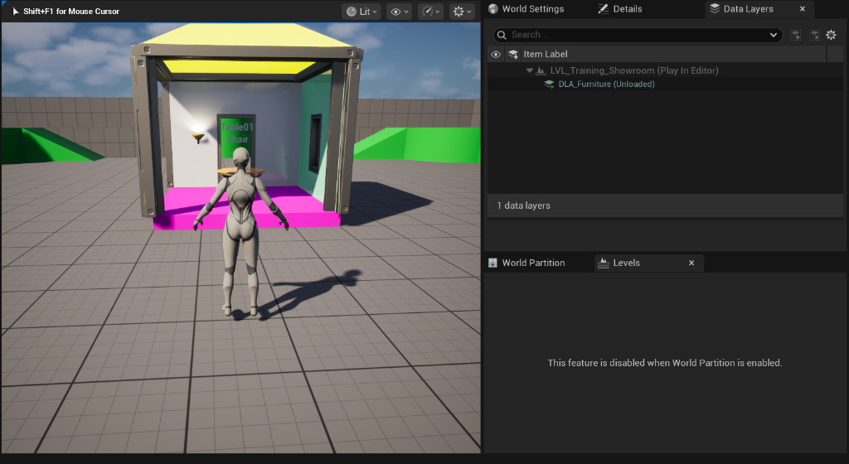
Figure 2: In-game view showing DLA_Furniture in the Unloaded state (furniture is hidden).
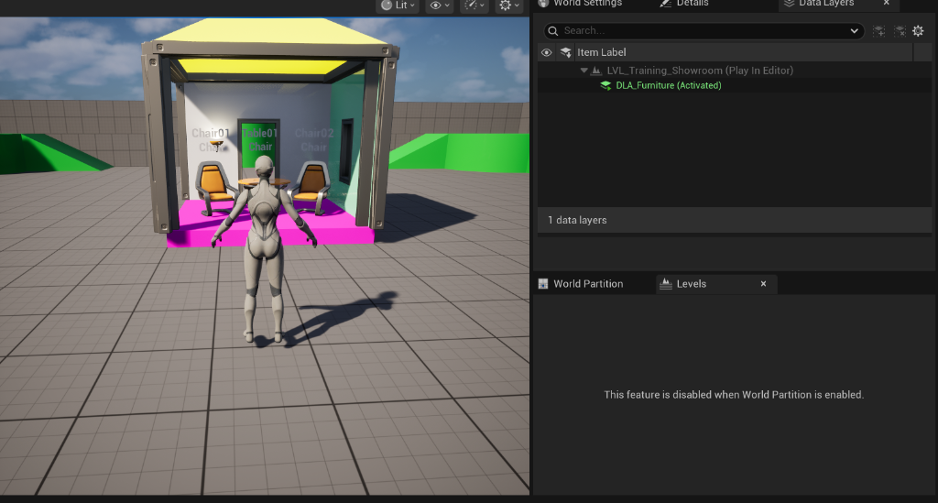
Figure 3: In-game view showing DLA_Furniture in the Activated state (furniture is rendered).

