Training Report - Exercise 2.1
Project Name: AVP_RohanChoudhary
Exercise: 2.1 - Create a C++ Architecture Object Component
Engine Version: Unreal Engine 5.7

Objective
Move architectural object metadata into a reusable C++ Actor Component (UArchObjectInfoComponent), attach it to selectable actors, and update the selection flow to read and display data from the component.

Completed Tasks
- Created a C++ Actor Component named UArchObjectInfoComponent.
- Added properties for ObjectID, DisplayName, Category, RoomName, Area, and Notes to the component.
- Exposed all component properties to Blueprint under the 'ArchViz' Details panel category.
- Implemented a Blueprint-callable function named GetFormattedObjectInfo() returning a formatted multiline display string of all properties.
- Attached the UArchObjectInfoComponent to the C++ base class AArchSelectableObject as a default subobject.
- Implemented bi-directional synchronization in OnConstruction() to bridge old actor properties and component properties seamlessly.
- Updated UpdateLabel() to render 3D Text labels using metadata fields queried from the component.
- Updated the selection event flow to display the formatted component data in the viewport and write to the editor log.

Technical Implementation
By utilizing Unreal Engine's Actor Component system, metadata is decoupled from the base actor class. This component-based architecture allows for flexible metadata assignment across various actor types in the future (such as custom lighting fixtures or structural walls) without cluttering actor-level variables. The bi-directional sync inside OnConstruction() automatically migrates existing configurations to the component on startup and refreshes the viewport text rendering instantly when values are edited.

Evidence - Component Details Panel
Screenshot of the selected actor showing the ObjectInfoComponent attached and its metadata properties exposed in the Details panel:
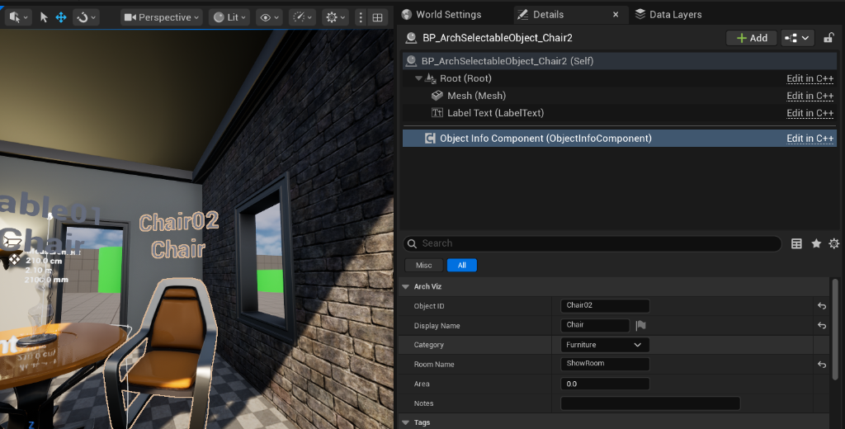
Visual verification: Object Info Component attached to BP_ArchSelectableObject and custom metadata properties exposed in Details panel.

Observations
Moving data to a dedicated Actor Component follows the principle of composition over inheritance. It yields clean, decoupled code and simplifies the process of extending metadata structures (such as adding 'Area' and 'Notes' fields) without affecting base actor logic. The real-time construction sync maintains an efficient, designer-friendly level editing experience in the editor viewport.

