Training Report - Exercise 2.2
Project Name: AVP_RohanChoudhary
Exercise: 2.2 - Unreal Type Practice for Object Metadata
Engine Version: Unreal Engine 5.7

Objective
Demonstrate the usage of core Unreal data types (FString, FText, FName, FVector, FRotator, TArray, and TMap) by implementing a visible 3D debug display panel that shows metadata and transformation values of selected architectural showroom objects.

Completed Tasks
- Created a C++ actor class ATypePracticeDisplay (TypePracticeDisplay).
- Declared FName SelectedObjectID to represent the unique object ID.
- Declared FText SelectedDisplayName to represent localized user-facing UI text.
- Declared FVector SelectedLocation to represent the 3D location of the selected actor.
- Declared FRotator SelectedRotation to represent the 3D rotation of the selected actor.
- Declared EArchObjectCategory SelectedCategory (enum) to represent object category.
- Declared FString SelectedNotes to represent internal, non-localized notes.
- Declared TArray<AArchSelectableObject*> AllSelectableObjects to store the dynamic list of selectable actors in the level.
- Declared TMap<FName, FArchObjectInfo> ObjectInfoDatabase to link ObjectIDs (FName) to metadata structs (FArchObjectInfo).
- Implemented a UTextRenderComponent to render a 3D debug overlay in the showroom level.
- Bound HandleObjectSelected() to the AArchObjectManager's OnObjectSelected native delegate to capture selection updates dynamically.
- Implemented RefreshDisplay() as a CallInEditor button and bound it to the 'R' key via Enhanced Input in the Player Controller.

Input Controls
Refresh Debug Panel: R Key (Mapped via Enhanced Input Action IA_RefreshDebug in IMC_Default)

Technical Note: FText vs FString
FText is preferred for user-facing UI text, while FString is preferred for internal notes and string manipulation. The reasons include:
- Localization: FText natively supports namespace key/value translation tables for multi-language localizations. FString cannot be localized automatically.
- Culture-Aware Formatting: FText::Format handles plural forms, gender configurations, and local rendering formats for numbers/dates correctly according to culture settings. FString has no built-in locale support.
- Performance: FText employs copy-on-write reference-counted pointing to global string tables, making passing or binding operations more performant than duplicating raw FString memory buffers.

Technical Implementation
The ATypePracticeDisplay actor uses the standard Unreal reflection system. At BeginPlay, it binds to the manager's C++ delegate. When selection occurs, it grabs location, rotation, and metadata from the selected actor, converting types into a unified multiline string. The data is set on the 3D TextRenderComponent, providing immediate visual verification.

Evidence - Visible Debug Panel
Screenshot of the TypePracticeDisplay placed in the level, showing active selection metrics (Chair01 selected, displaying position, rotation, notes, and object count):
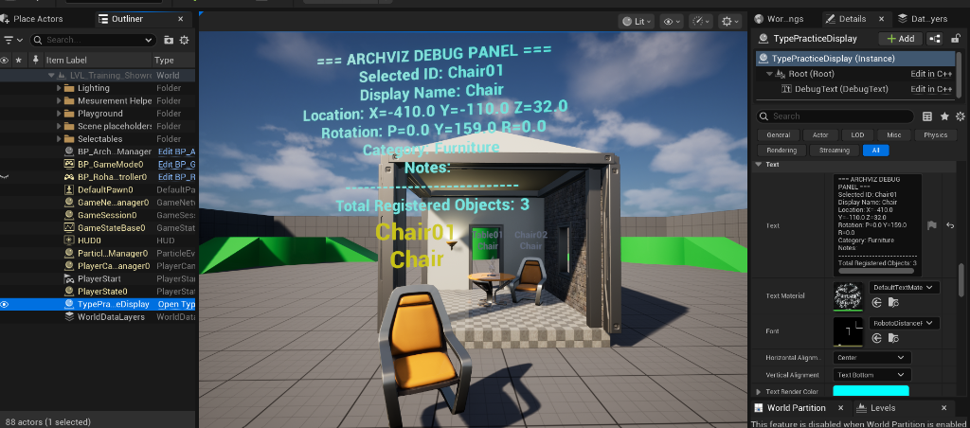
Visual verification: TypePracticeDisplay actor placed in the showroom level, rendering selected object metadata in 3D and Details panel.

Observations
Understanding data types is critical for optimizing Unreal memory footprints. Lightweight types like FName are excellent for TMap indexing keys, while math structs (FVector, FRotator) keep object coordinates easily readable. The native C++ delegate binding creates an event-driven flow where display modules can listen to selection changes without direct actor-to-actor dependency.

