Training Report - Exercise 1.7
Project Name: AVP_RohanChoudhary
Exercise: 1.7 - Blueprint Utility Layer for the Project
Engine Version: Unreal Engine 5.7

Objective
Create a reusable Blueprint utility layer for the project, incorporating enums, structs, function libraries, a debug macro, and selection events, with a show/hide toggle for Object IDs.

Completed Tasks
- Created a Blueprint Function Library named BPL_ArchVizUtilities in C++ containing format and debug print wrappers.
- Created a consistent debug logging C++ macro named ARCHVIZ_LOG to write to logs and the viewport simultaneously.
- Added OnObjectSelected as a BlueprintNativeEvent to AArchSelectableObject to handle default formatting and screen debug displays.
- Declared a native C++ delegate OnObjectSelected on AArchObjectManager to broadcast selection changes between C++ classes.
- Implemented a bShowObjectIDs flag on the manager with ToggleObjectIDs() and IsShowingObjectIDs() methods.
- Modified UpdateLabel() in AArchSelectableObject to query the toggle state and display only DisplayName when IDs are hidden.
- Registered the ToggleObjectIDsAction inside AAVP_RohanChoudharyPlayerController using the Enhanced Input system (mapped to the 'H' key).

Input Controls
Toggle Object IDs: H Key (Mapped via Enhanced Input Action IA_ToggleObjectIDs in IMC_Default)

Technical Implementation
The system follows the hybrid C++ + Blueprint architecture. Core logic is implemented in C++ for efficiency, type safety, and clean container usage, while exposing events and library functions to Blueprints. The ToggleObjectIDs action is triggered by pressing the 'H' key. This calls the AArchObjectManager to iterate through all AArchSelectableObject instances placed in the level, refreshing their TextRenderComponent visual labels dynamically to toggle the Object ID visibility.

Evidence - Object IDs Shown (Toggle ON)
Screenshot of the showroom scene with Object IDs turned ON and formatted object details printed on selection:
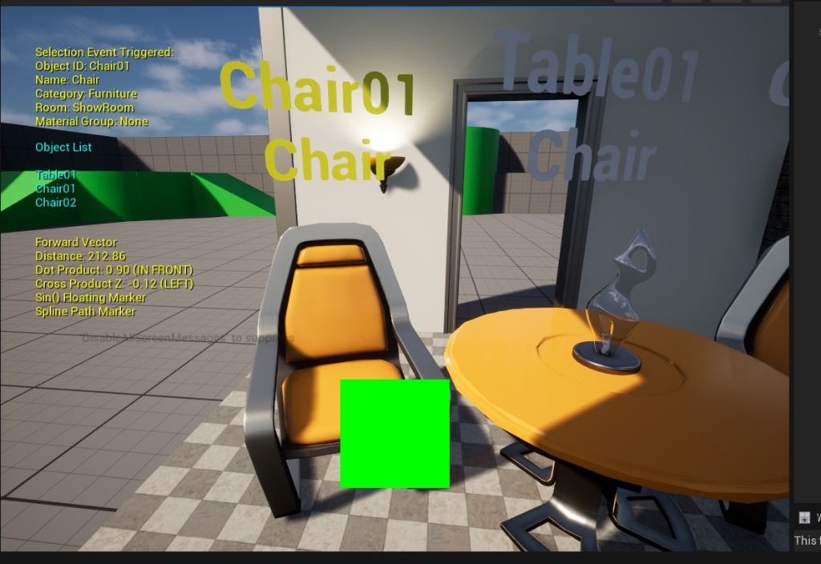
Visual verification: Object IDs shown and selected object details formatted.

Evidence - Object IDs Hidden (Toggle OFF)
Screenshot of the showroom scene with Object IDs turned OFF after pressing the bound 'H' key:
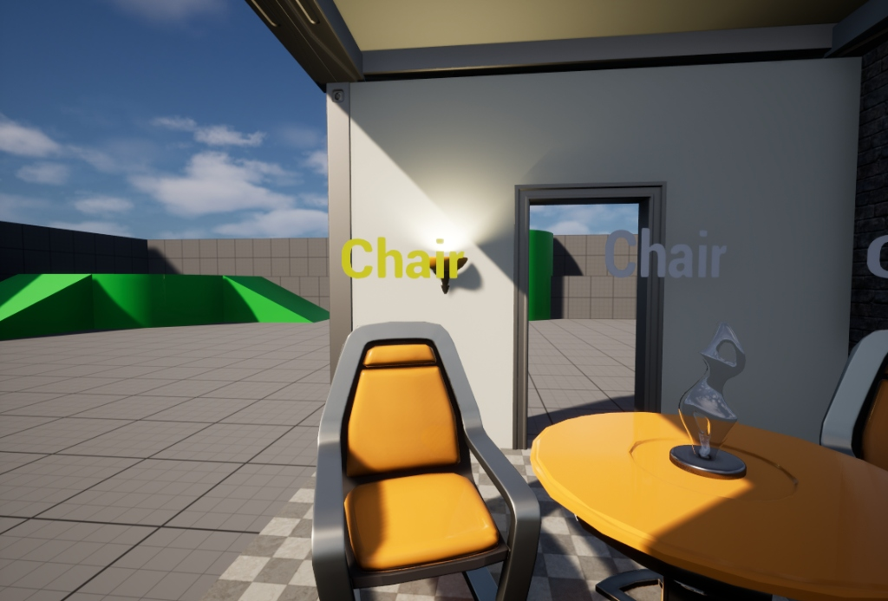
Visual verification: Object IDs hidden (toggled OFF via 'H' key), showing display names only.

Observations
Centralizing common visualization tasks in BPL_ArchVizUtilities keeps the code base highly organized. Toggling Object IDs via the Enhanced Input system (bound to the 'H' key) enables designers to perform layout checks and clean presentation sweeps on demand without modifying structural data. Using BlueprintNativeEvent ensures robust native C++ performance with easy-to-use overrides for designers working in Unreal Engine editor.

