Training Report: Exercise 4.5
Lighting and Presentation Polish Pass
1. Objective
The objective of this exercise is to execute a comprehensive lighting and presentation polish pass on the mini architecture showroom level. The scene's visibility, visual contrast, exposure control, and readability are significantly improved to meet professional architectural viz-review standards. A dedicated Post Process Volume, additional point lights, lens flare effects, and custom exposure settings are integrated to transform the scene into a high-fidelity, polished, and screenshot-ready prototype.
2. Technical Setup Specifications
Multiple actors and settings were configured to refine lighting gradients, control exposure, and solve reflection and glass readability issues. The technical setup specifications are detailed in the table below:
Polish Element | Actor / Component Class | Key Adjusted Parameter | Design Intended Effect
Advanced Post-Processing | APostProcessVolume | Lens Flare Intensity: 1.5  Bloom Method: Convolution  Lens Flare Tint: Warm | Adds visual bloom and lens flares around bright lights, creating a high-end cinematic and realistic camera aesthetic.
Lighting Refinement | APointLight / ASpotLight | Intensity: 2000lm  Source Radius: 15.0cm | Positions strategic point lights and wall sconces in the showroom to emphasize vertical surface textures and furniture readability.
Exposure Control | APostProcessVolume (Unbound) | Min EV100: 1.0  Max EV100: 1.0 (Fixed Exposure) | Locks eye adaptation to prevent dark blowouts or blinding highlights during camera movements.
Reflection & Glass | ABoxReflectionCapture / Lumen | Quality: 2.0  Resolution: 512px | Captures specular reflections on the glossy magenta flooring and provides readability to the glass panels.

3. Comparison: Raw vs. Polished Scene
The polish pass dramatically shifts the visual characteristics of the showroom. A direct comparison of the raw editor default configuration and the polished presentation configuration is described below:
Criteria | Before Polish (Flat / Standard) | After Polish (Polished / Lens Flares)
Point Lights & Lens Flares | Absent. Light sources look flat and do not project glows or flare highlights in the camera view. | Present. High-quality lens flares and bloom are visible around wall sconces and ceiling light sources.
Scene Depth & Fills | Dull. Lack of direct lighting fills results in flat color distributions and hard shadow borders. | Rich. Integrated point lights provide ambient fill, balancing bright emissive spots and softening shadows.
Eye Adaptation | Uncontrolled. Default auto-exposure causes the scene to brighten or darken dynamically, blowing out bright areas. | Fixed. Exposure is locked, ensuring a stable visual presentation when moving the camera through the space.
Glass & Specular Reflections | Barely visible. Glass panels are hard to read and the floor lacks reflection highlights. | Highly readable. Glass has clear reflections and the glossy floor reflects the environment lights.

4. Runtime Verification
Verification shows a clear visual improvement between the raw state and the final presentation pass:
- Before Polish (Figure 1): The close-up view has flat lighting, harsh contrast, and lacks post-processing bloom. The light sources have no glowing lens flares, and the glass paneling has minimal reflection details.
- After Polish (Figure 2): Shows the complete showroom presentation with final post-processing, bloom, and lens flares around the sconces. Optimized point lights illuminate the space and reflection captures define the glass and glossy flooring.
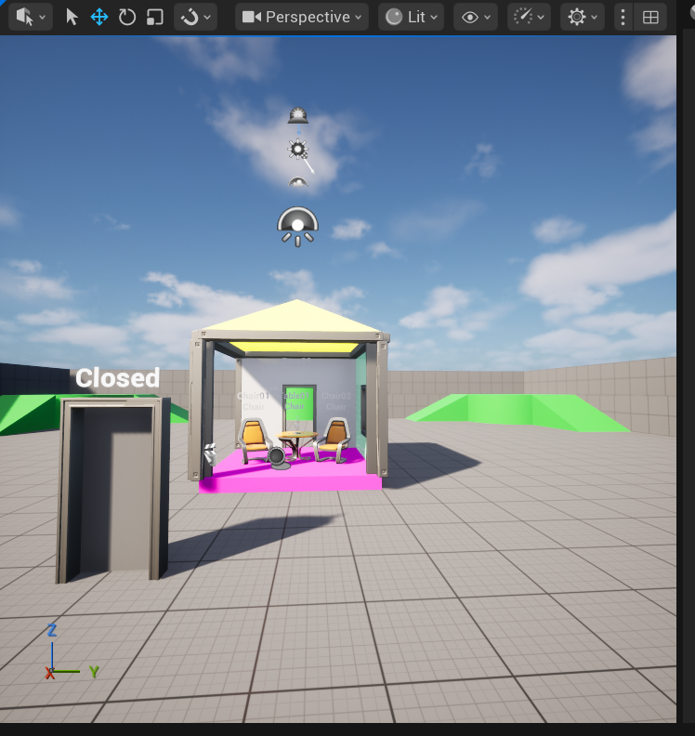
Figure 1: Close-up view of the showroom structure before polish, displaying flat lighting without lens flares.
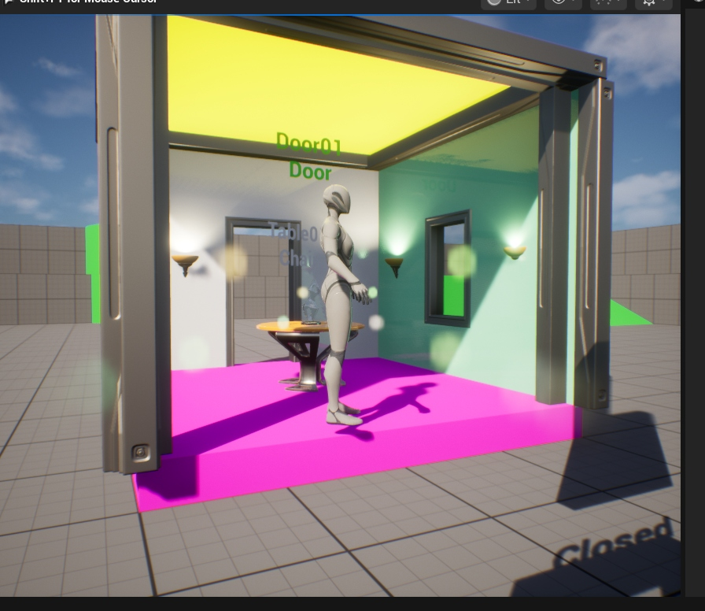
Figure 2: Showroom view after polish, featuring warm point lights, bloom post-processing, and lens flare highlights.
5. Remaining Visual Notes
A few minor visual issues remain for future refinement:
- Lightmap Resolution: Certain static meshes (such as the outer column frames) show slight shadow bleeding in the corners. Increasing their static lightmap resolution will resolve this in baked lighting.
- Glass Opacity Angle: Under certain extreme camera angles, the glass panels become slightly more opaque than desired. A Fresnel node in the glass material will adjust opacity based on view angle.

