Training Report - Exercise 1.2

Objective
Apply a clean naming convention and project organization strategy to establish a scalable Unreal Engine project structure.

Implementation Details
The project folder structure was reviewed and organized to match the training requirements. Dedicated folders were maintained for Blueprints, Maps, Materials, Meshes, UI, Data, Input, Sequences, Textures, and Documentation.
Naming conventions adopted:
- LVL_ for Levels
- BP_ for Blueprints
- WBP_ for Widgets
- M_ for Master Materials
- MI_ for Material Instances
- SM_ for Static Meshes
- T_ for Textures
- DT_ for Data Tables
- DA_ for Data Assets
- E_ for Enums
- S_ for Sequencer Assets
- IA_ for Input Actions
- IMC_ for Input Mapping Contexts

Benefits
Using a consistent naming convention improves project readability, simplifies asset discovery, reduces review time, and makes future migration and maintenance easier.

Result
The project now follows a production-style structure suitable for continued development throughout the training program.

Training Report - Exercise 1.3

Objective
Create reusable scale conversion utilities and visually validate architectural measurements within the showroom scene.

Implementation Details
A Blueprint Function Library named BPL_ScaleUtilities was created to centralize unit conversions. The library contains reusable conversion functions for meters, centimeters, and millimeters.
- MetersToCentimeters()
- CentimetersToMeters()
- MillimetersToCentimeters()
- CentimetersToMillimeters()
To validate scale visually, a reusable C++ measurement system was implemented. The system consists of AScaleMeasurementActor and a Blueprint child BP_ScaleMeasurementActor.
- Start Point and End Point editor handles define the measured distance.
- Distance is calculated automatically in OnConstruction.
- A spline component visualizes the measurement line.
- A widget component displays the measured value.
- Measurements are shown simultaneously in centimeters, meters, and millimeters.
- The system updates instantly while editing the level.

Project Scale Rule
The project follows the Unreal Engine standard scale where 1 Unreal Unit (UU) equals 1 centimeter (cm). All architectural dimensions are validated using centimeters as the primary unit.

Scale Validation
- Door Height: 210 cm (2.10 m / 2100 mm)
- Door Width: 90 cm (0.90 m / 900 mm)
- Table Height: 75 cm (0.75 m / 750 mm)
- Room Height Marker: 300 cm (3.00 m / 3000 mm)

Evidence
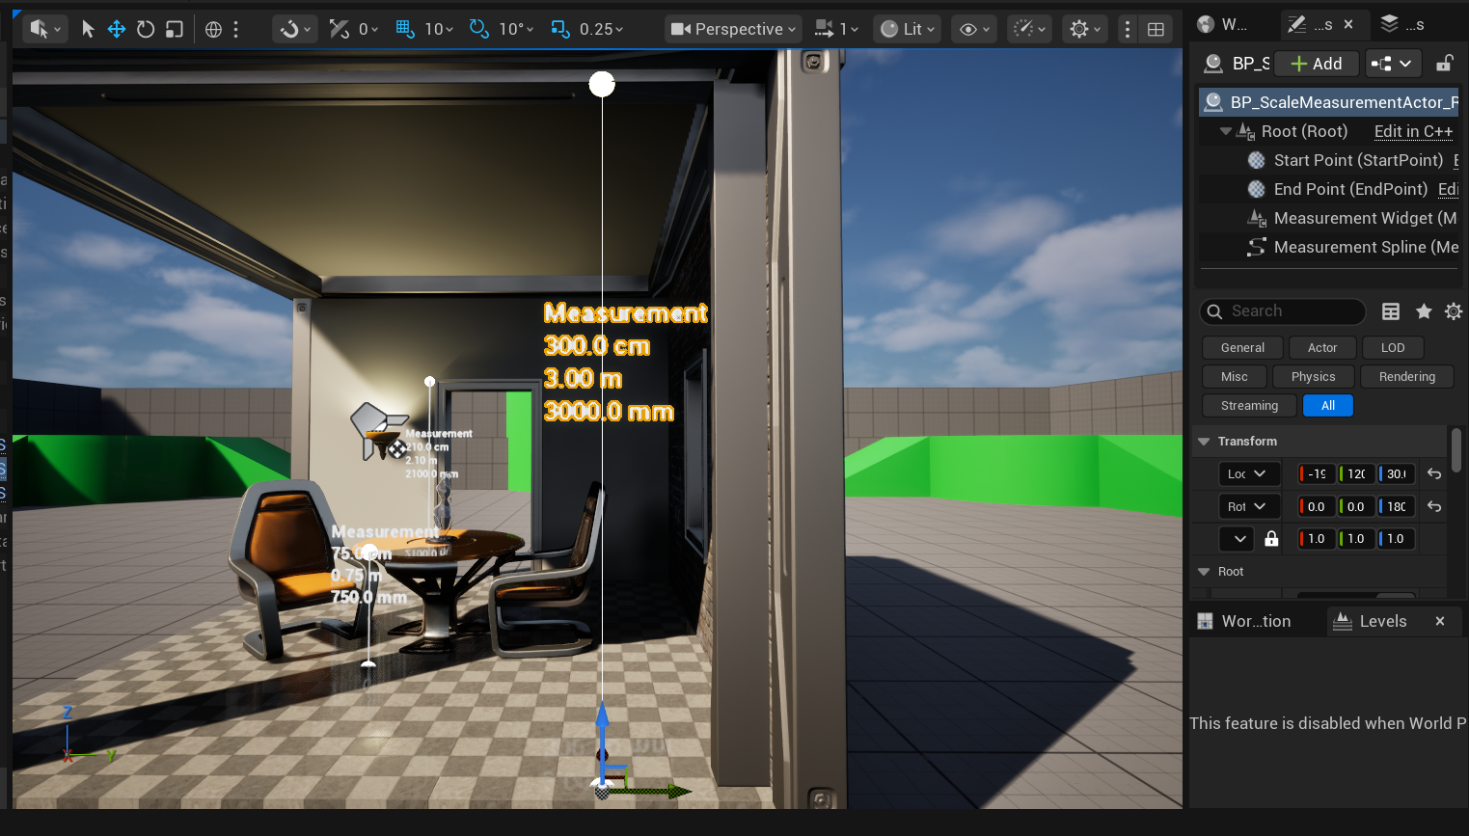

Observations
The measurement actor proved useful for validating real-world dimensions directly in the editor. The reusable utility functions and measurement visualization tool will also support future architecture visualization features.

