Training Report: Exercise 2.3
Load Object Metadata from CSV
1. Objective
The objective of this exercise is to make architectural scene object metadata data-driven by loading it dynamically from a CSV file. This approach removes hardcoded property configurations, allowing metadata modifications to be made in external spreadsheet editors. Additionally, the system provides a robust user experience by displaying real-time metadata in the level UI when objects are selected, and rendering visible warning notifications if an object's ID cannot be matched to any metadata row in the CSV file.
2. CSV Configuration & Schema
A CSV file named ArchObjectData.csv was created in the Content/Data folder. It contains 5 rows representing selectable objects. To enable smooth data table importing and prevent missing property mappings, a Name column was prefixed as the first column to serve as the database row name in Unreal Engine. The schema columns are defined below:
Column Name | Data Type | Description
Name | FName (Row Name Key) | Unique row key used by Unreal Engine's DataTable system during CSV importing.
ObjectID | FName | Unique identifier of the selectable showroom object, matching the Actor's ObjectID property.
DisplayName | FText | User-facing descriptive name for the selectable architectural element (fully localizable).
Category | EArchObjectCategory | Enum field mapping classification (e.g., Furniture, Fixture, Door, etc.).
RoomName | FName | Designated room location in the showroom showroom (e.g., LivingRoom, Office).
AreaSqM | float | Covered floor area of the object in square meters.
MaterialGroup | FName | Assigned material group configuration key.
Description | FString | Detailed multiline description of the product design and properties.

3. C++ System Implementation
To process and visualize this data-driven workflow, C++ integration was established through several modules:
• ArchObjectTypes.h: Defined the FArchObjectCSVRow struct inheriting from FTableRowBase to match the CSV schema fields.
• ArchObjectManager: Added a UDataTable UPROPERTY (ArchObjectDataTable) so the imported asset can be assigned in editor (BP_ArchObjectManager). Implemented the public method GetMetadataForObject(ObjectID, OutRow) which searches the data table by key in C++.
• ArchSelectableObject: In OnObjectSelected_Implementation, the actor looks up its row from the manager. It prints the detailed formatted data via ARCHVIZ_LOG to the screen log, and handles missing rows by outputting a warning print.
• TypePracticeDisplay: Caches room, area, material, and description properties. Upon receiving object selection events, it looks up the CSV row. If found, it draws a detailed list in 3D; if missing, it renders a prominent warning text 'WARNING: NO MATCHING CSV ROW FOUND!'.
4. Verification & Results
The project was successfully compiled using MSBuild. The DataTable was created from the CSV within the Unreal Editor and assigned to the ArchObjectManager instance. When playing in Editor (PIE), selecting Chair01 fetches and visualizes the correct data-driven metadata from the CSV source. The verification screenshot is shown below:
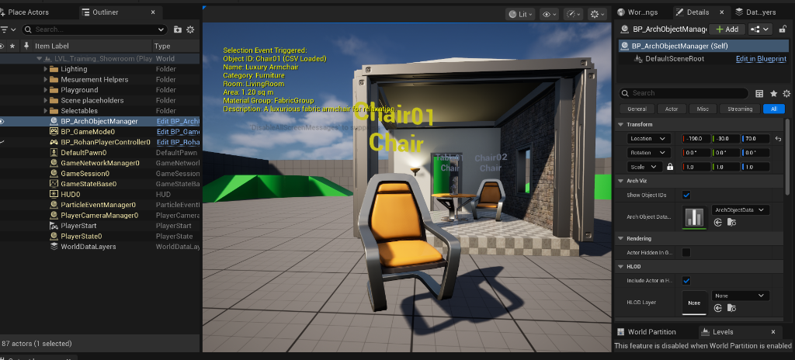
Figure 1: Showroom UI displaying loaded CSV metadata upon object selection.

