Training Report: Exercise 4.1
Animated Architecture Element
1. Objective
The objective of this exercise is to implement an interactive animated architectural element (a sliding showroom door). The component hierarchy, default local translations, interpolation logic, and player keybinding triggers are implemented in C++, while the timeline curve and visual status label updates are configured in a Blueprint subclass. The door is toggled on and off using the 'P' key via the Enhanced Input system.
2. C++ & Blueprint Hybrid Architecture
To maximize efficiency and maintain clean code guidelines, a hybrid workflow is established. Component structure and logic are built in C++, while visual timelines and UMG bindings are implemented in the editor. The architecture of the components is described below:
Component / Method | Class & Module | Technical Responsibility
FrameMesh | UStaticMeshComponent (Engine) | Static visual mesh representing the outer door frame. Acts as parent attachment for the sliding panel.
DoorMesh | UStaticMeshComponent (Engine) | Dynamic mesh representing the sliding door. Its local position is interpolated in real time.
StateWidgetComponent | UWidgetComponent (UMG) | A 3D world space widget component configured with WBP_TextBox class to display door status text above the frame.
ToggleDoor() | C++ Public Method | Inverts the bIsDoorOpen boolean state and invokes the OnToggleDoor BlueprintImplementableEvent.
UpdateDoorHeight(float Alpha) | C++ Public Method | Calculates a linear interpolation (Lerp) between ClosedLocalLocation (0,0,0) and OpenedLocalLocation (0,0,300.f) and sets it as the DoorMesh relative location.
HandleToggleDoor() | C++ PlayerController | Triggered by the P key. Iterates through all doors in the world, finds the nearest door, and calls its ToggleDoor() method.

3. 3D Widget Access & Blueprint Logic
A common technical issue in Unreal Engine is accessing and modifying UMG classes embedded inside a 3D Widget Component. To update the 'OPEN' or 'CLOSED' text in our WBP_TextBox from the door's blueprint, the standard Blueprint pattern is used:
1. Reference the State Widget Component.
2. Call Get User Widget Object, which retrieves the generic UserWidget instance running inside the 3D component.
3. Cast the widget to the specific class (WBP_TextBox).
4. Invoke the custom SetText function from the cast output pin, passing the status text based on bIsDoorOpen.
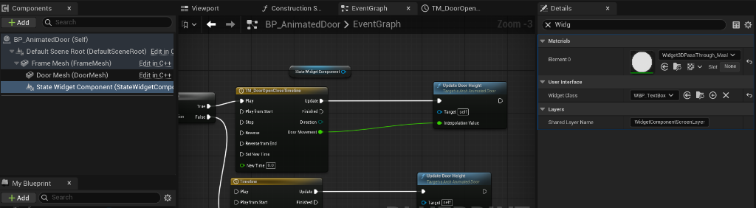
Figure 1: BP_AnimatedDoor Event Graph showing OnToggleDoor branching into the Timeline, updating height, and casting to WBP_TextBox.
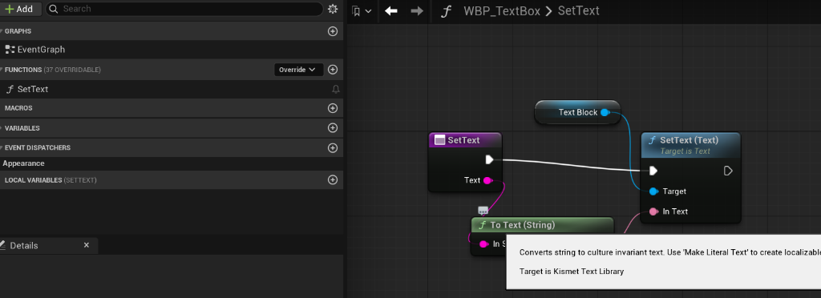
Figure 2: WBP_TextBox custom SetText function graph that updates the Text Block text component.
4. Comparison: Interactive Timeline vs. Static Models
Using interactive timeline-driven components provides substantial gameplay and visual visualization advantages compared to simple static models:
Feature | Timeline-Driven Interactive Door | Static Mesh Door Model
User Interaction | Allows players to toggle states in real time, encouraging hands-on exploration of layout design variants. | Acts purely as an obstacle. Requires players to bypass it or navigate around it, limiting immersion.
Visual Feedback | Provides smooth transition curves (Lerps) and real-time status labels ('Open' vs 'Closed') rendered in 3D world space. | No visual state changes. Status is visually ambiguous and cannot be configured dynamically.
State Prevention | C++ checks and timeline control prevent repeated keypresses from breaking the interpolation state (reverses/plays smoothly from current location). | No states to manage; remains completely unresponsive to inputs.
Space Optimization | Allows sections to open up and optimize walking routes in interactive visualizations dynamically. | Permanently blocks doorways, paths, or visibility tunnels inside architectural rooms.

5. Play-in-Editor Runtime Verification
Verification in the showroom level demonstrates that pressing the P key near the door successfully triggers the sliding animation in both directions. The status label updates correctly based on the door state:
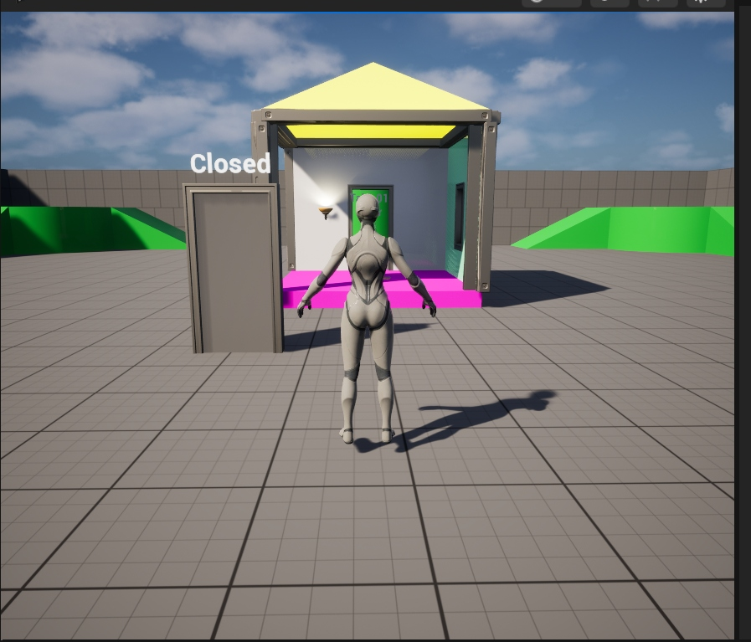
Figure 3: Showroom viewport showing the door in the Closed state with active world status label.
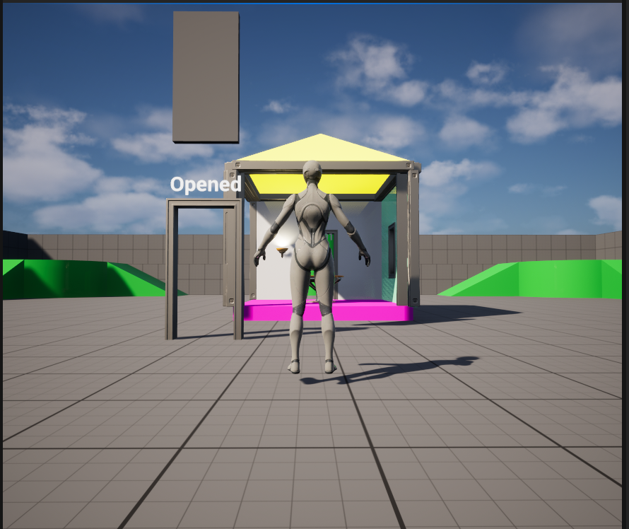
Figure 4: Showroom viewport showing the door in the Opened state (slid upward) with updated label.

