Training Report: Exercise 2.4
Export Review Notes to CSV
1. Objective
The objective of this exercise is to implement an export workflow that records review notes for selected objects and saves them to a CSV file (ReviewNotes.csv) in the project root. This feature enables coordinators, designers, and clients to interactively select showroom architectural objects, type in review notes, and export them. The implementation provides visual confirmation in the UI upon successful export and ensures notes are stored in a structured, RFC 4180-compliant CSV layout.
2. CSV Export Schema
The exported CSV file is dynamically structured with headers written automatically during the first export. Subsequent saves are appended as new rows. The CSV columns are defined as follows:
Column Name | Data Type | Description
Timestamp | FString (Format: YYYY-MM-DD HH:MM:SS) | The exact date and time when the note was saved.
ObjectID | FName | The unique identifier of the selected architectural object.
DisplayName | FText | The display name of the selected object for reference.
RoomName | FName | The showroom room location where the object is placed.
Note | FString | The review note typed by the user or hardcoded test note.

3. System Architecture
The export workflow is split into a robust C++ backend, a player input controller, and a custom UMG Widget system:
1. C++ CSV Exporter (BPL_ArchVizUtilities.cpp): Implements UBPL_ArchVizUtilities::ExportReviewNoteToCSV which uses FFileHelper::SaveStringToFile in append mode. It includes an escaping mechanism to correctly wrap fields containing commas, double quotes, or newlines.
2. Temporary Key Input Pipeline (AVP_RohanChoudharyPlayerController.cpp): Binds the N key to save a hardcoded note ("Temporary Hardcoded Note Test"). This verified the raw save and file write functionality before building the UI.
3. Interactive UMG Widget Base (ReviewNotesWidget.h/cpp): Inherits from UUserWidget and uses BindWidget metadata to bind UI components in WBP_ReviewNotes. Automatically listens to object selections, validates user notes, exports to CSV, and displays success/error feedback directly on the screen.
4. Verification & Screenshots
4.1. Hardcoded Note Export Verification (N Key)
Selecting Chair01 and pressing the N key prints a visual confirmation log on screen. This verified that the file append system functioned correctly, generating the initial ReviewNotes.csv file:
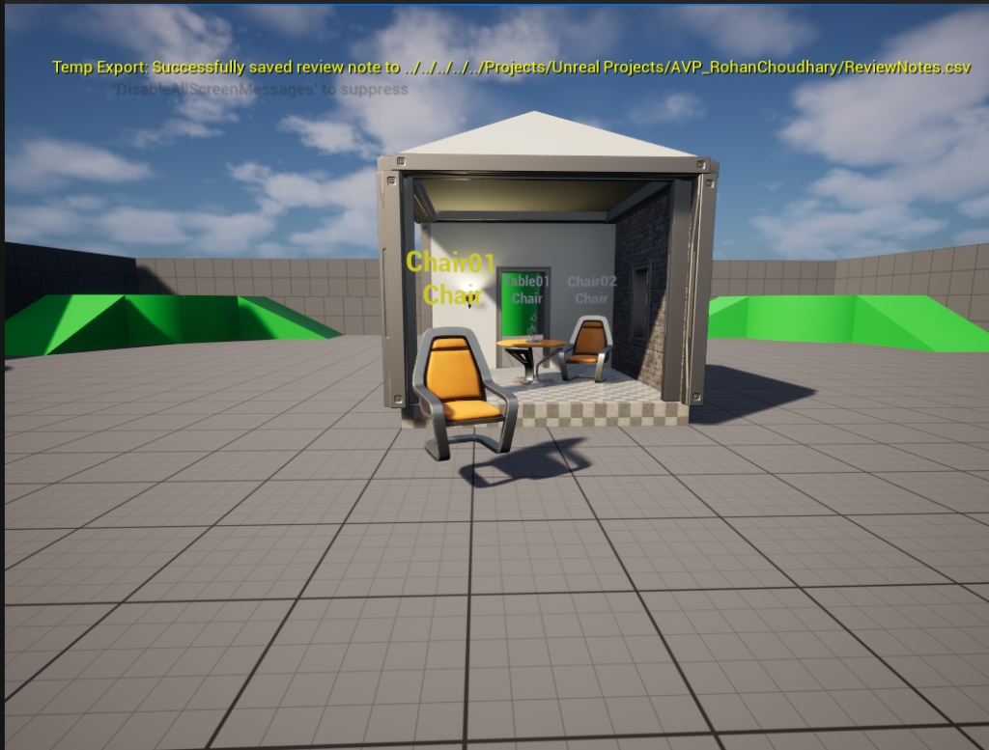
Figure 1: On-screen confirmation log when pressing the N key.
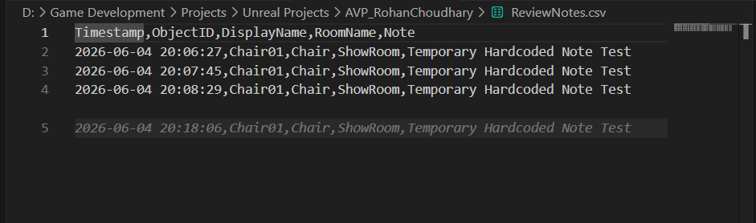
Figure 2: ReviewNotes.csv file populated with hardcoded rows after pressing the N key.
4.2. Interactive UI Note Export Verification
Using the WBP_ReviewNotes widget in PIE, typing a custom note (e.g., "Hello there"), and clicking the SAVE button displays a success notification. The note is appended with the selected object details:
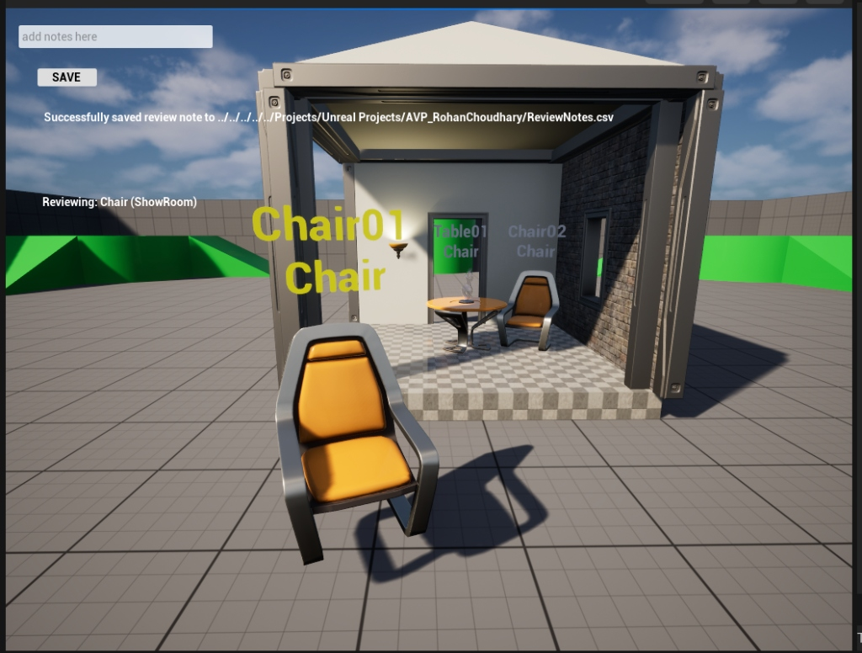
Figure 3: Interactive UI showing the review input box and successful save message.
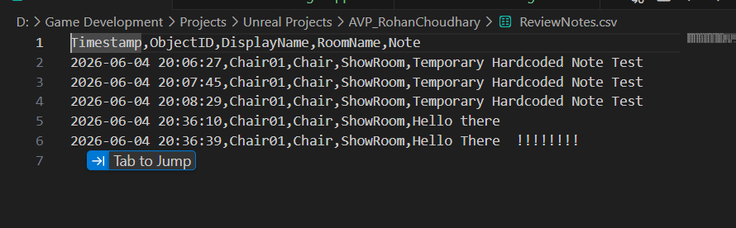
Figure 4: ReviewNotes.csv file verified externally with UI-entered notes successfully appended.

