Training Report: Exercise 3.2
Enhanced Input Mapping & Controls Overlay
1. Objective
The objective of this exercise is to implement an enhanced input mapping system for the ArchViz project and provide interactive on-screen controls overlay and debug feedback. We created and configured 10 specific Input Actions (Move, Look, Select, Back, Confirm, Open/Close Info Panel, Next Material Option, Previous Material Option, Play/Pause Presentation, and Toggle Cursor/UI Mode), grouped them cleanly inside an Input Mapping Context, and bound corresponding Keyboard/Mouse and Gamepad keys. Additionally, we set up on-screen input debug notifications showing the last action received, and built a custom toggleable controls hint overlay (WBP_ControlsOverlay) to guide the player.
2. Input Mappings Schema
The newly created Input Actions have been mapped inside IMC_Default to support unified Keyboard/Mouse and Gamepad schemes:
Input Action | Keyboard/Mouse Binding | Gamepad Binding | Description / Functionality
IA_Move | WASD Keys | Left Analog Stick | Character movement in the showroom.
IA_Look / IA_MouseLook | Mouse / Drag | Right Analog Stick | Camera rotation and orbit view.
IA_Select | E Key / Left Click | Gamepad A / Cross (Confirm fallback) | Select showroom object to load metadata.
IA_Back | Escape Key | Gamepad B / Circle | Cancel selection or go back.
IA_Confirm | Enter Key | Gamepad A / Cross | Confirm UI selections.
IA_ToggleControlsOverlay | H Key | Gamepad D-Pad Down (or F1/Select) | Toggle controls overlay hint panel on screen.
IA_NextMaterial | Right Arrow Key | Right Shoulder Button (RB/R1) | Switch object to next material option.
IA_PrevMaterial | Left Arrow Key | Left Shoulder Button (LB/L1) | Switch object to previous material option.
IA_PlayPausePresentation | P Key | Gamepad Menu / Options | Play or pause the showroom presentation path.
IA_ToggleCursorMode | C Key | Gamepad View / Share Button | Toggle mouse cursor display or game input focus.

3. System Implementation
1. Dynamic Input Logging: We implemented a public ShowInputDebugMessage() helper on AAVP_RohanChoudharyPlayerController which makes a call to GEngine->AddOnScreenDebugMessage using a unique key (4444). By reusing the same key, subsequent inputs overwrite the slot in real-time, displaying a persistent, clean indicator of the last action (e.g. Move, Jump, Select, Back).
2. Keybind Handlers: In AAVP_RohanChoudharyCharacter, we overrode the virtual Jump() method and updated Move() and Look() to call the player controller's debug printer. The player controller triggers logs for select, debug toggles, and exports.
3. Hints Overlay Widget (WBP_ControlsOverlay): Built a new standalone widget inheriting from a C++ parent class UControlsOverlayWidget. It binds CloseButton to collapse visibility. The player controller binds H to ToggleControlsOverlay, spawning it dynamically and toggling its visibility.
4. Verification & Screenshots
Below are screenshots confirming the successful implementation of the Enhanced Input Context and dynamic HUD overlay:
4.1. Play-in-Editor Verification
Playing the showroom scene displays the green debug notification 'Last Input Action: Toggle Controls Overlay (H Key)' indicating the correct keypress detection. The WBP_ControlsOverlay at the bottom lists the active bindings:
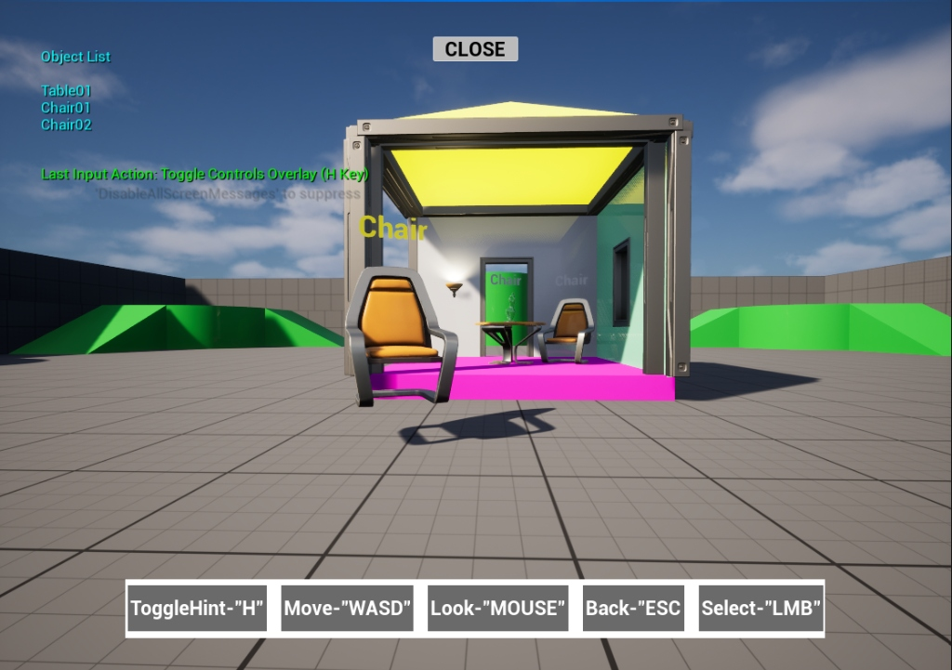
Figure 1: On-screen debug print and controls hint overlay displayed in PIE.
4.2. Input Action Assets
The configured Input Action data assets (IA_Jump, IA_Look, IA_MouseLook, IA_Move, IA_RefreshDebug, IA_Select, IA_ToggleMathDebugAction, IA_ToggleObjectIDs) stored under Content/Input/Actions/:
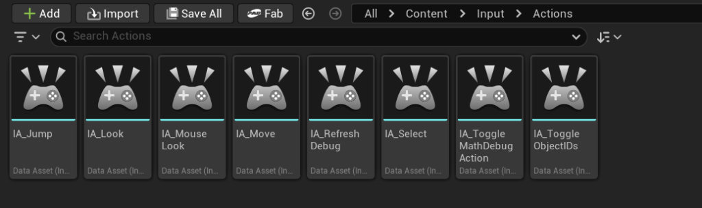
Figure 2: Custom Input Action assets created inside the Content Browser.
4.3. Input Mapping Context Configuration
Bindings registered within the default Input Mapping Context Details panel in Unreal Editor:
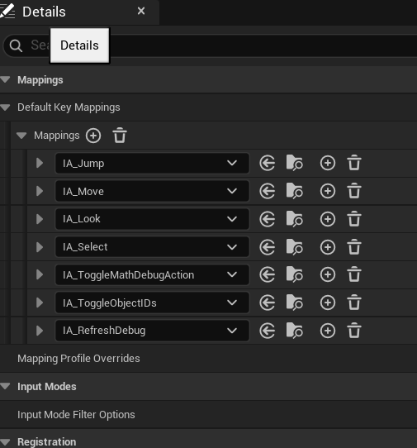
Figure 3: Details panel showing mapping bindings inside the Input Mapping Context.

