Training Report: Exercise 2.6
Create the Object Information Panel
1. Objective
The objective of this exercise is to design and implement a visible Object Information Panel (WBP_ObjectInfoPanel) that connects with selected showroom architectural objects. When an object is selected, the panel displays its specific details, including display name, category, room name, area, description, and material group. When no object is selected, a clear empty state is shown ("Select an object to view details"). Additionally, a close button allows hiding the panel visibly, and selecting another object automatically opens/updates it.
2. Panel Display Schema
The panel populates fields dynamically using metadata parsed from the selection system and the ArchObjectData CSV database. The fields bind directly to standard Text Block widgets in UMG:
Field Name | Widget Bind Name | Source & Formatting
Display Name | DisplayNameText | FText. Populated from CSV metadata Row.DisplayName.
Category | CategoryText | EArchObjectCategory enum. Formatted using UEnum::GetDisplayValueAsText.
Room Name | RoomNameText | FName. Formatted as FText::FromName.
Area | AreaText | float. Formatted with suffix, e.g., '{Area} sq m'.
Description | DescriptionText | FString. Displays details or 'No description available'Fallback.
Material Group | MaterialGroupText | FName. Displays material classification (e.g., FabricGroup, WoodGroup).

3. System Architecture & C++ Integration
The architecture links selection handlers to UI rendering through C++ classes, maintaining separation of concerns:
1. UObjectInfoPanelWidget: Custom base widget class inheriting from UUserWidget. It uses BindWidget meta-specifiers for components to ensure UI elements created in UMG map directly to C++ pointers. It subscribes to AArchObjectManager::OnObjectSelected. When an object is selected, it queries CSV metadata (AreaSqM, Description, MaterialGroup) from ArchObjectDataTable and populates the widgets. If no object is selected, it hides the details and toggles EmptyStateContainer to visible.
2. AAVP_RohanChoudharyPlayerController: Modified to handle panel instantiation. Spawns WBP_ObjectInfoPanel on BeginPlay and adds it directly to the local player viewport.
3. Selection Flow: AArchObjectManager registers selection changes. When a showroom object is clicked, UObjectInfoPanelWidget receives the delegate broadcast, updates all values, sets EmptyStateContainer to Collapsed, and sets MainPanelBorder to Visible.
4. Verification & Screenshots
The following screenshots verify the functional state of the Object Information Panel during Play in Editor (PIE):
4.1. Luxury Armchair (Chair01) Selection
Selecting Chair01 updates the Object Information Panel dynamically. The details show "Luxury Armchair" (Furniture, LivingRoom, 1.2 sq m, FabricGroup, with description) and the CLOSE button is displayed at the bottom:
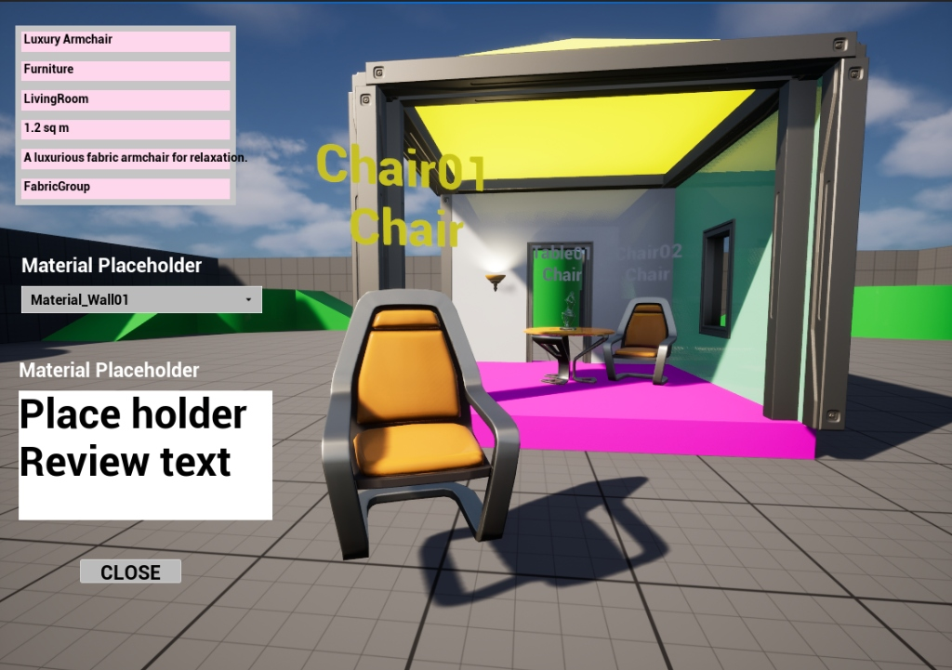
Figure 1: Selection details of Chair01 displayed on the Object Information Panel.
4.2. Round Dining Table (Table01) Selection
Selecting Table01 updates the panel immediately. The details show "Round Dining Table" (Furniture, DiningRoom, 2.5 sq m, WoodGroup, and oak table description):
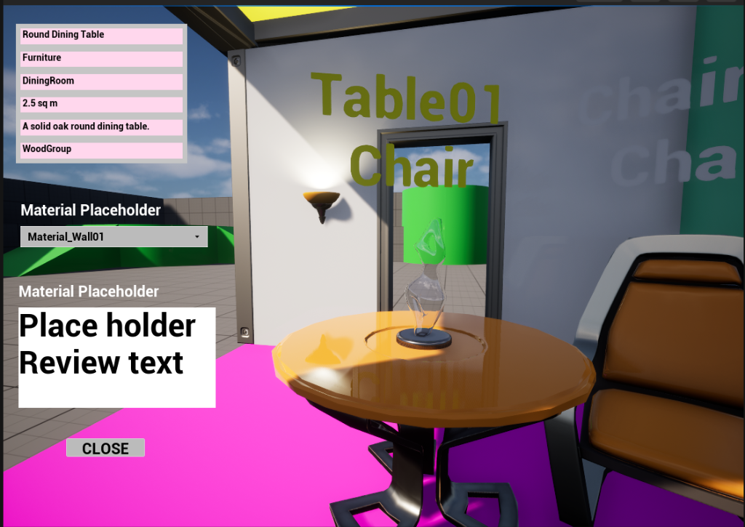
Figure 2: Selection details of Table01 displayed on the Object Information Panel.

