Training Report: Exercise 4.3
Guided Showroom Presentation (Level Start Sequencer)
1. Objective
The objective of this exercise is to design and implement a guided cinematic showroom presentation named S_Showroom_Presentation using Unreal Engine's Sequencer tool. This sequence serves as an automated, high-quality architectural flythrough triggered immediately upon loading the showroom level. The camera curates the viewer's path through the showroom, panning past key layout structures, showcasing animated elements in action, and focusing closely on selectable architectural features. Crucially, once the guided sequence completes, the system seamlessly transfers camera control back to the player character, enabling interactive free-roaming exploration and manual object selection.
2. Sequencer Asset & Camera Paths
The Sequencer asset S_Showroom_Presentation was created to orchestrate the guided showcase. A Cine Camera Actor (CineCameraActor) was added to the sequence, and its transform, focal length, and aperture properties were keyframed to generate a smooth, cinematic sweep through the environment. The sequence timeline is structured as follows:
Timeline Phase | Camera View / Action | Visual & Design Purpose
Start (0.0s - 3.0s) | Opening Wide Shot | Presents a comprehensive view of the entire mini architecture scene from the entrance doorway, establishing the scale, architectural layout, and overall ambient lighting scheme.
Middle-A (3.0s - 6.5s) | Slow Glide & Animated Door Focus | Dolly tracking shot moving deeper into the room. Focuses on the sliding showroom door which dynamically slides upward on the timeline, demonstrating functional dynamic components in the architecture.
Middle-B (6.5s - 9.5s) | Detail Shot (Lounge Chair) | Smooth transition to a tight, close-up tracking shot focusing on a selectable lounge chair to showcase material texture, lighting depth, and furniture design details.
End (9.5s - 11.0s) | Final Wide Shot & Transition | Sweeps upward and backward to settle into a final wide perspective of the showroom, easing out the camera movement before releasing possession back to the player's standard viewport.

3. Camera Control Handover Logic
To ensure a seamless user experience, the transition between the automated cinematic presentation and active gameplay is managed carefully. The timeline execution and player possession follow this strict lifecycle:
- Level Startup (Auto-Play): The Level Sequence Actor is configured with 'Auto Play' enabled. On level load, the sequence starts immediately, overriding the default camera view. The Player Controller's inputs are disabled during this presentation.
- Cinematic Cam Cut: The Sequencer contains a Camera Cut Track bound to the CineCameraActor, forcing the viewport to display the cinematic sequence rather than the default Player Camera Manager target.
- Possession Handover: The Level Sequence Actor's properties are set to 'Restore State' when the playback finishes. Additionally, an event bind on the Level Sequence Player's OnFinished dispatcher triggers. Once the sequence concludes, the Player Controller is possessed, and the view target gracefully blends back to the player character camera (BP_PlayerCharacter), allowing standard player movement and interaction controls.
4. Comparison: Guided Showroom Sequencer vs. Free-Roaming Player Control
Integrating both cinematic presentations and interactive gameplay modes balances visual marketing and functional exploration. A detailed comparison of these two modes is outlined below:
Criteria | Guided Showroom Sequencer (Level Start) | Free-Roaming Player Control (Standard Mode)
Player Autonomy | None (Locked). The player cannot move or rotate the camera, ensuring they follow the curated architectural presentation. | High autonomy. The player freely moves (WASD) and rotates the camera (Mouse), selecting objects of interest.
Camera Control | Automated. Camera track is controlled by keyframed transforms on the sequence timeline. | Manual. The camera is attached to the player pawn's spring arm component and responds to player look inputs.
Architectural Focus | Curated. Focuses precisely on chosen highlight areas (e.g., entrance layout, sliding door, lounge chair detail). | Ad-hoc. The player explores areas at their own pace, looking at elements and invoking hover/selection outlines.
Interactive Elements | Triggered by Sequencer. The sliding showroom door's upward movement is animated directly on the Sequencer timeline. | Triggered by Player. Interaction is executed via mouse clicks on selectable actors, displaying the Object Info Panel UI.
Primary Purpose | Establishes a strong visual opening, showcasing lighting changes, animated actors, and curated design angles. | Provides hands-on space inspection, metadata checking, and detailed interaction with selectable items.

5. Runtime Verification
Testing the showroom level confirms that the starting sequence functions correctly. On level load, the sequence instantly overrides the viewport to present a wide shot of the showroom (Figure 1). The camera glides forward smoothly as the showroom sliding door plays its open animation (Figure 2), revealing the interior space. The camera then pans and focuses on the selectable lounge chair (Figure 3), displaying its design in detail. Once the sequence ends, control seamlessly shifts back to the player character pawn, allowing normal movements.
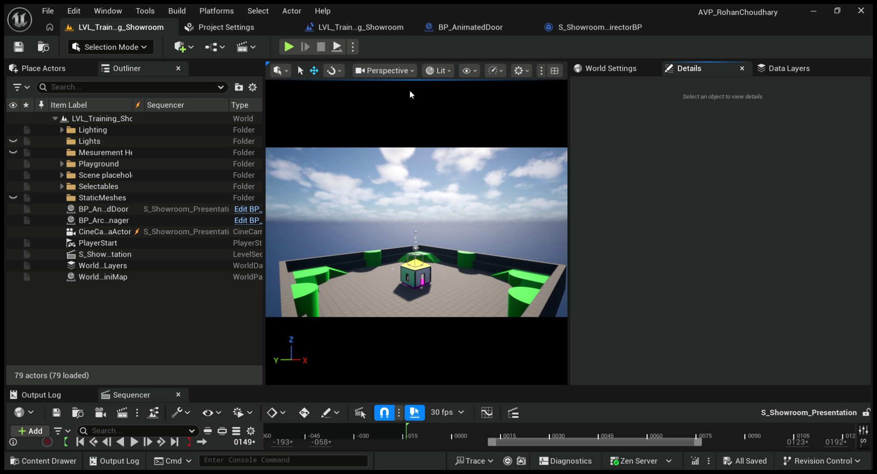
Figure 1: Opening wide shot of the showroom layout at level start.
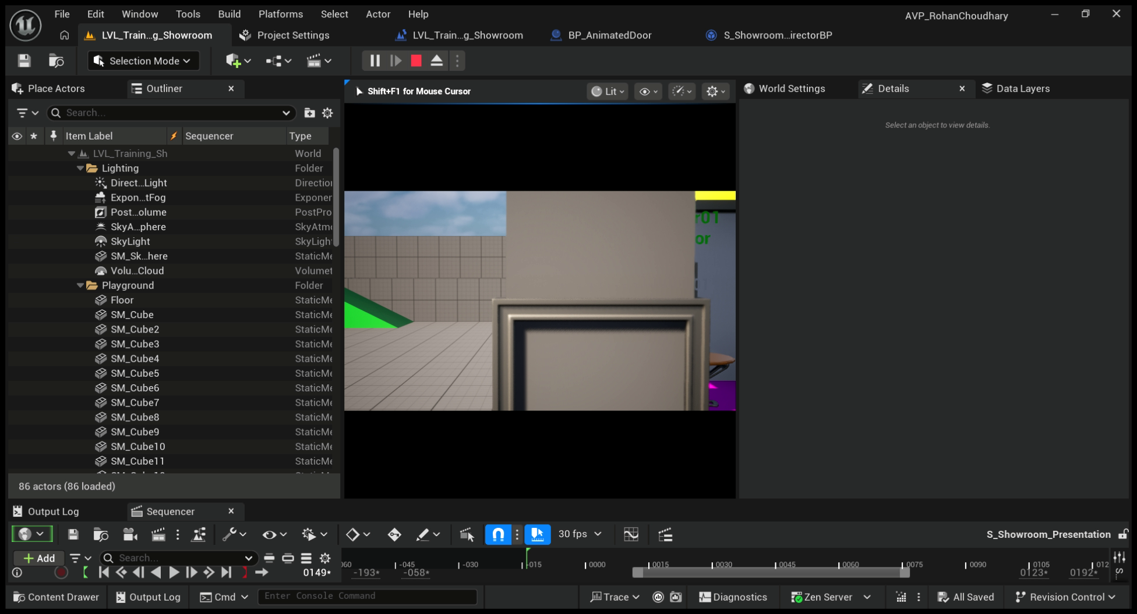
Figure 2: Dolly camera movement tracking forward as the sliding showroom door rises.
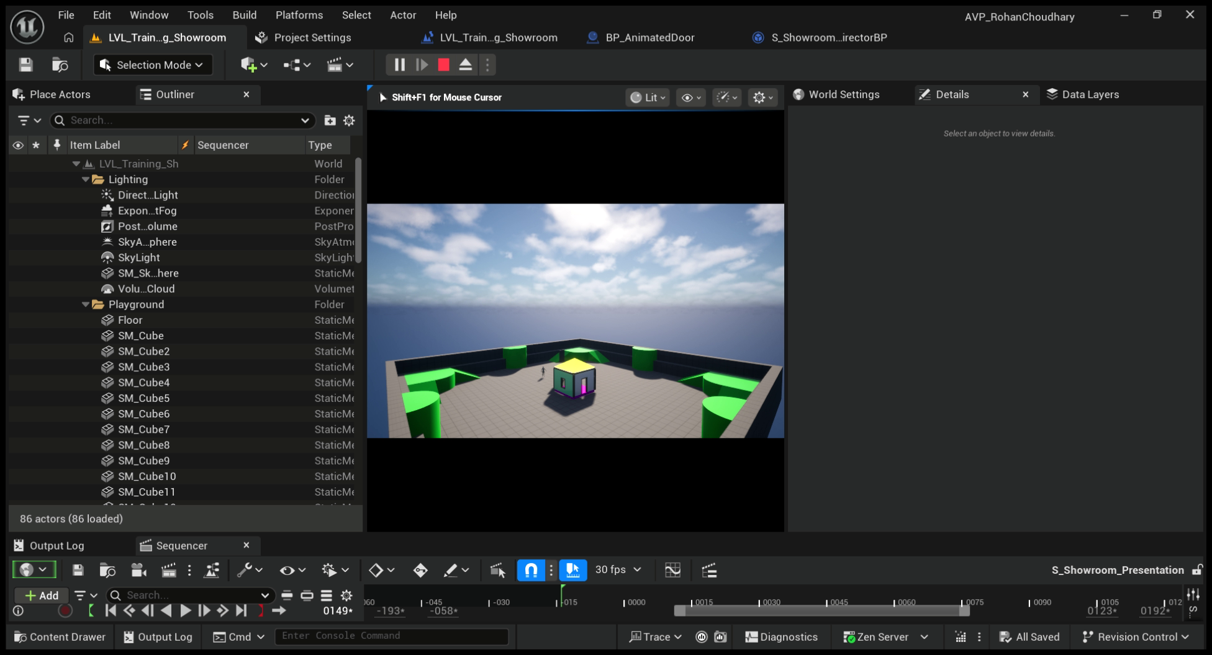
Figure 3: Cinematic close-up focus on the selectable lounge chair before control is returned to the player.

