Training Report: Exercise 3.3
Architecture Viewer Navigation System
1. Objective
The objective of this exercise is to implement a comfortable and intuitive navigation method for reviewing the architectural scene. A walking viewer mode was selected to allow developers and reviewers to traverse the showroom floor natively. Key enhancements include the integration of Walk and Sprint modes using the Enhanced Input system, boundary handling via the character's collision capsule, setting a comfortable camera Field of View (FOV) of 90 degrees, and displaying real-time navigation debug statistics (mode and speeds) directly on the screen.
2. Technical Architecture & Scripting
The navigation functionality is built on top of Unreal Engine's C++ framework, leveraging the native ACharacter class which incorporates capsule collision components and character movement behaviors automatically. The script modifications are detailed below:
Component / Script File | Changes & Core Logic | Implementation Goal
AVP_RohanChoudharyCharacter.h | • Declared WalkSpeed (300.0f) and SprintSpeed (700.0f) edit-anywhere properties.  • Declared UInputAction* SprintAction.  • Declared StartSprint() and StopSprint() methods.  • Declared Tick(float DeltaTime) override. | Extending the character header class with custom speed parameters, Sprint Enhanced Input hooks, and frame ticks for HUD logging.
AVP_RohanChoudharyCharacter.cpp (Constructor) | • Enabled ticking: PrimaryActorTick.bCanEverTick = true.  • Set default Field of View: FollowCamera->FieldOfView = 90.f.  • Initialized WalkSpeed = 300.f and SprintSpeed = 700.f.  • Assigned default MaxWalkSpeed to WalkSpeed. | Configuring a default comfortable camera FOV (90 degrees) and enforcing initial walk speed limits directly at startup.
AVP_RohanChoudharyCharacter.cpp (Input & Sprint) | • SetupPlayerInputComponent(): Bound SprintAction to ETriggerEvent::Started (calls StartSprint) and ETriggerEvent::Completed (calls StopSprint).  • StartSprint(): Sets MaxWalkSpeed to SprintSpeed.  • StopSprint(): Sets MaxWalkSpeed to WalkSpeed.  • Communicates status to PlayerController ShowInputDebugMessage. | Toggling movement speed dynamically via Enhanced Input triggers. Started corresponds to Left Shift pressed, Completed to release.
AVP_RohanChoudharyCharacter.cpp (Tick Debug HUD) | • Tick(): Uses GEngine->AddOnScreenDebugMessage to draw dynamic HUD overlay text.  • Displays Mode: Walking, Current Speed (calculated from Pawn Velocity), Max Speed, and Mode Label (Walk/Sprint). | Fulfilling the visual speed/mode label requirement with high-frequency updates on-screen without spamming multiple print lines.

3. Collision & Boundary Handling
By subclassing the ACharacter class, navigation collision and boundary constraints are automatically enforced. The CapsuleComponent restricts movement and prevents the viewer from walking through important walls, boundaries, and architectural elements. The physics simulation checks the capsule collider against static world geometry during every frame of movement input.
4. Verification & Screenshots
4.1. Real-time Sprinting Debug Output
In the running showroom scene, when Left Shift is held, the player sprints at 700 units/sec. The top-left debug print displays the correct mode, speed, and Last Input Action:
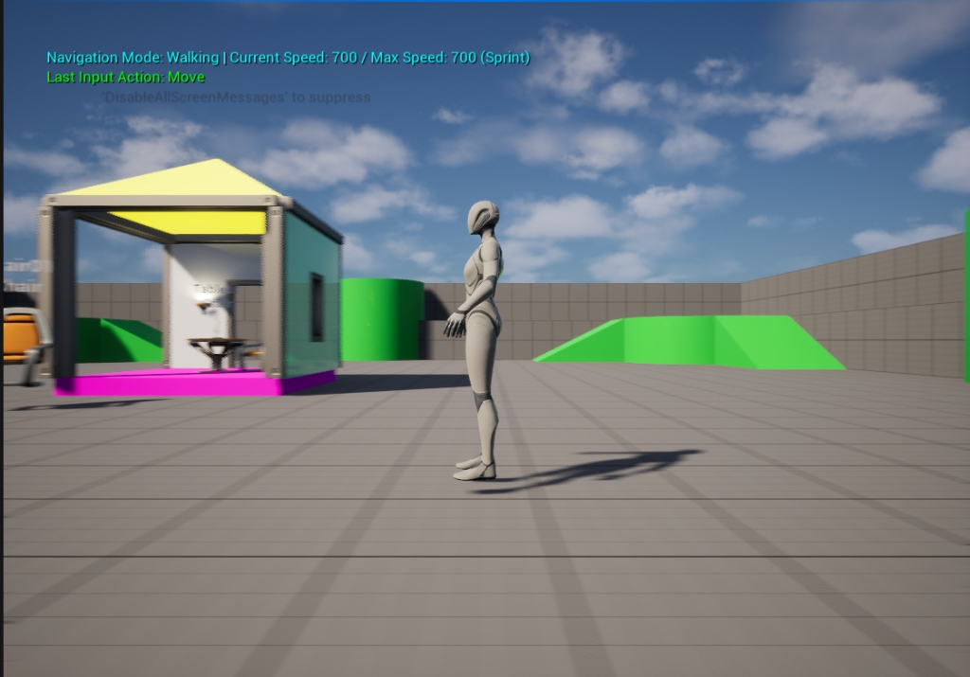
Figure 1: In-game walking view displaying the Sprint mode active (700 units/sec).
4.2. Blueprint Configuration & Field of View
Inside the Character Blueprint (BP_RohanChoudharyCharacter), the edit-anywhere properties for Walk Speed (300.0) and Sprint Speed (700.0) are exposed, alongside the Camera Component showing the configured Field of View (90.0 degrees):
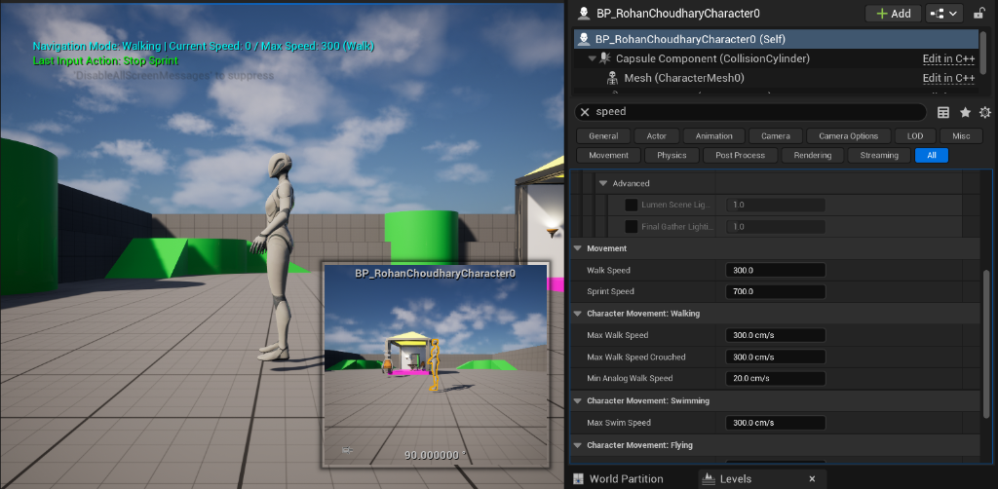
Figure 2: Details panel showing the character movement speed settings and camera FOV.
4.3. Enhanced Input Key Mappings
The Enhanced Input Mapping Context binds the Left Shift key to the custom IA_Sprint action:
Figure 3: Details panel of Input Mapping Context assigning Left Shift to IA_Sprint.

