Training Report - Exercise 1.1
Project Name: AVP_RohanChoudhary
Exercise: 1.1 - Create the Prototype Project
Engine Version: Unreal Engine 5.7

Objective
Create the base Unreal Engine architectural visualization prototype project that will be expanded throughout the training program.

Completed Tasks
- Created project AVP_RohanChoudhary.
- Created project folder structure: Blueprints, Maps, Materials, Meshes, UI, Data, Input, Sequences, Textures, and Documentation.
- Created main level: LVL_Training_Showroom.
- Added floor, walls, lighting, camera, and Player Start.
- Placed architectural placeholder objects.
- Saved the level and prepared it as the primary showroom scene.

Placeholder Objects Added
- Door Block
- Table Block
- Glass Wall
- Wall Panel
- Display Stand

Initial Setup Notes
A simple architectural showroom scene was created to serve as the foundation of the Mini ArchViz Prototype. The scene contains structural elements, furniture placeholders, lighting, and organized project folders. The project follows the training document requirements for Exercise 1.1.

Controls Placeholder
Controls will be documented in later exercises once the input system and viewer navigation are implemented.

Evidence
Screenshot of the showroom scene captured during Exercise 1.1:
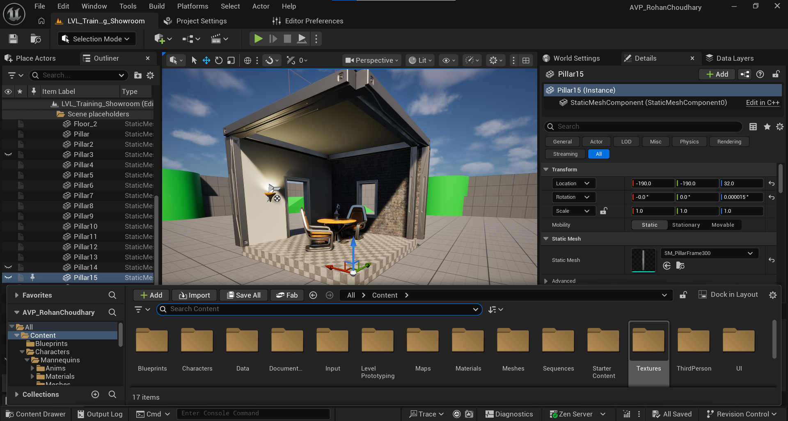

Known Issues
No known issues at this stage.

