Training Report: Exercise 4.2
UI Button & Key Controls Timeline Animation
1. Objective
The objective of this exercise is to allow the player to select the sliding showroom door and control its animation. Following design directives, the door is integrated into the core selection system by inheriting from the selectable object base class. The player can select the door by clicking it, and press the 'P' key to toggle the animation. The player controller prioritizes toggling the currently selected door, and falls back to toggling the nearest door if no selection is active.
2. C++ Inheritance & Visual Highlight Redirection
To make the door selectable without modifying the base selectable class, a clean inheritance and redirection strategy is used. The class hierarchy and redirection details are described below:
Component / System | Class & Inheritance | Integration Strategy
Base Selection Class | AArchSelectableObject | Defines standard outline stencils, hover states, and Object Info Panel integration. AArchAnimatedDoor inherits directly from this class.
Mesh Highlight Redirection | Mesh = FrameMesh.Get() | By reassigning the base class's Mesh pointer in the door constructor, the base class's UpdateVisualState() automatically highlights the door frame component without any Tick overhead.
Floating 3D Label | LabelText Component | Displays the Object ID and Name in 3D world space above the door actor, maintaining visual consistency with other selectable objects.
Input Action Integration | HandleToggleDoor() | Pressing the P key retrieves the current selection. If a door is selected, it executes its timeline animation. Otherwise, it falls back to proximity-based selection.

3. Input Prioritization Logic
To provide a natural control scheme, the player controller filters the input action mapping based on the active selection:
1. Retrieve the current selection from the ArchObjectManager.
2. If an object is selected, check if it is of type AArchAnimatedDoor using a dynamic Cast.
3. If the cast succeeds, trigger the selected door's ToggleDoor() function and return.
4. If no door is selected, fall back to locating all doors in the world, identifying the nearest door to the player, and toggling it.
4. Comparison: Selection-Based Control vs. Proximity Control
Implementing a selection-based control scheme for architectural elements provides several advantages and distinct differences compared to proximity-based auto-toggles:
Criteria | Selection-Based Control (Exercise 4.2) | Proximity-Based Fallback (Exercise 4.1)
Precision | High precision. The player explicitly points and clicks the element they wish to interact with, avoiding accidental triggers. | Lower precision. Will trigger any door that happens to be closest, even if the player is looking away.
Scale & Density | Excellent for dense levels. If multiple animated doors or panels are close to each other, the player can target individual doors. | Poor for dense levels. Hard to control a specific door if two doors are equidistant from the player.
User Feedback | Integrates with the Object Info Panel and custom stencil highlights to visually confirm which door is selected and ready to animate. | No selection state or highlight is active; the player must guess which door will trigger based on proximity.
Movement Freedom | Allows players to trigger animations from a distance as long as they can click the object, improving visual presentation. | Requires the player to physically walk up to each door frame, which can restrict camera angles during showcase walk-throughs.

5. Runtime Verification
Verification in the showroom level confirms that the sliding door is successfully registered as a selectable object. Hovering over the door frame activates the green stencil outline, and clicking it displays its custom metadata in the Object Info Panel. Pressing P toggles the animation of the selected door, satisfying all control requirements.
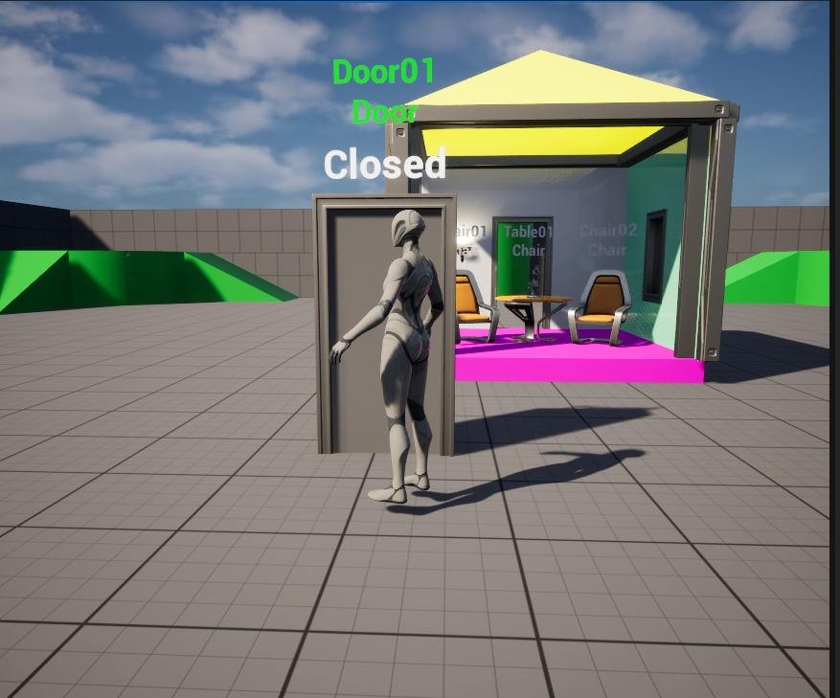
Figure 1: Hovering over the sliding door showing the green selection outline highlight and active green floating name label.
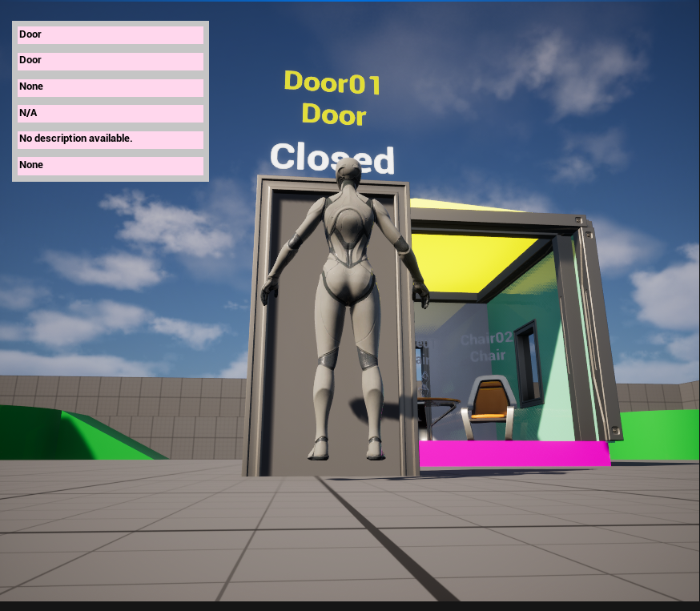
Figure 2: Selecting the sliding door showing the yellow outline, yellow floating label, and the Object Info Panel layout in the viewport.
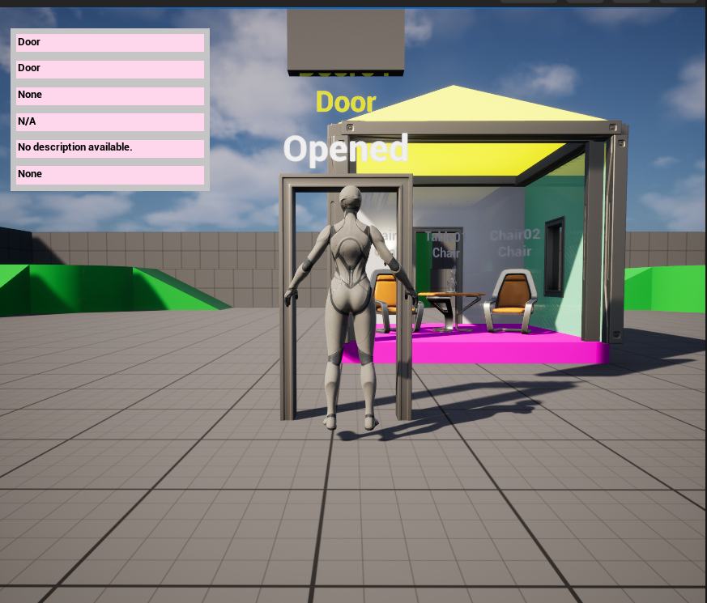
Figure 3: Animated door slid upward into its opened state showing the updated widget label text.

