Training Report: Exercise 4.4
UI Design Option Switcher (Interactive Layout Selection)
1. Objective
The objective of this exercise is to implement an interactive, UI-controlled design option switcher enabling fast architectural review in the showroom. The switcher is toggled via the 'M' key and presents a centered, navigable overlay containing three design options corresponding to three primary showroom furniture assets: Chair01 (Luxury Armchair), Table (Round Dining Table), and Chair02 (Ergonomic Office Chair). Selecting an option instantly updates the world scene by registering it as the active selectable object, displaying custom selection outlines, changing floating 3D text labels to yellow, and updating the viewport's Object Info Panel in real-time. Keyboard and gamepad navigation are supported natively.
2. C++ Class Design & UMG Architecture
The system split follows a clean hybrid C++/Blueprint architecture. Core logic, button delegates, and selection management are handled in C++, while visual styling (layout borders, fonts, colors) is managed in the Widget Blueprint (WBP_DesignOptionSwitcher). The primary class mappings and layout data options are described in the table below:
Option Index | Target ObjectID | Default Asset Name | Category / Material Group
Option 1 (Index 0) | Chair01 | Luxury Armchair | Furniture / FabricGroup
Option 2 (Index 1) | Table01 | Round Dining Table | Furniture / WoodGroup
Option 3 (Index 2) | Chair02 | Ergonomic Office Chair | Furniture / LeatherGroup

3. Input Management & Toggle Lifecycle
To ensure a seamless reviewer experience, the player controller binds the 'M' key and manages focus:
- Menu Toggle (M Key): Pressing 'M' triggers ToggleDesignSwitcher() in the player controller. If the widget doesn't exist, it instantiates UDesignOptionSwitcherWidget.
- Input Mode Routing: When opened, the controller switches to FInputModeGameAndUI and shows the mouse cursor. Simultaneously, the C++ method FocusActiveOption() is executed, focusing the button of the currently selected object. This ensures immediate keyboard (WASD/Arrows/Enter) or gamepad (D-pad/Joystick/A-button) control.
- Viewport Synchronization: Clicking a button calls SelectObject() on the ArchObjectManager, passing the resolved AArchSelectableObject actor. The widget calls RefreshUI(), which sets the active text label (Text_CurrentOption) to the format: '[DisplayName] (Category)' (e.g. 'Luxury Armchair (Chair)'), notifying the user of the selection.
- Menu Closing: Pressing 'M' again collapses the menu, hides the cursor, and restores input focus to game movement.
4. Comparison: UI-Controlled Option Switcher vs. Viewport Clicking
Implementing a dedicated UI Option Switcher provides distinct advantages for design reviews compared to manual viewport navigation and cursor clicking:
Criteria | UI Option Switcher (M Key) | Viewport Pointer Clicking (Click Select)
Navigation Speed | Very High. Jump between objects immediately from a centered modal menu without moving the player pawn. | Moderate. Requires the player to walk up to or look at the object, then point and click on the mesh in the viewport.
Keyboard/Gamepad Support | Native. Buttons take keyboard/gamepad focus automatically, enabling D-pad and arrow key selections. | Poor. Gamepads must simulate a virtual cursor or use tedious raycasting to select objects from a distance.
Visual Clarification | Excellent. Shows the active selection label directly on the switcher UI, updating the current focus state in real-time. | Moderate. The user must check the viewport outline colors or open the side-panel widget to read metadata.
Review Environment | Ideal for structured presentation reviews, quick design inspections, and demo showcases. | Ideal for free-roaming visual exploration and hands-on inspection of individual components.

5. Runtime Verification
Testing the switcher confirms complete synchronization between UMG UI elements and the scene:
- Luxury Armchair Focus: Toggling the menu and clicking 'Chair01' updates the active label at the bottom to 'Luxury Armchair (Chair)'. The armchair mesh gains a yellow custom outline, and the floating 3D text updates to yellow (Figure 1).
- Dining Table Focus: Selecting 'Table' updates the active label to 'Round Dining Table (Chair)'. The outline highlight and floating text transfer immediately to Table01 (Figure 2).
- Office Chair Focus: Selecting 'Chair02' updates the active label to 'Ergonomic Office Chair (Chair)'. The outline highlight and floating text transfer immediately to Chair02 (Figure 3).
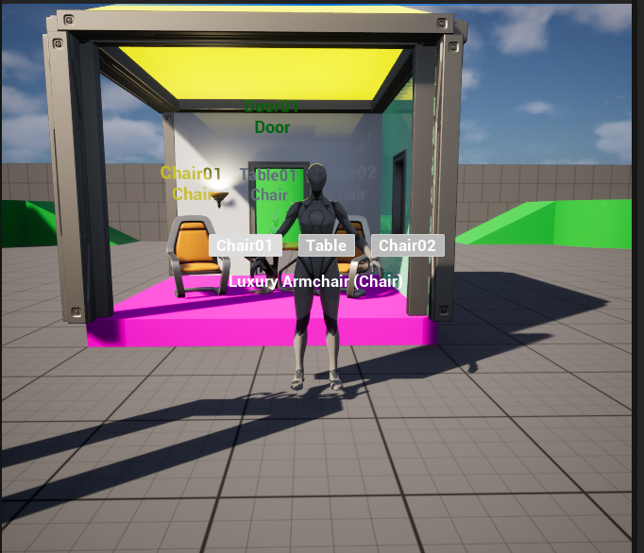
Figure 1: UI Switcher with Chair01 selected, updating the showroom scene selection.
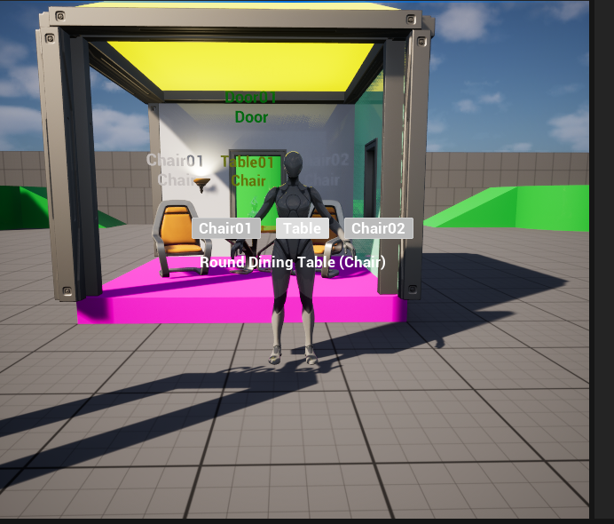
Figure 2: UI Switcher with Table selected, shifting outlines and label text to Table01.
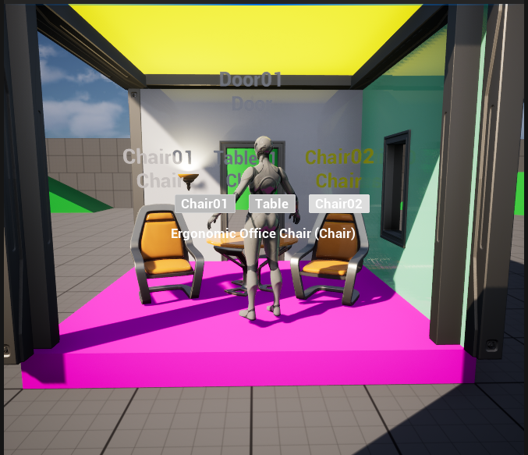
Figure 3: UI Switcher with Chair02 selected, transferring focus and label highlights.

