import java.io.\*;

import java.util.\*;

class Book {

String title, author;

double price;

int numPages;

Book() {

title="Default";

author="Default";

price=0.0;

numPages=0;

}

void setTitle(String t) {

title=t;

}

void setAuthor(String a) {

author=a;

}

void setPrice(double p) {

price=p;

}

void setPages(int np) {

numPages=np;

}

public String toString() {

return title+"\t"+author+"\t"+price+"\t"+numPages+"\n";

}

}

class BookDetails {

public static void main(String args[]) {

String t, a;

double p;

int np,n;

Scanner sc = new Scanner(System.in);

System.out.println("Enter the number of Books");

n = sc.nextInt();

Book b[]= new Book[n];

for(int i=0; i<n;i++) {

System.out.println("Enter the Title of the Books");

t= sc.next();

System.out.println("Enter the Author of the Books");

a= sc.next();

System.out.println("Enter the Price of the Books");

p= sc.nextDouble();

System.out.println("Enter the Number of pages of the Books");

np= sc.nextInt();

b[i] = new Book();

b[i].setTitle(t);

b[i].setAuthor(a)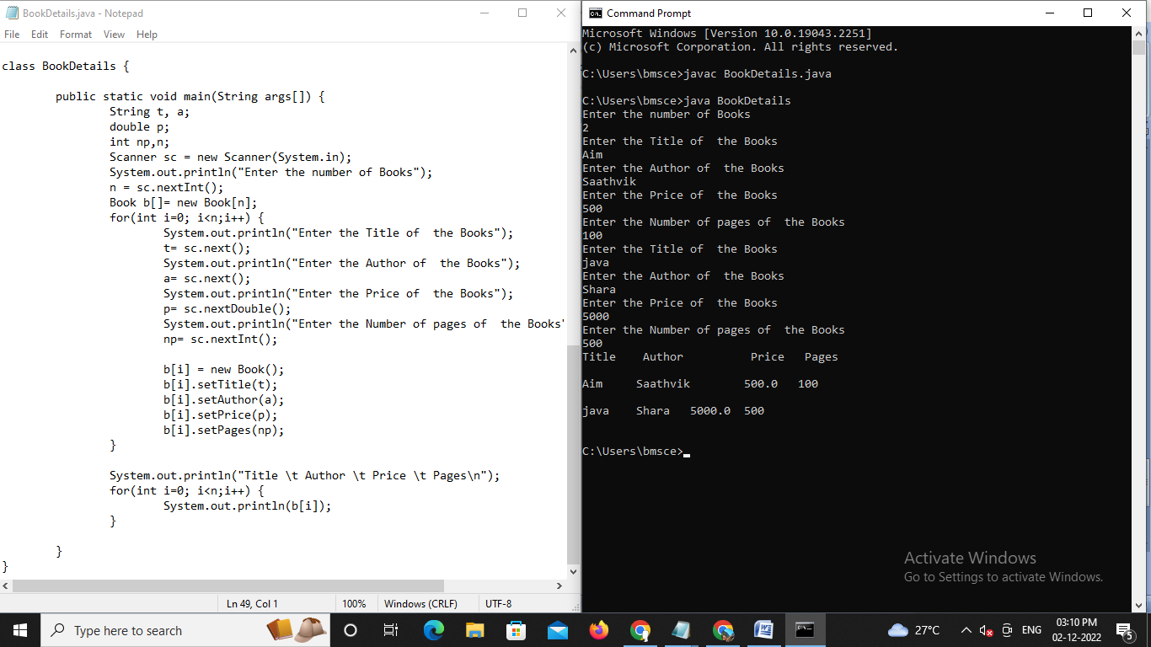;

b[i].setPrice(p);

b[i].setPages(np);

}

System.out.println("Title \t Author \t Price \t Pages\n");

for(int i=0; i<n;i++) {

System.out.println(b[i]);

}

}

}