

**CIE203**

**Software Engineering**

Project Name: BookIt

Software Design Document

Team Name: BugBusters

Team Leader: Mahmoud ElSayed

November 25, 2016

Contents

Instructions [To be removed] 3

Team 3

Document Purpose and Audience 3

System Models 4

I. System Decomposition 4

II. Class diagrams 7

III. Sequence diagrams 8

Class - Sequence Usage Table 10

IV. Physical Entity-Relationship Diagram 11

V. User Interface Design 11

VI. Algorithms and Data Structures 13

Ownership Report 13

Policy Regarding Plagiarism: 13

References 13

Authors 13

# Team

|  |  |  |  |
| --- | --- | --- | --- |
| **ID** | **Name** | **Email** | **Mobile** |
| 201304903 | Mahmoud ElSayed Abdelhameed | s-mahmoud.abdelhameed@zewailcity.edu.eg | 01285301109 |
| 201304766 | Omar Ibrahim Hagrass | s-omar.hagrass@zewailcity.edu.eg | 01095541958 |
| 201304126 | Rohanda ElSayed Abdallah | s-rohanda.abdallah@zewailcity.edu.eg | 01009644655 |

# Document Purpose and Audience

The purpose of this document is to describe the software design of the BookIt software, as detailed as possible to make life easy upon implementation and to make it easy for anyone to understand the system and its mechanisms.

The document includes system decomposition which is a breakdown of the system into main components, Class diagram and responsibilities which is a representation of the class model with their responsibilities and the relations among them, Database design which is an ER diagram showing entities, attributes and relations and keys along with any necessary description and finally this document includes Algorithm design which includes a flowchart of the used non trivial algorithms.

The target audience: software developers and software designers.

# System Models

## I. System Decomposition

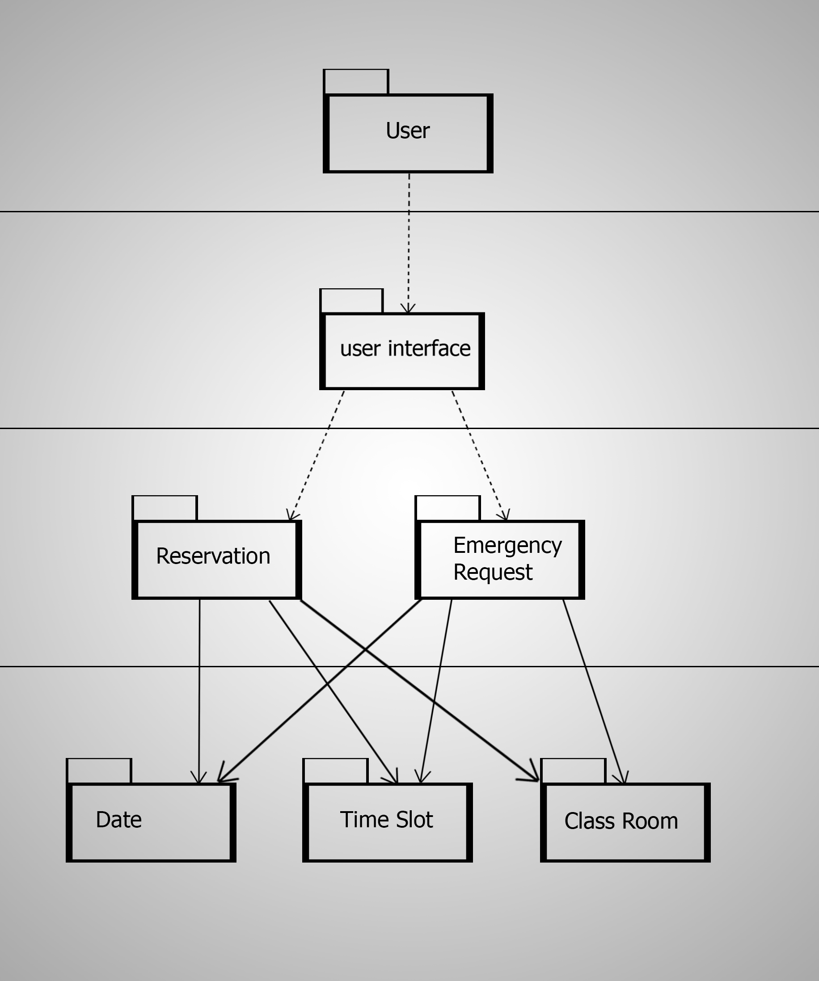

## II. Class diagrams (See the attached file)

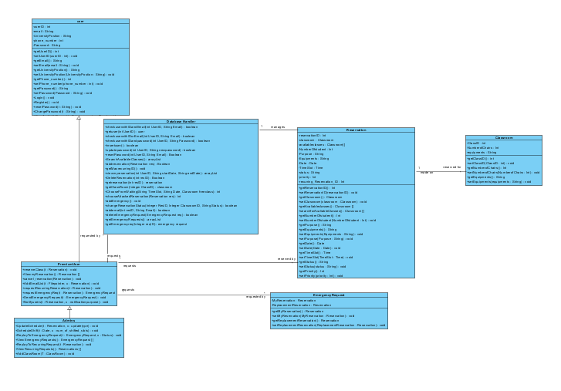

**III)Sequence Diagram (see attached files)**

* + **Make reservation**

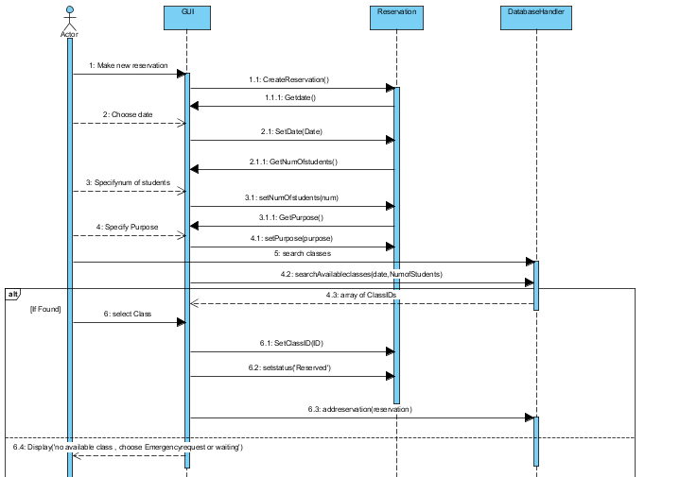

* + **Cancel Reservation**

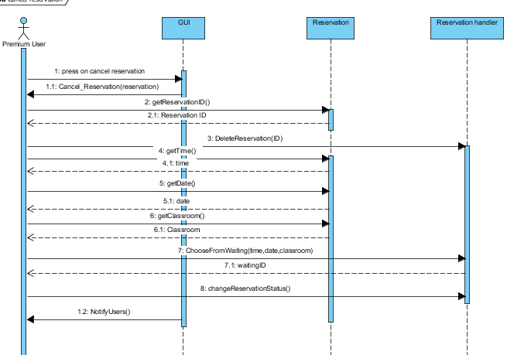

* + **Login**

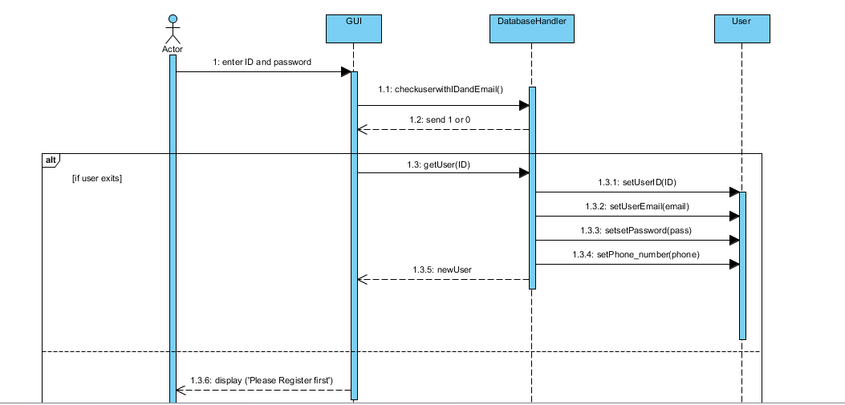

* + **Reply to recurring request**

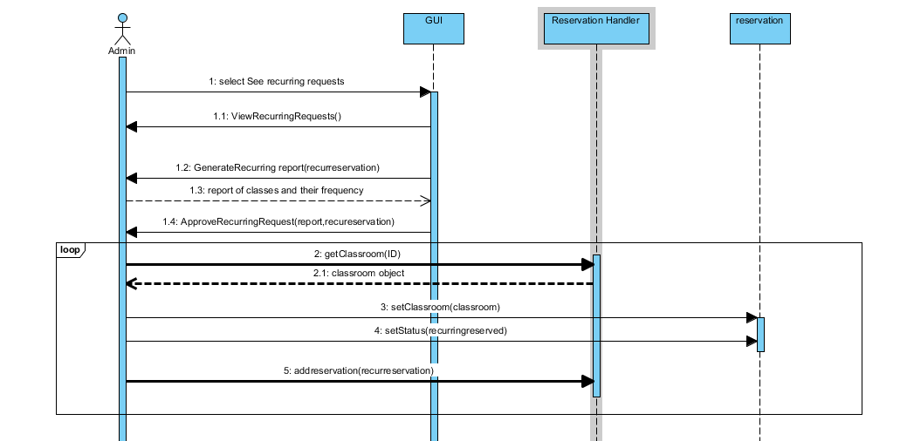

* + **Update Schedule**

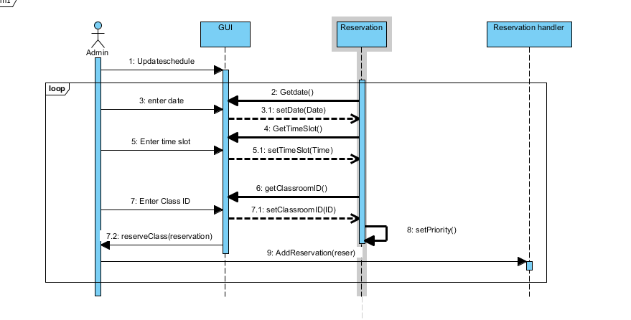

* + 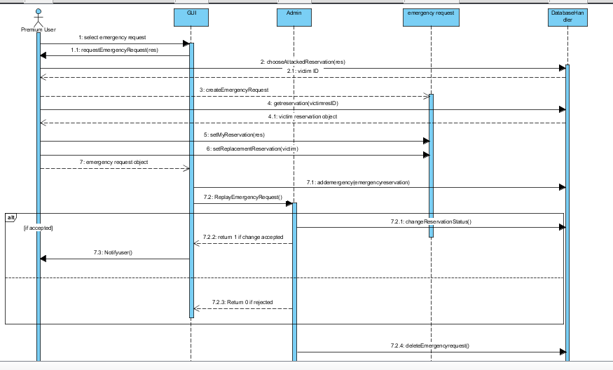**Reply Emergency request**

**List down your classes and describe them**

| **Class ID** | **Class Name** | **Subsystem ID** | **Description & Responsibility** |
| --- | --- | --- | --- |
| 1 | User | 1 | Hold the functions which can be done by this Normal user and the generic attributes of any user. |
| 2 | Premium User | 1 | Hold the functions which can be done by this premium user |
| 3 | Admin | 1 | Hold the functions which can be done by the admin. |
| 4 | Reservation | 3 | Hold the reservation specification and requirements. It also hold a function to search for the available class which meets the reservation requirements and hold a list of these avaliable classes and the status of reservation.  Note: it also hold a special attribute “recurring reservation_ID” to identify if the reservation is recurring and to indicate which reservation were done by the same recurring request  The object created here can be used as a parameter to add/cancel a reservation by the premium user or to update schedule by the Admin |
| 5 | EmergencyRequest | 3 | Used to create an emergeny request object which will be send by the Preimium user and replied to by the Admin |
| 6 | Class room | 4 | To Create a class room Object which is used to hold the classes attributes when we need to process a get the list of the avaliable classes from the data base or when we need to add a new class to the system |

## IV. Physical Entity-Relationship Diagram

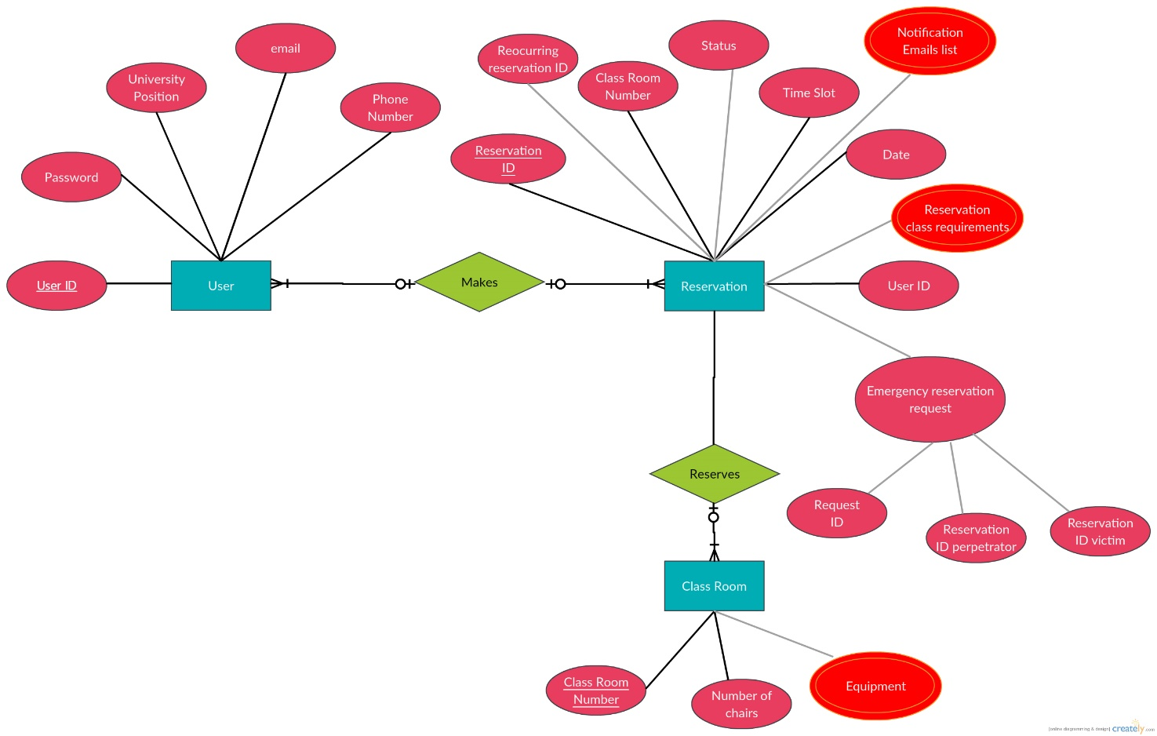

## 

## VI. Algorithms and Data Structures (see the attached file )

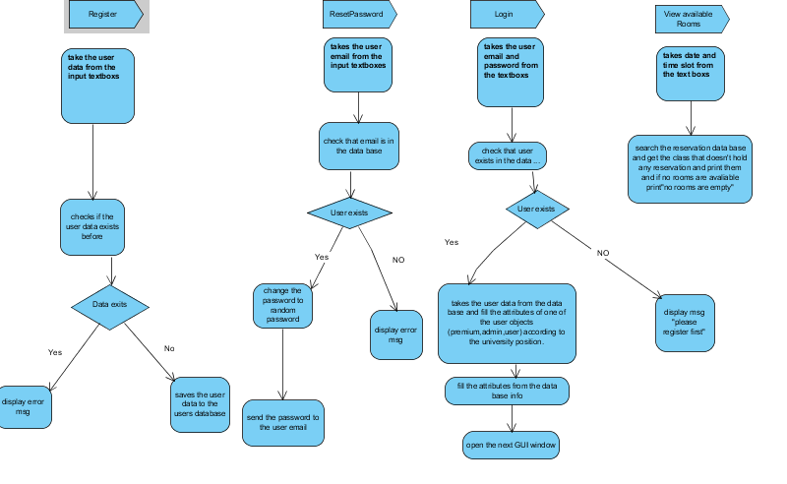

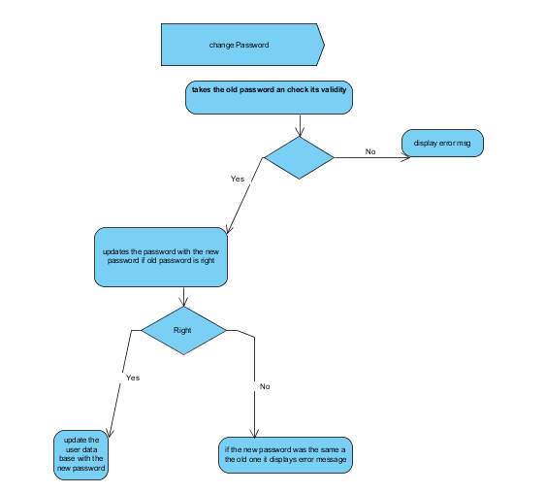

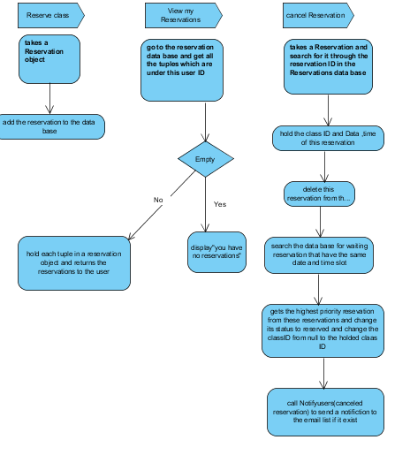

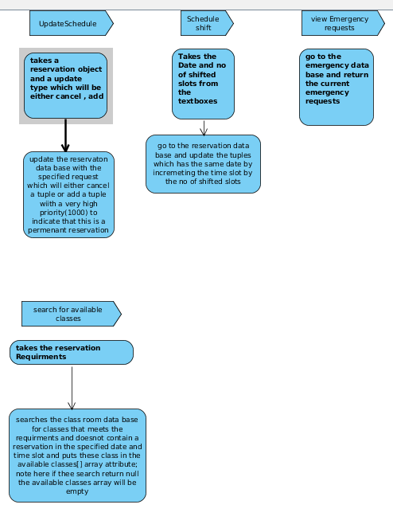

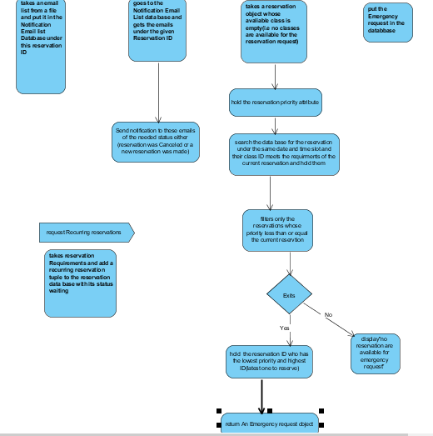

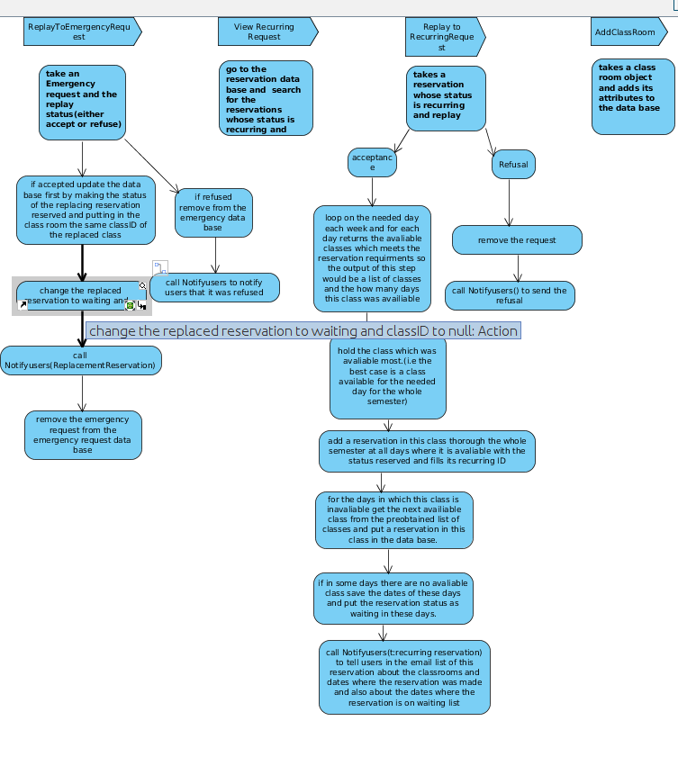

**User Interface**

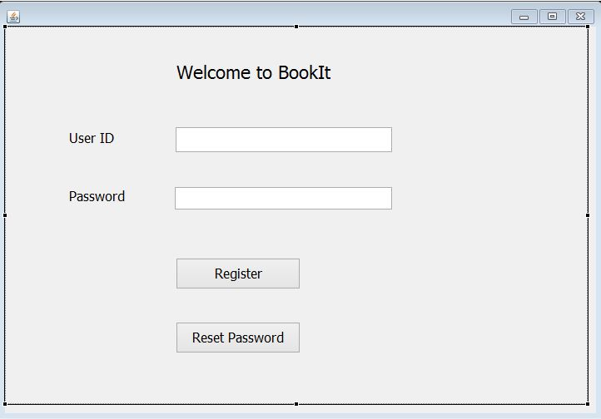

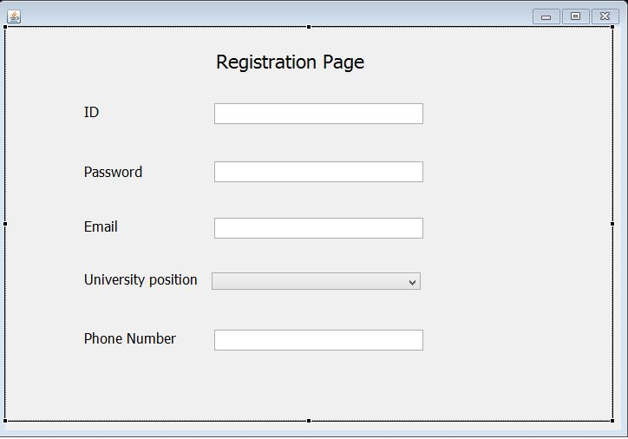

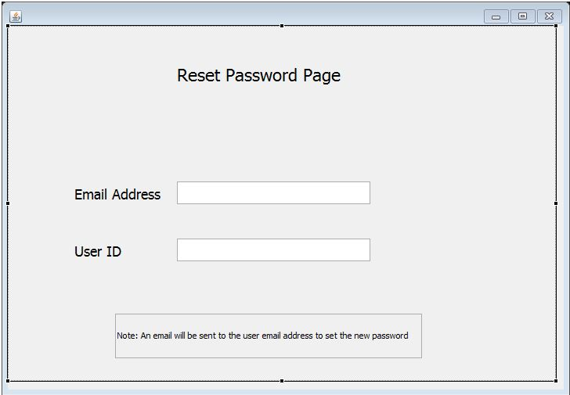

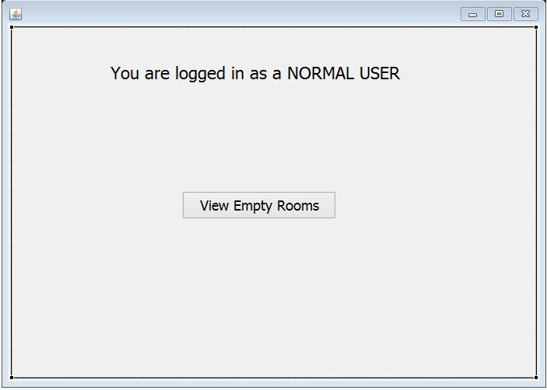

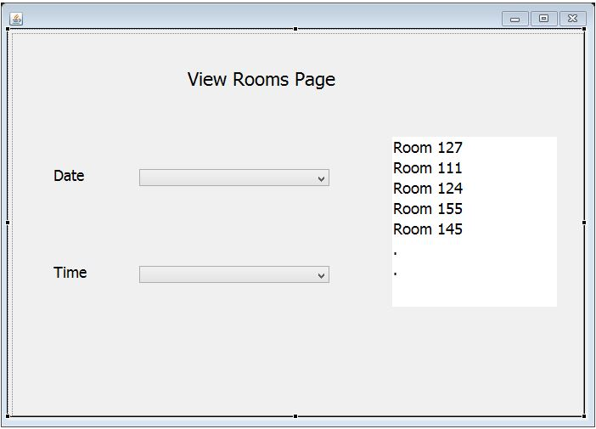

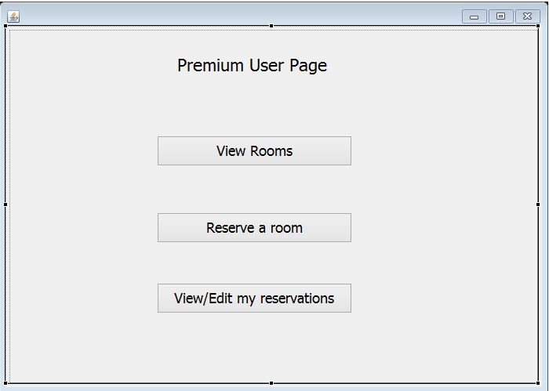

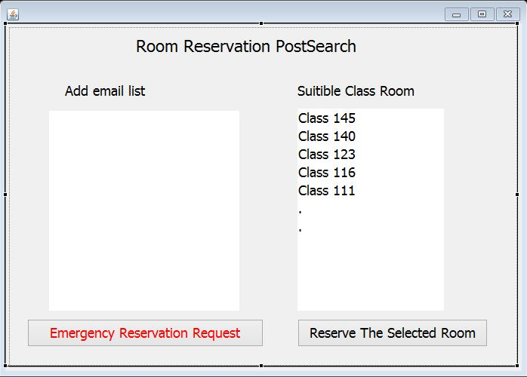

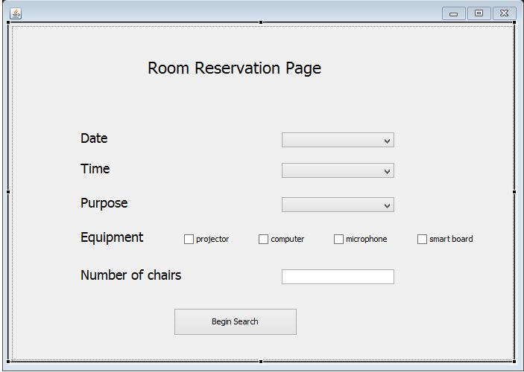

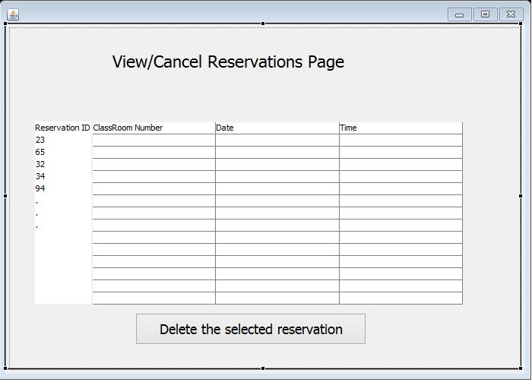

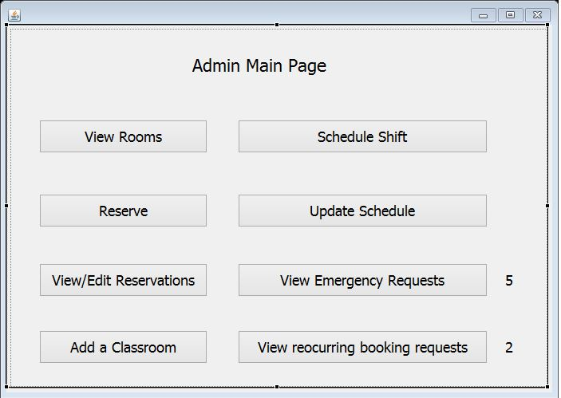

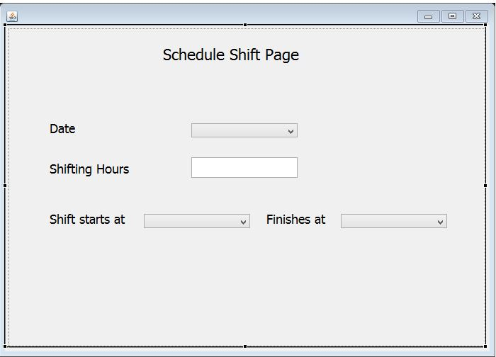

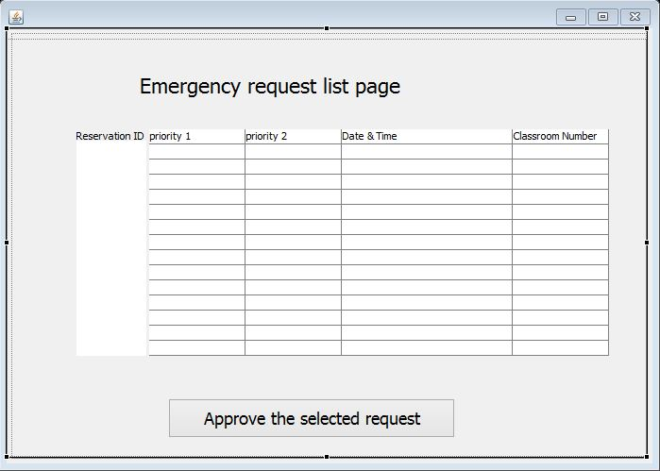

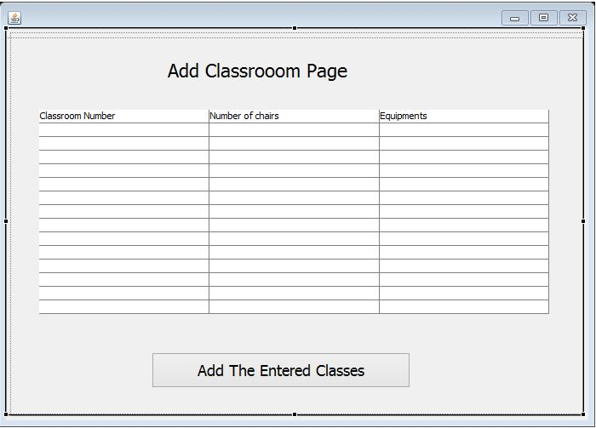

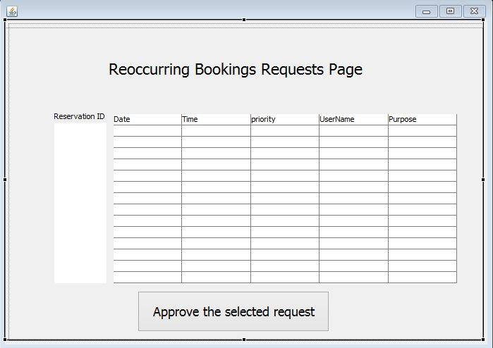

**OWNER SHIP**

|  |  |
| --- | --- |
| **Item** | **Owners** |
|  |  |
|  |  |