USER’S GUIDE

***Nutrition and Diet Application***

***by***

**The Best Team**

**Rohandra Macolm**

**Dobrian Zaprianov**

**Diamond Zetty**

**Dorrell Zimmerman**

Table of Contents

Introduction………………………………………………………3

Nutrition and Diet application………………………………3

System Features…………………………………………………5

Getting Started…………………………………………………..6

System Requirements……………………………………6

Installation…………………………………………………..7

Creating a Daily Diet Tracker……………………………8

Logging Food Item Data………………………………….9

Using the BMI calculator…………………………………….10

Using the BMR calculator……………………………………11

Exiting the Application……………………………………….12

**Introduction**

The Best Team is excited to present you with this state-of-the-art Diet and Nuntrition internet application! This software provides all necessary features to plan and track a healthy diet. It can calculate body mass index BMI and basal metabolic rate BMR parameters. The goal of this app is to help people around the world manage and track their food intake and achieve a healthy body weight!

**Nutrition and Diet Application**

The app is a Python based application that can be run on the user’s home desktop or laptop computer. It is platform dependent on Windows. However, it is browser independent!

**System Features**

Python based applications utilizing the latest Flask library tools.

|  |
| --- |
| [A blue and yellow snake logo  Description automatically generated](https://www.bing.com/images/search?q=&view=detailv2&id=DE51371A674888A582427D13DA4B589A2D11D2F6&ccid=dJToM1Ti&iss=fav&FORM=SVIM01&idpview=singleimage&mediaurl=https%253a%252f%252fbrandslogos.com%252fwp-content%252fuploads%252fimages%252flarge%252fpython-logo.png&expw=474&exph=472&thid=OIP.dJToM1TiZiJA0GYwzDHwjQAAAA) |
| [brandslogos.com](https://www.bing.com/images/search?q=&view=detailv2&id=DE51371A674888A582427D13DA4B589A2D11D2F6&ccid=dJToM1Ti&iss=fav&FORM=SVIM01&idpview=singleimage&mediaurl=https%253a%252f%252fbrandslogos.com%252fwp-content%252fuploads%252fimages%252flarge%252fpython-logo.png&expw=474&exph=472&thid=OIP.dJToM1TiZiJA0GYwzDHwjQAAAA) |

|  |
| --- |
| [A black and white image of a horn  Description automatically generated](https://www.bing.com/images/search?q=&view=detailv2&id=9A251BEE5EADC6FFB900A8AB7DC8166C7846D9BC&ccid=pelvrRMq&iss=fav&FORM=SVIM01&idpview=singleimage&mediaurl=https%253a%252f%252fwww.pngkey.com%252fpng%252ffull%252f98-985032_flask-logo-flask-python-icon.png&expw=800&exph=1028&thid=OIP.pelvrRMqLRe2X4Kxw0de0QHaJh) |
| [www.pngkey.com](https://www.bing.com/images/search?q=&view=detailv2&id=9A251BEE5EADC6FFB900A8AB7DC8166C7846D9BC&ccid=pelvrRMq&iss=fav&FORM=SVIM01&idpview=singleimage&mediaurl=https%253a%252f%252fwww.pngkey.com%252fpng%252ffull%252f98-985032_flask-logo-flask-python-icon.png&expw=800&exph=1028&thid=OIP.pelvrRMqLRe2X4Kxw0de0QHaJh) |

**Getting Started**

**System Requirements**

The Best Team Diet and Nutrition Application is a Python based application that should run on any system with Windows operating system. However, for the best experience it is strongly recommended to use Windows 11 or later.

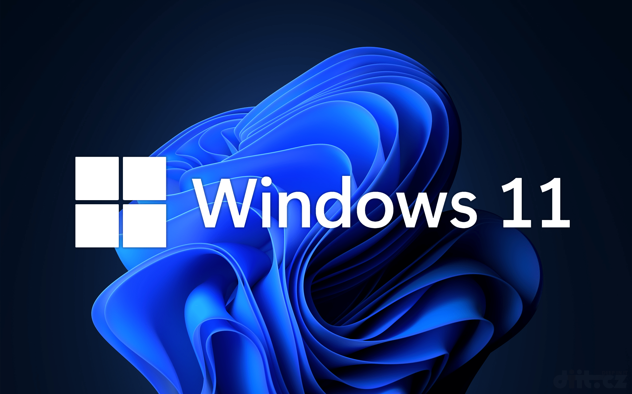

The latest version of Python and Flask should be installed prior to running this application.

**Installation**

You need to copy and paste the Diet Application_Final folder into your PycharmProjects folder. Then you need to select and run App.py in that folder. Finally, you need to press on <http://127.0.0.1:5000> at the bottom of the page.

**Creating a Daily Food Diary tracker**

The Food Diary page is easily accessible by pressing on the Food Diary option from the top menu bar of the internet application.

**Logging Food Item Data**

On the Daily Food Diary page, you can enter the food item that you ate and its calories. After that you need to click on the Add Food button and the food item will appear in the Food Diary log sheet. The total amount of calories will be conveniently updated for you!

**Using the BMI calculator**

The BMI calculator can be accessed by selecting it from the drop-down menu labeled Calculators. It will lead you to the BMI page. There you can enter your height in feet and inches and your age. After that you can click below on Calculate BMI button and the result will appear below!A screenshot of a computer

**Using the BMR calculator**

The BMR calculator can be accessed by selecting it from the drop-down menu labeled Calculators. It will lead you to the BMR page. There you can enter your height in inches, your weight in pounds and your age in years. You also need to select your gender from the drop-down menu below. After that you can click below on Calculate BMR button and the result will appear below!A screenshot of a computer

**Exiting the Application**

When you are ready to exit the application, the first step is to close your browser. Then then press to red stop button in your PyCharm editor. Finally, you need to close the PyCharm IDE by clicking on the X at the top right corner of the Python window.

