A SYNOPSIS ON

## DEPRESSION DETECTION USING FACIAL EXPRESSION & TEXT MINING

SUBMITTED TO THE SAVITRIBAI PHULE PUNE UNIVERSITY, PUNE

IN PARTIAL FULFILLMENT OF THE REQUIREMENTS

FOR THE AWARD OF THE DEGREE

**BACHELOR OF ENGINEERING**

*In*

**COMPUTER ENGINEERING**

*Of*

**SAVITRIBAI PHULE PUNE UNIVERSITY**

*By*

**RUSHIKESH LAHOLE ROLL NO: 40**

**KETAN KULKARNI ROLL NO: 45**

**JAYDEEP BHADANE ROLL NO: 08**

**ROHAN KAMBLE ROLL NO: 26**

Under the guidance

Of

**PROF. MADHAVI DESHPANDE**



**DEPARTMENT OF COMPUTER ENGINEERING**

**JSPM’s BHIVARABAI SAWANT INSTITUTE OF TECHNOLOGY & RESEARCH, WAGHOLI, PUNE - 412207**

**2021-2022**

## INTRODUCTION

**Background and basics**

Suicide is an important issue in the Indian context. More than one lakh (one hundred thousand) lives are lost every year to suicide in our country. In the last two decades, the suicide rate has increased from 7.9 to 10.3 per 100,000. There is a wide variation in the suicide rates within the country. The southern states of Kerala, Karnataka, Andhra Pradesh and Tamil Nadu have a suicide rate of > 15 while in the Northern States of Punjab, Uttar Pradesh, Bihar and Jammu and Kashmir, the suicide rate is < 3. This variable pattern has been stable for the last twenty years. Higher literacy, a better reporting system, lower external aggression, higher socioeconomic status and higher expectations are the possible explanations for the higher suicide rates in the southern states.

In 2020 the number of suicides in India had increased to 250,354. Suicide was the most common cause of death in both the age groups of 15-29 years and 15-39 years. About 900,000 people die by suicide worldwide every year, of these 135,000 (17%) are residents of India, a nation with 17.5% of world population.

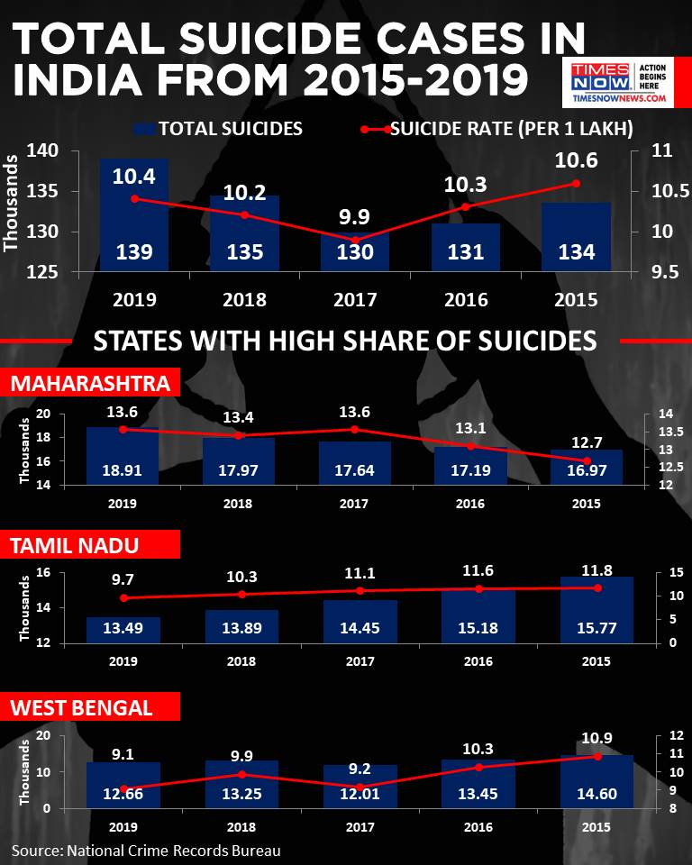

**Fig.1.1 Suicide deaths in India as a percentage of world**

India had the highest suicide rate in the South-East Asian region in 2020, a new report by the World Health Organization (WHO) has revealed. India’s own official statistics, which map the number and causes of suicides in the country, have not been made public for the last three years, hindering suicide prevention strategies and efforts to implement the WHO's recommendations in this regard.

The report presented suicide rates for countries and regions using data from the WHO Global Health Estimates for 2020. When classified according to region and income, India is part of the South-East Asia region and the Lower Middle-Income group of countries. India’s suicide rate (17.5) was higher than the rate of its geographic region (14.4) and the rate of its income group (12.4).

**Overview**

India’s suicide rate stood at 16.5 suicides per 100,000 people in 2016, according to the WHO report. This was higher than the global suicide rate of 10.5.

The objective of this project is to design a system which involves extraction of facial features, and detection of stress using emotions expressed through face using the Convolutional Neural Network (CNN) algorithm.

This system is basically used to classify positive and negative emotions and detects the stress based on usual threshold value. This system detects the emotions and helps to prevent rate of suicide.

**Motivation**

India reported an average 381 deaths by suicide daily in 2019, totaling 1,39,123 fatalities over the year, according to the latest National Crime Records Bureau (NCRB) data. A 3.4 per cent increase was observed in suicides during 2019 (1,39,123 suicides) as compared to 2018 (1,34,516) and 2017 (1,29,887), the data showed. The rate of suicide (incidents per 1 lakh population) rose by 0.2 per cent in 2019 over 2018, as per the data.

According to the statistics by the NCRB, which functions under the Union Home Ministry, the suicide rate in cities (13.9 per cent) was higher as compared to all-India suicide rate (10.4 per cent) in 2019. The motivation behind designing this project is to reduce the increasing suicidal rate using technique of emotion detection.

**Project Undertaken**

**Problem definition and objectives**

In early days suicidal rate is increased due to the depression therefore we need a automation system to find depressed person. Therefore, we design system which involves extraction of facial features, and detection of stress using emotions expressed through face using the Convolutional Neural Network (CNN) algorithm and classify positive and negative emotions and detects the stress based on usual threshold value.

**Project Scope**

Social networks have been developed as a great point for its users to communicate with their interested friends and share their opinions, photos, and videos reflecting their moods, feelings and sentiments. This creates an opportunity to analyze social network data for user’s feelings and sentiments to investigate their moods and attitudes when they are communicating via these online tools. This system will use in social media for automatic find person who are depressed using their post. This system can be helpful for psychologists/psychiatrist to cure the patients in near future.

**Methodologies and Problem Solving**

In this project, Face is captured using the camera. This detected face is processed and the emotions are classified as either positive or negative emotions. The detected image is processed to identify the face of the subject using Convolutional Neural Network (CNN) algorithm.

**Convolutional Neural Network (CNN):**

A Convolutional neural network (CNN) is a neural network that has one or more convolutional layers and are used mainly for image processing, classification, segmentation and also for other auto correlated data. A convolution is essentially sliding a filter over the input.

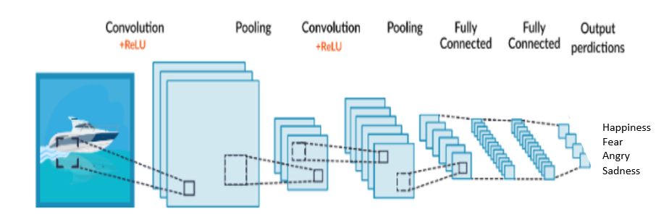

**Fig. 1.4CNN**

A Convolutional Neural Network (ConvNet/CNN) is a Deep Learning algorithm which can take in an input image, assign importance (learnable weights and biases) to various aspects/objects in the image and be able to differentiate one from the other.

**Existing System**

1. Considerable number of individuals experiences the ill-effects of despondency and just a division gets sufficient treatment every year.
2. Investigated the possibility to utilize online networking to identify and analyze any sign of significant depression issue in people.
3. Through their web-based social networking postings, they quantified behavioral credits identifying with social engagement, feeling, dialect and semantic styles, sense of the self-system, and notices of antidepressant medications.
4. The existing systems are capable of detecting depression either through video or text.
5. They use SVM, KNN which become inefficient when larger datasets are involved.
6. Datasets trained are either bag of words without any day to day phrases or the images.

**Proposed System**

1.) To Design web app for Depression detection using following methodology:

**A. Facial Expression (Emotion detection using CNN algorithm)**

**B. Text Mining ( NLP and naive Bayes)**

2.) Apply Image captioning after prediction.

3.) To generate detailed dashboard of user disease status.

4.) In proposed system we are using people’s videos and their text inputs.

5.) System uses CNN for processing video data and NLP + Naïve Bayes Classifier for text processing.

6.) If user found depressed, then further categorization of depression is done through video interview & accordingly he/she is provided with motivational material.

**Methodology Architecture :-**

Face of the subject is captured using the camera module. This detected face is processed and the emotions are classified as either positive or negative emotions. The detected image is processed to identify the face of the subject using Convolutional Neural Network (CNN) algorithm.

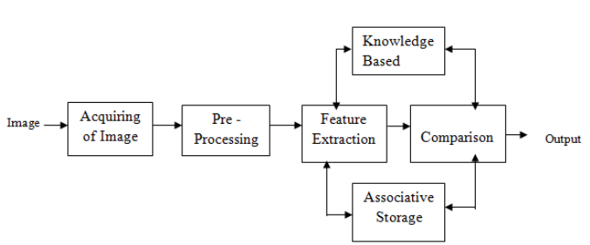

**Fig.3.2.1 Methodology Of the system**

This is plotted and an increase in the negative emotion can be inferred as increase in stress.

**Tools and Technologies Used**

**Python:**

Python is an interpreted, high-level, general-purpose programming language. Its language constructs and object-oriented approach aims to help programmers write clear, logical code for small and large-scale projects.

**CNN:**

A Convolutional neural network (CNN) is a neural network that has one or more convolutional layers and are used mainly for image processing, classification, segmentation and also for other auto correlated data. A convolution is essentially sliding a filter over the input.

**Python Libraries :**

Tensorflow, OpenCV, Numpy, Pandas

**Flask :**

Flask is a python framework used for creating web app.

**Algorithm Details**

**Algorithm 1/Pseudo Code**

Image Processing:

In computer science, image processing is the use of computer algorithms to perform image processing on digital images. We used image processing for detecting the faces from camera and to capture emotions on the detected images.

Steps for Image Detection :

Step 1:

Confirm the upper limit of the number of faces to be detected.

Step 2:

Adjust the scaling of the images according to the Device’s Camera.

Step3:

Give access of the device’s camera (to on and off) and pass the camera port as input to OpenCV library’s Video Capture method.

Step4 : Confirm the frequency of frames needed from the video and capture them within adjusted intervals.

**Mathematical Model**

Receive input data, process the information, and generate output

**Step 1:** Load the input images in a variable (say X)

**Step 2:** Define (randomly initialize) a filter matrix. Images are convolved with the filter

Z1 = X * *f*

**Step 3:** Apply the Relu activation function on the result

A = Relu(Z1)nf

**Step 4:** Define (randomly initialize) weight and bias matrix. Apply linear transformation on the values

Z2 = WT.A + b

**Step 5:** Apply the Relu function on the data. This will be the final output

O = Relu(Z2)

**Architectural Design**

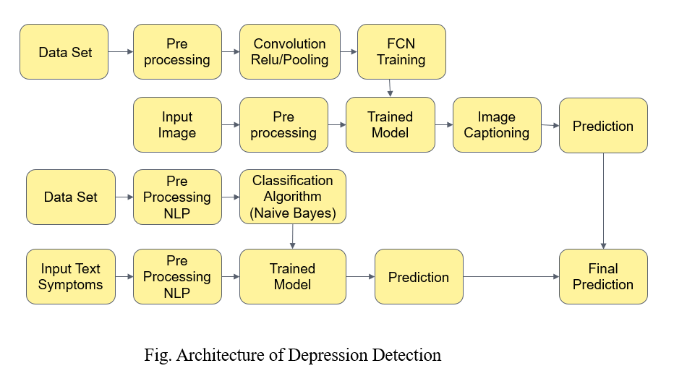

**Advantages:-**

1.) High Accuracy

2.) Less efficient

3.) Increase the precision of sentiment analysis for depression detection.

**Application :-**

1. Having observed that people tend to express their feelings on social media, this type of software integration can lead to early detection of depression.
2. If software used explicitly for Depression Detection (without integration on other platforms) then provides a remote service making it easier for people to assess their mental health.
3. Will be helpful as Psychiatrist’s tool for dealing with patients effectively.

**Conclusion**

The proposed system is successful at predicting depression in the test data from the dataset and also from real time video of user. In real world scenario when integrated with various web platforms, this system can create awareness about depression and also provide interface to detect their existing/upcoming depression. This model can help psychologists to detect depression of individuals and can suggest directions for future depression-related studies.

**References**

1. Author_Name : Aldarwish MM, Ahmad HF.

Topic_Name : Predicting depression levels using social media posts. In: 2017 IEEE 13th

international Symposium on Autonomous decentralized system (ISADS).

Year Of Published : 2017

2. Author_Name : Conway M, O’Connor D.

Topic_Name : Social media, big data, and mental health: current advances and ethical

implications. Curr Opin Psychol.

Year Of Published : 2016

Page no: 77-82

3. Author_Name : Greenberg LS.

Topic_Name : Emotion-focused therapy of depression

Year Of Published : 2017

4. Author_Name : Guntuku SC, et al.

Topic_Name : Detecting depression and mental illness on social media: an integrative

review.

Year Of Published : 2017

5. Author_Name : Mikal J, Hurst S, Conway M.

Topic_Name : Investigating patient attitudes towards the use of social media data to

augment depression diagnosis and treatment In: Proceedings of the fourth workshop on

computational linguistics and clinical psychology from linguistic signal to clinical reality.

Year Of Published : 2017

6. Author_Name : O’Dea B, et al.

Topic_Name : Detecting suicidality on Twitter

Year Of Published : 2015 and 2018

7. Author_Name : Scott J.

Topic_Name : Social Network analysis

Year Of Published : 2017

8. Author_Name : Serrat O.

Topic_Name : Social network analysis In knoledge solutions

Year of Published: 2017

Page no: 39-43

9. Author_Name : Wee J, et al.

Topic_Name : The influence of depression and personality on social networking.

Year Of Published : 2017

10. Author_Name : Zhang L, et al.

Topic_Name : Using linguistic features to estimate suicide probability of Chinese

microblog users. In: International conference on human centered computing.

Year Of Published : 2014

11. Author_Name : Zhou J, et al.

Topic_Name : Measuring emotion bifurcation points for individuals in social media. In

: 2016 49th Hawaii international conference on system sciences (HICSS).

Year Of Published : 2016