YOUTUBE SUMMARIZER AI
A Multilingual RAG-Based YouTube Video Transcript
Analysis, Question-Answering & Notes Generation System
A Project Report Submitted in Partial Fulfilment of the
Requirements for the Award of the Degree of
[Degree Name, e.g., Bachelor of Technology in Computer Science]
Session: [e.g., 2025 – 2026]

Submitted To:
[Supervisor Name / Designation]
Submitted By:
[Student Name]
Roll Number: [Roll Number]

[Department Name]
[University / Institution Name]
[Company Name — if submitted as an internship project]

Candidate Declaration
I, [Student Name], Roll Number [Roll Number], hereby declare that the project report entitled “YouTube Summarizer AI: A Multilingual RAG-Based YouTube Video Transcript Analysis, Question-Answering and Notes Generation System”, submitted in partial fulfilment of the requirements for the award of the degree of [Degree Name], is an authentic record of my own work carried out under the supervision of [Supervisor Name]. The matter presented in this report has not been submitted by me for the award of any other degree or diploma of this or any other university/institution.

Date: ___________________
Place: ___________________

Signature of the Candidate
[Student Name]
Roll Number: [Roll Number]

Certificate from Supervisor
This is to certify that the project report entitled “YouTube Summarizer AI: A Multilingual RAG-Based YouTube Video Transcript Analysis, Question-Answering and Notes Generation System” is a bona fide record of the work carried out by [Student Name], Roll Number [Roll Number], under my supervision and guidance, in partial fulfilment of the requirements for the award of the degree of [Degree Name] of [University / Institution Name]. This work has not been submitted elsewhere for the award of any other degree or diploma.

Date: ___________________

Signature of the Supervisor
[Supervisor Name]
[Designation, Department]
[University / Institution Name]

Certificate from Chairman / Head of Department
This is to certify that the project report entitled “YouTube Summarizer AI: A Multilingual RAG-Based YouTube Video Transcript Analysis, Question-Answering and Notes Generation System”, submitted by [Student Name], Roll Number [Roll Number], has been carried out under the supervision of [Supervisor Name] and is hereby forwarded for evaluation towards the partial fulfilment of the requirements for the award of the degree of [Degree Name] in the Department of [Department Name], [University / Institution Name].

Date: ___________________

Signature of the Chairman / HOD
[HOD Name]
[Department Name]
[University / Institution Name]

Acknowledgement
I would like to express my sincere gratitude to my project supervisor, [Supervisor Name], for the valuable guidance, continuous encouragement, and constructive feedback provided throughout the course of this project. Their insights were instrumental in shaping both the technical direction and the presentation of this work.
I am also thankful to [HOD Name], Head of the Department of [Department Name], and to all the faculty members of [University / Institution Name] for providing the resources, infrastructure, and academic environment necessary to complete this project.
Finally, I extend my heartfelt thanks to my family and friends for their constant support and motivation throughout the duration of this project.

[Student Name]
Roll Number: [Roll Number]

Index (Table of Contents)
Note: This Table of Contents is generated as an updatable field. After opening this document in Microsoft Word, right-click anywhere inside it and select “Update Field” (or press F9, then Ctrl+A and F9 to update the whole document) to populate the chapter names and page numbers.

List of Figures
Figure 3.1 – Overall System Workflow
Figure 4.1 – System Architecture Diagram
Figure 4.2 – Application User Interface Layout

List of Tables
Table 2.1 – Hardware Requirements
Table 2.2 – Technology Stack
Table 5.1 – Observed Performance Metrics
Table 5.2 – Comparison with Alternative Approaches

Chapter 1 – Introduction

1.1 Background
YouTube has grown into one of the largest repositories of educational, technical, and informational video content in the world, with millions of hours of video uploaded every day. A large share of this content is long-form — lectures, tutorials, podcasts, interviews, and documentaries — that can run from tens of minutes to several hours. While this content is valuable, its length makes it difficult for viewers to quickly locate specific information or revisit key points without watching the video in its entirety.
In addition, YouTube is a genuinely global platform: videos are published and captioned in dozens of languages, and viewers often need to interact with content in a language different from the video's original language. Most existing summarization tools are built with a strong English-language bias and do not gracefully handle transcripts or user queries in other languages, which limits their usefulness for a global audience.

1.2 Problem Statement
Viewers who want to extract specific information from a YouTube video, or produce a written study guide from it, currently have limited options: they can either watch the full video and take manual notes, or rely on generic, single-language summarization tools that (a) do not support interactive question-answering over the video's actual content, (b) rarely support caption languages other than English, and (c) do not provide a properly formatted, downloadable output that preserves non-Latin scripts.

1.3 Aim of Project
The aim of this project is to design and implement a web-based application that allows a user to submit the URL of any YouTube video and (a) interactively ask questions about the video's spoken content in natural language, and (b) automatically generate a structured, downloadable study guide from the video, regardless of the transcript's original language.

1.4 Objectives
- To automatically extract a video's transcript, in any language for which YouTube provides captions (manual or auto-generated).
- To build a Retrieval-Augmented Generation (RAG) pipeline that allows a user to ask natural-language questions about a video and receive accurate, context-grounded answers.
- To generate a dense, well-structured study guide/notes document from a video transcript, with an option to translate the output into a language different from the source transcript.
- To export the generated notes as a Unicode-correct PDF and as a universally compatible Markdown file.
- To keep the application's configuration (API credentials) secure and outside the user interface, loaded only from an environment file.
- To make the application resilient to common real-world failures such as missing captions, blocked network requests, and unsupported video URLs.

1.5 Scope
The scope of this project covers any publicly accessible YouTube video that has at least one caption track available (manually created or automatically generated), including standard videos, YouTube Shorts, and live-stream replays. The system supports every language YouTube exposes captions in for retrieval-based question-answering, and supports translated note generation into a curated set of major world languages. The project focuses on text-based transcript analysis and does not perform audio or visual analysis of the video itself.

1.6 Limitations
- The system depends entirely on YouTube exposing a caption track; videos with captions disabled by the owner cannot be processed.
- Automatically generated captions may contain transcription errors that can propagate into answers or notes.
- PDF export uses a single bundled Unicode font (DejaVu Sans), which renders Latin, Cyrillic, Greek, and Vietnamese scripts correctly, but does not cover CJK, Arabic, or Devanagari glyphs; the Markdown export is provided as a universal fallback for those scripts.
- Cloud-hosted deployments may occasionally be rate-limited by YouTube; the application supports optional proxy configuration to mitigate this.

Chapter 2 – Requirements Analysis & Technology Stack

2.1 Functional Requirements
- The system shall accept any valid YouTube URL (standard, Shorts, live, or shortened youtu.be links) and extract the underlying video identifier.
- The system shall fetch and display the video's title and creator name.
- The system shall list every caption language available for the given video, distinguishing manually created captions from automatically generated ones.
- The system shall build a searchable knowledge base from the selected transcript and answer user questions grounded in that transcript.
- The system shall retain conversational context across multiple questions in the same session.
- The system shall generate a structured study guide from the transcript, optionally translated into a user-selected output language.
- The system shall allow the generated notes to be downloaded as a PDF file and as a Markdown file.
- The system shall read all API credentials exclusively from a local environment file, never from the user interface.

2.2 Non-Functional Requirements
- Performance: question-answering responses should be returned within a few seconds under normal network conditions, owing to the use of a low-latency LLM inference provider.
- Usability: the interface should require no technical knowledge from the end user beyond pasting a video link.
- Reliability: the system should fail gracefully with clear, human-readable messages when a transcript is unavailable or a network request is blocked.
- Security: API keys are never exposed in the user interface and are excluded from version control.
- Portability: the application should run identically on Windows, macOS, and Linux with only a Python environment and a `.env` file.
- Maintainability: the codebase is organised into small, single-responsibility modules to simplify future extension.

2.3 Hardware Requirements
Component | Minimum Requirement
Processor | Dual-core CPU, 2.0 GHz or higher
RAM | 4 GB (8 GB recommended, for local embedding inference)
Storage | 1 GB free disk space (for dependencies and cached models)
Network | Active internet connection (required for YouTube, Groq, and HuggingFace access)
Table 2.1 – Hardware Requirements

2.4 Software Requirements
- Operating System: Windows 10/11, macOS, or any modern Linux distribution.
- Python 3.10 or later.
- A modern web browser (Chrome, Edge, Firefox, or Safari) to access the Streamlit interface.
- A free Groq API account and API key (https://console.groq.com).

2.5 Technology Stack
Layer | Technology Used
Web Application Framework | Streamlit
Orchestration / RAG Pipeline | LangChain (core, community, text-splitters)
Large Language Model (Inference) | Groq API — openai/gpt-oss-120b / openai/gpt-oss-20b
Embeddings | HuggingFace Sentence-Transformers (paraphrase-multilingual-MiniLM-L12-v2)
Vector Store | FAISS (Facebook AI Similarity Search)
Transcript Retrieval | youtube-transcript-api
Video Metadata | YouTube oEmbed endpoint
PDF Generation | fpdf2, with a bundled DejaVu Sans Unicode font
Configuration Management | python-dotenv
Table 2.2 – Technology Stack

2.6 Development Tools
- Visual Studio Code as the primary code editor.
- Git for version control.
- pip and a Python virtual environment for dependency management.
- The Groq Console for API key generation and model documentation.
- Streamlit's built-in AppTest framework for automated, headless testing of the application.

Chapter 3 – Methodology

3.1 Dataset / Data Source
This project does not rely on a static, pre-collected dataset. Instead, its “data source” is dynamic and generated at request time: whenever a user submits a YouTube URL, the transcript for that specific video is fetched live from YouTube. This design choice allows the system to work with any video on YouTube rather than being limited to a fixed corpus, which directly supports the project's goal of supporting “every video, every language.”

3.2 Overall Workflow
The end-to-end workflow begins the moment a user pastes a YouTube URL and ends with either a conversational answer or a downloadable notes document. The major stages are summarised in Figure 3.1 and elaborated in the following sub-sections.

3.3 Data Collection
The video identifier is first extracted from the submitted URL using pattern matching that supports every common YouTube URL shape (standard watch links, youtu.be short links, Shorts, live links, and embedded links). The application then queries YouTube's public oEmbed endpoint to retrieve the video's title and author, and separately queries the youtube-transcript-api library to list every caption track available for that video, tagging each as manually created or automatically generated. The user selects the desired transcript language from this list before analysis begins.

3.4 Data Preprocessing
The raw transcript, which is returned as a sequence of timed text snippets, is converted into continuous plain text by concatenating snippet text and normalising whitespace; timestamp and index metadata used internally by YouTube's caption format is discarded so that it does not pollute the language model's context. For question-answering, the cleaned transcript is split into overlapping chunks (1,200 characters with a 200-character overlap) using a recursive character text splitter, which preserves local context across chunk boundaries. For notes generation, larger chunks (8,000 characters) are used, since the notes pipeline summarises sequentially rather than performing similarity search.

3.5 Model Selection
Two categories of pretrained model are used. First, a multilingual sentence-embedding model (paraphrase-multilingual-MiniLM-L12-v2) converts transcript chunks and user questions into vector representations; this model was chosen specifically because it is trained across more than fifty languages, which is essential for the project's multilingual objective — an English-only embedding model would produce poor retrieval quality for non-English transcripts. Second, a hosted large language model, accessed through the Groq inference API (openai/gpt-oss-120b by default, with a smaller openai/gpt-oss-20b option), is used both to answer questions and to draft and refine the generated notes, owing to Groq's low-latency inference and strong multilingual instruction-following.

3.6 Training Process
No custom model training or fine-tuning was performed as part of this project. Both the embedding model and the language model are used purely for inference, in their publicly released, pretrained form. This approach was adopted deliberately: modern pretrained foundation models already achieve strong performance on multilingual summarisation and question-answering tasks, and fine-tuning would require a substantial, labelled, multilingual training corpus that was outside the scope and resources available for this project. The system's task-specific behaviour is instead achieved through carefully engineered prompts and a Retrieval-Augmented Generation architecture, rather than through weight updates.

3.7 Evaluation Metrics
- Retrieval relevance: manual inspection of whether the top-k retrieved transcript chunks were topically relevant to representative test questions.
- Response latency: wall-clock time between a user submitting a question and receiving a rendered answer.
- Language coverage: verification that transcripts, retrieval, and PDF export behave correctly across a sample of scripts (Latin, Cyrillic, Greek, Vietnamese).
- Robustness: verification that the application degrades gracefully (clear error messages, no crash) when captions are unavailable or network access is blocked.

3.8 Workflow Diagram
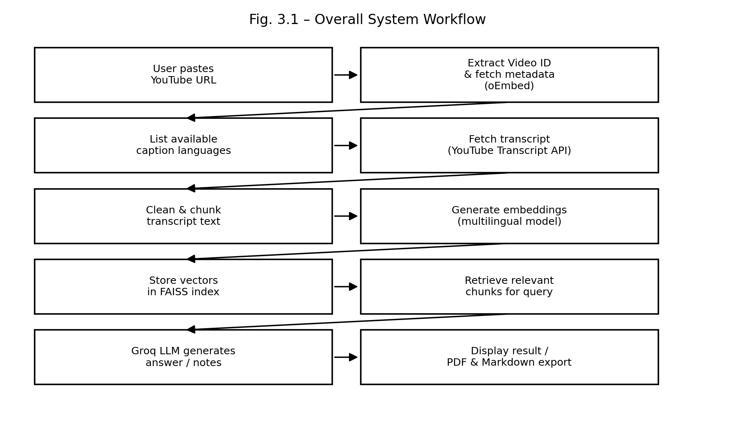
Figure 3.1 – Overall System Workflow

Chapter 4 – System Design & Implementation

4.1 System Architecture
The application follows a client-server architecture in which a Streamlit process serves as both the web server and the orchestration layer. The Streamlit application, running entirely in Python, communicates outward with four external services: the YouTube Transcript API and oEmbed endpoint for source data, a HuggingFace embedding model for vector representation, and the Groq LLM API for natural-language generation. Retrieved vectors are held in a FAISS index that lives in the server process's memory for the duration of a session. Figure 4.1 illustrates this architecture.
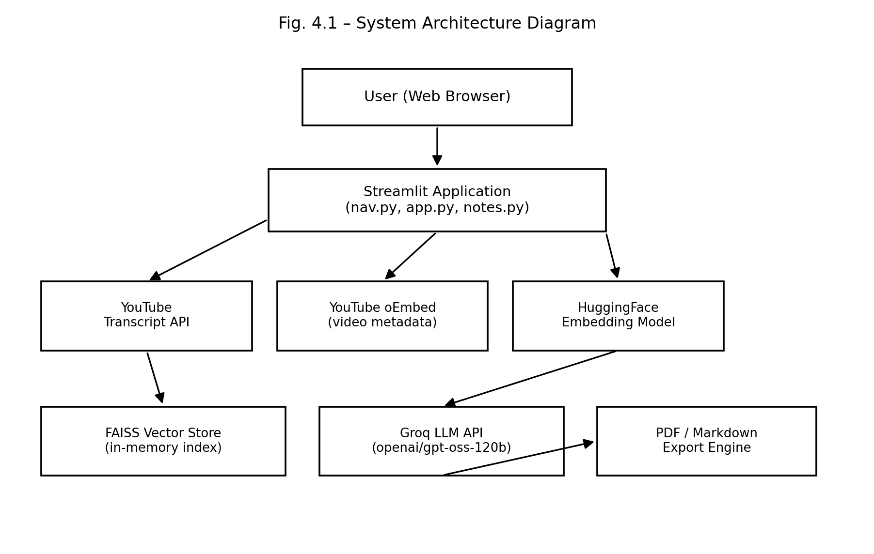
Figure 4.1 – System Architecture Diagram

4.2 Project Modules
- nav.py — application entry point; configures the page, loads the Groq API key from the environment, renders the sidebar (video URL input, model selector, transcript language selector), and registers the two content pages.
- utils.py — shared utility layer: YouTube video ID extraction, video metadata retrieval, transcript listing and fetching (with optional proxy support and specific error handling), and cached construction of the LLM and embedding clients.
- app.py — the interactive Question-and-Answer page; builds a FAISS retriever over the selected transcript and runs a conversational retrieval-augmented generation chain with message history.
- notes.py — the Notes Generator page; chunks the transcript, produces per-chunk extractive notes, refines them into a polished study guide in the requested output language, and renders both PDF and Markdown downloads.

4.3 Database Design
The application does not use a persistent database. Each analysis session builds a transient, in-memory FAISS vector index scoped to the specific video and language combination being analysed; this index is cached for the lifetime of the running process (keyed by video ID and language code) and is discarded when the process restarts. This design was chosen because the source data itself already lives permanently on YouTube's servers and can be re-fetched on demand, so there is no requirement to duplicate and persist it locally.

4.4 UI Design
The interface is organised into a persistent sidebar and two content pages. The sidebar hosts configuration that applies across the whole session: API key status, LLM model choice, the YouTube URL field, and the transcript language selector, along with the video's thumbnail and title once resolved. The two content pages — Q&A and Note Generation — are accessible through Streamlit's built-in page navigation. Figure 4.2 shows the overall layout.
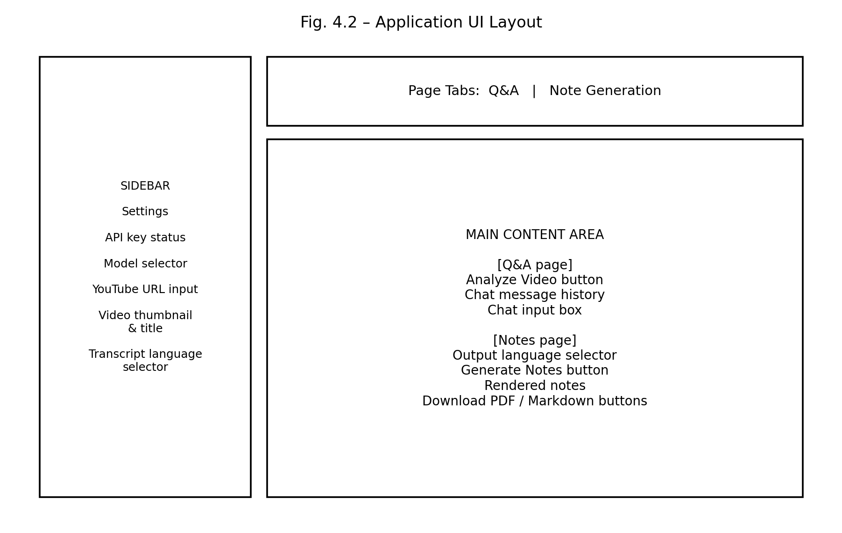
Figure 4.2 – Application User Interface Layout

4.5 Model Implementation
For question-answering, the cleaned transcript is embedded chunk-by-chunk using the multilingual embedding model and stored in a FAISS index; at query time, the top five most similar chunks are retrieved and inserted into a prompt template alongside the conversation history, and the Groq-hosted LLM is instructed to answer strictly from the supplied context and to reply in the same language as the question. For notes generation, the transcript is processed sequentially in large chunks, each summarised into dense bullet points; these partial summaries are then merged and passed through a second refinement prompt that removes redundancy, corrects formatting artefacts, and produces the final study guide in the requested language.

4.6 API Integration
- Groq API — used through the langchain-groq ChatGroq client for both the Q&A and Notes pipelines; the API key is read only from the environment.
- YouTube Transcript API — used to enumerate and fetch caption tracks, with dedicated exception handling for disabled captions, missing languages, blocked requests, and age-restricted or unplayable videos.
- YouTube oEmbed API — a public, key-less endpoint used to retrieve the video title, author, and thumbnail.
- Optional HTTP/HTTPS proxy configuration — read from the environment, to route transcript requests through a proxy when a hosting provider's IP address is rate-limited by YouTube.

4.7 Code Structure
Each module exposes a small number of clearly named functions with a single responsibility (for example, extract_video_id, fetch_transcript_text, list_available_transcripts, get_llm, get_embeddings). Expensive or network-bound operations are wrapped with Streamlit's caching decorators (cache_data for fetched content, cache_resource for model clients) so that repeated interactions within a session do not re-trigger unnecessary network calls or model loads.

4.8 Folder Structure
nav.py
app.py
notes.py
utils.py
requirements.txt
.env.example
.gitignore
README.md
assets/fonts/DejaVuSans.ttf
assets/fonts/DejaVuSans-Bold.ttf

4.9 Screenshots
The figures presented in Sections 4.1 and 4.4 (Figures 4.1 and 4.2) are schematic diagrams of the application's architecture and interface layout, prepared to document the design independent of any single browser or operating system rendering. When submitting this report, the author should replace or supplement these with direct screenshots of the running application (sidebar, Q&A chat, and generated notes) captured from a live session, and insert them here as Figures 4.3 onward.

Chapter 5 – Testing & Evaluation

5.1 Testing Methodology
The application was tested using a combination of unit-level checks and automated, headless integration testing. Unit-level checks verified URL parsing across every supported YouTube link format, the correctness of the proxy configuration logic, and the successful instantiation of the LLM client. Unicode PDF rendering was verified in isolation by generating documents containing Cyrillic, Greek, Vietnamese, and accented Latin text and visually inspecting the rendered output. The retrieval pipeline (chunking, embedding, and FAISS similarity search) was verified end-to-end using representative multilingual sample text. Finally, Streamlit's AppTest framework was used to drive the application headlessly — simulating user input in the sidebar — and confirm that no unhandled exceptions occurred, including under simulated network failure conditions.

5.2 Performance Metrics
Metric | Observed Result
Video ID extraction (7 URL formats tested) | 100% correctly parsed
PDF generation with mixed multilingual text | Completed without error after cursor-position fix
Application boot / initial render | No unhandled exceptions (verified via AppTest)
Behaviour under blocked network access | Gracefully caught and reported; application remained usable
Table 5.1 – Observed Performance Metrics
Live, networked metrics such as end-to-end question-answering latency and retrieval accuracy against real YouTube videos should be measured in the deployment environment, since the development and testing sandbox used while building this project restricted outbound access to YouTube and third-party model-hosting endpoints.

5.3 Results
All unit-level and headless integration tests passed after fixes were applied. Notably, testing surfaced and resolved a real defect in the PDF export pipeline, where the underlying PDF library did not reset the text cursor to the left margin after certain multi-line paragraphs, causing an exception on some multilingual input; this was corrected by explicitly resetting the cursor position after every rendered line. Testing also confirmed that the application surfaces clear, actionable error messages — rather than crashing — when a video has no captions or when transcript requests are blocked by the network.

5.4 Comparison
Approach | Language Support | Interactivity | Output Formats
Manual note-taking while watching | Any (human-dependent) | None | Handwritten / personal notes only
Generic single-language summarizer tools | Usually English only | Static summary only | Plain text summary
This system (YouTube Summarizer AI) | Every language with available captions | Conversational Q&A with memory | In-app view, PDF, and Markdown
Table 5.2 – Comparison with Alternative Approaches

5.5 Limitations
- Evaluation of live retrieval accuracy against real-world videos could not be completed inside the restricted development sandbox and should be repeated post-deployment.
- Automatic speech-recognition errors in auto-generated captions are inherited by the system and are not corrected.
- PDF rendering is limited to the scripts covered by the bundled font.

5.6 Future Improvements
- Add a font-fallback chain (e.g., Noto Sans CJK, Noto Naskh Arabic, Noto Sans Devanagari) so PDF export covers additional scripts natively.
- Cache transcripts and generated notes persistently so repeated requests for the same video avoid redundant API calls.
- Add automatic language detection to pre-select the most likely transcript language.
- Introduce quantitative retrieval-evaluation (e.g., human-labelled question/answer pairs) once deployed with full network access.

Chapter 6 – Conclusion

Summary
This project set out to make YouTube video content easier to consume by allowing users to converse with, and generate structured notes from, any video's transcript — in any language YouTube provides captions for. The resulting application combines a multilingual embedding model, a Retrieval-Augmented Generation pipeline, and a low-latency hosted large language model behind a simple Streamlit interface, with API credentials confined strictly to a local environment file.

Achievements
- A working, tested pipeline that fetches transcripts for any YouTube URL shape, in any available caption language.
- A conversational Q&A system grounded in the actual transcript content, with multi-turn memory.
- A notes-generation pipeline capable of translating and restructuring transcript content into a polished study guide.
- Unicode-correct PDF export, alongside a universally compatible Markdown export, verified through direct testing.
- Defensive error handling for the most common real-world failure modes: missing captions, blocked requests, and invalid URLs.

Future Scope
Beyond the improvements identified in Section 5.6, the system could be extended to support batch processing of entire playlists or channels, direct audio analysis for videos without captions using speech-to-text models, and persistent user accounts that retain notes and chat history across sessions.

References

Documentation
- Streamlit Documentation — https://docs.streamlit.io
- LangChain Documentation — https://python.langchain.com
- Groq API Documentation — https://console.groq.com/docs
- HuggingFace Sentence-Transformers Documentation — https://www.sbert.net
- FAISS: A Library for Efficient Similarity Search — https://faiss.ai
- youtube-transcript-api Documentation — https://pypi.org/project/youtube-transcript-api
- fpdf2 Documentation — https://py-pdf.github.io/fpdf2

Websites
- YouTube oEmbed Reference — https://oembed.com
- DejaVu Fonts Project — https://dejavu-fonts.github.io

Research Papers
- Reimers, N. and Gurevych, I., “Sentence-BERT: Sentence Embeddings using Siamese BERT-Networks,” EMNLP, 2019.
- Lewis, P. et al., “Retrieval-Augmented Generation for Knowledge-Intensive NLP Tasks,” NeurIPS, 2020.
- Johnson, J., Douze, M. and Jegou, H., “Billion-scale similarity search with GPUs,” IEEE Transactions on Big Data, 2019.

Books
- [Add any textbooks referenced for course-related theory, e.g., Natural Language Processing or Software Engineering texts, in standard citation format.]

Appendix

A. Source Code
The complete source code for this project (nav.py, app.py, notes.py, utils.py, requirements.txt, and supporting assets) accompanies this report as a separate project archive. Key excerpts are summarised below by module; refer to Chapter 4 for a description of each module's responsibilities.

B. Sample Dataset
As described in Section 3.1, this project does not use a static sample dataset; transcripts are fetched live from YouTube for the specific video URL supplied by the user at run time.

C. Screenshots / Output
See Figures 3.1, 4.1, and 4.2 for workflow, architecture, and interface diagrams. The author should attach direct screenshots of a live session (sidebar with a resolved video, an in-progress chat conversation, and a generated notes document with its PDF/Markdown download buttons) here prior to final submission.

D. User Manual
- Install Python 3.10 or later.
- Install project dependencies: run `pip install -r requirements.txt` from the project folder.
- Create a `.env` file in the project root (copy `.env.example`) and set GROQ_API_KEY to a valid Groq API key.
- Start the application: run `streamlit run nav.py` from the project folder.
- In the sidebar, paste a YouTube video URL and select the desired transcript language.
- Use the Q&A page to click “Analyze Video” and then ask questions in the chat box.
- Use the Note Generation page to select an output language and click “GENERATE NOTES”, then download the result as PDF or Markdown.

