* **Product/Idea**

● What is the problem you are trying to solve?

(Do you have any supporting statistics from reliable sources, if so please do share.)

Ans: THE GOAL OF THIS CHALLENGE IS THE EARLY DETECTION OF SEPSIS USING PHYSIOLOGICAL DATA. THE EARLY PREDICTION OF SEPSIS IS POTENTIALLY LIFE-SAVING. SO WE WILL DEVELOP A SMART AI SOLUTION THAT USES MACHINE LEARNING TECHNIQUES TO PREDICT SEPSIS ATLEAST 6 HOUR BEFORE THE OCCURENCE OF DISEASE IN PATIENTS.

INTERNATIONALLY, AN ESTIMATED 30 MILLION PEOPLE DEVELOP SEPSIS AND 6 MILLION PEOPLE DIE FROM SEPSIS EACH YEAR. EARLY DETECTION HELPS IN IMPROVING SEPSIS OUTCOMES, WHERE EACH HOUR OF DELAYED TREATMENT HAS BEEN ASSOCIATED WITH ROUGHLY AN 4-8% INCREASE IN MORTALITY .

● How does your idea address the problem?

Ans: WE USE DEEP LEARNING CLASSIFIER TO CLASSIFY SEPSIS AND WE HAVE USED AUTO ENCODERS FOR DIMENSIONALITY REDUCTION AND HAVE REDUCED THE COMPLEXITY BY A FACTOR OF e^12 USING AUTO ENCODERS AND WERE ABLE TO REDUCE NUMBER OF LABELS FROM 40 TO 28 . THE AUTO ENCODERS ARE PROGRAMMATICALLY IMPLEMENTED, AND ARE NOT TAKEN FROM ANY PRE BUILT LIBRARY .

WE ARE ABLE TO ACHIEVE AN ACCURACY OF 88.94% FOR POSITIVE CASES AND AN OVERALL ACCURACY OF 73%.

● Who are the target customers?

Ans: Hospital are our primary target customers who can use our model for early detection of sepsis which is potentially live saving as treatment of patient can begin in due time.

We also plan to distribute the model to insurance firms as the model will predict the chances a person will have sepsis well in advance which can help them settle health claims in due time.

● What makes your idea unique?

Ans: The USP of our project are:-

*We have a offline working App which can detect sepsis without internet. Most of the ML model focusing on health care run online, so at the places or time being if the internet is not available, the major chances are, it will jeopardize the patient survival chances. So to curb this problem we have made the offline working app so that even areas having very low to minimal connection can access the model and hereby increasing the chances of patient survival.

* The accuracy of our model is quite significantly better than even the most advanced ML model built on the subject.(67% accuracy was achieved by professor at GIT(published in NCBI) and we have an overall accuracy of 73%, the data is for prediction of sepsis 6 hours before the patient actually have the disease. )

● Do you have a revenue generation model? If so please do share.

* We Plan To Earn By Doing Tie Ups With The Insurance Companies.
* In addition,we Plan To Co-ordinate with The Hospitals to Predict on Their Patients. This Will Help Us To Raise Funds And Will Also Help Their Patients Recover Faster Because They Now Will Be Able To Predict Whether Their Patient Is Going To Have Sepsis Or Not.
* Since it is A Huge Untapped Market, We Can Easily Grow.
* We intent to give a fixed amount of prediction to each user and when the limit is crossed the user should pay a monthly subscription for continuing using the service

● What are the geographies, do you think the idea would be suitable for?

Ans: Our idea is suitable for Geographies like US, Europe and India, who have high cases of sepsis each year.

● What are the risks associated with your idea and how can you mitigate it?

* SINCE WE ARE DEALING WITH THE LIVES OF PEOPLE,WE HAVE TO BE EXTREMELY CAREFUL.
* IF WE PREDICT SEPSIS TO SOMEONE WHO HAS LESS CHANCE THEN IT CAN LEAD TO WASTAGE OF CRITICAL RESOURCES OF HOSPITAL.
* ALSO ,IF WE PREDICT IT WRONGLY,PATIENT MAY SUFFER THE ILLNESS AND MAY DIE AS WELL.
* SO IT’S A HIGH RISK PREDICTION AND WE HAVE TO DO IT WITH EXTREME ACCURACY.
* We plan to mitigate it by improving our efficiency and accuracy so that false sepsis positive detection cases can reduce significantly to save the valuable time and resources.

● Who are the stakeholders involved in order to take bring this idea/product/service to the market?

(Ex: State govt, Department of trade and taxes, pollution control board, Manufacturers)

Ans: Department of Health, Insurance Firm and Hospital

* **Intellectual Property Assessment**

● Is your idea built existing work? If so how is it different?

Ans: Though there are several pre existing ML model based on Sepsis Prediction, we have made our model and the revolving Architecture from scratch.

* **Prototype/ Proof of Concept**

● What is the nature of the prototype/ proof of concept, you would be able to submit?

(Ex: Github repository, Hardware prototype)

Ans: We are sharing our working Website and Android APK file, the link for which can be found in our Github Repository

● Have you completed pilot tests for your POC/prototype?

Ans: No haven’t still conducted our pilot tests but we are talking with few hospitals. As its really the matter of life and Death for the patients, the hospitals are taking some time before taking some time so for the time being we have only tested our model on the test data set, which has shown satisfactory results.

● What is the approximate cost of developing the prototype?

Ans: **Web**: Domain Name and Hosting Price

**App:** Publishing on PlayStore Price

**Human cost**: The Developers and Designers working on the project

● Please share the relevant elements while submitting the POC/ Prototype

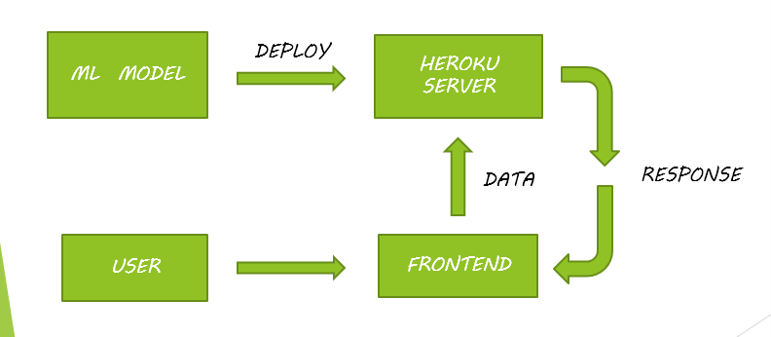

* **Data Flow and Block Diagram**

● What regulatory requirements have to be met to bring the idea to life?

Ans: *Websiteand App Registration.

*Firm Registration

*Product Distribution License.

● Do you have a business plan/ commercialization strategy? If so please share.

* We Plan To Earn By Doing Tie Ups With The Insurance Companies.
* In addition, we Plan To Co-ordinate with The Hospitals to Predict on Their Patients. This Will Help Us To Raise Funds And Will Also Help Their Patients Recover Faster Because They Now Will Be Able To Predict Whether Their Patient Is Going To Have Sepsis Or Not.
* Since it is A Huge Untapped Market, We Can Easily Grow.
* We intent to give a fixed amount of prediction to each user and when the limit is crossed the user should pay a monthly subscription for continuing using the service

● What is rough estimate of manufacturing/operational costs?

Ans: The operational cost include the Web Hosting of Backend API and other logistic requirements.The rough estimate is about 3-4k per month.

● What is volume of products/ amount of revenue do you expect to make in the first year?

Ans: According to a report published in Times of India, 1 out of 4 ICU admits develop sepsis either due to HAI or medical negligence in India, and the approx cost of ICU and sepsis treatments can be anywhere between 1lac -10 lacs depending upon the severity of case.

There are almost 1000 ICU beds in Delhi(Govt. plus private Hospitals ), so there would be about 250 sepsis patients in Delhi about any time. So if we project there would be about 5000 sepsis patients in a year and we give about 20 free detections to each hospital we would have a effective 4000 detections(profitable) and we charge a minimal amount of 500 rupees per patients, we would be able to generate a revenue of **20 lacs** in our first year of operation.