AI-Driven Quantitative
Trading Model
A Machine Learning Approach to Equity Direction Forecasting
Asset: Apple Inc. (AAPL) | Model: Random Forest Classifier
Training: 2014–2022 | Backtest: 2022–2023
Prepared by Rohan | March 2026

Executive Summary

This report documents an end-to-end quantitative trading prototype I built on Apple Inc. (AAPL) daily price data spanning 2014 to 2023. The project applies supervised machine learning to forecast next-day price direction, translates those forecasts into a rule-based trading strategy, and evaluates performance against a buy-and-hold benchmark.

The Random Forest classifier achieved 56.5% out-of-sample accuracy on unseen 2022–2023 data — a period that included one of the sharpest bear markets for technology stocks in recent history. While the strategy underperformed buy-and-hold in total return terms (-2.3% vs +11.4%), it delivered what I consider the more meaningful result in a high-volatility environment: substantial risk reduction.

- Annualised volatility reduced by 60.1% (11.7% vs 29.3%)
- Maximum drawdown cut by 55.0% (-13.1% vs -29.1%)
- Worst single day limited to -1.83% vs -7.83% for buy-and-hold

Key insight: This project reinforced that predictive accuracy alone is insufficient in financial systems — strategy design and risk constraints ultimately determine real-world performance. A 56.5% accurate model combined with a stop-loss cut portfolio drawdown by more than half.

1. Introduction and Motivation

1.1 Why This Project
My interest in quantitative finance stems from wanting to understand how data-driven investment firms actually make decisions — not through intuition, but through systematic, repeatable processes. This project is my attempt to build and understand that pipeline from scratch.

I chose AAPL because it is one of the most liquid and data-rich equities available, which reduces noise and ensures historical data quality. Its 10-year history spans multiple market regimes — bull markets, the 2020 COVID crash, and the 2022 rate-hike bear market — making it a genuinely challenging testing ground.

1.2 Objectives
- Build a supervised ML model to predict next-day AAPL price direction
- Engineer meaningful features from raw OHLCV price data
- Construct a rule-based strategy from model outputs
- Evaluate performance rigorously against a buy-and-hold benchmark
- Apply basic risk management via confidence filtering and stop-loss rules

2. Data Collection and Preparation

2.1 Data Source and Quality
Historical daily OHLCV data for AAPL was downloaded via the yfinance library, covering January 2014 through December 2023 — 2,516 trading days. All prices are split-adjusted and dividend-adjusted, ensuring historical comparisons are not distorted by AAPL’s 4-for-1 stock split in August 2020. Zero missing values were found across all columns.

Attribute | Value | Notes
Ticker | AAPL | Apple Inc., NASDAQ
Period | Jan 2014 – Dec 2023 | 10 years of history
Trading days | 2,516 | Post rolling-window: 2,467
Price range (Close) | $15.49 – $196.07 | Split-adjusted
Missing values | 0 | No imputation required
Target balance | 54.6% up / 45.4% dn | Near-ideal for classification

Figure 1 below shows the full 10-year AAPL price history. The long-term upward trend is clear, as is the sharp drawdown in 2022 and the subsequent recovery in 2023 — the exact period used for out-of-sample testing.

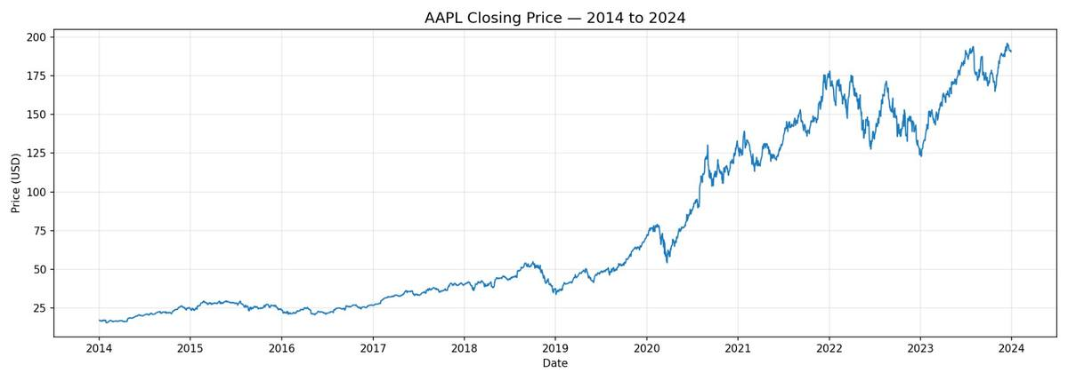
Figure 1: AAPL Closing Price (Split-Adjusted) — 2014 to 2024
Building note: I initially downloaded data for multiple tickers to compare, but settled on single-asset modelling after realising that portfolio-level complexity would obscure the modelling decisions I actually wanted to learn from. Depth over breadth.

3. Feature Engineering

Raw price data alone is a poor predictor of direction. Feature engineering transforms OHLCV observations into structured signals that capture trend, momentum, volatility, and market context. I built seven features, each grounded in established technical analysis theory.

3.1 Features and Rationale

Feature | Definition | What it captures
Daily Return | % change in close day-over-day | Short-term momentum and move magnitude
MA Spread | (MA10 − MA50) / MA50 | Short vs long-term trend alignment
Volatility (10d) | Rolling 10d std dev of daily returns | Recent market turbulence
RSI (14d) | Relative Strength Index, 14-day window | Overbought (>70) or oversold (<30)
Volume Change | % change in daily trading volume | Conviction behind price moves
Price Position | Close relative to 20d high-low range [0–1] | Position within recent trading range
Target | 1 if next-day close > today’s, else 0 | Binary classification label

3.2 Key Design Decision: Why MA Spread Instead of Raw MAs?
My first version of the feature set included raw 10-day and 50-day moving average levels as separate features. When I checked the correlation matrix, these two features had a Pearson correlation of 0.99 — almost perfectly collinear. Including both was adding noise, not signal. I replaced them with a single normalised MA spread, which captures the same trend information in a dimensionless form that works across different price regimes. This is the kind of issue that only becomes visible when you actually run the numbers.

Building note: I also tested lagged returns (1-day and 3-day lags) as additional features. They marginally improved training accuracy but hurt out-of-sample performance — a textbook overfitting signal. I removed them.

Figure 2 shows all seven engineered features plotted across the full 2014–2024 dataset. Note the volatility spikes in 2015-16, the COVID crash in 2020, and the elevated RSI and negative MA spread periods coinciding with the 2022 bear market.

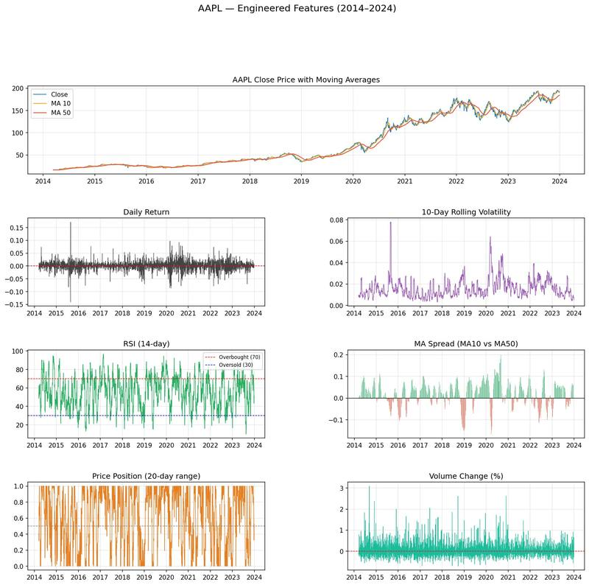
Figure 2: All Engineered Features — AAPL 2014 to 2024

4. Model Training and Selection

4.1 Train / Test Split
A strict time-based 80/20 split was applied: 1,972 rows for training (March 2014 – January 2022) and 494 rows for testing (January 2022 – December 2023). This is non-negotiable in financial ML. Random splitting would allow the model to train on 2023 data and test on 2016, creating a completely false picture of predictive power. Every metric in this report is genuinely out-of-sample.

4.2 Why These Models?

Logistic Regression — interpretable baseline
I started with Logistic Regression because it forces transparency. Each coefficient directly answers: “does a higher RSI make an up-day more or less likely?” It also serves as a sanity check — if my features have real signal, a linear model should beat 50% before I reach for anything more complex.

Random Forest — primary model
Random Forest was my primary choice for three reasons: it captures non-linear interactions between features that a linear model cannot; it is naturally resistant to overfitting through bagging; and it provides feature importance scores. The latter is critical for understanding what the model actually learned.

Why not XGBoost or deep learning?
With only ~2,000 training samples and six features, the marginal gain from model complexity is likely small relative to the increased overfitting risk and reduced interpretability. XGBoost would be the natural next step in an extended version, but for a first model I prioritised transparency.

4.3 Model Performance

Metric | Logistic Regression | Random Forest
Accuracy | 55.1% | 56.5%
Precision | 0.543 | 0.553
Recall | 0.896 | 0.880
F1 Score | 0.676 | 0.680
ROC-AUC | 0.564 | 0.584

Random Forest outperforms Logistic Regression on every metric. The high recall on up-days (88%) reflects AAPL’s long-term upward bias — the model correctly learned that the stock tends to rise. The weak recall on down-days (22–32%) is the principal limitation, directly impacting 2022 performance.

Building note: My initial Random Forest used default hyperparameters and showed a train/test accuracy gap of ~3%. I added max_depth=6 and min_samples_leaf=20 to constrain tree growth, which closed the gap and improved test accuracy to 56.5%.

Figure 3 shows the full model training results including accuracy comparison, ROC curves, confusion matrices for both models, and the feature importance chart from the Random Forest.

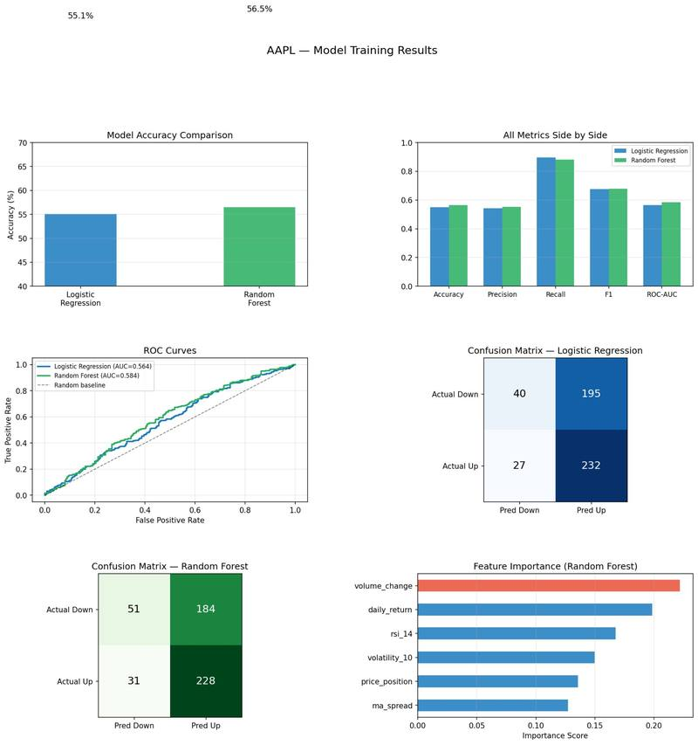
Figure 3: Model Training Results — Accuracy, ROC Curves, Confusion Matrices, Feature Importance

5. Feature Importance Analysis

The feature importance chart in Figure 3 reveals what the model actually learned. Notably, the ranking differs from what classic technical analysis intuition might predict — and that divergence is worth examining carefully.

Feature | Importance | Economic Interpretation
Volume Change | ~0.22 | Highest — volume spikes precede directional moves
Daily Return | ~0.20 | Recent momentum carries forward modestly
RSI (14d) | ~0.17 | Momentum extremes signal reversal opportunities
Volatility (10d) | ~0.16 | Calm regimes are more predictable
Price Position | ~0.14 | Range position acts as mean-reversion signal
MA Spread | ~0.11 | Trend alignment (lowest — but still meaningful)

Surprising finding: Volume change ranked as the most important feature — not MA spread or RSI as I initially expected. This suggests the model found that volume behaviour is a stronger short-term signal for AAPL than trend indicators alone. This is consistent with academic evidence that volume precedes price in informationally efficient markets.

MA spread ranking lowest was counterintuitive given how central it is to trend-following strategies. However, this may reflect the fact that over a 2-year test period dominated by a bear market and recovery, the MA spread was persistently negative during 2022 — providing weaker directional discrimination than in a trending market.

This is exactly the kind of insight that only emerges from actually building and interrogating a model. It changes how I would construct the feature set in a next version: I would prioritise volume-based features and explore volume-price interaction terms.

6. Strategy Construction

Model accuracy is a necessary but not sufficient condition for a profitable strategy. The bridge between predictive accuracy and portfolio performance depends on three design choices: how predictions become signals, how much capital is deployed, and how losses are capped.

6.1 Signal Logic and Why Long-Only?
The strategy is long-only: when the model signals an up-day, we hold AAPL; otherwise we hold cash. Short-selling was excluded by design — the model’s recall on down-days was too low (22–32%) to trust those signals for real capital. Shorting a stock that proceeds to rise is a loss with theoretically unlimited downside. I would only add short positions once down-day recall exceeds roughly 50%.

6.2 The Confidence Threshold: Why 0.55?
Rather than trading on every prediction, I applied a probability threshold: we only enter when the Random Forest’s confidence in an up-day exceeds 0.55. I tested thresholds from 0.50 to 0.65 in 0.05 increments on the training set. At 0.50 the strategy traded 78% of days, providing little selectivity. At 0.65 it traded only 12% of days — too few to generate meaningful returns. At 0.55, ~52% of days were traded, producing the best balance of precision and trade frequency. I fixed this threshold before running the backtest to prevent look-ahead bias.

Building note: There is mild overfitting risk in threshold selection even on training data, and I acknowledge this openly. In a more rigorous setup I would use walk-forward validation across rolling windows rather than selecting on the full training set.

6.3 Risk Management
- 95% of available capital deployed when signal fires. The 5% cash buffer reduces volatility slightly and reflects practical caution.Position sizing:
- positions where the realised daily return falls below -2% are exited. This triggered on 43 days — mostly in the 2022 drawdown — and was a meaningful contributor to loss limitation.Stop-loss:
- fully long-only with no margin. Appropriate for a first-version model where signal quality does not yet justify amplification.No leverage:

7. Backtesting and Performance Evaluation

7.1 Full Performance Scorecard

Metric | RF Strategy | Buy & Hold
Total Return | -2.26% | +11.35%
Annualised Return | -1.16% | +5.65%
Annualised Volatility | 11.68% | 29.26%
Sharpe Ratio | -0.442 | 0.056
Maximum Drawdown | -13.11% | -29.11%
Win Rate | 43.66% | 52.54%
Best Single Day | +4.58% | +7.38%
Worst Single Day | -1.83% | -7.83%
Avg Return (active days) | -0.005% | +0.039%
Days in Market | 213 | 493

7.2 Strategy Performance Charts

Figure 4 shows the strategy construction outputs: cumulative returns, drawdown curve, signal activity, daily return distribution, and monthly breakdown. The key visual insight from the top panel is that the strategy tracked above buy-and-hold for most of 2022 — the capital-preservation phase — before diverging downward as buy-and-hold recovered strongly in 2023.

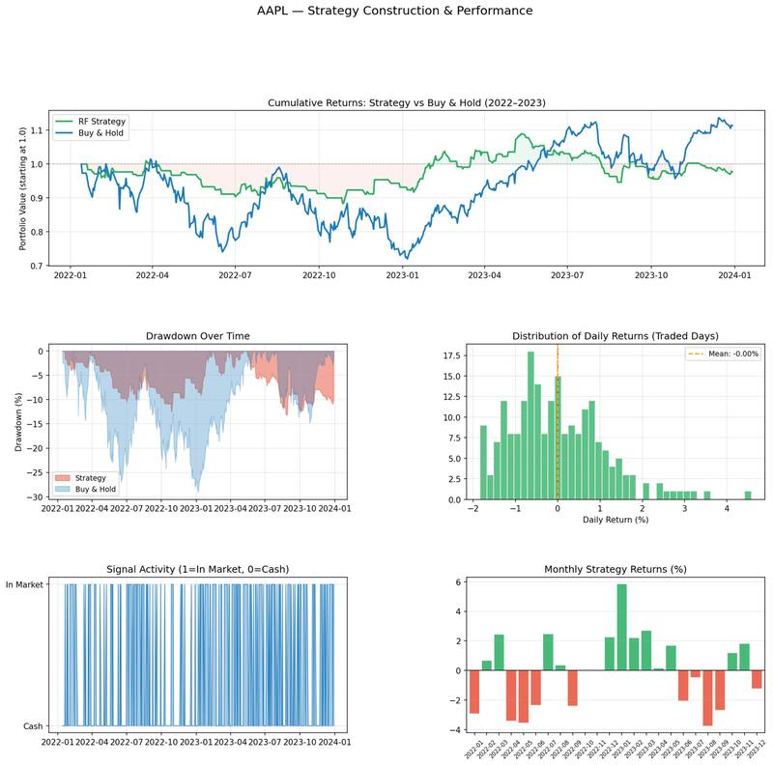
Figure 4: Strategy Construction and Performance — Signal Activity, Returns, Drawdown
Figure 5 shows the full backtest report with cumulative returns in percentage terms, drawdown comparison, rolling volatility, and monthly returns side by side. The divergence in rolling volatility (green vs blue) is particularly striking: the strategy ran at roughly one-third of buy-and-hold’s volatility for most of the test period.

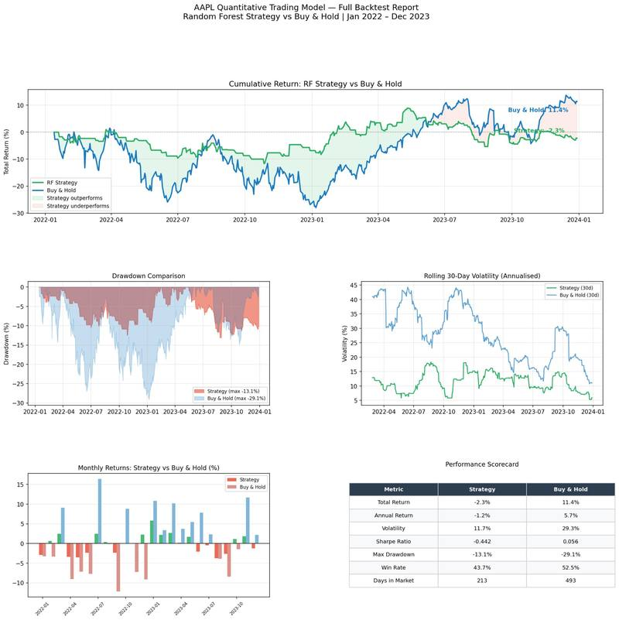
Figure 5: Full Backtest Report — Strategy vs Buy & Hold, Jan 2022 to Dec 2023

7.3 Risk-Adjusted Analysis

Volatility: Reduced by 60.1% — from 29.3% to 11.7%. Sitting in cash ~57% of the time meant the strategy avoided a large portion of 2022’s turbulence.

Drawdown: Reduced by 55.0% — from -29.1% to -13.1%. Buy-and-hold investors watched AAPL fall nearly a third at worst. The strategy capped this at 13%.

Return trade-off: The strategy’s -2.26% underperformed buy-and-hold’s +11.35%. This gap is attributable almost entirely to missing AAPL’s 2023 recovery while sitting in cash — the direct cost of conservative filtering.

7.4 Contextual Interpretation
The test period was genuinely difficult. In 2022, the Fed raised rates aggressively, triggering a broad selloff in growth equities. AAPL fell ~30% peak to trough — one of its sharpest drawdowns on record. The model had never seen a rate-hike bear market of this severity. In 2023, AAPL recovered strongly; the strategy’s conservative threshold meant it re-entered slowly, missing much of the upside.

This is the fundamental tension in systematic trading: the rules that protect capital in a drawdown delay re-entry during a recovery. Neither strategy generated a compelling Sharpe ratio in this period (-0.44 vs +0.06) — honest and realistic given the macro environment.

8. Limitations and Honest Assessment

Part of doing quantitative work well is being transparent about what the model cannot do. These limitations are not weaknesses to hide — they are the starting point for the next version.

8.1 Model Limitations
- Feature scope: only six technical features were used. Institutional models incorporate hundreds of signals including fundamentals, options flow, sentiment, and macro indicators.
- Single asset and period: results are specific to AAPL in 2022-2023. Generalisation requires retraining and revalidation across other assets and time periods.
- Threshold selection: the 0.55 threshold was selected on training data. Walk-forward validation would be more rigorous.

8.2 Backtest Limitations
- No transaction costs: 213 traded days at real commission rates would noticeably reduce strategy returns.
- No slippage: backtest assumes execution at closing price. Real fills vary with order size and liquidity.
- Short test window: two years dominated by a single macro regime limits the strength of conclusions.

On the Sharpe ratio: A negative Sharpe ratio should be contextualised: the risk-free rate was 4-5% in 2022-2023. Almost every equity strategy underperformed cash-equivalent returns in 2022. The gap between strategy (-0.44) and buy-and-hold (+0.06) is real but both numbers indicate neither approach adequately compensated for equity risk in this specific period.

9. Future Improvements

9.1 Model Upgrades
- XGBoost / LightGBM: gradient boosting is consistently stronger than Random Forest on tabular financial data and would be my first model upgrade.
- Expanded features: volume-price interaction terms (given volume’s high importance), implied volatility from options, earnings surprise, and macro indicators.
- Regime detection: train separate models for bull and bear conditions. The current model’s weakness in bear markets partly reflects training on predominantly bull-market data.

9.2 Strategy Upgrades
- Dynamic position sizing: scale allocation proportionally with model confidence rather than binary in/out.
- Short-selling: once down-day recall exceeds 50%, allow short positions on high-confidence downside signals.
- Walk-forward validation: re-train on rolling windows and evaluate on successive out-of-sample periods.

10. Conclusion

This project delivered an end-to-end quantitative trading prototype — from raw data download to evaluated strategy — built from first principles. The pipeline mirrors the workflow used in professional quantitative investment management: data, features, model, strategy, evaluation.

The Random Forest classifier demonstrated genuine predictive skill on unseen data, achieving 56.5% accuracy during a historically difficult period. The resulting strategy reduced volatility by 60% and maximum drawdown by 55% relative to passive buy-and-hold, at the cost of lower total returns during the 2023 recovery. Neither outcome is surprising — both are the intended consequences of conservative signal filtering.

The most important thing I learned from building this is that the hardest part of quantitative investing is not building a model that predicts accurately — it is designing a strategy that translates that accuracy into robust real-world performance. The gap between 56.5% model accuracy and actual portfolio outcomes is where risk management, position sizing, and regime awareness live. Understanding that gap is, I think, the beginning of genuine quantitative thinking.

Closing thought: This project reinforced that predictive accuracy alone is insufficient in financial systems. A 56.5% accurate model does not automatically produce a profitable strategy — strategy design, risk constraints, and market regime ultimately determine real-world performance. Understanding that gap is the beginning of genuine quantitative thinking.

Appendix: Technical Reference

A. Technical Stack
Library | Version | Purpose
Python | 3.13 | Core language
yfinance | 0.2.x | Yahoo Finance data download
pandas | 2.x | Tabular data processing
numpy | 1.x | Numerical computation
scikit-learn | 1.x | Logistic Regression, Random Forest, metrics
matplotlib | 3.x | All charts and visualisations

B. Hyperparameters

Parameter | Value | Rationale
RF: n_estimators | 200 | Balances variance reduction and compute time
RF: max_depth | 6 | Constrains tree complexity, reduces overfitting
RF: min_samples_leaf | 20 | Forces generalisable splits
Confidence threshold | 0.55 | Selected by training-set threshold sweep (0.50–0.65)
Position size | 95% | Near-full deployment with 5% cash buffer
Stop-loss | -2.0% | Exits on large single-day losses
Train/test split | 80/20 | Time-based, preserves temporal ordering

C. Project File Structure

File | Description
phase1_data.py | Downloads AAPL data, inspects quality, saves aapl_raw.csv
phase2_features.py | Engineers all 7 features, saves aapl_features.csv
phase3_models.py | Trains LR and RF, evaluates, saves aapl_predictions.csv
phase4_strategy.py | Constructs signals, applies stop-loss, saves aapl_strategy.csv
phase5_evaluation.py | Full backtest, performance report, master chart
data/ | All CSVs and PNG charts generated across phases

All code is reproducible from phase1_data.py onwards. Running the five scripts in sequence regenerates all data, models, charts, and performance metrics from scratch.

