RISC – V PROJECT REPORT

(UE20EC302)

**SIMULATION OF A BILAYER FEED FORWARD PERCEPTRON USING SYSTEM VERILOG**

M POORNACHANDRA (PES1UG20EC134)

ROHAN M RAO (PES1UG20EC156)

**Topic: simulation of a simple perceptron model**

**Abstract:**

Perceptron is a linear classifier (binary). It helps to classify the given input data.

The perceptron consists of 4 parts:

* Input values
* Weights and bias
* Net sum
* Activation function

**How it works?**

1)all inputs x are multiplied with their weights w. Lets call it k.

2) Add all the multiplied values and call them Weighted Sum.

3)Apply that weighted sum to the correct [Activation Function.](https://medium.com/towards-data-science/activation-functions-neural-networks-1cbd9f8d91d6)

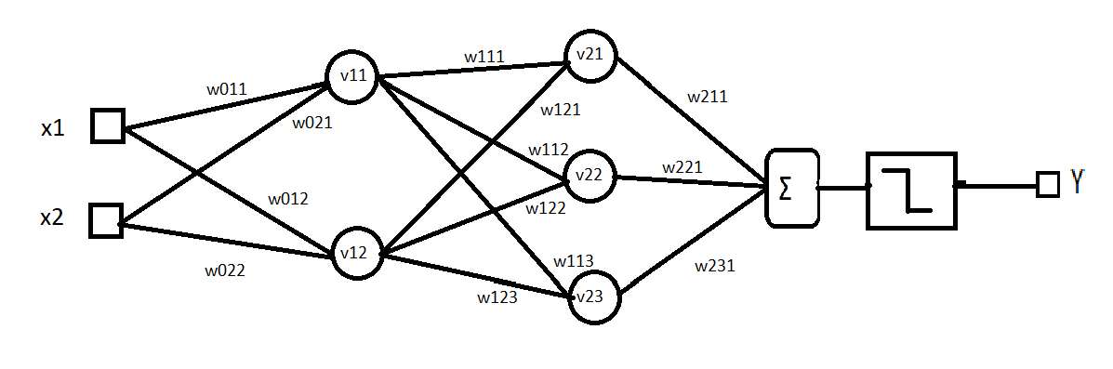

**IMPLEMENTATION:**

* The simulation was implemented using Verilog.
* The model of perceptron we considered has 2 layers in its hidden layer.
* The user inputs 2 binary values x1 , x2 and sets the binary weights of the hidden layer of the perceptron.
* All the multiplied values are added up called the weighted sum S
* This is then applied to the hard limit function. Let the result be P

|  |  |
| --- | --- |
| Weighted sum | P |
| S>0 | 1 |
| S=0 | 0 |

**Waveform:**

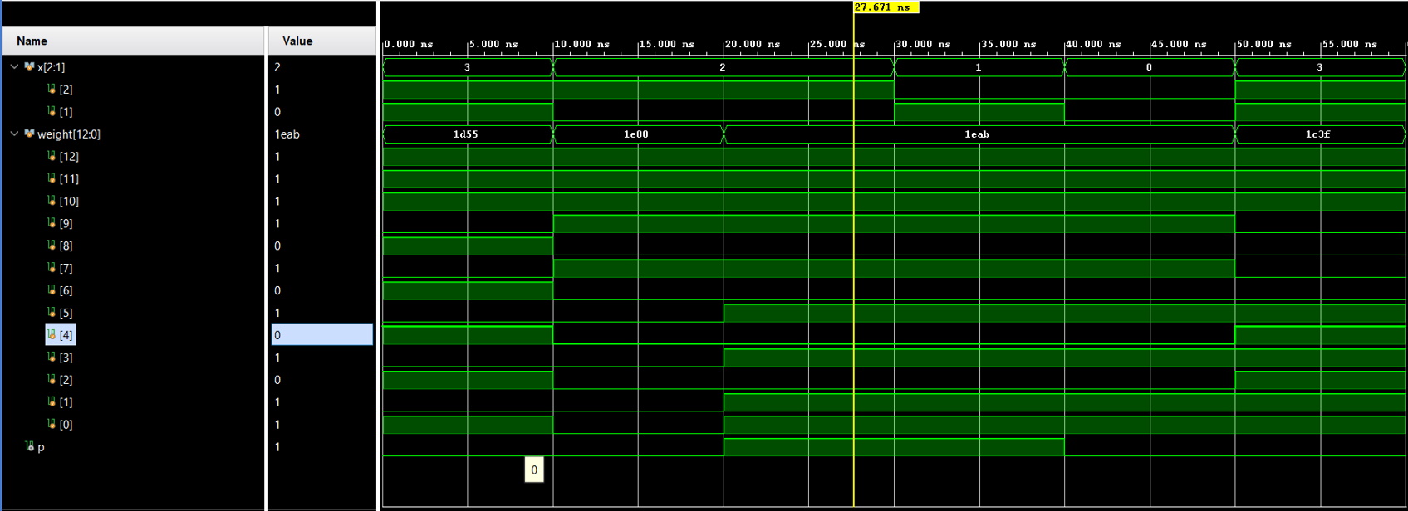

**RTL SCHEMATIC:**

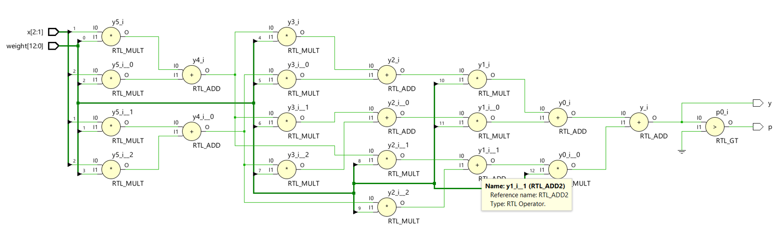

**SYNTHESIS DESIGN:**

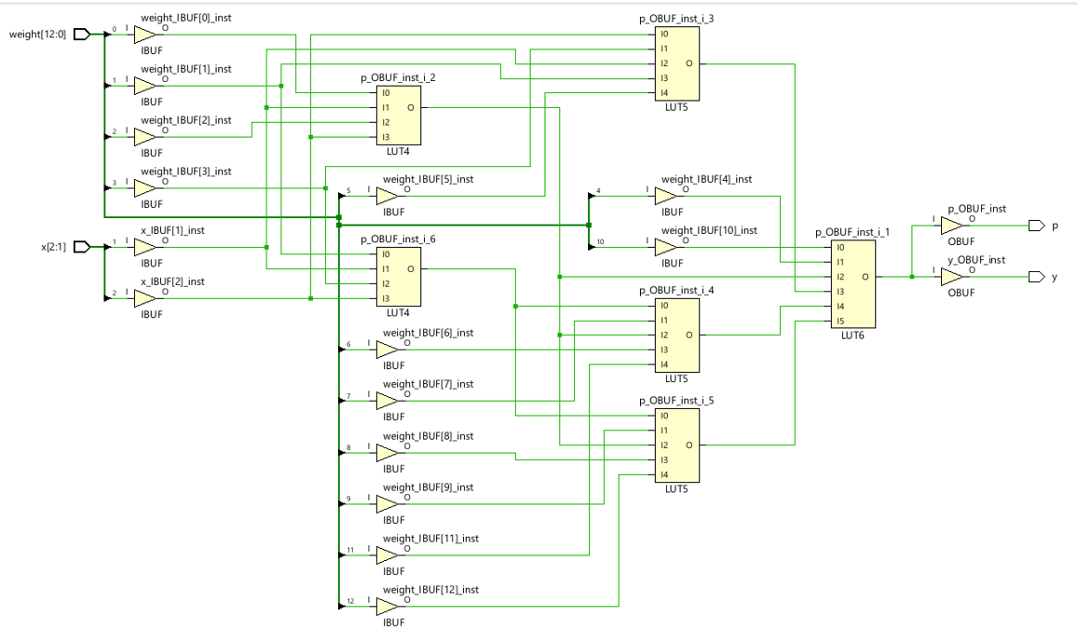

**UTILIZTION SUMMARY:**

