SQL Project
Retail Sales Management System
The Retail Sales Management System is a system that helps retail stores manage their daily work. It keeps all important information in one place so the store can run smoothly.
The system stores details about products, customers, orders, and stock. When a customer buys something, the system creates an order and adds all the products they purchased. It also reduces the stock automatically so the store knows what items are left.
The system also keeps audit logs, which means it records important actions such as creating an order, updating stock, or completing a payment. This helps the store know who did what and when.
Stores use this system to check:
- How much sales they made
- Which products are selling the most
- Which items are running low in stock
- What payment methods customers prefer
- How each store is performing
The system also keeps customer information so the store can understand their needs and serve them better

🧩 Database Overview
Main Entities:
Table | Description
Stores | Contains details of each retail outlet (name, location).
Customers | Holds information about customers.
Products | Lists all available items, with price and stock count.
Orders | Represents customer orders.
order_items | Contains individual items per order.
audit_logs | Tracks administrative or system-level actions.

PROBLEM STATEMENTS AND QUERIES
Problem Statement 1 Display all store names and their locations.
( Concepts Used: WHERE clause & ORDER BY)
Purpose
To retrieve the list of company stores and their locations.

SQL QUERY:
SELECT store_id, name, location
FROM stores
WHERE location IS NOT NULL
ORDER BY store_id;
OUTPUTS:
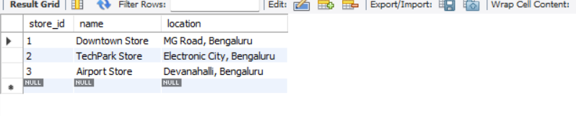

Problem Statement 2 List customers with formatted names and emails
Purpose: Show customers with string formatting.
Concepts Used: STRING FUNCTIONS (UPPER, LOWER)
SQL QUERY :
SELECT
UPPER(full_name) AS customer_name,
LOWER(email) AS email_lowercase,
phone
FROM customers;;
OUTPUTS:
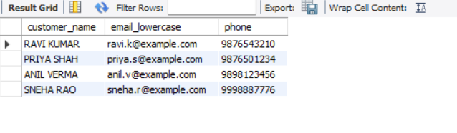

Problem Statement 3 Electronics products sorted by price rank
Purpose: Rank electronics by price.
Concepts Used: WINDOW FUNCTION (RANK OVER PARTITION)

SQL QUERY:
SELECT name, price,
RANK() OVER (ORDER BY price DESC) AS price_rank
FROM products
WHERE category = 'Electronics';
OUTPUTS:
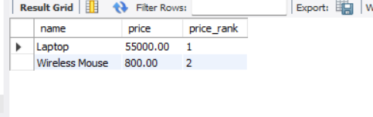

Problem Statement 4 Total customers grouped by the year they joined
Purpose: Count customers based on registration year.
Concepts Used: GROUP BY, DATE FUNCTION (YEAR)

SQL QUERY :
SELECT
YEAR(created_at) AS joining_year,
COUNT(*) AS total_customers
FROM customers
GROUP BY joining_year;
OUTPUTS:
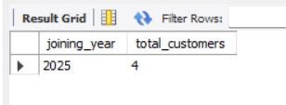

Problem Statement 5 Completed orders in last 30 days using date functions
Purpose: Filter time-based data.
Concepts Used: DATE FUNCTIONS (NOW, INTERVAL), WHERE
SQL QUERY :
SELECT order_id,customer_id, total_amount, created_at
FROM orders
WHERE order_status = 'Completed'
AND created_at >= NOW() - INTERVAL 30 DAY;
OUTPUTS:
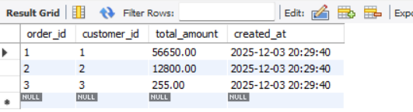

Problem Statement 6 Orders with customer & store using join
Purpose: Combine three tables for full order info.
Concepts Used: JOIN (customers + stores + orders)
SQL QUERY :
SELECT
o.order_id,
c.full_name AS customer,
s.name AS store,
o.total_amount
FROM orders o
JOIN customers c ON o.customer_id = c.customer_id
JOIN stores s ON o.store_id = s.store_id;
OUTPUTS:
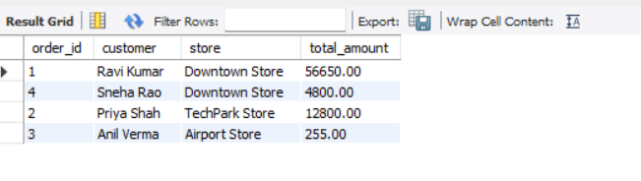

Problem Statement 7 Total sales per store.
Purpose: Calculate store revenue.
Concepts Used: GROUP BY, HAVING

SQL QUERY :
SELECT
s.name AS store,
SUM(o.total_amount) AS total_sales
FROM stores s
JOIN orders o ON s.store_id = o.store_id
GROUP BY s.store_id
HAVING total_sales > 0;
OUTPUTS:
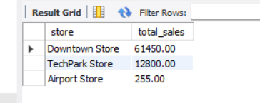

Problem Statement 8 Number of orders per customer using LEFT JOIN
Purpose: Show customers even if they have no orders.
Concepts Used: LEFT JOIN, GROUP BY
SQL QUERY:
SELECT
c.full_name,
COUNT(o.order_id) AS total_orders
FROM customers c
LEFT JOIN orders o ON c.customer_id = o.customer_id
GROUP BY c.customer_id;
OUTPUTS:
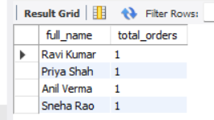

Problem Statement 9 Total quantity sold per product using subquery
Purpose: Combine aggregated and base data.
Concepts Used: SUBQUERY + GROUP BY
SQL QUERY:
SELECT p.name,
(SELECT SUM(quantity)
FROM order_items oi
WHERE oi.product_id = p.product_id) AS total_qty
FROM products p;
OUTPUTS:
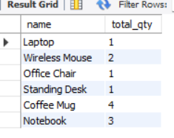

Problem Statement 10 Revenue by product category .
Purpose: Add logic to categorize revenue.
Concepts Used: CASE, GROUP BY
SQL QUERY :
SELECT
CASE
WHEN category = 'Electronics' THEN 'Tech Products'
ELSE 'Other Products'
END AS product_group,
SUM(oi.quantity * oi.price_each) AS total_revenue
FROM products p
JOIN order_items oi ON p.product_id = oi.product_id
GROUP BY product_group;
OUTPUTS:
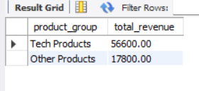

Problem Statement 11 Customers who spent more than 50,000
Purpose: High-value customers.
Concepts Used: HAVING + SUM
SQL QUERY:
SELECT
c.full_name,
SUM(o.total_amount) AS total_spent
FROM customers c
JOIN orders o ON c.customer_id = o.customer_id
GROUP BY c.customer_id
HAVING total_spent > 50000;
OUTPUTS:
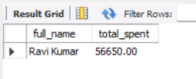

Problem Statement 12 Orders paid via UPI
Purpose: Show limited output.
Concepts Used: WHERE + LIMIT
SQL QUERY:
SELECT order_id,total_amount, payment_method
FROM orders
WHERE payment_method = 'UPI'
LIMIT 5;
OUTPUTS:
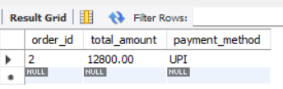
Problem Statement 13 Completed & pending orders per store
Purpose: Combine two filtered results.
Concepts Used: UNION, GROUP BY
SQL QUERY:
SELECT
s.name AS store,
o.order_status,
COUNT(*) AS total_orders
FROM stores s
JOIN orders o ON s.store_id = o.store_id
WHERE o.order_status = 'Completed'
GROUP BY s.store_id

UNION
SELECT s.name,
o.order_status,
COUNT(*)
FROM stores s
JOIN orders o ON s.store_id = o.store_id
WHERE o.order_status = 'Pending'
GROUP BY s.store_id;
OUTPUTS:
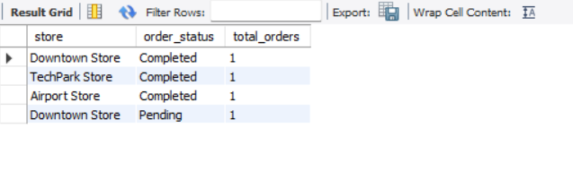

Problem Statement 14 Top 5 best-selling products.
Purpose: Identify best sellers.
Concepts Used: GROUP BY, ORDER BY, LIMIT
SQL QUERY:
SELECT p.name,
SUM(oi.quantity) AS total_sold
FROM products p
JOIN order_items oi ON p.product_id = oi.product_id
GROUP BY p.product_id
ORDER BY total_sold DESC
LIMIT 5;
OUTPUTS:
