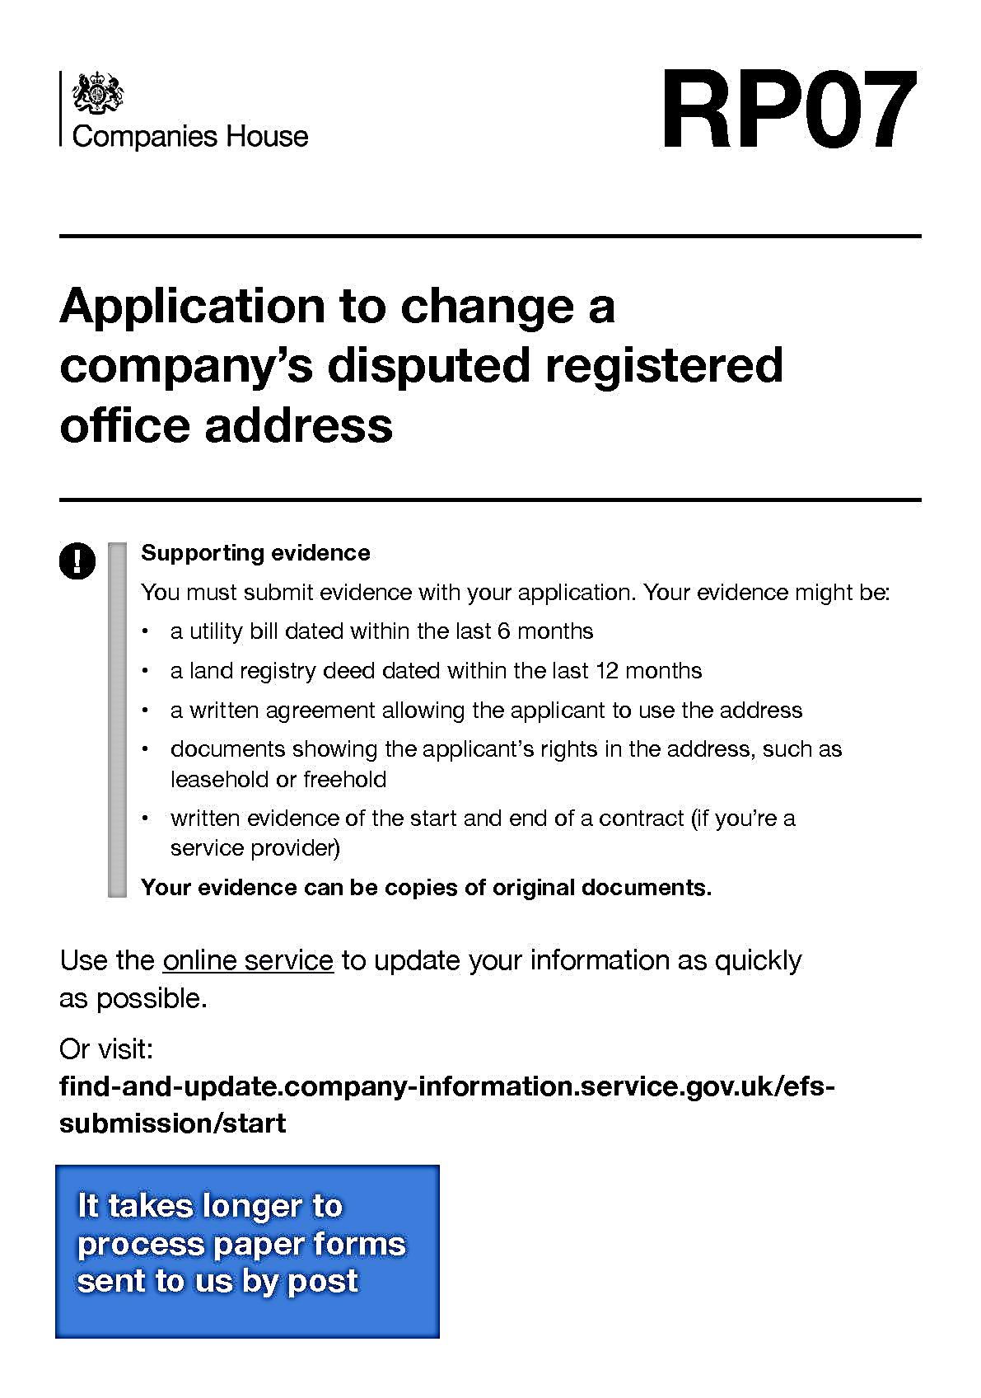

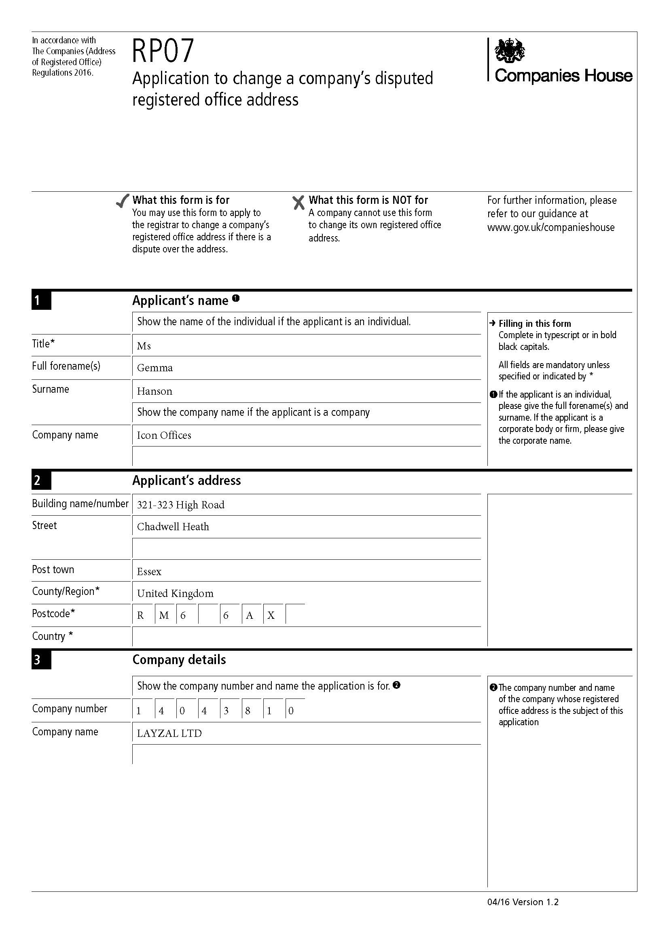

{{c8}}

{{c7}}

{{c6}}

{{c5}}

{{c4}}

{{c3}}

{{c2}}

{{c1}}

{{Company_Name}}

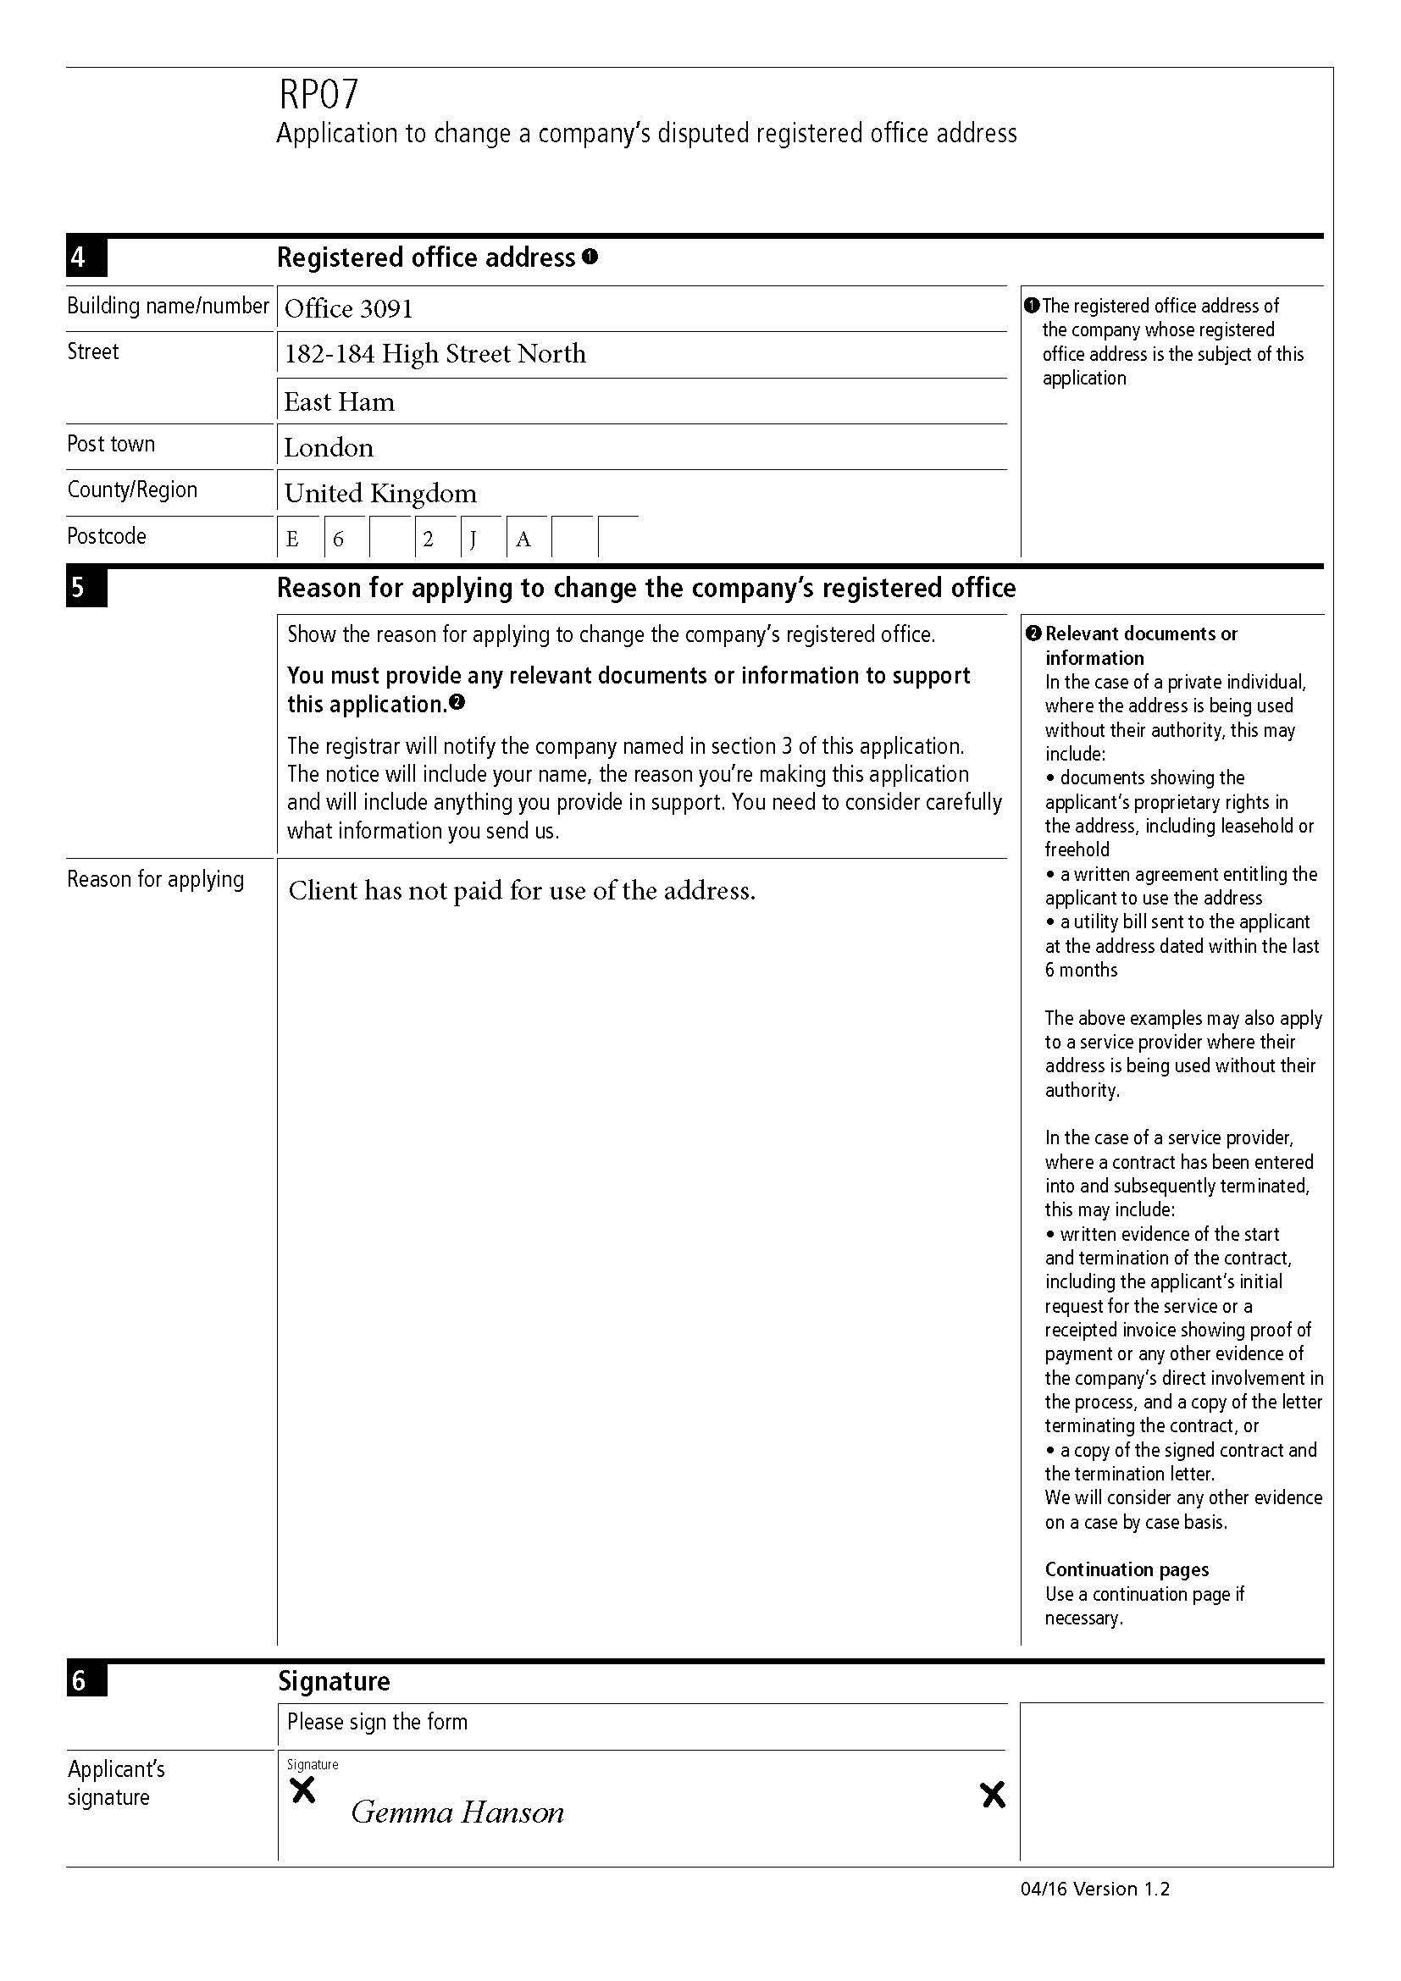

{{p8}}

{{p7}}

{{p6}}

{{p5}}

{{p4}}

{{p3}}

{{p2}}

{{p1}}

{{RP07_ADDRESS_FIELD4}}

{{RP07_ADDRESS_FIELD3}}

{{RP07_ADDRESS_FIELD2}}

{{RP07_ADDRESS_FIELD1}}

