RP07

**Application to change a company’s disputed registered office address**

**Supporting evidence**

You must submit evidence with your application. Your evidence might be:

* a utility bill dated within the last 6 months
* a land registry deed dated within the last 12 months
* a written agreement allowing the applicant to use the address
* documents showing the applicant’s rights in the address, such as leasehold or freehold
* written evidence of the start and end of a contract (if you’re a service provider)

**Your evidence can be copies of original documents.**

Use the [online service](https://find-and-update.company-information.service.gov.uk/efs-submission/start) to update your information as quickly as possible.

Or visit:

**find-and-update.company-information.service.gov.uk/efs- submission/start**

**It takes longer to process paper forms sent to us by post**

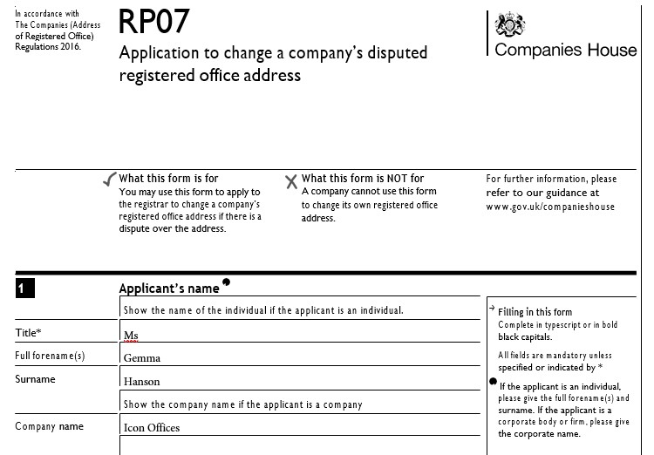



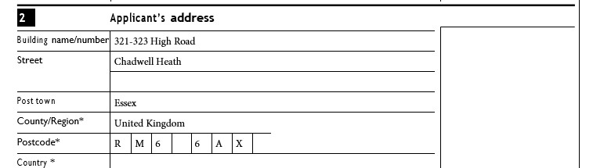

**Company details**

**3**

 The company number and name of the company whose registered office address is the subject of this application



|  |  |  |  |  |  |  |  |  |  |
| --- | --- | --- | --- | --- | --- | --- | --- | --- | --- |
|  | Show the company number and name the application is for. | | | | | | | | |
| Company number | {{c1}} | {{c2}} | {{c3}} | {{c4}} | {{c5}} | {{c6}} | {{c7}} | {{c8}} |  |
| Company name | {{Company_Name}} | | | | | | | | |
|  | | | | | | | | |

# RP07

Application to change a company’s disputed registered office address

## Registered office address 1

**4**

**1** The registered office address of the company whose registered office address is the subject of this application

|  |  |  |  |  |  |  |  |  |  |
| --- | --- | --- | --- | --- | --- | --- | --- | --- | --- |
| Building name/number | {{Address_1}} | | | | | | | | |
| Street | {{Address_2}} | | | | | | | | |
|  | | | | | | | | |
| Post town | {{Address_City}} | | | | | | | | |
| County/Region | {{Address_Country}} | | | | | | | |  |
| Postcode | {{p1}} | {{p2}} | {{p3}} | {{p4}} | {{p5}} | {{p6}} | {{p7}} | {{p8}} | |
|  |  |  |  |  |  |  |  |  | |

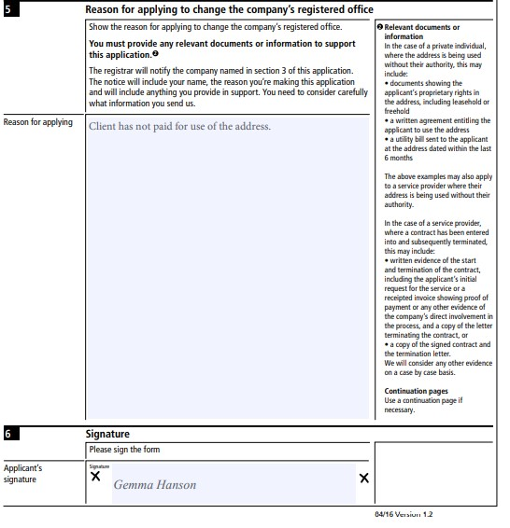

# RP07

Application to change a company’s disputed registered office address

## Presenter information



|  |  |  |  |  |  |  |  |  |  |
| --- | --- | --- | --- | --- | --- | --- | --- | --- | --- |
| You do not have to give any contact information, but if you do it will help Companies House if there is a query on the form. | | | | | | | | | |
| Contact name | Gemma Hanson | | | | |  |  |  |  |
| Company name Icon Offices | | | | | | | | | |
|  | | | | | | | | | |
| Address | 321-323 High Road | | | | |  |  |  |  |
| Chadwell Heath | | | | | | | | | |
|  | | | | | | | | | |
| Post town | Essex | | | | |  |  |  |  |
| County/Region United Kingdom | | | | | | | | | |
| Postcode | | R | M | 6 |  | 6 | A | X |  |
| Country | | | | | | | | | |
| DX | | | | | | | | | |
| Telephone | 0203 432 5444 | | | | |  |  |  |  |

**Checklist**

### We may return forms completed incorrectly or with information missing.

**Make sure you have remembered the following:** You have completed all relevant sections of this form.

You have given the grounds for the application and provided documents or information to support it. You have signed the form

## Important information

**The information on this form will not appear on the public record.**

**!**

## Where to send

### You may return this form to any Companies House address. However for expediency we advise you to return it to the appropriate address below:

**For companies registered in England and Wales:**

The Registrar of Companies,

Registered Office and Directors’ Disputes Team Companies House, Crown Way, Cardiff,

Wales, CF14 3UZ.

DX 33050 Cardiff.

### For companies registered in Scotland:

The Registrar of Companies, Companies House, Fourth floor, Edinburgh Quay 2,

139 Fountainbridge, Edinburgh, Scotland, EH3 9FF.

DX ED235 Edinburgh 1

or LP - 4 Edinburgh 2 (Legal Post).

**For companies registered in Northern Ireland:** The Registrar of Companies, Companies House, Second Floor, The Linenhall, 32-38 Linenhall Street, Belfast, Northern Ireland, BT2 8BG.

DX 481 N.R. Belfast 1.

**Further information**

***i***

For further information, please see the guidance notes on the website at [www.gov.uk/companieshouse](http://www.gov.uk/companieshouse) or email [enquiries@companieshouse.gov.uk](mailto:enquiries@companieshouse.gov.uk)

This form is available in an alternative format. Please visit the forms page on the website at [www.gov.uk/companieshouse](http://www.gov.uk/companieshouse)



|  |  |  |  |
| --- | --- | --- | --- |
| RP07 - continuation  Application to change a company’s disputed registered office address  **5 Reason for applying to change the company’s registered office** | | | |
|  | Show the reason for applying to change the company’s registered office.  **You must provide any relevant documents or information to support this application. 2**  The registrar will notify the company named in section 3 of this application. The notice will include your name, the reason you’re making this application and will include anything you provide in support. You need to consider carefully what information you send us. | | **2 Relevant documents or information**  In the case of a private individual, where the address is being used without their authority, this may include:   * documents showing the applicant’s proprietary rights in the address, including leasehold or freehold * a written agreement entitling the applicant to use the address * a utility bill sent to the applicant at the address dated within the last 6 months |
| Reason for applying | Client has not paid for use of the address. |  |
|  |  | The above examples may also apply to a service provider where their address is being used without their authority. |
|  |  | In the case of a service provider, where a contract has been entered into and subsequently terminated, this may include:   * written evidence of the start and termination of the contract, such as the applicant’s initial request   for the service or a receipted invoice showing proof of payment or any other evidence of the company’s direct involvement in the process, or   * and a copy of the letter terminating the contract. |
|  |  | We will consider any other evidence on a case by case basis. |

04/16 Version 1.2