6. Write a C program for ciphertext has been generated with an affine cipher. The most frequent letter of the ciphertext is “B,” and the second most frequent letter of the ciphertext is “U.”Break this code.
PROGRAM :
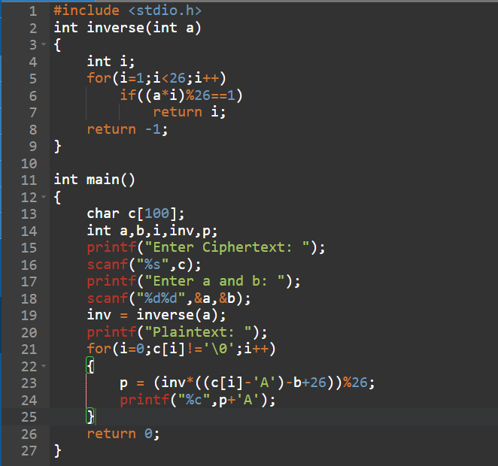

OUTPUT :
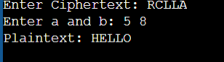

7. Write a C program for the following ciphertext was generated using a simple substitution algorithm. 53‡‡†305))6*;4826)4‡.)4‡);806*;48†8¶60))85;;]8*;:‡*8†83 (88)5*†;46(;88*96*?;8)*‡(;485);5*†2:*‡(;4956*2(5*—4)8¶8* ;4069285);)6†8)4‡‡;1(‡9;48081;8:8‡1;48†85;4)485†528806*81 (‡9;48;(88;4(‡?34;48)4‡;161;:188;‡?; Decrypt this message. 1. As you know, the most frequently occurring letter in English is e. Therefore, the first or second (or perhaps third?) most common character in the message is likely to stand for e. Also, e is often seen in pairs (e.g., meet, fleet, speed, seen, been, agree, etc.). Try to find a character in the ciphertext that decodes to e. 2. The most common word in English is “the.” Use this fact to guess the characters that stand for t and h. 3. Decipher the rest of the message by deducing additional words.
PROGRAM :
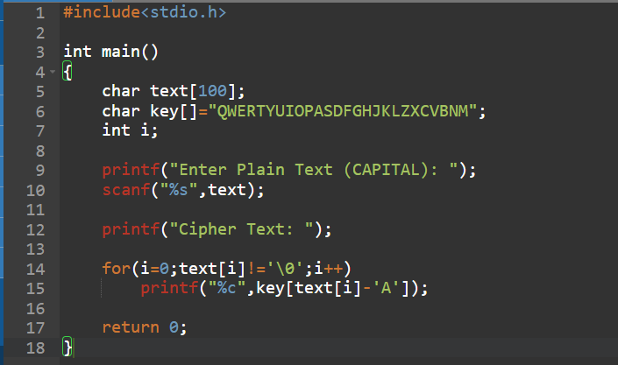
OUTPUT :


8. Write a C program for monoalphabetic cipher is that both sender and receiver must commit the permuted cipher sequence to memory. A common technique for avoiding this is to use a keyword from which the cipher sequence can be generated. For example, using the keyword CIPHER, write out the keyword followed by unused letters in normal order and match this against the plaintext letters: plain: a b c d e f g h i j k l m n o p q r s t u v w x y z cipher: C I P H E R A B D F G J K L M N O Q S T U V W X Y Z
PROGRAM :
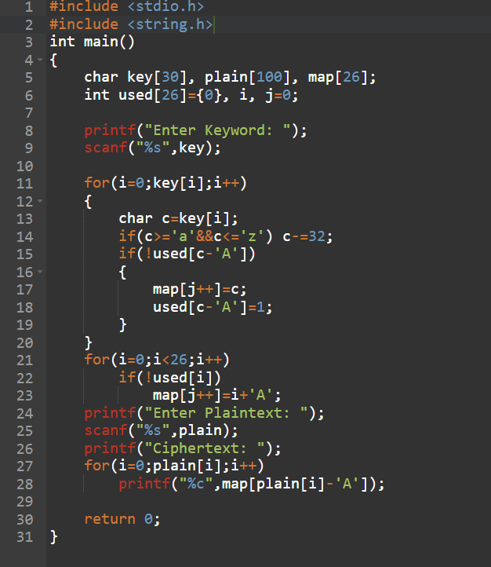
OUTPUT :
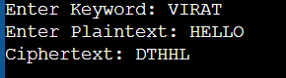

9. Write a C program for PT-109 American patrol boat, under the command of Lieutenant John F. Kennedy, was sunk by a Japanese destroyer, a message was received at an Australian wireless station in Playfair code: KXJEY UREBE ZWEHE WRYTU HEYFS KREHE GOYFI WTTTU OLKSY CAJPO BOTEI ZONTX BYBNT GONEY CUZWR GDSON SXBOU YWRHE BAAHY USEDQ
PROGRAM :
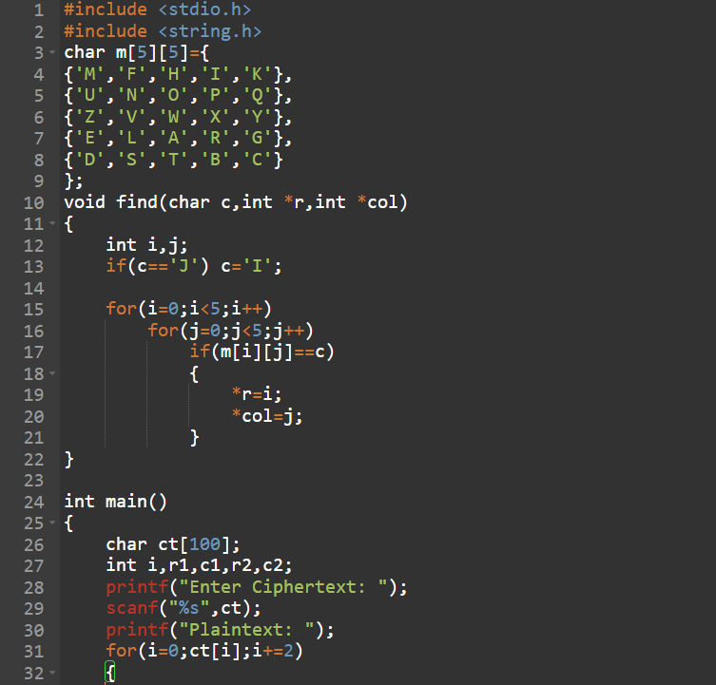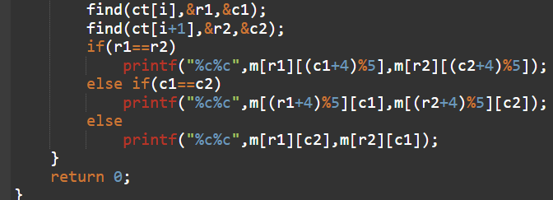
OUTPUT :
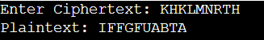

10. Write a C program for Playfair matrix: M F H I/J K U N O P Q Z V W X Y E L A R G D S T B C Encrypt this message: Must see you over Cadogan West. Coming at once.
PROGRAM :
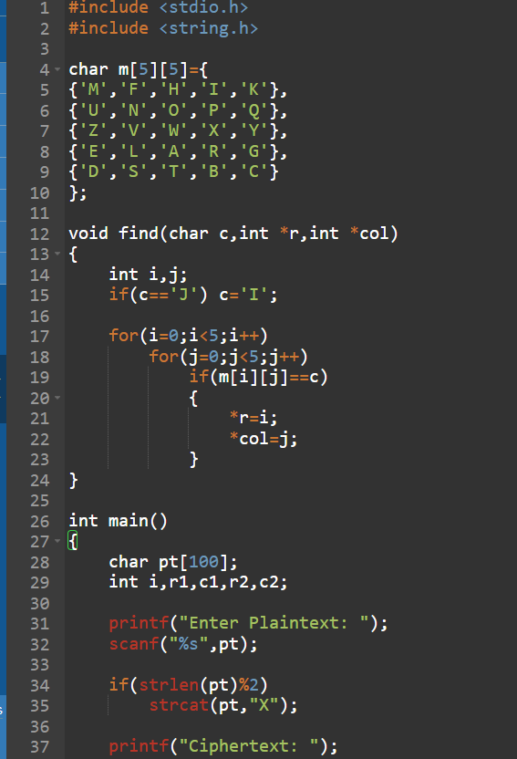
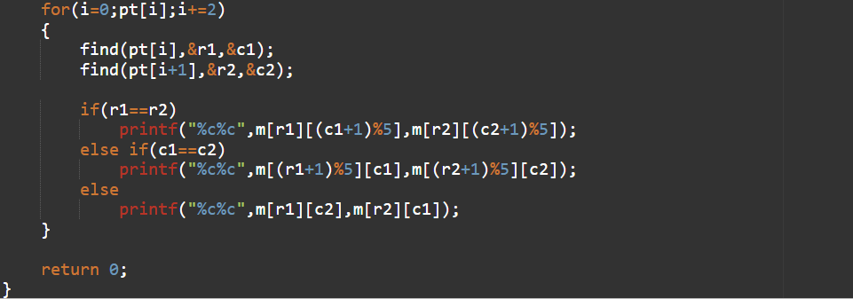
OUTPUT :
