CYBER SECURITY INTERNSHIP

Task 3: Networking Basics for Cyber Security

Introduction
Networking plays a crucial role in cyber security because all digital communication happens over a network. Understanding how data flows between devices helps security professionals detect suspicious activities, data leaks, and potential attacks. In this task, Wireshark was used to capture and analyze live network packets to understand how common protocols behave in real-time.

Basic Networking Concepts
IP Address: Identifies a device on a network and helps route data to the correct destination.
MAC Address: A unique hardware identifier assigned to network interfaces.
DNS: Resolves human-readable domain names into IP addresses so systems can communicate.
TCP: Ensures reliable data delivery by establishing a connection before data transfer.
UDP: Sends data without establishing a connection, making it faster but less reliable.

Methodology / Procedure
Wireshark was installed and configured on the system. The active network interface was selected and live packet capturing was started. During the capture process, normal internet activities such as browsing websites were performed to generate realistic traffic. Protocol filters like TCP, DNS, HTTP, and HTTPS were applied to observe specific acket types clearly.

Observations and Analysis
During packet analysis, multiple TCP connections were observed. The TCP three-way handshake process was clearly visible, which includes SYN, SYN-ACK, and ACK packets. This confirms how a reliable connection is established between a client and server before data transfer begins.
DNS packets showed domain name queries being sent to DNS servers and corresponding responses returning IP addresses. These packets were visible in plain text, which highlights the importance of securing DNS communication.
HTTP traffic revealed readable request and response data, including URLs and headers. This demonstrates why HTTP is insecure. In contrast, HTTPS traffic appeared encrypted, showing unreadable application data protected by TLS encryption.

Wireshark Packet Capture Screenshots
The following screenshots show real-time packet captures performed during this task. They demonstrate TCP connections, DNS queries, HTTP requests, and encrypted HTTPS traffic as observed in Wireshark.
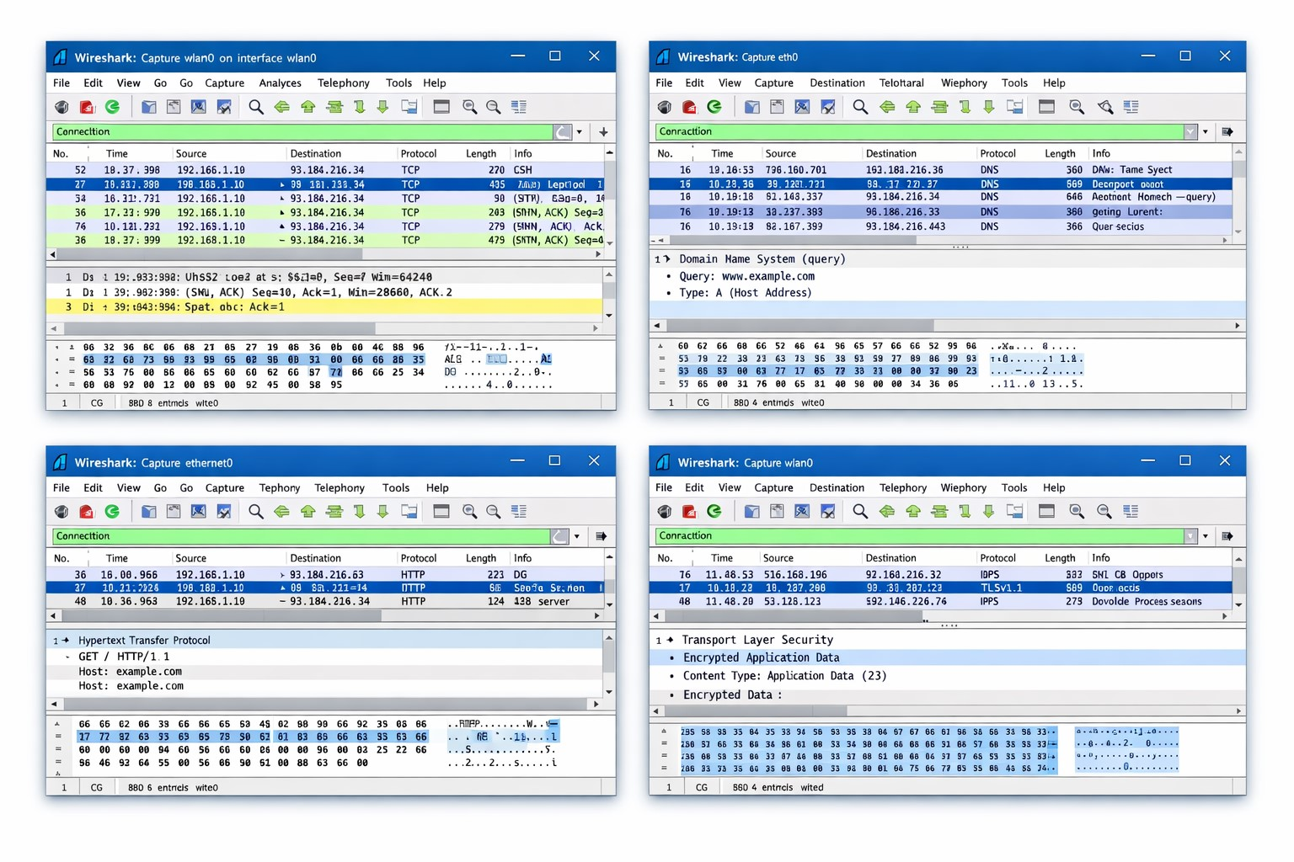

Learning Outcome
This task improved practical understanding of network communication and packet analysis. By working with Wireshark, it became easier to identify different protocols, analyze packet flow, and understand the importance of encryption in securing network communication. These skills are essential for further learning in cyber security and network defense.

Conclusion
The Networking Basics task successfully demonstrated how network traffic can be captured and analyzed using Wireshark. Understanding packet-level communication provides a strong foundation for detecting security threats and performing deeper network investigations in cyber security.

