HTML

* Basics of HTML :

HTML – HTML stands for Hyper Text Markup Language and is the standard markup language for creating web pages. It describes the structure of a web page.

HTML elements tell the browser how to display the content.

Uses:

* Creating webpages.
* Defining content.
* Text Formatting.
* Linking webpages.
* Embed media.
* Creating interactive elements.

Structure of HTML:

HTML has a hierarchical structure where elements are nested within each other to define the content and layout of a web page.

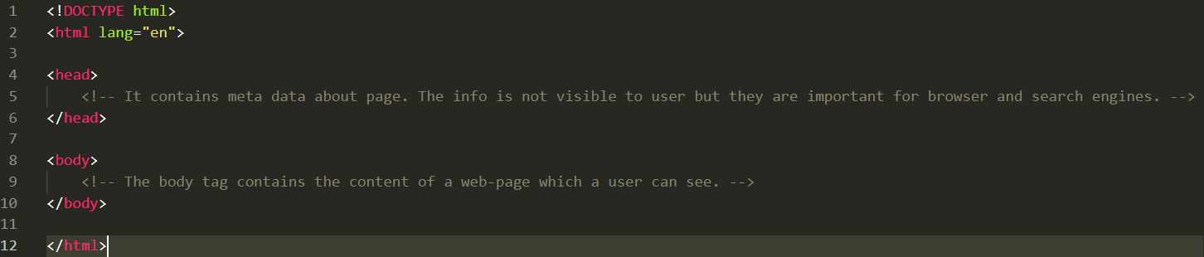 Basic HTML Structure:

* HTML tags:

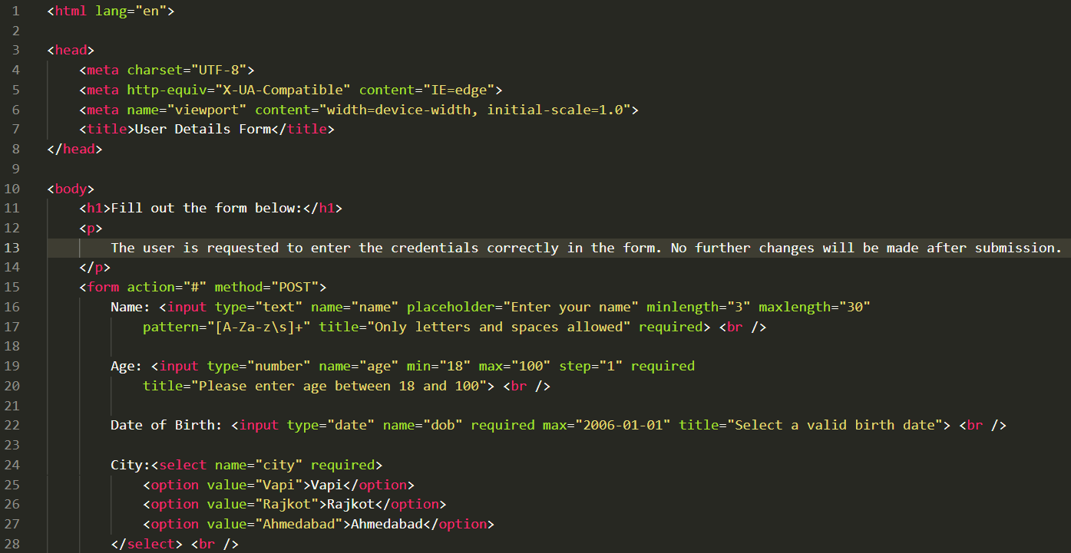

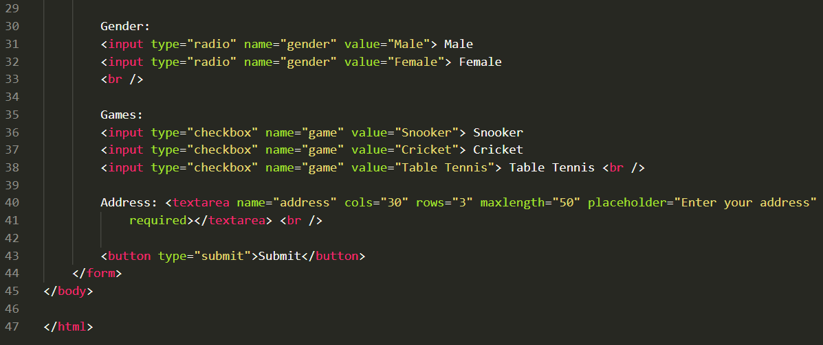

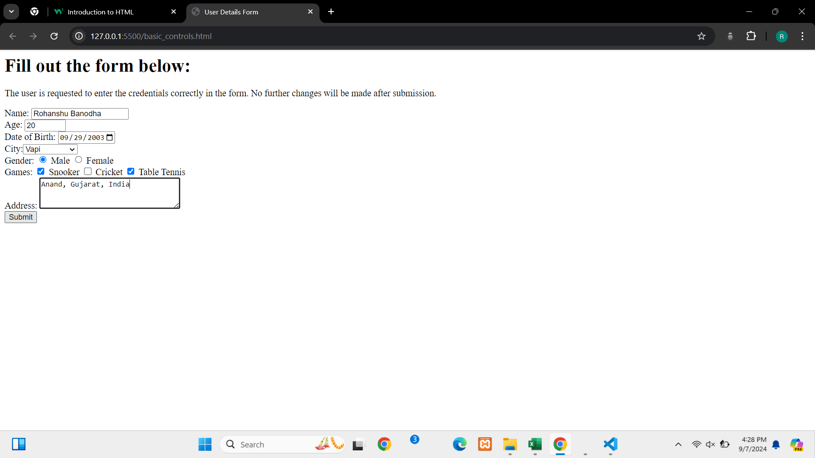

* Meta tags :
* The meta tag defines meta data about an HTML document. meta-data means data about data.
* It goes inside head element and is used to specify character set, author, keywords, page description, etc.
* Meta-data will not be displayed on page, but is machine parsable and are used by browsers and search engines.

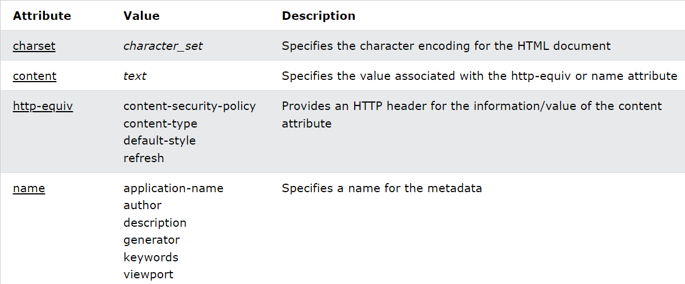

* **Responsive Websites:**
* A responsive website automatically adjusts its layout and contents according to the screen in which it is being displayed.
* It ensures than a website looks good whether it is opened in phone or tablet or computer screen and remains functional regardless of the device used.
* **Tips for making a responsive website:**

1. While writing CSS, make sure to used %-based height and width.
2. Add media queries by mentioning the width of screen before writing CSS styles.
3. Use relative units such as “rem” or “em” rather than using fixed unit such as “px”.

Global Attributes:

* **accesskey**: shortcut keys for focusing on elements(Alt + key)
* **contenteditable**: specifies whether the content in the div is editable or not. Takes Boolean value(true/false).
* **enterkeyhint**: Changes the text of Enter key of virtual keyboard (Eg. done, enter, go, next, previous, search, send).
* **hidden**: specifies that element is no longer relevant.
* **inert**: Disables the a links and buttons inside the element having inert mentioned.
* **inputmode**: Allows to change the appearance of the virtual keyboard as per the input tag.

(Eg. numeric, decimal, email, search, url, tel)

* **popover**: Pops the element thus getting all the attention over the popped up element. Possess popovertarget and popovertargetaction(show, hide, toggle).
* **tabindex**: Specifies the tab order of an element while navigating.
* **title**: Specifies extra information about the element. It acts like a tooltip which invokes when mouse is hovered over that element content.

Event Attributes:

(will cover it in Javascript basics)