**DAILY ONLINE ACTIVITIES SUMMARY**

|  |  |  |  |  |  |  |  |
| --- | --- | --- | --- | --- | --- | --- | --- |
| **Date:** | **22/05/2020** | | | | **Name:** | **Rohan Vashista BM** | |
| **Sem & Sec** | **6th Sem & B** | | | | **USN:** | **4al17cs078** | |
| **Online Test Summary** | | | | | | | |
| **Subject** | | **OR Test1** | | | | | |
| **Max. Marks** | | **30** | | **Score** | | **30** | |
| **Certification Course Summary** | | | | | | | |
| **Course** | **Full Stack Web development** | | | | | | |
| **Certificate Provider** | | | **Udemy** | **Duration** | | | **20hrs** |
| **Coding Challenges** | | | | | | | |
| **Problem Statement:**  1. Python program to print all Prime numbers in an Interval. Given two positive integers start and end. The task is to write a Python program to print all Prime numbers in an Interval.  2. Python Program to find sum of array. Given an array of integers (take input from keyboard), find sum of its elements | | | | | | | |
| **Status: completed** | | | | | | | |
| **Uploaded the report in Github** | | | | **yes** | | | |
| **If yes Repository name** | | | | <https://github.com/Rohanvasista/Coding-activities> | | | |
| **Uploaded the report in slack** | | | | **yes** | | | |

**Online test details**

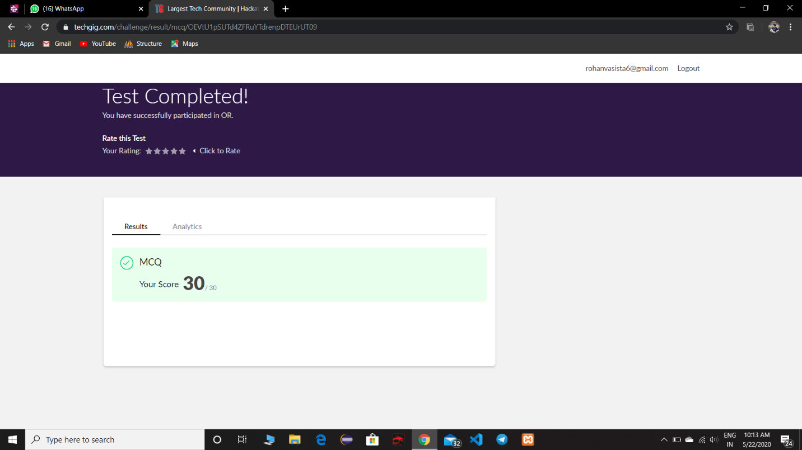

**Online Certification Details**

Completed modules

* Intoduction
* HTML
* CSS
* ReactJS
* Bootstrap

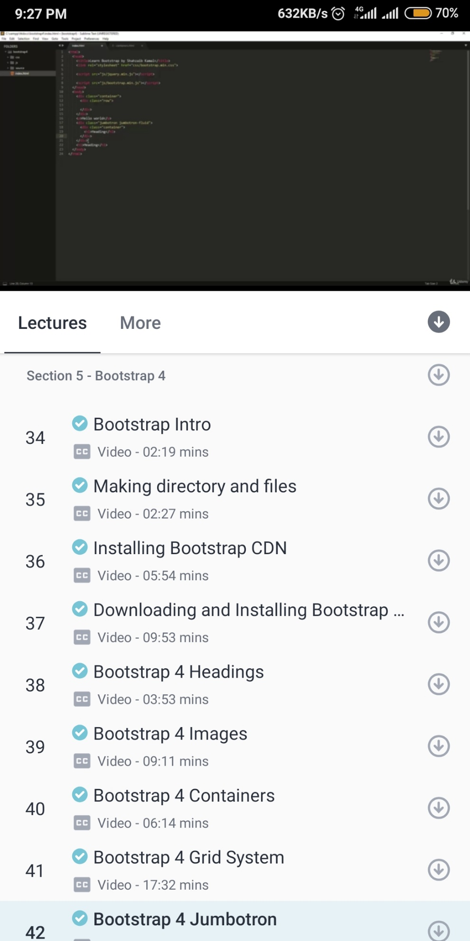

**Coding Challenge Details**

1. Python program to print all Prime numbers in an Interval. Given two positive integers start and end. The task is to write a Python program to print all Prime numbers in an Interval.

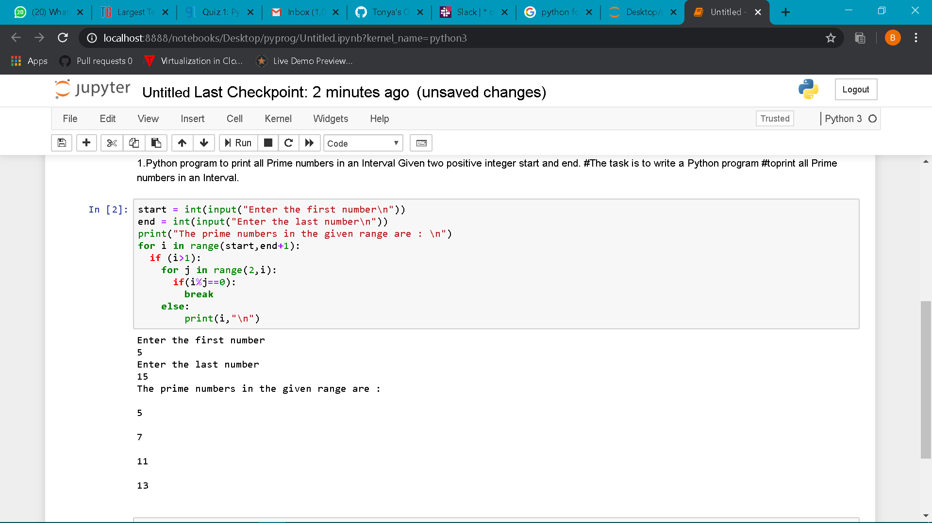

1. Python Program to find sum of array. Given an array of integers (take input from keyboard), find sum of its elements

