APPROACH
The following assignment focuses on detecting circle and color of the circle from an image. To make this possible we made use of following libraries
- Cv2 (OpenCV)
- Numpy
- Matplotlib.pyplot
- Skearn
- Webcolors

Cv2 (OpenCV)
OpenCV (Open Source Computer Vision) is a library of programming functions mainly aimed at real-time computer vision. In simple language it is library used for Image Processing. It is mainly used to do all the operation related to Images.

Numpy
NumPy is a package in Python used for Scientific Computing. NumPy package is used to perform different operations. The ndarray (NumPy Array) is a multidimensional array used to store values of same datatype. These arrays are indexed just like Sequences, starts with zero.

Matplotlib.pyplot
Matplotlib.pyplot is a collection of command style functions that make matplotlibwork like MATLAB. Each pyplot function makes some change to a figure: e.g., creates a figure, creates a plotting area in a figure, plots some lines in a plotting area, decorates the plot with labels, etc.

Sklearn
It is on NumPy, SciPy and matplotlib, this library contains a lot of efficient tools for machine learning and statistical modelling including classification, regression, clustering and dimensionality reduction.

Detecting Circle

Read Image
img = cv2.imread("test1.png")

clone = img.copy()
gray = cv2.cvtColor(clone, cv2.COLOR_BGR2GRAY)
Using cv2.imread() to read an image, we convert to image to Grayscale using cv2.BGR2GRAY
We load our image off disk and create a copy of it so we can draw our detected circles without destroying the original image. We convert the RGB colour space to grayscale, 8bit, single channel image for detection.

Thresholding
Sometimes in image processing, we need to separate an image into some regions (or their contours), the process is called segmentation. So, the natural way to segment such regions is image thresholding. which is nothing but separation of dark and light regions.
Analysing images using image thresholding techniques. Image thresholding is a simple, yet effective, way of partitioning an image into a foreground and background. This image analysis technique is a type of image segmentation that isolates objects by converting grayscale images into binary images.
Now, how to select the value of threshold for global thresholding. This can be done by trial and error method. So, to make it easier we use a trackbar to adjust threshold to get desired edge detection.
cv2.namedWindow("Treshed")

#create trackbars for threshold for color change
cv2.createTrackbar("Threshold","Treshed", 0, 255, nothing)

Edge Detection and Contouring
By adjusting thresholding from previous step, we perform edge detection using Canny Edge Detection. Edge detection helps in finding different features of contour which is later used in detecting circles present image.
ret, gray_threshold = cv2.threshold(gray, r, 255,cv2.THRESH_BINARY)
bilateral_filetered_image = cv2.bilateralFilter(gray_threshold,5,175,175)
edge_detected_image = cv2.Canny(bilateral_filetered_image,75,200)
contours, hierarchy=cv2.findContours(edge_detected_image, cv2.RETR_TREE, v2.CHAIN_APPROX_SIMPLE)

A bilateral filter is a non-linear, edge-preserving, and noise-reducing smoothing filter for images. It replaces the intensity of each pixel with a weighted average of intensity values from nearby pixels. This weight can be based on a Gaussian distribution. It helps in improving the accuracy.

Detect Circle and radius
By finding different features of contour like area, centre etc, we are now capable of using algorithms to detect circles in image. After determine the circle we find radius of circle using the contour area.
for contour in contours:
approx = cv2.approxPolyDP(contour, 0.01*cv2.arcLength(contour,True),True)
area = cv2.contourArea(contour)
if((len(approx) > 8 ) & (area>30)): #10000> area>30

contour_list.append(contour)
rad = math.sqrt(area/math.pi)
radius.append(round(rad, 2))
for c in contour_list:
(c_x, c_y), c_r = cv2.minEnclosingCircle(c)
M = cv2.moments(c)
cX = int(M['m10']/M['m00'])
cY = int(M['m01']/M['m00'])
if c_r>r:
if (cX == c_x) | (cY == c_y):

c_r = str(c_r)
cv2.putText(clone, c_r, (cX - 40, cY - 40),
cv2.FONT_HERSHEY_SIMPLEX, 0.5, (255,0,0), 2)
cv2.drawContours(clone, contour_list, -1, (255,0,0),2)

Using cv2.moments(), we find the centre of the circle. In case of concentric circle, we match centre of the circle to minimum enclosing circle using cv2.minEnclosingCircle and provide the min enclosing circle’s radius of the circle on the image. This helps increase the accuracy of our circle detection. After execution we use drawCountour to draw the shape of circle detected on our image and the radius of image when detected.

OUTPUT
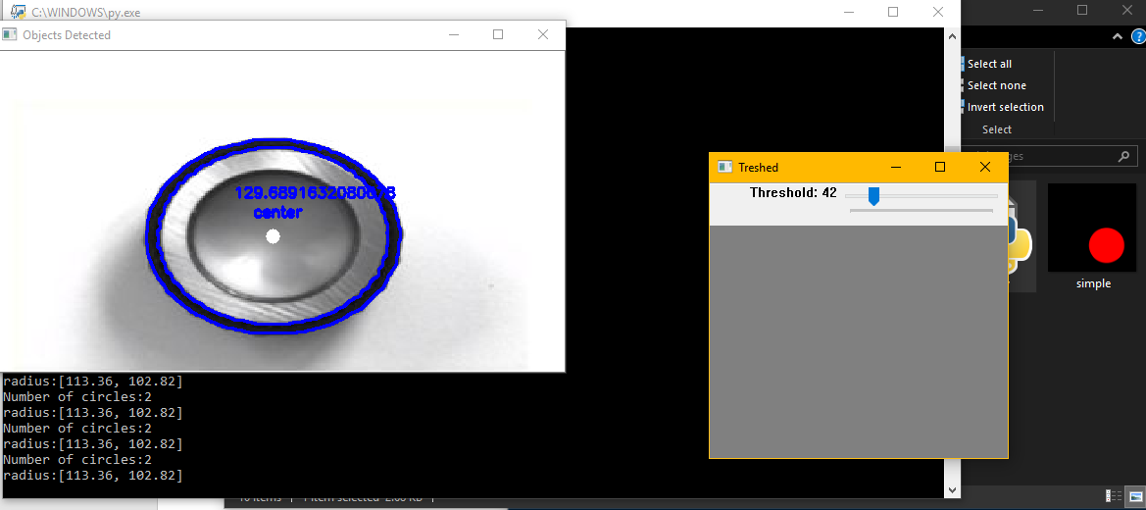
Figure 1: 2 Concentric circle with radius [113.36 px, 102.02 px]
We have found 2 Concentric circle with radius [113.36, 102.02] px respectively

Color Detection

For Detecting Color, we use KMeans clustering to form clusters of dominant colors and then using function rgb color code of the dominant colors, we made a function which would will help tell us actual name of the color and the closest actual name of the color that exist if former is NONE
We created functions
- dominantColors
this function uses KMeans clustering to find dominant colors in the image. Using cluster of 3, we find 3 to speed up the process, the function returns us colors variable which is a list containing dominant colors in the image (in this case only three)
- plotHistogram
this function plots a histogram of dominant colors to better visualise the colors that are dominant and how much they are dominant in the image.
- closest_colour
This function finds the closest color that exists in Webcolors library. This library has a set of predefined names and their rgb color code to colors and using the rgb values of dominant colors which we got from dominantColors Function, we can get closest color name which exists in Webcolors.
- get_colour_name
This function is use to get name of the color using the rgb color code.
def dominantColors(self):
#read image
img = cv2.imread(self.IMAGE)
#convert to rgb from bgr
img = cv2.cvtColor(img, cv2.COLOR_BGR2RGB)
#reshaping to a list of pixels
img = img.reshape((img.shape[0] * img.shape[1], 3))
#save image after operations
self.IMAGE = img
#using k-means to cluster pixels
kmeans = KMeans(n_clusters = self.CLUSTERS)
kmeans.fit(img)
#the cluster centers are our dominant colors.
self.COLORS = kmeans.cluster_centers_
#save labels
self.LABELS = kmeans.labels_
#returning after converting to integer from float
return self.COLORS.astype(int)

#plot histogram for dominant colors
def plotHistogram(self):
#labels form 0 to no. of clusters
numLabels = np.arange(0, self.CLUSTERS+1)
#create frequency count tables
(hist, _) = np.histogram(self.LABELS, bins = numLabels)
hist = hist.astype("float")
hist /= hist.sum()
#appending frequencies to cluster centers
colors = self.COLORS
#descending order sorting as per frequency count
colors = colors[(-hist).argsort()]
hist = hist[(-hist).argsort()]
#creating empty chart
chart = np.zeros((50, 500, 3), np.uint8)
start = 0
#creating color rectangles
for i in range(self.CLUSTERS):
end = start + hist[i] * 500
#getting rgb values
r = colors[i][0]
g = colors[i][1]
b = colors[i][2]
#using cv2.rectangle to plot colors
cv2.rectangle(chart, (int(start), 0), (int(end), 50), (r,g,b), -1)
start = end
#display chart
plt.figure()
plt.axis("off")
plt.imshow(chart)
plt.show()
#get closest predefined color code to our required color code
def closest_colour(requested_colour):
min_colours = {}
for key, name in webcolors.css3_hex_to_names.items():
r_c, g_c, b_c = webcolors.hex_to_rgb(key)
rd = (r_c - requested_colour[0]) ** 2
gd = (g_c - requested_colour[1]) ** 2
bd = (b_c - requested_colour[2]) ** 2
min_colours[(rd + gd + bd)] = name
return min_colours[min(min_colours.keys())]
#get name of the color code and name of the closest predefined color code
def get_colour_name(requested_colour):
try:
closest_name = actual_name = webcolors.rgb_to_name(requested_colour)
except ValueError:
closest_name = closest_colour(requested_colour)
actual_name = None
return actual_name, closest_name

OUTPUT
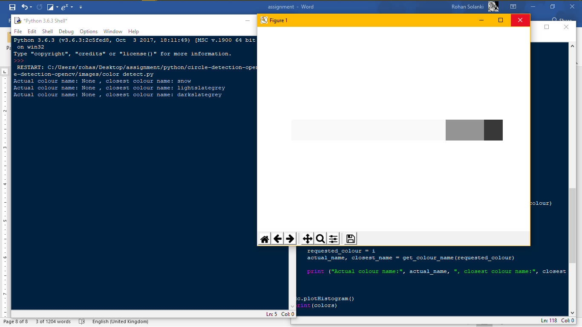
Figure 2: Detect color and histogram
Dominant colors in the image are
- snow
- lightslategrey (circle)
- darkslategrey (circle)

ALGORITHMS
Algorithms used in this assignment are as follows:

Canny Edge Detection
Canny Edge Detection is a popular edge detection algorithm. Steps of algorithms are
- Noise Reduction
- Finding Intensity Gradient of the Image
- Non-maximum Suppression
- Hysteresis Thresholding
And the reason for using this algorithm is due to it’s last two steps
- Non-Maximum Suppression - Edges candidates which are not dominant in their neighbourhood aren't considered to be edges.
- Hysteresis Process - While moving along the candidates, given a candidate which is in the neighbourhood of an edge the threshold is lower.

Douglas–Peucker algorithm
The purpose of the algorithm is, given a curve composed of line segments (which is also called a Polyline in some contexts), to find a similar curve with fewer points.
The starting curve is an ordered set of points or lines and the distance dimension ε > 0.
Now, the choice of ε is usually user-defined. Like most line fitting / polygonal approximation / dominant point detection methods, it can be made non-parametric by using the error bound due to digitization / quantization as a termination condition.
This Algorithm approximates a contour shape to another shape with a smaller number of vertices depending upon the precision we specify.
To understand this, suppose we are trying to find a circle in an image, but due to some problems in the image, you didn't get a perfect square, but a "bad shape" (As shown in first image below). Now you can use this function to approximate the shape. In this, second argument is called epsilon, which is maximum distance from contour to approximated contour. It is an accuracy parameter.
In this case, I used contour approximation because I wanted to reduce the number of (x, y)-coordinates that comprise the contour, while ensuring that all points in the resulting approximation were also part of the original shape and to detect concentric shapes occurrence with our changing threshold value.
approx = cv2.approxPolyDP(contour, 0.01*cv2.arcLength(contour,True),True)
area = cv2.contourArea(contour)
if((len(approx) > 8 ) & (area>30)): #10000> area>30

KMeans Clustering
KMeans algorithm creates clusters based on the supplied count of clusters. In our case, it will form clusters of colors and these clusters will be our top colors.
k-means works really well when we have a small dataset. It can segment the objects in the image and give impressive results. But the algorithm hits a roadblock when applied on a large dataset (a greater number of images).
It looks at all the samples at every iteration, so the time taken is high.

Problems Faced

Detecting Concentric Circle
We can not rule out the possibility of concentric circles in detecting circle in our image as can be seen in our output. So it is must for our algorithm to be able to detect concentric circle but it seems that the OpenCV Hough Circle detection isn't able detect concentric circles according to a passage in the book "Learning OpenCV: Computer Vision with the OpenCV Library"
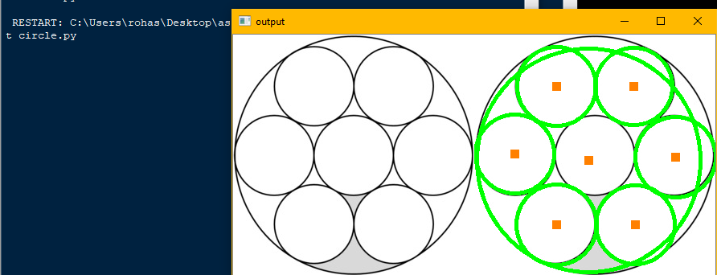
“Finally, because centres are considered in ascending order of their associated accumulator value and because new centres are not kept if they are too close to previously accepted centres, there is a bias to keeping the larger circles when multiple circles are concentric or approximately concentric.”
Figure 3: Concentric circle example

Assuming the circles are not touching:
- Perform edge detection on them. (if you already have, then just check the edge map image once, to ascertain that circles are not touching and clear)
- Perform the approxPolyDP to detect polygon shape (in our case Circle). Store the centres and radii of detected circles
- For each such component detected, check if its centre is close to minimum enclosing area of detected circular contour detected. Basically, check if the component has a corresponding detected Circle. It need not match exactly.
So, we can basically avoid parameter-fiddling with the approxPolyDp. Obviously, the connected component will correspond to the exact location of the Centre.

Increase the accuracy
Image thresholding is one of the simplest methods to separate regions which are higher than the set threshold and it is directly proportional to the accuracy of our project. But it may not be good in all the conditions where image has different lighting conditions in different areas. As can be seen below,
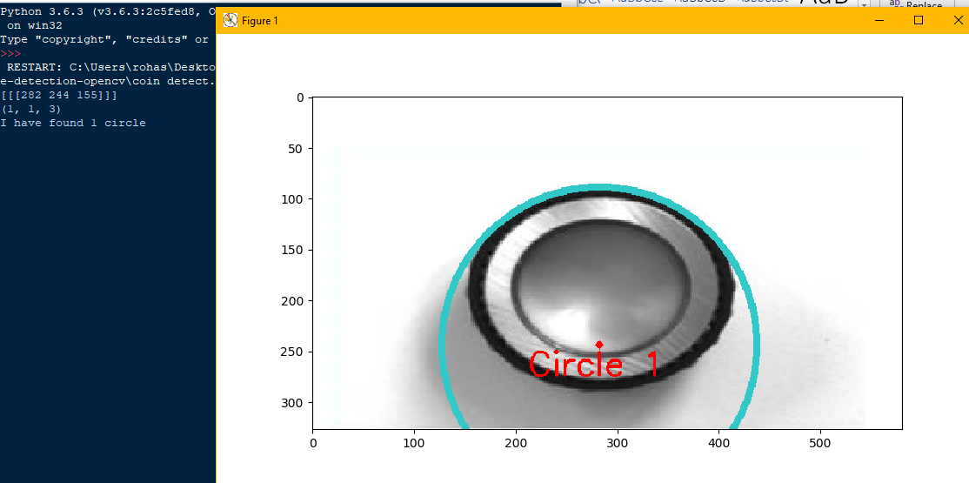
Figure 4 Error one
We need a way to fix a threshold to get maximum result with maximum accuracy in our image which has different lightening conditions.
So, to fix that, I have implemented a trackbar to manually adjust the threshold to get the desired result or closest to desired result.
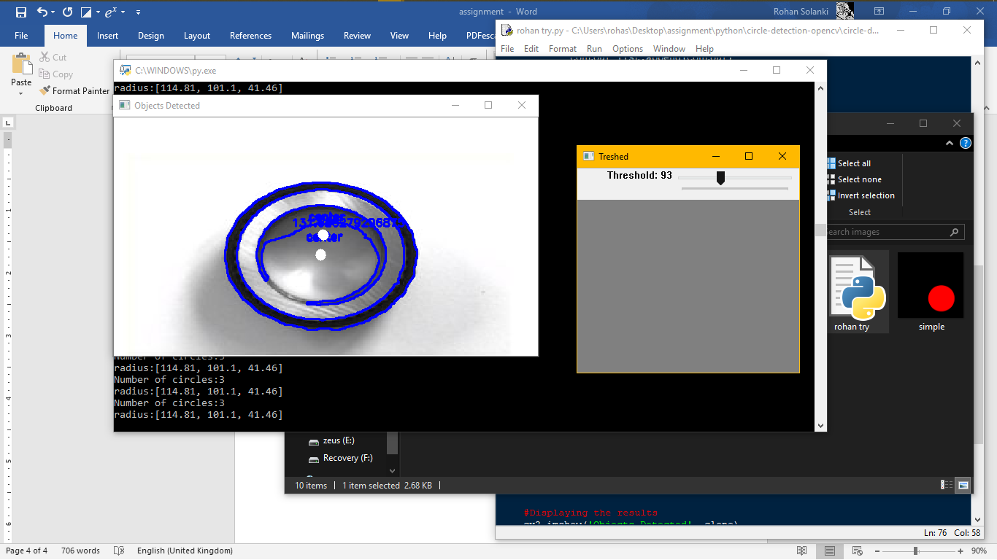
Figure 5: Threshold Trackbar window

But Increasing the threshold over a limit produces inaccuracy in result as contour formed is more sensitive to light.
Figure 6: Inaccuracy due to increased Threshold

Convert color tuple to a color name
While detecting color of circle, a point was reached where detecting the right name for the colors found in the image seemed like a big challenge. To gather a dataset containing name and create a function to convert the rgb color code to a name might cause inaccuracy in our model as then our model would be solely dependent on the flexibility and how versatile the dataset would be.
To counter it, I used a common python library, Webcolors, which contains a set of pre-defined color codes and color names. Using pre-defined function rgb_to_name() in that library saved time and complexity of the code.

Figure 7: Detect color and histogram

