The PERSEUS Security Framework



TPM Manager

Requirements, Design, and Implementation

Responsible Organizations | Ruhr-University Bochum,  Sirrix AG security technologies
Authors | Anoosheh Zaerin (anoosheh.zaerin@rub.de),  Christian Stueble (stueble@sirrix.com)
Abstract | The goal of the “TPM Manager” project is the development of an open-source TPM management software providing an easy to use graphical user interface. In the first step, the TPM Manager will be developed under Linux, while later releases should also be usable as a PERSEUS application. The TPM Manager will be published under the GNU GPL license.
Keywords | Trusted computing, secure operating system, TPM

Table of Contents
1 Motivation and Problem Description 5
1.1Open Issues 5
2 Requirements Specification 6
2.1Security Environment 6
2.1.1Assumptions 6
2.2Threads 6
3 Functional Requirements (Use Case Model) 6
3.1Goal 6
3.2Target Groups 6
3.3Roles and Actors 7
3.4Overview 7
3.5Use Cases (Detailed Description) 8
3.5.1Info 8
3.5.2Owner Settings 13
3.5.3TPM Settings 16
3.5.4Advanced 20
3.5.5Misc 23
4 Security Objectives & Security Requirements 23
4.1Security Objectives 23
4.2Security Requirements 23
5 Supplementary Requirements 24
5.1Preconditions 24
5.2Required Criteria 24
5.3Desired Criteria 24
5.4Distinguishing Criteria 24
5.5Execution Environment 24
5.5.1Software 24
5.5.2Hardware 25
5.6Development Environment 25
5.6.1Software 25
5.6.2Hardware 25
6 Testplan 26
6.1Preliminaries 26
6.2Make, Configure 26
6.3State: TSS stopped 26
6.4State: TPM disabled, No Owner 27
6.4.1Test Status tab 27
6.5State: TPM enabled, No Owner 28
6.5.1Show/Save Endorsement Key(EK) 29
6.5.2Deactivate the TPM 29
6.5.3Take Ownership 30
6.6State: TPM enabled, Owner set 30
6.6.1Disabling/Enabling TPM 30
6.6.2Restrict Enodrsement Key 31
6.6.3Change Owner Password 31
6.6.4Clear Owner Password 31

List of figures
Figure 1: Overview of all use cases realised by the TPM Manager. 9
Figure 2: Dialog showing the TPM state /UC 10/. 10
Figure 3: Dialog showing the capabilities supported by the TPM /UC 20/. 11
Figure 4: TPM and TSS details tab dialog /UC 30/ 12
Figure 5: PCR value dialog /UC 40/ 13
Figure 6: Ownership tab Dialog /UC 100/, /UC 101/ and /UC 102/ 15
Figure 7: Maintenance tab dialog /UC 110/, /UC 120/ 16
Figure 8: TPM operational modes dialog. Implements /UC 200/ and /UC 201/ 17
Figure 9: Endorsement tab Dialog /UC 210/, /UC 211/, /UC 212/, /UC 213/ 19
Figure 10: Tab dialog to perform a full TPM self test /UC 220/ 20
Figure 11: Tab dialog to enable critical features /UC 300/. 21
Figure 12: Disable Maintanence /UC 320/ 22
Figure 13: Revoke Trust tab Dialog /UC 330/ 23

List of Tables

Motivation and Problem Description
The computer industry has recently come up with Trusted Computing (TC), a new generation of computing platforms based on new architectures both in hardware and software. The results of their investigations are the TCG initiative that has published the corresponding hardware and software specifications.
The basic idea is to embed elementary security functions into the underlying hardware of the computing platform while keeping the assumption on tamper-resistance as weak as possible, and reducing costs by keeping the trusted component as small as possible.
The stated goal of these architectures is to improve the security and trustworthiness of computing platforms. Indeed, these platforms offer many useful functions which can be used to increase a platform's security. They extend the conventional PC architecture by new mechanisms to (i) protect cryptographic keys, (ii) generate random numbers in hardware, (iii) authenticate (the configuration of) a platform (attestation), and (iv) cryptographically bind the data to be encrypted to certain information, e.g., the system configuration and the identifier of the invoking application (sealing).
However, there is still an ongoing public debate about the negative economical, social, and technical consequences of these platforms. People are concerned about the potential dangers of the capabilities of such platforms: They may give vendors and content providers too much control power over personal systems and users' private information. Although most complains about trusted computing are speculative, it is highly important to observe its development carefully, and to improve this technology by putting together the missing pieces for more secure platforms in future.
Today, only a few software components supporting TPMs are available, especially in the context of open-source operating systems like Linux. We observed that many people, who would like to experience with a TPM, have many problems using the provided management software, i.e., libtpm and Trousers. Moreover, many open-source projects in the context of trusted computing lack support of a TPM management.

Open Issues
- Make KDE-Support optional (using a ./configure option)
- Make the TPM Manager optionally a KConfig instance

Requirements Specification

Security Environment
This section describes the security aspects of the environment in which the product is intended to be used and the manner in which it is expected to be employed.

Assumptions
A description of assumptions shall describe the security aspects of the environment in which the product will be used or is intended to be used. This shall include the following:
- information about the intended usage of the product, including such aspects as the intended application, potential asset value, and possible limitations of use; and
- information about the environment of use of the product, including physical, personnel, and connectivity aspects.

ToBeDone...

Threads
A description of threats shall include all threats to the assets against which specific protection within the product or its environment is required. Note that not all possible threats that might be encountered in the environment need to be listed, only those which are relevant for secure product operation.
A threat shall be described in terms of an identified threat agent, the attack, and the asset that is the subject of the attack. Threat agents should be described by addressing aspects such as expertise, available resources, and motivation. Attacks should be described by addressing aspects such as attack methods, any vulnerabilities exploited, and opportunity.
ToBeDone...

Functional Requirements (Use Case Model)

Goal
The goal of the “TPM Manager” project is the development of an open-source TPM management software providing an easy to use graphical user interface. In the first step, the TPM Manager will be developed under Linux, while later releases should also be usable as a PERSEUS application. The TPM Manager will be published under the GNU GPL license.

Target Groups
Defines the users/other components that wish to use the product.

- Home user (Single-user platform at home)

Roles and Actors
In this section we define different roles and actors important for the use case model. Actors are parties outside the system that interact with the system; an actor can be a class of users, roles users can play, or other systems. Note that, depending on the use case, some parties or actors may not be involved.

- Owner: The owner of a platform is an entity who defines the allowed configurations of the underlying platform. Note that this also includes certain changes to the platform's configuration. In practice, these changes are patches/updates. The platform owner is also owner of the TPM and thus is aware of the owner authorization information. Typical examples are an enterprise represented by an administrator or an end-user owning a personal platform.

- User: The user of a computing platform is an entity interacting with the platform under the platform's security policy. Examples are employees using enterprise-owned hardware. User and owner might also be identical, e.g., in an end-user environment.

Overview
Figure REF gives on overview of all use cases realized by the TPM Manager. The use cases are separated into different subsets:

- Info: Display information about the TPM that can be read without an authorization.
- Owner Setting: Use cases related to TPM Owner management and SRK management issues.
- TPM Setting: Use cases related to TPM state management.
- Advanced: Critical use cases that may couse permanent changes to the TPM
- Misc: Utility use cases like password dialogs or warning messages.

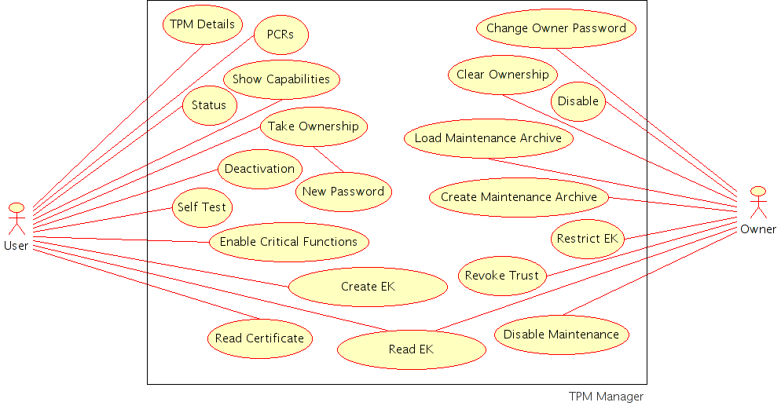Figure 1: Overview of all use cases realised by the TPM Manager.

Use Cases (Detailed Description)
Each use case focuses on describing how to achieve a single business goal or task. From a traditional software engineering perspective a use case describes just one feature of the system. For most software projects this means that multiple, perhaps dozens, of use cases are needed to fully specify the new system. The degree of formality of a particular software project and the stage of the project will influence the level of detail required in each use case.
A use case defines the interactions between external actors and the system under consideration to accomplish a business goal.
Use cases treat the system as a "black box", and the interactions with the system, including system responses, are perceived as such from outside the system. This is a deliberate policy, because it simplifies the description of requirements, and avoids the trap of making assumptions about how this functionality will be accomplished.
A use case should:
- describe a business task to serve a business goal
- have no implementation-specific language
- be at the appropriate level of detail
- be short enough to implement by one software developer in a single release.

Info
The use cases described in this section display information about the TPM that can be read without an authorization.

Use case unique ID | /UC 10/
Title | Status
Short description/purpose(s) | Show the status of TPM.
Roles | User
Displayed Items | For example show the items:  - TPM driver found  - TSS system found  - TPM Enabled  - Owner set  - TPM activated  - EK available

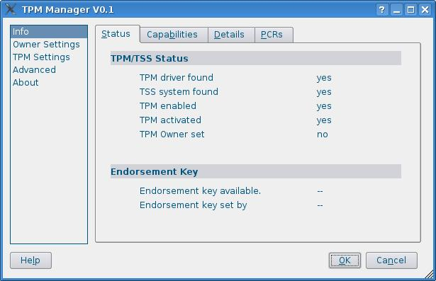Figure 2: Dialog showing the TPM state /UC 10/.
Use case unique ID | /UC 20/
Title | Show TPM Capabilities
Short description/purpose(s) | Show the capabilities of the TPM
Roles | User
Displayed Items | Examples:  - Number of PCRs  - Available features  - etc.

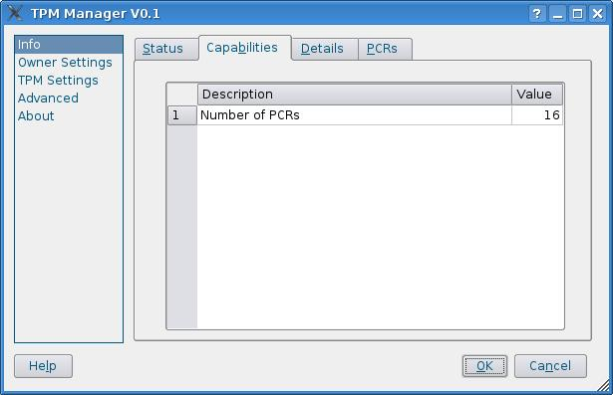Figure 3: Dialog showing the capabilities supported by the TPM /UC 20/.
Use case unique ID | /UC 30/
Title | TPM Details
Short description/purpose(s) | Show detailed information about the TPM and the TSS.
Roles | User
Displayed Items | For Example shows the:  - Information about TPM such as: Vendor, Version, Firmware  - Information about TSS such as: Version, Vendor

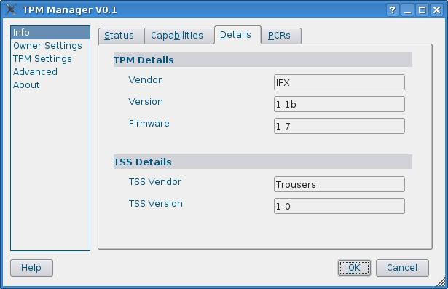Figure 4: TPM and TSS details tab dialog /UC 30/

Use case unique ID | /UC 40/
Title | PCRs
Short description/purpose(s) | Show the current PCR values.
Roles | User

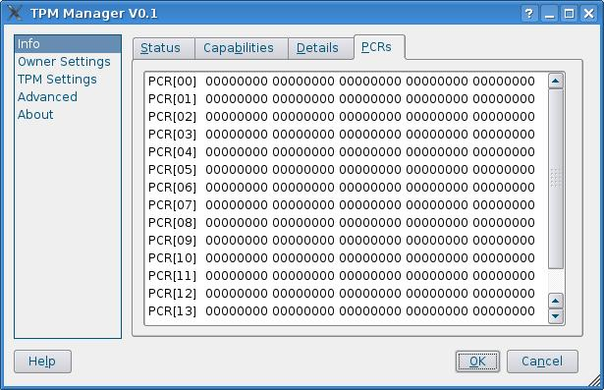Figure 5: PCR value dialog /UC 40/

Owner Settings
The use cases of this section are related to TPM Owner management and SRK management issues.

Use case unique ID | /UC 100/
Title | Take Ownership
Short description/purpose(s) | Configure the Owner and set the embedded Security features
Roles | Owner
Includes | New Password
Preconditions | No TPM owner set
Postcondition | TPM Owner set

Use case unique ID | /UC 101/
Title | Change Owner Password
Short description/purpose(s) | Change the password used to authenticate the TPM owner.
Roles | Owner
Includes | Owner authentication /UC /,  New Password /UC /
Preconditions | TPM Owner set
Postcondition | Owner set with new password

Use case unique ID | /UC 102/
Title | Clear Ownership
Short description/purpose(s) | Delete the TPM ownership and set TPM to factory defaults.
Roles | Owner
Includes | Owner authentication /UC /,  Warning /UC /
Preconditions | Owner set
Postcondition | TPM Disabled, Deactivated, and no Owner set.

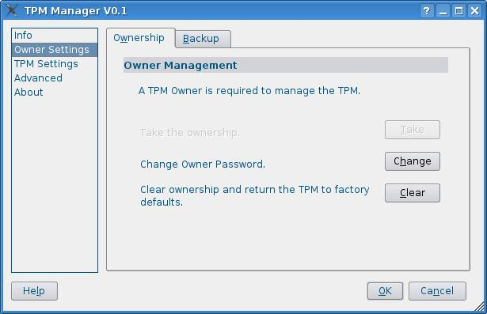Figure 6: Ownership tab Dialog /UC 100/, /UC 101/ and /UC 102/
Use case unique ID | /UC 110/
Title | Create Maintenance Archive
Short description/purpose(s) | Create a backup of the SRK
Roles | Owner
Includes | File selection, Owner authorization
Preconditions | TPM supports maintenance feature
Normal Flow | - Owner hits “maintenance create” button.  - Owner selects destination for archive file.  - Owner authorization  - Confirm create the archive

Use case unique ID | /UC 120/
Title | Load Maintenance Archive
Short description/purpose(s) | Restore the SRK backup archive
Roles | Owner
Includes | File selection, Owner authorization
Preconditions | SRK archive was created by the TPM manufacturer.
Normal Flow | - Owner hits “maintenance load” button.  - Owner selects archive file.  - Owner authorization  - Confirm load SRK archive
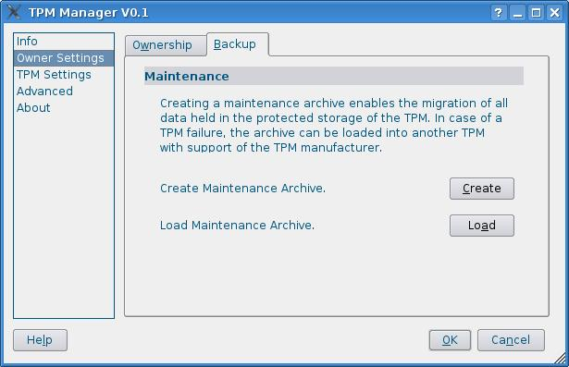Figure 7: Maintenance tab dialog /UC 110/, /UC 120/

TPM Settings
Use case unique ID | /UC 200/
Title | TPM Deactivation
Short description/purpose(s) | TPM can be switched from activated to temporarily deactivated mode.
Roles | User
Includes | Warning Message /UC ??/
Preconditions | TPM is activated
Postcondition | TPM is temporarely deactivated
Normal Flow | - User hits “Deactivate” Button  - Warning message  - Confirmation message

Use case unique ID | /UC 201/
Title | Disable (Enable) the TPM
Short description/purpose(s) | In this Section can TPM can be switched to enabled or disabled mode.
Roles | Owner
Includes | Owner Authorization /UC ??/,  Warning /UC ??/
Normal Flow | - Owner hits “Disable” (“Enable”) Button  - Owner authorization  - Warning message  - Confirmation message
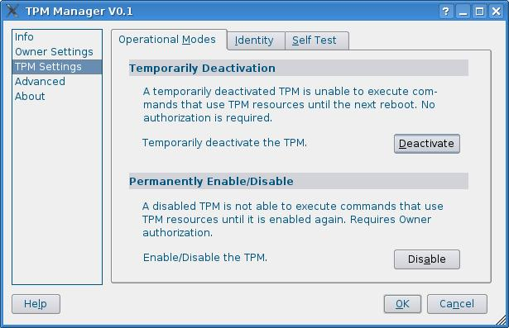Figure 8: TPM operational modes dialog. Implements /UC 200/ and /UC 201/
Use case unique ID | /UC 210/
Title | Create Endorsement Key
Roles | User
Preconditions | No Endorsement Key is set by Manufacturer
Postcondition | TPM has Endorsement Key

Use case unique ID | /UC 211/
Title | Read Public Endorsement Key
Short description/purpose(s) | Read the Public part of EK
Roles | User

Use case unique ID | /UC 212/
Title | Restrict Public Endorsement Key
Short description/purpose(s) | Disable reading of EK without owner authorization
Roles | User
Preconditions | Role = User
Postcondition | Role = Owner

Use case unique ID | /UC 213/
Title | Read TPM Endorsementcertificate
Short description/purpose(s) | Read the Endorsement Certificate of the TPM
Roles | User

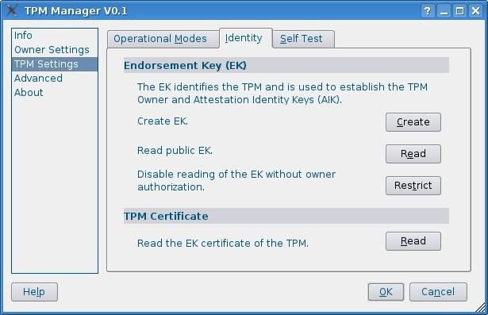Figure 9: Endorsement tab Dialog /UC 210/, /UC 211/, /UC 212/, /UC 213/

Use case unique ID | /UC 220/
Title | Self test
Short description/purpose(s) | Perform a full self test of each TPM internal function.
Roles | User

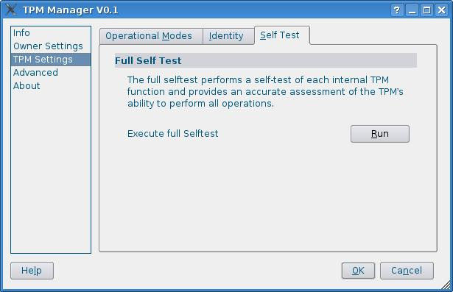Figure 10: Tab dialog to perform a full TPM self test /UC 220/

Advanced
Use case unique ID | /UC 300/
Title | Enable Critical Functions
Short description/purpose(s) | The “Advanced” section needs to be enabled explicitly by the user, because the provided features that can perform critical and permanent changes of the TPM.
Roles | Owner
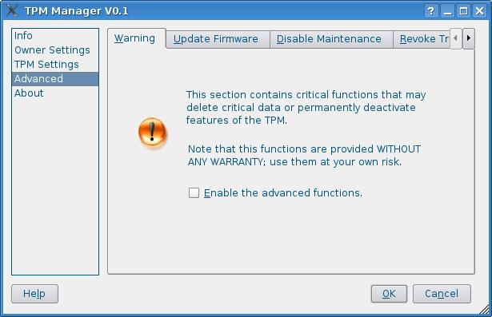Figure 11: Tab dialog to enable critical features /UC 300/.

Use case unique ID | /UC 320/
Title | Disable Maintenance Feature
Short description/purpose(s) | Kill Maintenance feature
Roles | Owner
Includes | Owner authorization
Preconditions | ...
Postcondition | (none)

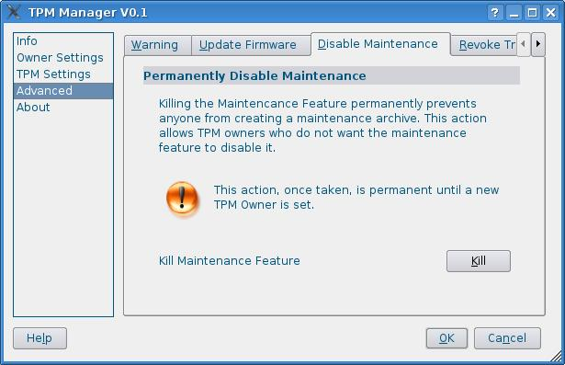Figure 12: Disable Maintanence /UC 320/

Use case unique ID | /UC 330/
Title | Revoke Trust
Short description/purpose(s) | Delete Endorsement Key
Roles | Owner
Includes | Owner Authentication, Warning Message
Preconditions | TPM has Endorsement Key
Postcondition | No Endorsement key

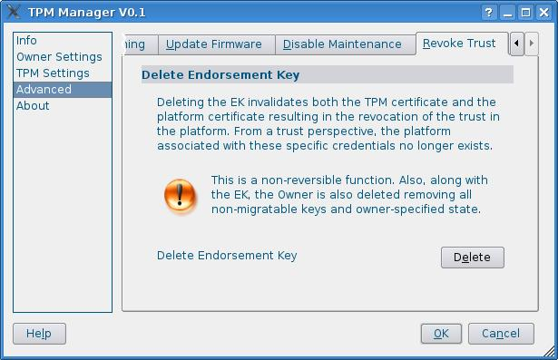Figure 13: Revoke Trust tab Dialog /UC 330/

Misc
The uses cases of this section include utility dialogs like password dialogs or warning messages.

Use case unique ID | /UC 400/
Title | New Password
Short description/purpose(s) | User/Owner enters a new passphrase
Roles | Owner, User

Use case unique ID | /UC 410/
Title | Owner Authentication
Short description/purpose(s) | Owner authorization using the owner secret
Roles | Owner

Use case unique ID | /UC 420/
Title | Warning Message
Short description/purpose(s) | System shows a warning message
Roles | Owner, User

Security Objectives & Security Requirements

Security Objectives
The security objectives shall address all of the security environment aspects identified. The security objectives shall reflect the stated intent and shall be suitable to counter all identified threats and cover all identified organizational security policies and assumptions. A threat may be countered by one or more objectives for the product, one or more objectives for the environment, or a combination of these.

ToBeDone...

Security Requirements
This part of the requirement specification defines the security requirements that have to be satisfied by the product. The statements shall define the functional and assurance security requirements that the product and the supporting evidence for its evaluation need to satisfy in order to meet the security objectives.
ToBeDone...

Supplementary Requirements
Obligatory criteria, mandatory for successful completion.

Preconditions
Requirements that have to be fulfilled already, because they were needed for the development process.
/PR 100/ TSS
The TPM Manager will depend on an existing TSS implementation.
/PR 200/ Widget Library
The TPM Manager will depend on an open-source widget library.
/PR 300/ TPM-enabled BIOS
The BIOS has to support TPM's to be able to enable it.

Required Criteria
Mandatory criteria, that are obligatory for successful completion.
/RC 10/ Linux support
The realization of the use cases should be based on an Linux-based architecture.
/RC 20/ PERSEUS support
The realization of the use cases should be based on a PERSEUS-based architecture.

Desired Criteria
Optional criteria, that are not mandatory for successful completion.
/DC 10/ Xen support
The realization of the use cases should be based on a Xen-based architecture.

Distinguishing Criteria
What our product does not provide.

Execution Environment
This section specifies software and hardware the user requires at least to run our product successfully.

Software
- Linux Distribution based on kernel 2.6.x, including
  - Trousers
  - TPM Driver
  - Widget Library
- Perseus Architecture, including
- TPM Driver
- Widget Library
- Trust Manager

Hardware
- HP Notebook with Infineon TPM 1.1.b
- Desktop PC with ST TPM 1.2
- ThinkPad T41p with Atmel TPM 1.1b

Development Environment
This section specifies hard- and software that developers need at least to implement the product successfully.

Software
- Linux 2.6.x
- gcc 3.4.x
- eclipse-3.1
- Borland Together X.Y.Z

Hardware
- HP Notebook

Testplan
Date:
Linux distribution:
Hardware:
TPM vendor/version:
TSS vendor/version:

Please note your test's result, and other consideration after each test.

Preliminaries
Please start the test with following status: TPM disabled, no owner. For this purpose, please reset the TPM with BIOS to the factory defaults.

Make, Configure
Run configure and make the project. Configurations must pass without any critical failure.
_____________________________________________________________________________________________________________________________________________________________________________________________________________________________________________________________________

State: TSS stopped
Ensure that trousers core service (tcscd) is stopped (run '/etc/init.d/tcsd stop'). Run the TPM Manager. GUI should be work without problem. The tab “Status” should show the following information:
TPM driver found yes
TSS System found no
Endorsement key available ?(unknown)
TPM enabled ?
TPM activated ?
TPM Owner set ?
_____________________________________________________________________________________________________________________________________________________________________________________________________________________________________________________________________

If TPM driver is not found try to find the appropriate driver and install it, and be sure that driver is loaded correctly.
_____________________________________________________________________________________________________________________________________________________________________________________________________________________________________________________________________

Check if in all other tabs all buttons are deactivated.
_____________________________________________________________________________________________________________________________________________________________________________________________________________________________________________________________________

There should be shown no Information in “Details” tab and “Capabilities” tab.
_____________________________________________________________________________________________________________________________________________________________________________________________________________________________________________________________________

State: TPM disabled, No Owner
First be sure that trousers is started (run '/etc/init.d/tcsd start') Note that '/etc/tcsd.conf' must be owned by tss:tss as user:group.

Test Status tab
Run TPM Manager. You see at first a warning window. Click 'ok' and continue.
_____________________________________________________________________________________________________________________________________________________________________________________________________________________________________________________________________

Check if TPM/TSS status is:
TPM driver found yes
TSS System found yes
Endorsement key available yes/no
(if it is not available, that means that EK is not set by Company)
TPM enabled no
TPM activated ? (unknown)
TPM Owner set no
_____________________________________________________________________________________________________________________________________________________________________________________________________________________________________________________________________

Information on “Status” tab should be the same as the state shown in “TPM Status” group box (left-bottom of the GUI).
_____________________________________________________________________________________________________________________________________________________________________________________________________________________________________________________________________

Go to the “Details” tab and see the TPM and TSS details. You should see the vendor name as short name(such as INX for Infineon), version and firmware of the TPM, and TSS vendor and version (e.g., TSS Vendor: Trousers, TSS Version: 1.0, rev 0.1). Are the shown information correct?
_____________________________________________________________________________________________________________________________________________________________________________________________________________________________________________________________________

Go to the “Capabilities” tab. Is number of available PCRs shown here correct?
_____________________________________________________________________________________________________________________________________________________________________________________________________________________________________________________________________

Go to the “PCRs” tab. The PCR values should not be visible, because the TPM is not enabled.
_____________________________________________________________________________________________________________________________________________________________________________________________________________________________________________________________________

All other tabs except “TPM Selftest” (see below) should be disabled.
_____________________________________________________________________________________________________________________________________________________________________________________________________________________________________________________________________

Select “TPM Settings” at the left menu. Choose the “Self Test” tab and run TPM Selftest and check if it is done successfully.
_____________________________________________________________________________________________________________________________________________________________________________________________________________________________________________________________________

State: TPM enabled, No Owner
Restart your computer now, enable the TPM in the BIOS. After starting the TPM Manager, the “Status” tab should show the following information:
TPM driver found yes
TSS System found yes
Endorsement key available yes/no
TPM enabled yes
TPM activated yes
TPM Owner set no
_____________________________________________________________________________________________________________________________________________________________________________________________________________________________________________________________________

Information on “Status” tab should be the same as the state shown in “TPM Status” group box (left-bottom of the GUI).
_____________________________________________________________________________________________________________________________________________________________________________________________________________________________________________________________________

Click on the other tabs of “Info”: Details, Capabilities, PCRs. Compare the Information at Details and Capabilities with Information from last test.
_____________________________________________________________________________________________________________________________________________________________________________________________________________________________________________________________________

It should be possible now to see the PCR values at “PCRs” tab.
_____________________________________________________________________________________________________________________________________________________________________________________________________________________________________________________________________

Select “Owner Settings” from the left Menu:
In “Ownership” tab, “Take” Ownership button should be activated now, and all other buttons should be remain inactive.
_____________________________________________________________________________________________________________________________________________________________________________________________________________________________________________________________________

Select “TPM Settings” from the left Menu:
“Deactivate” button should be active now.
_____________________________________________________________________________________________________________________________________________________________________________________________________________________________________________________________________

Choose “Identity” tab. If you have had status “Endorsement Key available” in last step, you should be able now to see the Endorsement key info(see below).
_____________________________________________________________________________________________________________________________________________________________________________________________________________________________________________________________________

Select “Advanced” from the left Menu. All buttons should be inactive now.
_____________________________________________________________________________________________________________________________________________________________________________________________________________________________________________________________________

Show/Save Endorsement Key(EK)
Select “TPM Settings” from the left Menu and choose the “Identity” tab. If you have had status “Endorsement Key available” in last step, you should be able now to see the Endorsement key info and save it as a File. “Create”- and “Restrict” button should be inactive.
Click on “Show”, and see the Information about EK in another dialog. You should see the Version, Type, Algorithm and Key Size. Maybe Encryption Scheme and Signature Scheme are unknown. Close the “Info” dialog.
_____________________________________________________________________________________________________________________________________________________________________________________________________________________________________________________________________

Click on Save and store the EK on your hard disc.
_____________________________________________________________________________________________________________________________________________________________________________________________________________________________________________________________________

Deactivate the TPM
Select “TPM Settings” from the left Menu and choose the “Operational Modes” tab.
You should be able to deactivate your TPM, but not to disable that.
Click on “Deactivate” button to deactivate the TPM. Reply the warning with yes. You should see in “TPM Status” group box(Left-Bottom) the following State:
TPM Status:
enabled yes
activated no
owner set no
Select “Info” from the Left Menu and be sure that current state is the same as information in “Status” tab.
_____________________________________________________________________________________________________________________________________________________________________________________________________________________________________________________________________

Restarting your computer will activate TPM automatically. Reboot your computer and check if state changes to activated.
_____________________________________________________________________________________________________________________________________________________________________________________________________________________________________________________________________

Take Ownership
The TPM state is now enabled, activated, no owner.
Select “Owner Settings” from the left menu. Click on button “Take”, to take ownership. Enter an owner password and confirm that. On the next dialog enter a SRK password.
_____________________________________________________________________________________________________________________________________________________________________________________________________________________________________________________________________

In “Ownership” tab should be buttons “Change” and “Clear” now active and “Take” inactive.
_____________________________________________________________________________________________________________________________________________________________________________________________________________________________________________________________________

Check if state is changed to:
TPM Status:
enabled yes
activated yes
owner set yes
Select “Info” from the left menu and be sure that this state is the same as information in “Status” tab.
_____________________________________________________________________________________________________________________________________________________________________________________________________________________________________________________________________

Select “TPM Settings” from the left menu. In “Operational Modes” tab the “Disable” button should be active.
_____________________________________________________________________________________________________________________________________________________________________________________________________________________________________________________________________

Click on the “Identity” tab. “Restrict” button should be active now.
_____________________________________________________________________________________________________________________________________________________________________________________________________________________________________________________________________

State: TPM enabled, Owner set

Disabling/Enabling TPM
After Take Ownership it is possible to Disable/Enable the TPM in GUI.
Select “TPM Settings” at the left menu. Click on “Disable” button. Enter your owner password and choose yes from next Dialog.
Check if State is changed to:
TPM Status:
enabled no
activated ?
owner set yes
_____________________________________________________________________________________________________________________________________________________________________________________________________________________________________________________________________

Select TPM Settings from the left menu. Click on “Enable” button. Enter your owner password and choose yes from next Dialog. Check if State is changed to:
TPM Status:
enabled yes
activated yes
owner set yes
_____________________________________________________________________________________________________________________________________________________________________________________________________________________________________________________________________

Restrict Endorsement Key
Select “TPM Settings” from the left menu. Click on “Restrict” button to restrict the Endorsement key. Enter your owner password, and see if it is done successfully.
_____________________________________________________________________________________________________________________________________________________________________________________________________________________________________________________________________

“Restrict” button should be disabled after restriction.
_____________________________________________________________________________________________________________________________________________________________________________________________________________________________________________________________________

Change Owner Password
Select “Owner Settings” at the left menu. Click on “Change” button to change the Owner Password. Enter your old password and then new password.
_____________________________________________________________________________________________________________________________________________________________________________________________________________________________________________________________________

Clear Owner Password
Select “Owner Settings” from the left menu. Click on “Clear” button to clear the ownership. Enter your Owner Password and see if it is cleared. You should reboot your computer after clearing Owner Password.
After reboot you will be back to state: TPM disabled, no owner
_____________________________________________________________________________________________________________________________________________________________________________________________________________________________________________________________________

http://www.perseus-os.org

